ARTISTSEXHIBITIONSPUBLICATIONSNEWSABOUTCONTACT

Location: UKPRESS RELEASE WORKS
BACK
24 July - 7 September 2002
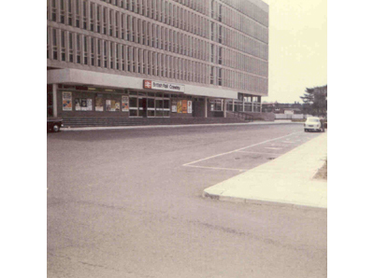
BANK, Richard BILLINGHAM, Adam CHODZKO, Layla CURTIS, Shez DAWOOD, Corinne DAY, Pamela GOLDEN, Tom HUNTER, Peter KENNARD, Andrew LEWIS, Sarah LUCAS, Rut Blees LUXEMBURG, Hannah MAYBANK, Martin PARR, Ingrid POLLARD, Hannah STARKEY, Christopher STEWART, George SHAW, Alia SYED, Mark WALLINGER
Where are we? Location: UK illustrates where we are, from a point on a map, to a cultural identity. Drawing together artists from across the social, racial and cultural map of the UK, this exhibition examines the relationships we have with the places and locations in which we live. Crossing the threshold of a collective identity defined by a national boundary, Location: UK unravels the multifaceted nature of UK living.
We are constantly being told in the news media that the world is a smaller place; the effects of increasingly global economies, not to mention military activities means that we have more in common with our neighbours overseas than our next door neighbours. However, it is the immediate landscapes and environs which surround us that define who and what we are. Location: UK aims to show not only where we are now, but where we are going. The assessments of our national situation are both bleak and promising. On one hand an increasing insularity on national and local levels may be viewed with caution; witness the aggressive nationalism of marginal political parties and the localised protests against asylum seekers. On the other hand, a re-evaluation of what it means to live, work and grow in the UK can be affirming in its diversity and astonishing in its complexity.
The works of art on display in this exhibition are indicators of the multiple demographic constituencies that make up the UK. Our daily lives, our fears, concerns, dreams and desires. The local and national boundaries and borders that impact on our lives may have been constructed arbitrarily, but they do serve a purpose. This exhibition will examine how notions of place and location inform works of art made within the geographical boundary of the United Kingdom. What may surprise us however, are the works which undermine those boundaries and discuss issues of travel and dislocation. We are a nation coming to terms with our global position after all.
A place and a nation is constructed not only through the people within its boundaries, but also by the products that they make. Although the works presented may shift from gritty urban dramas to the tranquil serenity of the countryside and back to presenting violent and political tensions, they all have a common thread: to reflect and re-present the site and situation in which they were created. The fulcrum of these works is their setting, their place, their location: UK.

T. +44 (0)20 7493 2488 E. INFO@GIMPELFILS.COM

