FireMind: Trialling a new Tool for Training
Fire and Rescue Service Decision-making⁷

Arendtsen, B.², Baker, S. ⁶, Bertels, M.⁴, Brookes, D. ⁶,
Catherwood, D. ⁶, Christiansen, K.², Cuypers, W. ⁵, Edgar, G. ⁶,
Krawczynska, S.¹, Maes, V. ⁵, Sallis, G. ³, Stegienko, K. ¹, Thoelen, F. ⁵,
Van Craybex, G. ⁵, Vastmans, J.⁵, Vorenkamp, F. ⁴, Weewer, R.⁴, Wenarski, G.¹

¹CNBOP-PIB (Centrum Naukowo-Badawcze Ochrony Przeciwpozarowej - Panstwowy Instytut Badawczy) Scientific and Research Centre for Fire Protection National Research Institute (Poland)
²FALCK (Fire Services) (Denmark)
³Gloucestershire Fire and Rescue Service (GFRS) (UK)
⁴IFV (Institute for Fysical Safety) Brandweeracademie/Fire Service Academy (Netherlands)
⁵PLOT (Provincie Limburg Opleiding en Training: Provincial Centre for Education & Training: Fire and Rescue Training Centre) (Belgium)
⁶University of Gloucestershire (UK) (CRACKLE Centre for Research in Applied Cognition, Knowledge, Learning & Emotion)

⁷The FireMind project was funded by the Erasmus Plus scheme.

FireMind: Trialling a new Tool for Training Fire and Rescue Service Decision-making

FireMind: background and aims:
FireMind is an innovative online training tool aimed at supporting and enhancing the training of decision-making by Fire and Rescue personnel. The project was funded by the Erasmus Plus grant scheme and developed by collaboration across major Fire and Rescue training facilities in Belgium (PLOT), Denmark (FALCK), Netherlands (IFV), Poland (CNBOP-PIB) and UK (GFRS) and a University of Gloucestershire research centre (CRACKLE).

Effective decision-making in fire and rescue operations clearly requires good understanding of the situation or good Situation Awareness (SA). Such awareness requires good selection of correct and appropriate information about the situation or incident. Prior research by the UK team (Catherwood, Edgar, Sallis, Medley, & Brookes, 2012; Sallis, Catherwood, Edgar, Brookes & Medley, 2013) has shown however that even well-trained individuals may not always use the available information well and may make errors as a result. This is due to the “Information Bias” of the decision-maker.
Under pressure, decision-makers may show one of two types of Bias pattern in how they use the available information. They may tend to tunnel down or “zoom in” on a narrow band of information and so use only a few details or a narrow amount of the available information in their decision-making. Alternatively they may do the opposite and “zoom out”, trying to use a very wide span of details or information but only able to filter or check this at a shallow or superficial level. There are many reasons for this bias tendency but one main factor is the natural processing limitation of the human brain. Key processing systems in the brain hold information “on-line” in the brain during decision-making, but these systems can only cope with a limited number of details at any one time. If the brain is overloaded under pressure, people may either tunnel down on a narrow set of details or instead try to take in a wide span of details but only at a shallow level without adequate checking. Overloading the brain’s processing power has been linked to errors in real-world decision-making including fireground operations (Endsley & Rogers, 2008; Klein et al., 2010; McLennan et al., 2005; Useem et al., 2005). Experience helps to guard against these errors (Gasaway, 2008; Klein et al., 2010) but it can also cause an individual to miss or overlook information if the experience does not fit the current circumstances (Perry et al., 2009).

Neither Bias tendency is necessarily bad and each may be appropriate at some point in an incident. Nevertheless, it is important to know that either tendency is associated with errors. “Zooming in” (narrow bias) carries the risk of overlooking useful information and so making “miss” errors. In contrast, “Zooming out” (wide bias) carries the risk of treating all information as equally important and so making “false alarm” errors, where inappropriate or even false information is unwittingly used to make decisions. The Bias of an individual may vary with the circumstances, but there is good evidence that under pressure, individuals will usually tend to show the same type of Bias reaction (Sallis, 2016).

FireMind Tool: the basic approach
The FireMind tool offers a means to appraise the SA and Information Bias of individuals in digital scenarios that represent key types of fire and rescue operations appropriate to their roles and duties. The tool can be used either by individuals alone or as part of a training routine. The basic approach of the tool uses visual and textual material to show the stages and essential aspects of a fire and rescue incident. At intervals the individual is asked to respond “True” or “False” to statements about the incident and these replies provide the basis for a measure of both SA and Bias. The individual is also asked to score how confident they feel about their answers. The confidence ratings provide a measure of “Perceived” SA (PSA) - that is, how good the individual thinks or perceives their SA to be. PSA need not be the same as actual SA and indeed a gap between these may be of concern. For example, high PSA but low SA could lead to judgment errors due to unwarranted overconfidence and possibly poor self-checking or monitoring of performance.
The responses to the probe statements are analysed by a method called QASA (Quantitative Assessment of Situation Awareness) (see: Catherwood, Edgar, Sallis, Medley, & Brookes, 2012; Edgar and Edgar, 2007 for further details). This approach sorts the replies into four types (two correct and two incorrect) - “hits” (saying “true” to correct statements), “correct rejections” (saying “false” to false statements), “misses” (saying “false” to correct statements) and “false alarms” (saying “true” to false statements) (see Table1). There are operational consequences of each type of decision: Hits and Correct Rejections are likely to result in lean and effective performance, while Misses may lead to risky or ineffective operations and False Alarms to wasteful performance with inappropriate allocation of personnel and resources (see Table 1).

Table 1.
The four types of decision and operational response to the probe statements

 | Actual situation: “TRUE”  Specific threat or opportunity was present | Actual situation: “FALSE”  Specific threat or opportunity was not present
DECISION / RESPONSE: “TRUE”: Act upon threat or opportunity | HIT:  Effective operation | FALSE ALARM:  Wasteful operation
DECISION: / RESPONSE:  “FALSE”: Ignore threat or opportunity | MISS:  Riskful or ineffective operation | CORRECT REJECTION:  Lean operation

The QASA calculation provides three scores: SA, Bias and PSA. Each of these scores is scaled from -100 to +100. For SA, the higher the score above zero, the better the SA and the lower the score below zero the more misguided or wrong the SA. For Bias, the higher the score above zero, the more narrow or “zoomed-in” is the Bias, the lower the score below zero the more wide or “zoomed out” is the Bias (with zero reflecting no Bias either way). For PSA, the higher the score, the more sure the person is of their SA, while the lower the score, the more unsure the person is about their SA.
Trialling the FireMind Tool:
A draft version of the FireMind tool was developed by Gloucestershire Fire and Rescue Service (FRS) personnel with staff from CRACKLE and then trialled in 2014-2015 at key FRS training facilities in Belgium, Denmark, Netherlands and Poland. The draft tool was based on preliminary testing with UK FRS personnel and represented a fireground incident within the UK environment but also had generic FRS operational aspects. This version consisted essentially of a Powerpoint presentation that showed a sequence of images and videos representing a fire at a large rubber-moulding factory. The same material was used across all the sites to provide a common basis for comparison for this initial draft version. See examples of the images in Figure 1. There were 42 probe statements (26 true, 16 false). These statements and the dialogue in two video clips were presented in the relevant languages for each of the partner sites. In this trial version, the images were timed but there was unlimited time for the responses.

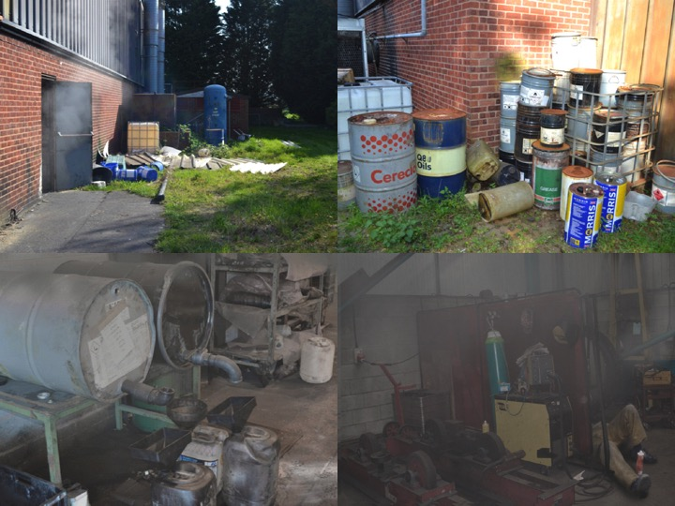
Figure 1: Examples of the images shown during the presentation

The presentation involved the following sequence of material:
- an aerial view of the fireground
- the “turn-out” sheet, the building plans and Hazchem details
- a video of the drive to the incident
- 12 slides showing the exterior of the factory site
- 12 questions about the preceding material: e.g., “The factory had an asbestos roof”
- video of a worker saying there was a missing person, location uncertain
- A further 32 slides showing views of the inside and outside areas of the factory
- 12 more questions: e.g., “The exit was different to the access”
- a video with a man in a helmet saying that there may now be 2 or 3 missing persons, location uncertain
- 36 slides showing various views of the inside and outside of the factory
- 10 more questions: e.g., “There were 2 bodies in the factory.”
- 30 more slides with views of the factory interior and exterior
- 8 questions: e.g., “There were a number of oil containers.”
The scenario was presented on a large screen at each site to operational FRS personnel including incident commanders who had agreed to take part in the trials. There were 44 participants in total, ranging in age from 25 to 56 years and in experience from < 1 to 33 years, with similar ranges in age and experience across the four sites (see Figure 2 for numbers at each site).
The trials were conducted in groups but the individuals completed the task without interaction with others. The responses to the statements were written on a prepared answer sheet for this preliminary trial (but will be collected via the online platform in the final version of the tool). The sheets were anonymised to protect the identity of the individuals.
Results of the Trial:
The QASA calculations were performed to provide the 3 scores for SA, Bias and PSA respectively. The scores for the individuals at each of the four sites are shown in Figure 2 and the average (mean) scores for each of the four sites in Figure 3. For ethical reasons to protect the identity of individuals, the countries are anonymised as A, B, C or D. The tool is clearly able to show individual differences in SA, Bias and PSA.
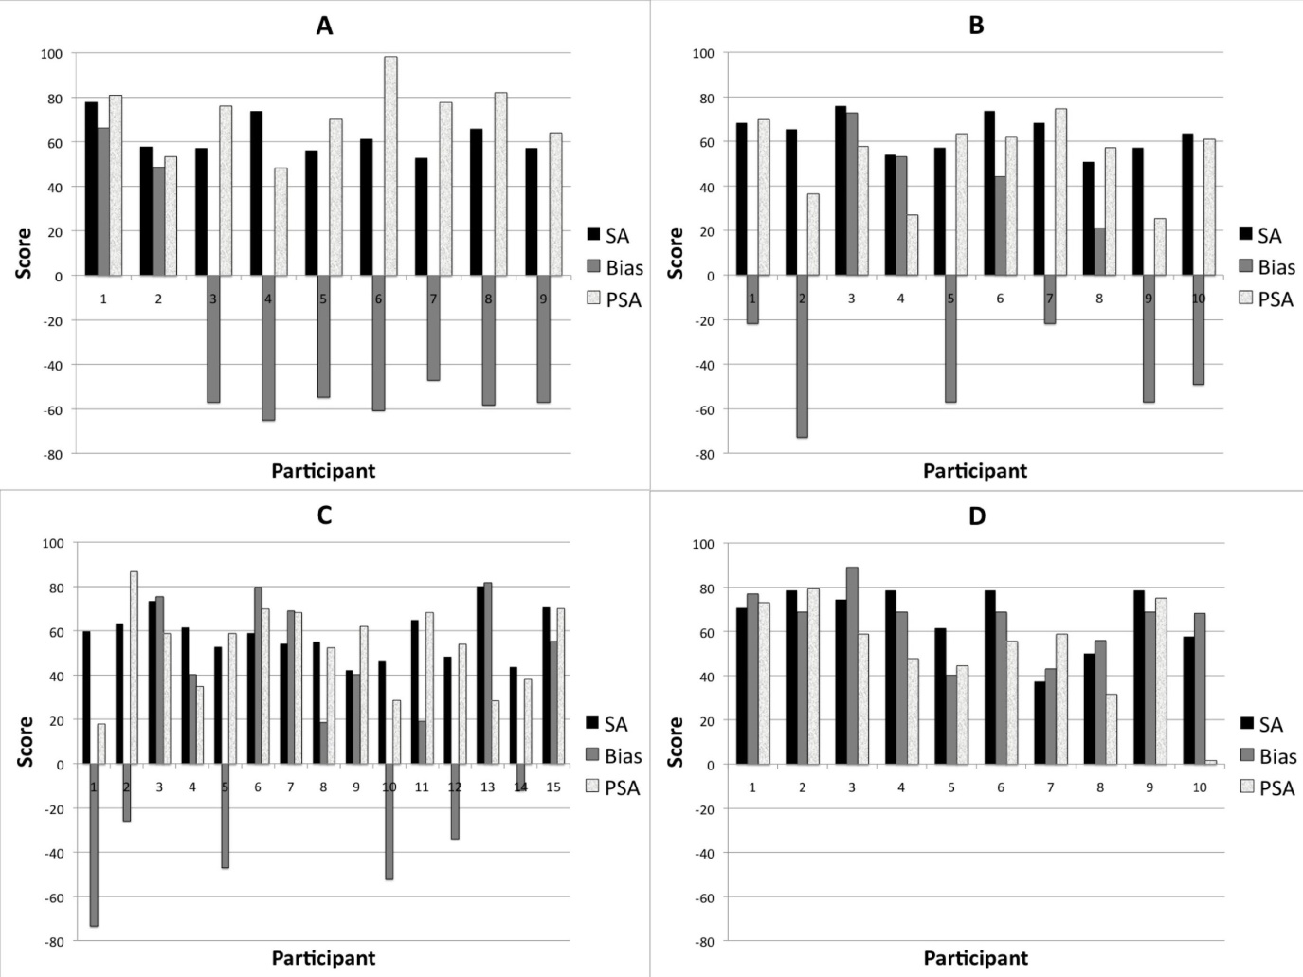
Figure 2. SA, Bias and PSA scores for each individual at each of the four partner sites (The four sites are respectively anonymised as A, B, C or D to protect individual identity.
As shown, there were 9 people at A, 10 at B, 15 at C and 10 at D)

SA was high for all the four sites (62.7 on average across the four sites) but there are differences in SA for individuals within each site, with the range of scores being from 37.4 to 80.1. The tool is thus able to reflect a wide range of understanding about the scenario.
Likewise, the tool is also able to reflect differences in Bias tendencies for individuals and also partner sites. Overall, 25 individuals show a Narrow or “Zoom-in” Bias (i.e., a score above zero) and 19 individuals show a “Zoom out” or Wide Bias (i.e., a score below zero).

Figure 3. Average (mean) SA, Bias and PSA scores for the four partner sites

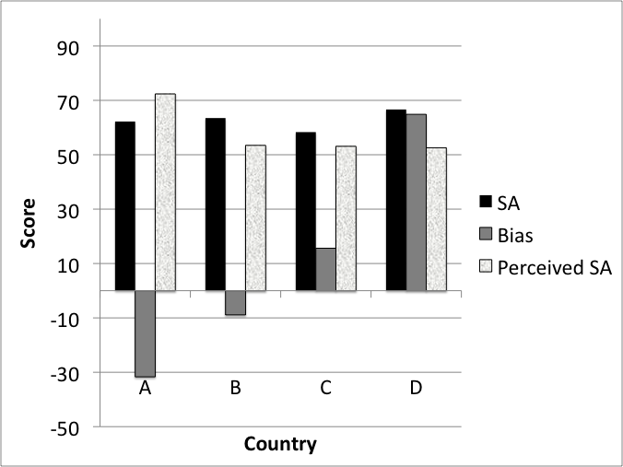
The tool is also sensitive to degree of Bias, with some people showing only a minor Bias and others more marked tendencies (see Figure 2).
There are also national differences in Bias with all the individuals at Site D showing a Narrow Bias, those at Sites A and B mostly a Wide Bias, and those at Sites C more mixed results. This could simply reflect different samples of people or different trial conditions but may also reflect different training strategies and this is an issue for further consideration.
Finally the tool is also able to reflect individual differences in PSA or confidence, with a wide range of scores from 1.6 to 98.3. There are also national differences in PSA with Site A showing an average of 72.4 and the others showing lower averages of approximately 52. Of particular concern is that there is no statistically significant correlation or correspondence between actual SA and PSA (p≥ 0.14) for any of the four sites. So people may have had good SA but poor confidence or alternately poor SA but high confidence. Such gaps between SA and PSA are clearly of potential relevance to any efforts to improve safety in FRS decision-making.
To sum up, the trials with this draft version of the tool confirm that this type of approach and analysis can reflect individual differences in SA, Bias and PSA. Training that includes strategies for self-checking and self-monitoring of Bias and PSA in particular may be of great value in reducing risk in FRS operations. Bias and PSA may vary with circumstances, but it is critical to know that these factors may influence decision-making and potentially cause errors.
The future of FireMind:
It is important to stress that the development of the FireMind tool and approach is ongoing and that this report is only for the first trials with the draft version. Feedback from the participants in the trials at all sites has been invaluable in refining the tool, with one key change being that responses will be time-limited to increase the pressure and validity of the exercise. An item analysis was also performed on the responses to the probe statements and any item which was answered incorrectly by the majority of people was removed for future use. For example, less than 10% of people answered correctly to “There was only a small amount of storage” (True) so this item was removed. In addition, two firefighters were asked to rate the probe statements for importance to the scenario and the consequences of any errors. Eleven probes that both raters judged of low or no importance were removed, further improving the validity of the exercise for future use.
Since the completion of these trials, each partner site has also developed and has trialled or is trialling their own scenarios to add to the final FireMind portal and future reports will disseminate information about these trials when available. These additional scenarios will adopt a similar basic approach but will be especially relevant to each national operational and training environment and so will greatly enrich the material available via the FireMind portal.
FireMind is not intended to provide a fixed assessment of an individual’s competence but may offer self-awareness of personal tendencies that could influence decision-making under pressure. Bias and confidence tendencies may explain errors of judgment even in highly-trained professionals. Training that includes strategies for self-monitoring and self-checking of such tendencies may enhance the safety of operations in Fire and Rescue Services.

References
Catherwood, D., Edgar, G. K.,, Sallis, G., & Medley, A. & Brookes, D. (2012). Fire Alarm or
False Alarm?! Decision-making “Bias” of Firefighters in Training Exercises. International Journal Emergency Services, 1 (2), 135-158.
Edgar, G., & Edgar, H. (2007). Using Signal Detection Theory to Measure Situation
Awareness: The Technique, The Tool (QUASATM), the TEST, the Way Forward. In M. Cook, J. Noyes & Y. Masakowski (Eds.), Decision making in complex environments (pp. 373-385). Aldershot, UK: Ashgate.
Endsley, M. R., & Rogers, M. D. (1998). Distribution of attention, situation awareness, and workload in a passive air traffic control task: implications for operational errors and automation. Air Traffic Control Quarterly, 6, 21-44.
Gasaway, R. B. (2008). Making intuitive decisions under stress: understanding fireground incident command decision-making. Fire Safety, Technology & Management, 10, 41- 51.
Klein, G., Calderwood, & Clinton-Cirocco, A. (2010). Rapid decision-making on the
fireground: the original study plus a postscript. Journal of Cognitive Engineering and Decision Making,4, 186-209.
McLennan, J., Pavlou, O., & Omedei, M. M. (2005). Cognitive control processes
discriminate between better versus poorer performance by fireground commanders. In H. Montgomery, R. Lipshitz, & B. Brehmer (eds.), How professionals make decisions. Mahwah, New Jersey: Lawrence Erlbaum (pp. 209-221.)
Perry, N., Wiggins, M., Childs, M., & Fogarty, G. (2009). Decision support for competent
and expert firefighters. Proceedings of 8th Industrial & Organizational Psychology Conference, 101-105.
Sallis, G. (2016). How does bias / scope influence the operational outcome of pressurised fire incident command decisions? Unpublished Ph.D. thesis, University of Gloucestershire.
Sallis, G., Catherwood, D., Edgar, G., Brookes, D., Medley, A. (2013). The human brain:
trustworthy fire-fighting equipment? International Fire Professional, 5, 21-24.
Useem, M., Cook, J., & Sutton, L. (2005). Developing leaders for decision making under
stress: wildland firefighers in the south canyon fire and its aftermath. Academy of Management Education and Learning, 4, 461-485.

