Is It Still Fashionable To Be A Fashion Photographer?

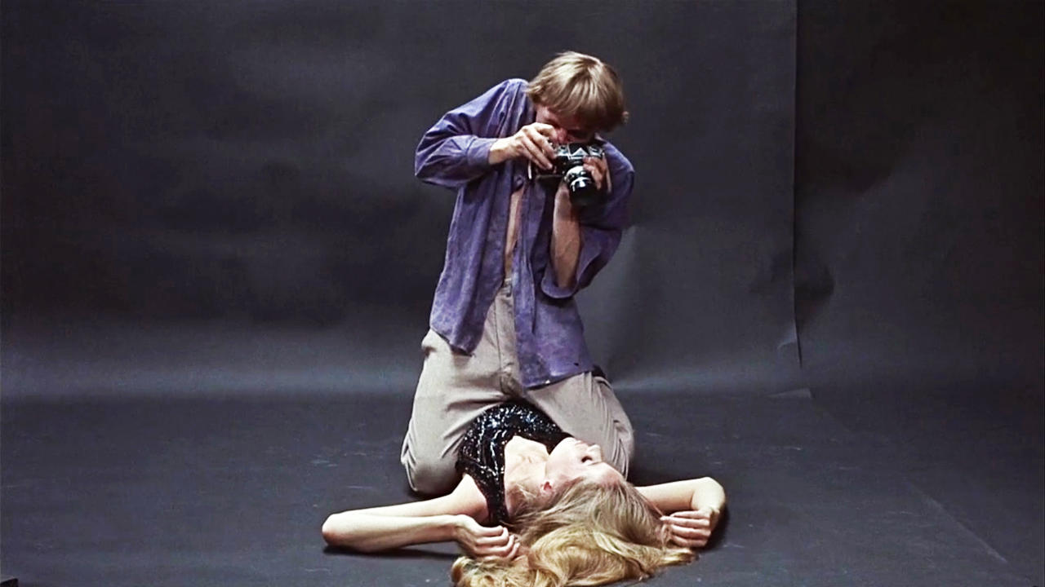

The blueprint for the life and approach of the fashion photographer was drawn long ago with the release of Michelangelo Antonioni’s Blow Up in 1967. The film that launched a whole generation of testosterone filled fashion photographers eager to emulate the adventures and escapades of the lead character played by actor David Hemmings. A character allegedly based on Sixties photographic renegades Bailey, Donovan and Duffy, shot in a studio owned by fashion photographer John Cowan and featuring stills shot by Don McCullin. Blow Up had it all sex, intrigue, style, sixties attitude in spades and of course an iconic poster that epitomised for many the fashion photographer/subject relationship, with the photographer clearly the dominant partner. No longer was the light footed approach of Fred Astaire as Dick Avery/Richard Avedon in Funny Face the inspirational role model.
It was a stereotype that remained throughout the 1970’s and well into the 1980’s as the decades of fashion excess were documented in brilliant Kodachrome, wind-machine blowing, leaping, smiling brilliance by male photographers such as Albert Watson, Bill King, Hans Feurer, Norman Parkinson, Chris Wagenheim, Arthur Elgort, Helmut Newton, Oliverio Toscani and Neil Kirk amongst many others. Interestingly female photographers such as Sarah Moon and Deborah Turbeville were travelling a very different road, exploring femininity, atmosphere and abstraction through fashion photography. However, the male photographer main stream remained exactly that, but as the 1980’s drew to a close fashion photography started to fragment and defined camps began to emerge.
As the supermodel (Linda, Naomi, Christy, Helena, Stephanie, Elle etc.) became a permanent fixture of the fashion glossies so did the work of Bruce Weber, Herb Ritts, Paolo Roversi and Peter Lindbergh. The stereotype of the fashion photographer was evolving. The established photographers were working with the established ‘name’ models and both were starting to become a major factor in establishing major fashion brands such as Versace and Calvin Klein. Meanwhile in the UK there was a reaction against this corporate approach with young guns such as Corrine Day, David Sims, Glen Lutchford and Nigel Shafron inspired by Larry Clark and Nan Goldin and facilitated by The Face magazine creating anti-fashion images inspired by documentary photographers and cinema with Kate Moss as their very own supermodel. Of course it was not long before the young guns became the new establishment joining Steven Meisel, Mario Testino, Steven Klein and Mert Alas and Marcus Piggott amongst others shooting for Vogue, Elle and Harpers Bazaar whilst also having a platform for experimentation thanks to Nick Knight’s Showstudio.
Of course this is a very potted history of the past forty years of fashion photography but I think that it’s worth having at least a brief understanding of the past when dealing with the present and future. What is interesting to note is how many of the photographers I have named who are still shooting fashion for the lead magazines and brands. In fact the only names that I have mentioned who are not still working are the ones who have died. This raises many questions concerning the conservative attitude of many magazines and brands when it comes to spending there commissioning budgets and the value for photographers of developing an aesthetic approach and sticking to it whatever way the fashion wind blows.
But I would like to deal here with the issue of becoming and working as a fashion photographer today. We all know that digital photography has made high quality image capture available to all and if you’ve got a team of experienced assistants, lighting techs and a post-production studio available to you, your ability to create appropriate quality images for a fashion client are greatly increased. And this is the issue.
I have worked with many photographers over the years whose technical ability has been severely lacking leading to an unhealthy reliance on their assistants. An argument often given for this is that removing the technical aspects of a shoot allows the photographer to concentrate on directing the mood, talent and overall narrative of the shoot. To concentrate on working with the fashion editor, hair and make-up artist and model and all of this can be true and I have no issue with this approach. But fashion photography today is rapidly moving to a point at which original photographic thought is not only absent it is no longer a requirement.
The truth is that it is now easier to become a fashion photographer by not studying photography at all but by studying fashion or fashion styling instead. Pin Interest and mood boards of others work is now the staple inspiration for the fashion shoot. A passion for fashion is now the dominant requirement. The role of the fashion photographer is no longer that of the swaggering photographic gunslinger, today it is of the fashion informed, the fashion connected, a photographic implementer not innovator.
If we accept that the principle reason for mainstream fashion photography is to sell clothes then this may not seem to be too much of an issue, but once young photographers realise this commercial reality, it is no wonder that many choose to side step the defined role as ‘fashion photographer’ and instead choose to position themselves as photographers creating fashion based work that is more likely to appear on the gallery wall or within the unpaid pages of an independent fashion/art magazine. Photographers such as Viviane Sassen and Ryan McGinley are the aspirational heroes to a new breed of ‘art’ based fashion photographer just as comfortable sitting in the Deutsche Börse Photography Prize or the Witney Museum of Modern Art as they are shooting for Levi’s or Paul Smith.
So is it still fashionable to be a fashion photographer? I don’t think so. The idea is appealing to many but the reality is not. The aspiration today of many young photographers both male and female is to have creative freedom and for their work to be seen as a personal statement not a collaborative conclusion. The exciting lifestyle that was once perceived to be that of a fashion photographer is now seen as being shallow instead of aspirational. The fashion photographer is no longer seen as being in charge of their own images.
Of course there are exceptions to this statement and I have already mentioned some of those established photographers whom are given both creative freedom and respect. I am painting here with a very broad brush and addressing the main stream. However, you only need to spend some time watching the excellent 2009 documentary September Issue featuring the staff of US Vogue and photographers Mario Testino and David Sims amongst others to see that the main stream fashion industry today sees the fashion photographer as an instrument to be used as a means to an end.
Many outside of the commissioned environment will no doubt say that this has always been the way with commissioned work and to a certain extent they would be right. The difference with the new world of fashion photography is that photographic ability is fast becoming the least important skill you will need to succeed.

