Developing FireMind: A tool for measuring and improving firefighter situation awareness on the fireground.

Geoff Sallis*⁺, Graham Edgar*, Di Catherwood*,

David Brookes* & Andrew Medley*

Centre for Research in Applied Cognition, Knowledge, Learning and Emotion (CRACKLE), University of Gloucestershire* and

Gloucestershire Fire and Rescue Service⁺

Originality/Innovation

In managing an operational incident within the British FRS there has been a move away from the purely experience-based approach combined with repetitive training. The model used within British FRS is the ‘Managing Incident: Decision-making model’ (FRS manual 2008) as shown below.

Within this model, without the optimal selection of information, situation awareness (SA) fails and decision-making breaks down. Previous research has focused on how good an individuals’ SA is compared to the ‘ground truth.’ This approach, while useful, does not address a key aspect of SA derived from the model – how is available information used to build SA? That is, do individual’s try and use as much information as possible (risking overload) or do they try and select information (risking missing potentially important details)? Or do they combine both approaches?

This paper reports studies using a technique developed by the authors (the FireMInd tool) that measures three aspects of SA:

- Actual SA: how good an individual’s SA is compared to the ground truth.

- Perceived SA: How good an individual believes their SA to be.

- Bias: The tendency to use more, or less, information in building SA.

These three measures provide a unique insight into the building of SA on the fireground. No other technique provides this range of measures.

Methodology:

A measurement technique referred to as QASA (Quantitative Analysis of Situation Awareness) has been developed that uses true/false probe statements drawn from the situation of interest. Answers to these statements allow the calculation (using signal detection theory) of the three aspects of SA. The approach is underpinned by theory and research in cognitive psychology and neuroscience. Indeed, the authors have successfully linked the bias measure, particularly, to underlying patterns of brain activity (Catherwood et al., 2014).

The approach has been successfully applied in military, health, driving, and educational domains, suggesting a valid approach. The QASA tool has now been adapted for testing of fireground scenarios, and this is the FireMind tool.

The FireMind tool has been applied in three different fireground-based studies to measure actual SA (ASA), perceived SA (PSA) and bias (information use). These studies were:

- A test of concept. Firefighters undertaking a breathing apparatus (BA) exercise were tested on aspects of the situation immediately after they emerged from a smoke-filled building.

- Low-pressure simulation. Firefighters undertook two low-pressure ‘tabletop’ simulated exercises – one a house fire, the other a factory fire.

- High pressure simulation. Firefighters undertook two high-pressure incident command exercises; simulations designed to reflect the pressures of a real incident as closely as possible.

Scope:

The studies were wide ranging in scope and produced the following results (2&3 summarised in the figure):

- Test of concept. The bias measure proved to be especially useful, with some firefighters tending to ‘tunnel down,’ potentially missing crucial information. For example, almost all the participants failed to register a propane gas canister placed immediately adjacent to the entry door. This suggests that bias measures an aspect of information-processing crucial to performance.

- Low-pressure simulation. It was found that neither bias nor actual SA were correlated for individuals across the scenarios. For example some firefighters had higher SA in one scenario, lower in the other. Bias was, likewise, not correlated across scenarios. Perceived SA, however, was. This suggests that firefighters’ belief in their level of SA was consistent across scenarios, and not necessarily related to how good their actual SA was – creating potentially dangerous mismatches.

- High-pressure simulation. The pattern of results changed compared to (2). Actual SA still varied across scenarios, but both perceived SA and bias were correlated. This suggests that, when the pressure is on, firefighters appear to fall back on a ‘resting bias.’ Whether they tend to take in a little, or a lot, of information, they will tend to be consistent under pressure - but not otherwise.
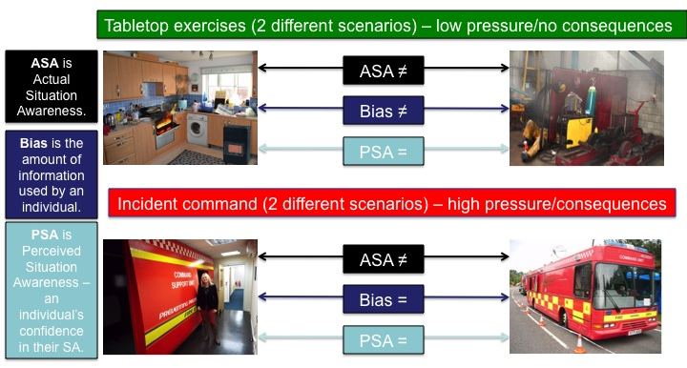

Contribution

This research is relevant to any firefighters that may have to make decisions under pressure and has profound implications for both training and practice.

The data suggest:

- Firefighters’ perceived SA appears to be consistent across situations, whether or not there is pressure. Actual SA, however, varies.

- When under pressure, firefighters appear to fall back on a ‘resting bias’. Generally, there is a tendency to ‘tunnel down’ and focus on a small amount of information, but this is not the case for all firefighters; some open out and try and take in more information. Whichever pattern of bias an individual shows, they seem to maintain that across situations – but only when under pressure.

The implications are:

- A mismatch between actual and perceived SA is potentially problematic. In particular, if an individual believes their SA to be good, but find themselves in a situation where their actual SA is poor.

- An individual’s information-use (bias) is consistent when under pressure – and can be measured. It thus becomes possible to predict aspects of an individual’s performance under pressure.

- There is a qualitative difference between performance in low- and high-pressure exercises – which can be measured. This has profound implications for training. If the pressure in the training exercise does not match that in the situation being trained for, individuals’ information-handling may be fundamentally different, compromising the utility of the training.

Additional Comments

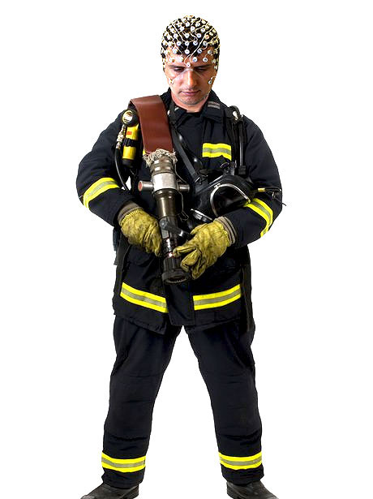
The FireMind tool represents a highly productive synergetic collaboration between academic scientists and the fire service. The pure and applied research is still developing in parallel, with benefits to both - and the findings can also be applied to many situations outside the fire service. The FireMind tool, having been developed in collaboration with the Gloucestershire and Avon fire services, will now be trialled in fire services across Europe as a result of the team having been successful in obtaining an EU Erasmus+ grant to test the tool in the UK, Belgium, Denmark, Holland and Poland.

The academic development of the tool is also ongoing and benefits greatly from the test-bed provided by the fire service trials. In particular, measurements of brain activity (using electroencephalography – EEG) are being developed that potentially allow an individual’s bias to be inferred from measures of brain activity. Thus the research may lead to significant advances in the measurement of bias objectively in real time – a technique that could then be applied in the fire service. The future firefighter shown here, however, is probably still some way off…

References

Fire and Rescue manual (2008), Fire Service Operations, Incident Command 3rd Edition, Volume 2)

Catherwood, D., Edgar, G. K., Nikolla, D., Alford, C., Brookes, D., Baker, S., & White, S. (2014). Mapping brain activity during loss of situation awareness: an EEG investigation of a basis for top-down influence on perception. Human Factors, In press.

