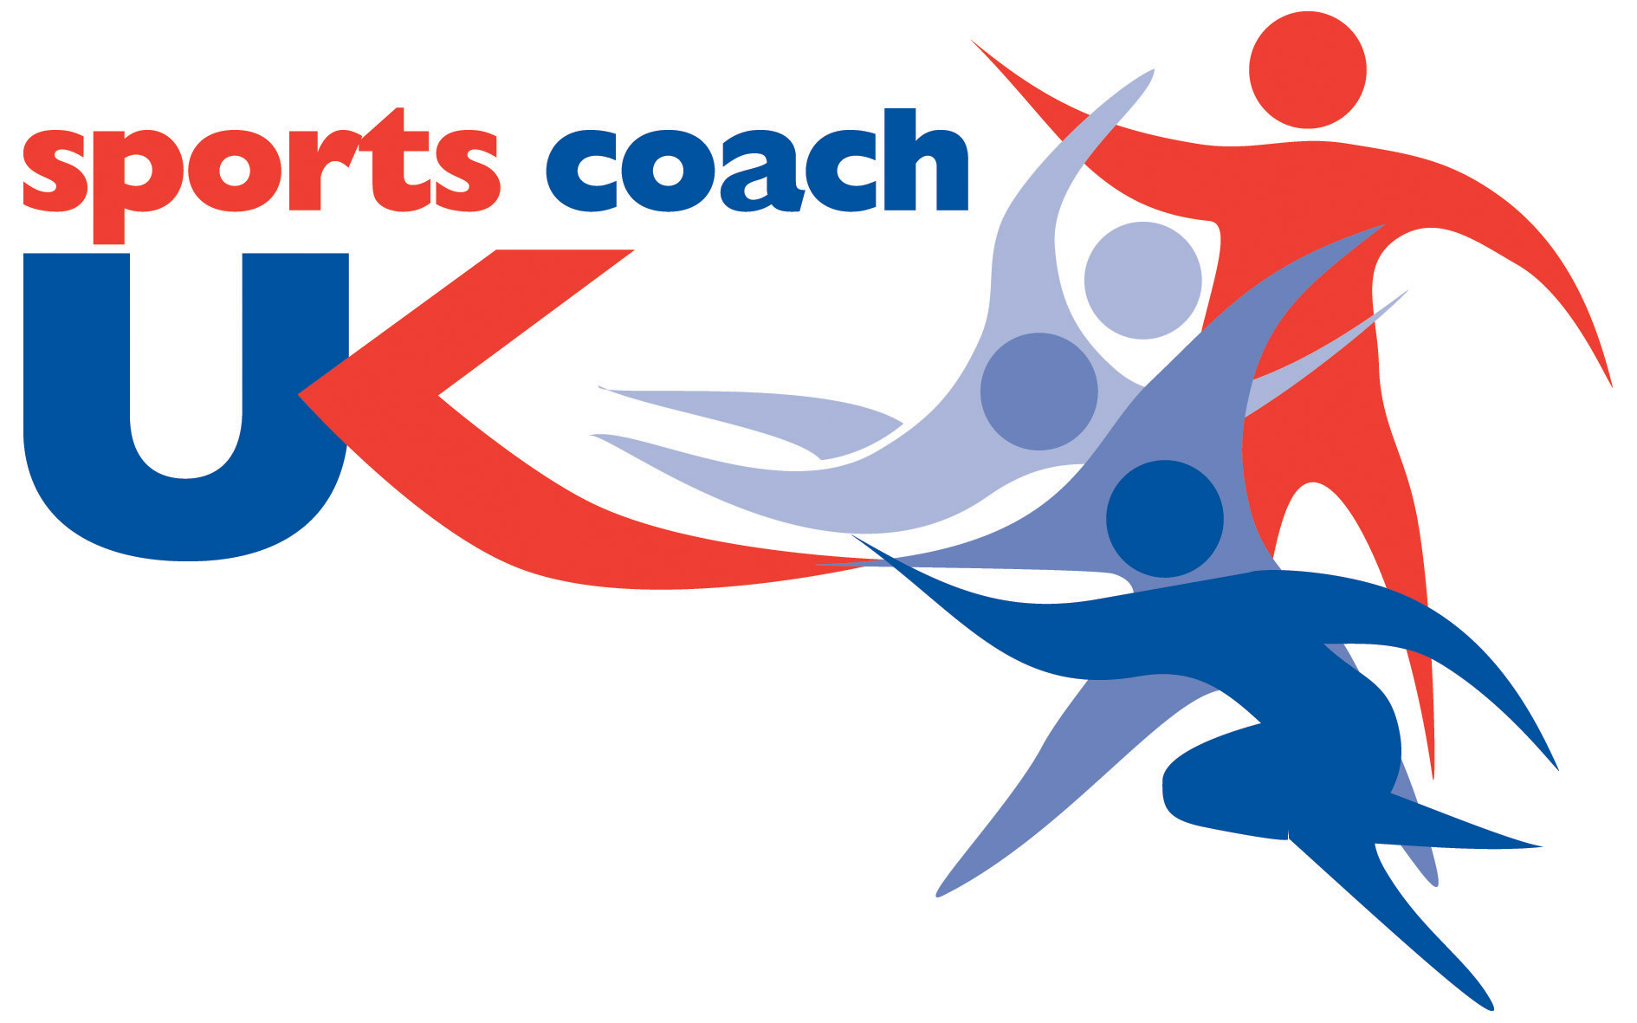

Evaluating Good Practice in Coaching Delivery between Governing Bodies of Sport and County Sports Partnerships UK

Don Vinson, Andrew Parker, Colin Baker, Alison Croad and Simon Padley

March 2013

Acknowledgements

We are extremely grateful to the Coach Development Managers and officers at the National Governing Bodies of Sport who contributed their time and expertise to this investigation.

This project was entirely funded by sports coach UK. We are indebted to Simon Thomas and John McIlroy at sports coach UK whose expertise, support and guidance have been invaluable throughout this project.

Don Vinson
School of Sport and Exercise, Faculty of Applied Sciences University of Gloucestershire, UK.

To reference this document, please cite: Vinson, D., Parker, A., Baker, C., Croad, A., & Padley, S. (2013) Evaluating Good Practice in Coaching Delivery between Governing Bodies of Sport and County Sports Partnerships UK, Leeds: National Coaching Foundation.

Table of Contents

Section |  |  |  |  |  |  |  | Page
1.0 | Introduction |  |  |  |  |  |  | 8
2.0 | Background research |  |  |  |  |  |  | 9
 |  | 2.1 | Partnership working in not-for-profit sporting organisations |  |  |  |  | 9
 |  | 2.2 | Coach development and education |  |  |  |  | 13
3.0 | The England Coaching Network |  |  |  |  |  |  | 16
4.0 | Methods |  |  |  |  |  |  | 18
5.0 | Quantitative data |  |  |  |  |  |  | 19
 |  | 5.1 | Respondent profile |  |  |  |  | 19
 |  | 5.2 | Partnership profile |  |  |  |  | 19
 |  | 5.3 | Main scales |  |  |  |  | 21
 |  |  |  | 5.3.1 | Comparison of NGBs and CDMs |  |  | 22
 |  |  |  | 5.3.2 | Partnership effectiveness |  |  | 23
 |  |  |  | 5.3.3 | Benefits and challenges |  |  | 24
 |  | 5.4 | Good practice and key priorities |  |  |  |  | 27
6.0 | Qualitative data |  |  |  |  |  |  | 35
 |  | 6.1 | The establishment and operationalization of the ECN |  |  |  |  | 35
 |  | 6.2 | Coaching and partnerships |  |  |  |  | 37
 |  | 6.3 | Successful impacts |  |  |  |  | 39
 |  | 6.4 | Challenges to successful impacts |  |  |  |  | 42
 |  | 6.5 | Going forward |  |  |  |  | 44
7.0 | Discussion |  |  |  |  |  |  | 46
 |  | 7.1 | The impact of what successful partnerships between CSPs and NGBs should deliver for sports coaching |  |  |  |  | 46
 |  | 7.2 | Enablers for successful partnership working between CSPs and NGBs |  |  |  |  | 47
 |  | 7.3 | Facilitators of successful partnership working |  |  |  |  | 48
 |  | 7.4 | Barriers to successful partnership working |  |  |  |  | 49
 |  | 7.5 | The extent to which key stakeholders share a common understanding of the partnership and what is required to make the collaboration successful |  |  |  |  | 51
8.0 | Conclusions and recommendations |  |  |  |  |  |  | 52
 |  | 8.1 | Conclusions |  |  |  |  | 52
 |  | 8.2 | Recommendations |  |  |  |  | 53
9.0 | References |  |  |  |  |  |  | 54
 | Appendices
 |  |  | Appendix I: Key aspects of partnership working |  |  |  |  | 59
 |  |  | Appendix II: Online questionnaire |  |  |  |  | 61
 |  |  | Appendix III: Interview question guide |  |  |  |  | 69

List of Tables

Table 1 | Challenges in multiple cross-sector partnerships |  | 11
Table 2 | Insufficient resources |  | 20
Table 3 | Main scale data |  | 21
Table 4 | Correlations between partnership characteristics and indicators of partnership effectiveness |  | 23
Table 5 | Examples of good practice - CDM |  | 28
Table 6 | Examples of good practice – NGB |  | 31
Table 7 | Key Priorities – CDM |  | 32
Table 8 | Key Priorities – NGB |  | 34

List of Figures

Figure 1 | Time working in partnership | 19
Figure 2 | Comparison of decision making (%) | 20
Figure 3 | Comparison of scores for main scales | 22
Figure 4 | Perceived benefits and challenges | 25

Executive Summary

Introduction
Between October 2011 and October 2012, 15.51 million people engaged in sport at least once per week, an increase of just above the targeted 1% rise from the previous year (Sport England, 2012). Additionally, there are more than 1.1 million people delivering coaching in the UK (North, 2010). Despite the considerable number of people impacted by the work which goes on between County Sport Partnerships (CSPs) and National Governing Bodies (NGBs) of sport, to date there have been no formal investigations into the effective functioning of these collaborations. Successful partnership working has long been considered of vital importance in other areas of sport development (Robson, 2008) with factors such as the pooling of expertise and resources being typically cited as potential benefits of such work. In light of this, the present project seeks:

- To establish what impact a successful partnership between CSPs and NGBs should deliver for sports coaching
- To determine the enablers for successful partnership working between CSPs and NGBs
- To determine the key facilitators of successful partnership working between CSPs and NGBs
- To determine the barriers to successful partnership working between CSPs and NGBs
- To investigate the extent to which key stakeholders share a common understanding of the partnership and what is required to make the collaboration successful.

Methods
A standardized online questionnaire targeting nationwide responses from NGBs and CDMs on a range of aspects which have been shown to be critical to partnership working was completed by 36 respondents. In addition, 12 telephone interviews were conducted. Representatives included NGB officers (n = 6) and CDMs (n = 6).

Results
In total, there were 36 responses to the online questionnaire; 32.4%, (n = 12) from NGBs, 62.2% (n = 23) from CDMs with one ‘other’. These quantitative data revealed that respondents were generally happy with decision making processes, although CDMs perceived their influence to be greater than did their NGB counterparts. Examination of partnership characteristics showed consistent, strong, correlations between communication and four measures of effectiveness including satisfaction (Τ = 0.566) and ownership (Τ = 0.534). The quantitative data revealed a complicated relationship between perceived challenges and benefits. For partners to perceive that ‘there are many more benefits than difficulties’ concerning collaboration working, it is evident that respondents needed to perceive approximately four times as many benefits as costs.

The qualitative data revealed that the vast majority of respondents considered the establishment of the ECN as a positive step. In particular, partners perceived the flexibility of the ECN enabled CDMs to provide a needs-led approach to coach development which greatly benefitted the workforce. The interview data also revealed that regular, informal and varied communication strategies are particularly well suited to effective partnership functioning in this area. It is these communication strategies which provide the foundation for the generation of trust and respect between partner agencies.

Conclusions
Findings demonstrate that CSPs and NGBs are committed to developing high quality coaching through a range of formal and non-formal opportunities. The ECN functions well as a flexible rather than a prescriptive template for CDM-NGB interaction allowing partnership arrangements to take place on a ‘needs-led’ localised basis. Respondent opinion indicates that the ECN should retain its focus on appointing key personnel to specific roles. Most notably, the leadership and management of partnerships is considered to be excellent across the respondent cohort. High quality leadership facilitates high levels of enthusiasm amongst partnership staff and allows a considerable degree of flexibility within the construction of partnerships themselves.

As with many partnership-related studies, findings also demonstrate that central to partnership success is good communication. There is a need for CDMs to emphasise the benefits of partnership working in order to build commitment and ownership within NGBs thereby helping to offset the impact of negative barriers and challenges. At times, partner agencies need persuading of the value of partnership working and may be unwilling to invest in such relationships as a consequence of the perceived burdens of collaborative working. Funding remains a core challenge concerning all parties within the partnerships, particularly given the lack of funds available and the short-term nature of related decisions in sport in the UK.

Recommendations
- CDMs should ensure that NGBs understand the role of CSPs in coach development by communicating key aims, objectives and functions. The ECN should be used a vehicle for doing this, whether implicitly or explicitly, depending on the situation.
- It is important that CDMs continue to embrace the flexibility afforded by the ECN and focus on providing bespoke, local and needs-led coaching support.
- It is important that CDMs understand the communication preferences of NGBs so that a range of regular, formal and informal communication strategies can be utilised to maximum effect.
- CDMs should continue to demonstrate high levels of reliability and consistency within the context of partnership working in order to secure the trust, commitment and ownership of NGB partners.
- CSPs should investigate strategies to increase the longevity of the roles of key partnership personnel.
- CDMs should seek to promote and reinforce the benefits of partnership working with NGB officers.
- CDMs and NGBs should consider how to maintain their engagement should strategic directions be altered.
- CDMs should consider whether their coach development strategy could be tailored to better support the needs of a range of NGBs
- Improved communication on behalf of NGBs would assist in the development of emerging collaborative relationships and help maintain clarity of roles and responsibilities for those already established with CDMs.
- CDMs should continue to promote the role of CSPs in coaching development, both formally and informally, in order to underpin their relevance across the sporting landscape.
1.0 Introduction

Between October 2011 and October 2012, 15.51 million people engaged in sport at least once per week, an increase of just above the targeted 1% rise from the previous year (Sport England, 2012). North (2009) states that such participants are served by over a million coaches, underlining the breadth of the impact of coaching practice on the UK population. Furthermore, coaching practice is impacted by the work of 49 County Sports Partnerships (CSPs) in England who are commissioned by Sport England to aid National Governing Bodies of sport (NGBs) with the implementation of their Whole Sport Plans. Despite the considerable reach of the work of CSPs and NGB partnerships, to date there has been no research into the effective functioning of these collaborations. Successful partnership working has long been considered of vital importance in other areas of sport development (Robson, 2008) with typical factors such as the pooling of expertise and the reduction of work-based duplication cited as potential benefits of such work. Numerous tensions and challenges also exist around these partnerships, perhaps most notably evident in areas such as competition for resources, power imbalances and contrasting political motives of the various parties involved (Babiak and Thibault, 2008; 2009; Hayhurst and Frisby, 2010). Such tensions are sometimes founded upon the idealistic assumption that partner agencies share common goals and understandings, a factor which is particularly highlighted when organizations concerned with the delivery of both high performance sport and sport-for-development come together (Green, 2004). Despite these challenges, partnership approaches have been firmly established as a critical component of a broad policy approach that aspires to secure increased sport participation, greater efficiency and local consultation (Bloyce and Smith, 2010; Houlihan and Green, 2009) both in the UK (Robson, 2008) and beyond (Babiak and Thibault, 2009). Hence, it is important to examine these partnerships to further our understanding of the challenging contexts of sporting, and coaching, provision in the UK. In particular, the present project seeks:

- To establish what impact a successful partnership between CSPs and NGBs should deliver for sports coaching
- To determine the enablers for successful partnership working between CSPs and NGBs
- To determine the key facilitators of successful partnership working between CSPs and NGBs
- To determine the barriers to successful partnership working between CSPs and NGBs
- To investigate the extent to which key stakeholders share a common understanding of the partnership and what is required to make the collaboration successful.
  - Background research
  - Partnership working in not-for-profit sporting organisations

Partnership has long been promoted as a principal means of engaging a wide variety of agencies and individuals in order to tackle complex social issues (Miller and Ahmad, 2000; Newman, 2001). Partnership in sport policy has become the key driver for the delivery of services in this area (McDonald, 2005; Phillpots, Grix and Quarmby, 2011), although it remains a relatively new principle for the types of organisations under consideration within this investigation (Frisby, Thibault and Kikulis, 2004). Extensive literature is available concerning the theory and practice of collaboration within business, public health and policy development. However, despite the emphasis placed on partnership working at the community level (Houlihan and Lindsey, 2008, Lindsey 2009), little evidence is available concerning collaboration as a mechanism for coordinating local activity in support of community sport and physical activity development or the implications for those involved. One reason for this may be the difficulty in unpacking the diversity of interests associated with partnership in the UK sport context which is inherently contested and competitive (Babiak, 2009; Babiak and Thibault, 2008; 2009).

Lindsey (2009) makes a convincing case for the need to focus on the context in which collaboration takes place and places specific emphasis on understanding factors at the local level. Here, authors have reported that management, communication, role clarity and leadership are fundamental to the overall health of collaborative relationships (Casey, Payne and Eime, 2009; Frisby et al., 2004; Parent and Harvey, 2009). Casey et al., (2009) reported that the diversity of skills, resources and management approaches were crucial to ensuring the health and effectiveness of sport and recreation programmes delivered by health sector and community-based organisations. Nevertheless, the development of more critical evidence concerning collaboration in the present context might help sport practitioners to better understand the reality of partnership working in practice and provide useful practical information. Studies in the area of not-for-profit, sport-related partnerships have commonly reported a great deal of enthusiasm relating to the benefits of collaborative working (e.g. Houlihan, 2000), although Flintoff (2003) has argued that some partnership working is undermined when competition exists between the individual organisations concerned. Flintoff’s study (2003) was conducted within the state school setting and found that such environments added further complications to partnership working, especially with respect to the potentially undermining influence of non-educationally-focused organisations. This reinforces the point that not all partners should necessarily have an equally legitimate claim in partnerships (McQuaid, 2007).
Anderson and Japp (2005) report that the majority of cross-sector partnerships fail. Whilst partnerships between CSP and NGBs do not fall into the ‘cross-sector’ bracket, there are still lessons to be learned in terms of effective collaborative functioning. Babiak and Thibault (2009: 117) suggest that the main challenges in partnership working can be attributed to:

- Environmental constraints
- Diversity on organisational aims
- Barriers in communication
- Difficulties in developing joint modes of operating
- Managing perceived power imbalances
- Building trust
- Managing the logistics of working with geographically dispersed partners.

From a non sport-related perspective, Alexander (1998) contends that within partnerships further complexity can occur through: performance measures that are unclear, the empirical measurement of goals, the need to comply with government regulations, and the fragmented nature of funding streams. Such challenges are apparent in the present context whereby the diversity of representatives common to partnership working between sport and non-sport organisations also increases the complexity of managing contrasting external and internal demands (Babiak and Thibault, 2008). Further, Hardy and Phillips (1998) suggest that exploitation, repression, questionable management strategies and asymmetrical power relations can also negatively impact on partnership functionality. Indeed, recent evidence from research across the sport sector suggests that partnership working is inherently unequal, asymmetric and reflective of state-led policy with strong managerial control and tightly defined objectives (Grix, 2010; Grix and Phillpots, 2011; Phillpots et al., 2011).

Further compounding these issues is the challenge that, because partnerships are a relatively new strategy within non-profit sporting organisations, there is a danger that leaders and managers may lack the skills to coordinate and operate the partnerships effectively (Babiak and Thibault, 2008). Babiak and Thibault (2009) go on to suggest that the perceived loss of control, autonomy in decision making and power can add to managerial uncertainty. Whilst partnerships are often seen as mechanisms which have the potential to broaden the horizons of the various parties involved, Linden (2002) suggests that by relying on the capabilities of partner organisations, managers may not invest in the development of their own personnel so readily and may instead perceive a reduction in operational flexibility.
Frisby et al’s (2004) research concerning partnerships between Canadian local government sport/recreation departments and not-for-profit commercial organizations found that managerial structures were commonly inadequate. They contend that a lack of clear planning, indistinguishable/vague role definition and insufficient human resources all negatively impacted the functioning of the partnerships themselves. These factors reflect those reported by Parent and Harvey (2009) who, after an extensive literature review combining multiple theoretical disciplines, proposed that the management of partnerships requires consideration of three major areas: formation; management, and evaluation. These areas can be considered concomitantly or sequentially, although Parent and Harvey (2009) concede that their model requires further testing. Power imbalances, competing values and the differing political motives of the various parties involved in high performance sport represent the key tensions reported by Hayhurst and Frisby (2010). Hence, for many managerial personnel, partnership working may not be an instinctively desirable concept. In light of these debates, Babiak and Thibault (2009) have put forward two categories of challenges (see Table 1) which, in their view, serve to identify the principle tensions and difficulties facing those engaging in partnership working.

Table 1: Challenges in multiple cross-sector partnerships (Babiak and Thibault, 2009)
Structural challenges | Strategic challenges
- Governance, roles and responsibilities  - The complexity of partnership forms | - Focus on competition vs. collaboration  - Changing missions and objectives

The structural challenges in Table 1 are characterised by delayed decision making due to some organizations having to consult at a political level before actions can be taken. Furthermore, the complexity of the partnerships caused a lack of clarity concerning the overall responsibility for the management and evaluation of the partnership. Babiak and Thibault (2009) found that although partners were seemingly collaborating, there were undercurrents of competition between the various organisations. This draws attention to the notion that partnership working might reflect a calculated response to a need to acquire essential resources in a highly contested environment (Zakus, 1998). Furthermore, the missions of the various organisations frequently shifted focus causing additional difficulties in the overall strategic direction of the partnerships. With funding for UK NGBs being determined both by growth of participation and by the pursuit of podium success, the potential for similar shifts in funding patterns and subsequent priorities reported by Babiak and Thibault (2009) are strongly mirrored. What this indicates is that the concept of collaboration translates in different ways and in different contexts and is subject to the influence of a range of interrelated and complex factors.

  - Coach development and education

Coach development is an all-encompassing term referring to the process of enhancing expertise (Mallett, Trudel, Lyle and Rynne, 2009) and so represents one of the principle concerns of partnerships between NGBs and CSPs. Coach development and education is crucial in maintaining and enhancing the quality of coaching and making meaningful strides in the journey to professionalization. Whilst the establishment of the United Kingdom Coaching Certificate (UKCC) has been proposed as an enabler of the development and professionalization of coaching in the UK (Taylor and Garratt, 2008), the strength of the more informal structures and processes in place are less clear. The professionalization of sports coaching is crucial to the up-skilling of coaches and critical if the workforce is to have a meaningful impact on the participation and health-related challenges currently targeted by the industry (Taylor and Garratt, 2008). Sports coaches engage in a wide range of learning experiences both formal and informal that contribute to their learning and development with varying perceived value and impact (Mallet et al., 2009). Following the lead of previous reports produced for sports coach UK, the coach development and education components of this investigation are structured around Coombs and Ahmed’s (1974) framework of formal, non-formal and informal learning. Cushion et al., (2010) caution that the separation of these different forms of learning is undesirable and that it is the synthesis of a range of learning opportunities which will have the most meaningful impact on coach development. The provision of a range of learning opportunities, should, therefore, be an important driver for the partnerships under consideration.

Informal learning experiences which coaches have been reported to perceive as beneficial to their development include unofficial mentoring (e.g. Cushion, 2001), knowledge gained as a performer (e.g. Jones, Armour and Potrac, 2004), acting as an apprentice to a more experienced coach (Cassidy, 2010) and also experiential coaching practice (Abraham, Collins and Martindale, 2006). Additionally, coaches are reported to have searched the internet (see Schempp et al., 2007), read coaching-related literature (Abraham et al., 2006) and utilised a range of video-based footage of coaching sessions and athletic performance (Schempp et al., 2007) in order to learn from informal opportunities. Within the coach development literature, there is a lack of consensus over how coaches should be accredited for their varied learning experiences, especially where informal methods are used (Mallett et al., 2009). Despite this, it is recognised that experiential learning is an important part of the development of many coaches (Roberts, 2010). Informal learning experiences lie beyond the remit of NGB and CSP partnership working, thus this report is concerned with the more formal aspects of coach education.
Coombs and Ahmed (1974: 8) identify non-formal learning activities as “any organised, systematic, educational activity carried on outside the framework of the formal system to provide selected types of learning to particular subgroups in the population”. For coaches, such activities are most likely to feature coaching conferences, workshops and seminars. Some research has reported that non-formal learning activities have had a positive impact of coach learning (e.g. Conroy and Coatsworth, 2006; Kidman and Carlson, 1998), although the rigour and breadth of these studies has been questioned (Cushion et al., 2010). Other non-formal learning opportunities fall within the category of Continuing Professional Development (CPD). CPD is a complex term to interpret within the context of sports coaching as there is no pre-requisite level of training required to commence as a practitioner (Cushion et al., 2010). Indeed, the vast majority of literature discussing CPD for coaches is drawn from the teaching profession (Armour, 2011). Whilst acknowledging the similarities and differences between teaching and coaching, Cushion et al., (2010) propose that the lessons learnt from CPD in the field of education should be considered highlighting that CPD providers in sport coaching should embrace the complexity (non-linearity) of professional learning to find ways to better understand the evaluation of the impact of CPD activities on practice.

Coombs and Ahmed (1974: 8) describe formal learning as an “institutionalised, chronologically graded and hierarchically structured educational system”. For coaches, this predominantly relates to NGB coach awards which may or may not follow the UKCC accreditation structure. For some coaches, studying Higher Education coaching courses may also fall into this bracket, although there is currently very little research related to this type of formal coach education. The formal aspects of coach learning through NGB coach awards represents the most extensive body of research relevant to this investigation and to the partnerships between NGBs and CSPs. Numerous research reports have revealed the limited value which coach practitioners attribute to NGB awards, although there is little evidence linking competencies with such formal learning opportunities (Cushion et al., 2010; Gilbert and Trudel, 1999). Despite this, some research has shown that coaches have requested further support from NGBs in terms of resources and follow-up workshops beyond the traditional coach education courses (Roberts, 2011). Irrespective, formal coach education has been reported to be less valued than experiential learning and other informal opportunities with the benefits to elite coaches being particularly questionable (Mallett et al., 2009). Taylor and Garratt (2010: 104) support this notion suggesting:

... that in a critical number of cases coach education courses were found to be of little direct benefit to the professional development of different areas of sports coaching. The suggestion is that in the past UK NGB coach education courses have tended to focus primarily on the technical issues of coaching, whilst ignoring the importance of the development of coaches’ pedagogical and conceptual knowledge and understanding. The inherent failure to intellectualise the process in this way has effectively undermined coaching in its claim to possess a theoretical body of occupational knowledge.

Furthermore, Cushion et al. (2010: 49) have suggested that: “[T]he research critiquing formal provision would seem to locate it as training rather than education”. Despite advances in the formalized structures in coach education in the UK, there is evidence that some coaches perceive that little has changed (Cassidy, 2010). Cassidy (2010) is sceptical that NGBs are engaging with non-traditional coaching methodologies or associated support mechanisms such as CPD. Others argue that professional education should go further than the UKCC to incorporate HE kite marking schemes and that coaching practice should be built around expertise, not minimum standards (Taylor and Garratt, 2008). There is a difference between training, education and learning (Mallet et al., 2009); these conceptual distinctions should play an important part in the provision of coach development opportunities delivered through the partnership of CSPs and NGBs.
- The England Coaching Network

Whilst recognising the importance of NGBs in developing the coaching workforce, Sport England, sports coach UK and CSPs are committed to enhancing their support of coaching provision at the local level. Sport England has prioritised the following three areas as particular foci for development through the partnership between NGBs, CSPs and sports coach UK:

- Developing more coaches and supporting existing coaches
- Prioritising resources towards making a tangible impact on increasing and/or sustaining adult sports participation
- Focusing in on making a real difference in specific sports and specific areas.

Sport England has challenged CSPs to engender a greater level of depth and quality in their support of NGBs by focusing on eight coaching objectives which are aimed at building on previous successes enjoyed through the development of the Local Coaching Support System Networks (CSSN) resulting in the launch of the England Coaching Network (ECN). The ultimate aim of the ECN is for CSPs to provide support to NGBs in delivering a coaching workforce which will positively impact the NGBs’ 16+ and England Talent Pathways. The eight coaching objectives are:

- Support an increase in the number of qualified coaches within 49 CSPs, based on the workforce development needs of a NGB
- Develop a local solution by which coaching data can be managed and coaches can be tracked to provide local intelligence reports fed back into NGBs or Sport England
- Increase the number of NGB active coaches accessing needs-led continuous ‘professional’ development opportunities
- Facilitate the establishment of a support network for coaches within 49 CSPs to provide a community of learning
- Identify and promote funding schemes/grants that will aid local coaches in obtaining CPD opportunities at a reduced cost
- Create a pathway from the leaders programme into entry level coaching opportunities and CPD
- Support coaches seeking to increase their coaching hours by promoting the availability of local coaching opportunities within 49 CSP area
- Provide employment and deployment guidance to coaching providers operating within the CSP.
In order to support the development of the ECN, a number of ‘ways of working’ were also established in order to clarify the role of the various partners and support mechanisms. It was established that:

Sport England will:
- Provide a clear and agreed performance management process for the coaching investment across 49 CSPs
- Provide clarity on what success looks like in terms of delivering the eight coaching objectives
- Ensure engagement of the CSPs, through sports coach UK and the CSPN, in any discussions around any changes in the direction of coaching delivery across the 49 CSPs.

CSPs will:
- Provide strong checking and challenging in response to any suggested changes in the direction of coaching delivery across the 49 CSPs
- Provide clear and consistent communications on national policy decisions around the direction of coaching delivery across the 49 CSPs
- Provide support to Sport England in terms of the performance management process for coaching for CSPs.

Sports coach UK will:
- Provide direct technical guidance in relation to the eight coaching objectives
- Provide learning and development opportunities as identified by coaching leads and other CSP staff
- Act as a conduit for feedback from national to local and local to national to effect necessary changes in coaching policy
- Facilitate stronger engagement relationships nationally, regionally and locally with NGBs in order to provide more specific plans for network delivery
- Provide support to Sport England in terms of the performance management process for coaching for CSPs.
- Methods

The research team adopted a pragmatic methodology to explore the nuances of the issues under investigation. A mixed method strategy (including a qualitative and quantitative component) assisted the acquisition of a comprehensive data set concerning the perceptions of NGB officers and CDMs (or equivalent). Purposive (i.e. selecting participants based on their perceived relevance to the needs of the research) and opportunistic sampling (i.e. recruiting participants as and when opportunities arose) strategies were deployed to ensure that examples of good practice were identified in a range of locations. In particular, a snowballing strategy was implemented where CDMs suggested a key NGB partner who had been central to the delivery of the ECN in their area.

The quantitative component of the research involved a standardized online questionnaire (see Appendix I) targeting nationwide responses from NGBs and CDMs that investigated perceptions on a range of aspects which have been shown to be critical to partnership working. Questions relating to age, gender and ethnic background established a profile of respondents. The quantitative data were analyzed using descriptive and comparative analysis to establish patterns and key differences. The principal aspects of partnership working were isolated in order to help unpack the data (see Appendix I).

The qualitative component comprised a range of telephone interviews (n = 12) to investigate the perceptions and experiences of staff employed to develop and implement coaching development strategies at the local level (see Appendix II for interview question guide). Representatives included NGB officers (n = 6) and CDMs (n = 6). Based on the research specification, questions focused on identifying examples of good practice and the salience of collaborative approaches. Interviews were transcribed in full and forwarded to respondents for verification and/or amendment as required (Hammersley and Atkinson, 2007). Inductive content analysis (Waltz, Strickland and Lenz, 2010) was used to analyze the data which involved a series of coding ‘text units’ (or sections of text), initially into general themes and then through a systematic review of these into more detailed themes and subthemes. Memos, or notes, were attributed to each text unit specifically to move from description to potential meaning in order to understand the participants’ perceptions and to provide a voice for their experiences and opinions within the text. Following this, a systematic review of themes was conducted to confirm or amend themes to ensure they accurately represented the data.

- Quantitative Data

5.1 Respondent profile

In total, 36 responses were received from NGBs (32.4%, n = 12) and CDMs (62.2%, n = 23) with one respondent stating ‘other’ (Lecturer in Coach Education). Data for this respondent was included in the analysis as it was possible to identify that the respondent worked in collaboration with either an NGB or CDM in terms of coaching development. The majority of respondents were male (62.2%, n = 23) and White English (89.2%, n = 33). The mean age of respondents was 37.5 years (SD = 10.2).

Partnership profile

The majority of respondents (78.4%, n = 29) confirmed that they had worked in collaborative relationships before with more than one third indicating that they had been working in partnerships for more than 3 years (Figure 1). Overall, the mean duration of the NGB – CDM partnership was 27.8 months (SD = 18.8), with respondents spending an average of 21.1 hours a month (SD = 28.8) on partnership related activities e.g. meetings, preparing information.

Figure 1: Time working in partnership

5.4%

Many partnerships had established clear lines of accountability (91.9%, n = 34) and the capacity to undertake evaluations to monitor the partnership’s progress (91.9%, n = 34), with nearly two-thirds agreeing that the partnership had sufficient resources to accomplish its objectives (62.2%, n = 23). The reasons provided by those stating that there were insufficient resources (n = 5) are listed in Table 2.

Table 2: Insufficient resources
N | Reason
1 | I believe the CSP does not have enough staff
2 | Need more professional staff members
3 | No, most partnerships are very reliant on significant others to contribute e.g. workforce
4 | The resource required always seems to be funding; however, there is always some – just never enough
5 | Yes, to some objectives, but funding limits achievements
6 | I believe the CSP does not have enough staff

Overall, respondents indicated that they were generally happy with decision making processes. On a scale measuring perceived influence in decision making (ranked between 0 and 10, 10 signifying a lot of influence), the mean score was 6.7 (SD = 2.0). However, comparing the CDM and NGB responses revealed that CDMs rated their perceived influence (7.3) more highly than their NGB counterparts (Mean = 5.9). This was reflected in the finding that more CDMs were ‘very comfortable’ with decision making processes than NGBs (Figure 2).

Figure 2: Comparison of decision making (%)

5.3 Main scales

We asked a number of questions about partnership working. These questions included a number of items based on scales which respondents used to rate their level of agreement with certain statements (See Appendix II). Summative scores were computed for each of the main questions deployed in the research (Table 3) which established the parameters for each of the questions used in the survey. This provided a means of a) exploring differences between NGBs and CDMs on the same questions and b) investigating the relationship between key aspects of partnership working that the survey explored i.e. management, and key measures of partnership effectiveness.

To help unpack the data we compared the mean scores for CDMs and NGBs in order to assess differences on various aspects of the partnership. Following this we explored the four key measures of partnership effectiveness. We separated satisfaction, synergy, commitment and ownership from the rest of the survey questions in order to compare them. These have been reported as useful indicators of how effective people perceive the partnership and provide a practical way of understanding the complexity of collaborative relationships (Butterfoss and Kegler, 2002; El Ansari, Oskrochi, and Phillips, 2008; Rogers et al., 1993).

Table 3: Main scale data
Areas |  | N | Mean* | SD | Range | Min | Max
Partnership characteristics
 | Management | 37 | 67.7 | 10.0 | 37 | 48 | 85
 | Leadership | 37 | 51.1 | 7.4 | 32 | 33 | 65
 | Communication | 37 | 31.9 | 6.0 | 23 | 21 | 44
 | Contributions | 37 | 14.4 | 3.1 | 15 | 5 | 20
 | Benefits | 37 | 48.2 | 9.3 | 48 | 17 | 65
 | Challenges | 37 | 15.3 | 6.6 | 25 | 7 | 32
 | Outcomes | 35 | 40.2 | 8.5 | 42 | 12 | 54
Partnership effectiveness
 | Satisfaction | 36 | 22.1 | 4.6 | 21 | 9 | 30
 | Synergy | 36 | 33.7 | 6.4 | 30 | 13 | 43
 | Commitment | 36 | 16.6 | 3.3 | 12 | 8 | 20
 | Ownership | 36 | 14.4 | 4.3 | 18 | 2 | 20
* Mean scores help to establish the parameters of the data in order to conduct further investigations. Scores between scales are not directly comparable because of the different nature and number of scale items i.e. a higher number does not indicate a ‘better’ score. SD = Standard Deviation i.e. the size of variations in scores away from the mean. Range = the difference between the largest and smallest values. Min / Max = the actual lowest and highest scores on the scale. Definitions of the above factors are provided in Appendix I.

5.3.1 Comparison of NGBs and CDMs

Figure 3 shows that CSPs and CDMs largely shared the same perceptions concerning various aspects of the partnership i.e. the extent to which they agreed with the questions posed in the survey. However, it was possible to identify larger differences between scores (-3.4 to 7.9) in that CDMs rated synergy (+5.6) and outcomes (+7.9) more highly than NGBs suggesting that they recognised more impact than their NGB counterparts. NGBs rated challenges more highly (17.5) suggesting that they felt participation could be more of a problem than for their CDM partners (14.1).

Figure 3: Comparison of scores for main scales

Note: mean scores vary for each aspect of partnership due to the varying scales deployed.

5.3.2 Partnership effectiveness

Table 4 presents correlation coefficients between the partnership characteristics and indicators of partnership effectiveness. Correlation coefficients establish statistical relationships between variables whereby a score of 1 indicates a strong positive relationship. These help to identify relationships between certain aspects of partnership and to highlight dependent relationships i.e. that one aspect of partnership is associated with another. The findings are interpreted below.

Table 4: Correlations between partnership characteristics and indicators of partnership effectiveness
Partnership characteristics | Measures of effectiveness
 | Synergy | Satisfaction | Ownership | Commitment
Management | .283 | .436** | .470** | .459**
Leadership | .375** | .522** | .482** | .458**
Communication | .481** | .566** | .534** | .446**
Contributions | .296 | .133 | .041 | .110
Benefits | .490** | .403** | .426** | .421**
Challenges | -.160 | -.160 | -.280 | -.340**
Outcomes | .555** | -.183 | .444** | .529**

Kendall’s tau-b. Boldface indicates strong correlations (Τ > .500). ** Correlation is significant at the 0.01 level (2-tailed).

Interpretation of findings:

- Management and leadership are consistently correlated with the four measures of effectiveness which suggests that partnership processes, management approaches and leadership style have a bearing on the nature of partnership effectiveness. Leadership has a particularly strong association with satisfaction.
- Communication is consistently correlated with the four measures of effectiveness, highlighting the criticalness of effective communication approaches. The strong correlation with satisfaction and ownership suggest that effective communication has a deterministic influence on how partners feel about the partnership.
- Perceived benefits are consistently correlated with the four measures of effectiveness suggesting that they play a key role in demonstrating effectiveness to partners.
- The perceived challenges, or costs, of participation are negatively associated with all four measures of effectiveness suggesting that higher costs might have a detrimental effect on partnership effectiveness.
- The strong correlation between outcomes and commitment suggest that partnerships that are able to produce tangible or meaningful outcomes will have a positive effect on member commitment.

5.3.3 Benefits and challenges

Perceived benefits and challenges, or costs, have been demonstrated as being significant to stakeholder participation (Chinman and Wandersman, 1999; El Ansari and Phillips, 2004). As such, exploring these aspects provides a practical means of understanding how partners understand their relationship with the partnership. Figure 3 identifies that partners generally shared the same opinion concerning benefits but that NGBs perceived slightly higher costs.

To understand the notion of benefits and challenges more broadly, we asked partners to rate the relative balance according to the following responses:

- There are many more difficulties than benefits
- There a few more difficulties than benefits
- The difficulties and benefits are about the same
- There are a few more benefits than difficulties
- There are many more benefits than difficulties.
We divided the sample into groups based on each of these responses. For each of these groups we calculated the actual benefits and challenges i.e. the score given by partners for the benefits and challenges questions (i.e. the mean score based on all the items combined for each question). This allowed us to develop a benefits and challenges score for each group (rather than a score for the whole sample) so that we could compare perceptions. It is possible to see in Figure 4 that actual benefits and challenges scores did not necessarily follow a pattern one might expect based on the five different groups for example, for those who were classified ‘The difficulties and benefits are about the same’, their actual benefits and challenges scores were not balanced.

Figure 4: Perceived benefits and challenges

Note: no respondents indicated ‘There are many more difficulties than benefits.’
Interpretation of findings:

- We expected to see that benefits increased across the groups so that ‘there are many more benefits than difficulties’ would demonstrate the highest level of perceived benefits. This was not entirely the case. It is likely the small sample size impacted the results. As such, discounting the data for ‘there are many more difficulties than benefits’, it is apparent that benefits increase across the groups.

- We expected to see that challenges, or costs, decreased across the groups so that ‘there are many more benefits than difficulties’ would demonstrate the lowest level of perceived benefits. Whilst this was true it was apparent that costs declined more slowly than the rate at which benefits increased.

- For ‘the difficulties and benefits are about the same’ we expected to see that costs and benefits were about the same. This was not the case. Even when partners perceive an equal balance it is evident that benefits were higher. This suggests that for partners to perceive an equal balance there needs to be approximately twice as many benefits as costs.

- For partners to perceive that ‘there are many more benefits than difficulties’ it is evident that there needs to be approximately four times as many benefits as costs.

- Collectively, the findings show that the benefits-to-costs relationship is complex and that maximising the perceived benefits of participation in the partnership is crucial.

5.4 Good practice and key priorities

We asked participants identify examples of good practice based on their experiences (Tables 5 and 6, comments presented verbatim). We presented three key areas for comments based on the key strands of the ECN system:

- Communication, funding support, workforce management and coach support services
- Workforce planning, coach recruitment campaigns and CPD programmes
- Mentoring schemes, targeted workforce development, CPD and TNA, auditing and mentoring schemes.

In addition, we asked participants to identify three areas that represented a priority for their work. These are presented in Tables 7 and 8 (comments presented verbatim).

Table 5: Examples of good practice - CDM
- Communication, funding support, workforce management and coach support services
- Coaching bursary scheme linked to active involvement in workforce development group
- Communication - a very clear project brief with actions, timeframes and accountabilities is attached to the minutes/notes from each meeting ensuring each partner stays on track and manages their area effectively. (Background; Impact; Outcomes; Outputs; Activity required) There is also a good mixture of communication for the project -email, phone calls, meetings, coffee breaks etc... based on the level of interaction required
- Communication. We have quarterly Coaching Development Group meetings enabling local partners to contribute to our projects. We have frequent communications utilising coaching SY, SYSport newsletters and club and coach specific newsletters. Funding: We have run a bursary scheme in Feb 2012, offer support through Sportivate and distribute a general funding guide to partners.
- Communication within the partnership is 2 way and can be carried out formally and informally. Clear parameters that are agreed at the start of the partnership are in place that detail the award of funding and what has to be achieved.
- CPD courses are needs led and identified by clubs. these courses are the held at the clubs venue to prevent travel costs and reduce time volunteer coaches have to commit to therefore engaging more coaches to take up MSD CPD. We have seen an increase in coaches taking up CPD by doing this and giving clubs this opportunity
- Developing flexibility and underpinning coach tracking in bursary support
- Funding support - Coach Bursary funding committed to Clubs to show CSP/NGB commitment to raising the quality of coaching in identified Clubs.
- Funding support: * CSP Coach Bursary utilised to support NGB participation programme by un-skilling coaches to Level 2 for delivery. Also supports links to clubs as club coaches delivering participation programme. * LA Coach Bursary linked into the above as well. * County Association Coach Bursary next challenge to link in. * Sportivate funding used to deliver participation programme. * Reduced cost facilities accessed through LA network. Communication: * Utilise CSP network to promote coach development opportunities e.g. Level 2 course and bursary linked to it. Drives participation numbers which allows coaching hours to be delivered which allows coach to develop and go on to club coaching.
- Identifying funding streams and ensuring through the NGB that the funding goes to those that it will benefit the most and have the most impact on participation.
- Needs led Coaching Conference See link http://www.sportscoachuk.org/resource/partnership-working-makes-life-easier
- Our Coaching newsletters are up to date, relevant and distributed to a wide audience who have signed up to receive the information. We have been able to provide local coaches with a funding bursary to support their development from L1-L2 We offer a legally compliant coach deployment solution using temp workers on a PAYE basis Our Coaching Scholarship is set up to support the community of learning for the 8 coaches that are included in the scheme
- Promotion and delivery of Netball Development Pilot http://www.coachinghampshireiow.co.uk/mission_possible/netball_coaching_pilot http://www.youtube.com/watch?v=JNlPG-WfGjE&list=UUL4fyebkzDOFJwkEPIx3hBw&index=16
- Regular communications to coaches registered on the local data management system as requested by the NGB.
- See below re Annual RFL CPD Programme - excellent lines of communication developed due to time being spent building great working relationship with RFL Service Area Coordinator. **** has a desk in the office which helps tremendously with the day to day lines of communication, setting up meetings and sorting concerns / queries out quickly.
- The partnership will only work if the coaching support/ programme is fully understood by the NGB and the clubs. Clear communications are critical to this.
- The use of Get Coaching Cornwall data management system as specific NGB coach database has not only allowed CSP to access another 150+ coaches but the NGB is able to monitor and validate their own coaches.
- Workforce planning, coach recruitment campaigns and CPD programmes
- Aquatic academy - supporting and developing 14-16 year olds to support the talent pathway. This is a needs led academy and the need was identified by the club network groups.
- By working in partnership with the NGB we are able to advertise and promote specific coach CPD programmes and influence workshops we can provide and would benefit coaches locally.
- By working in partnership with various officers within the RFL we have developed an annual CPD Programme which involves Specific RFL courses, "Developing the Kicking Game", UKCC level 1/2s and Generic courses around Nutrition, Speed & Acceleration, Strength & Conditioning. Setting up lines of communication between officers, clubs & coaches
- By working with the university we have a stronger and more effective route to market for the courses and deployment opportunities we need to try and fill. The university know their students better than we ever would so working with them has matched our particular expertise and skill sets to achieve different outcomes for each partner but utilising the same process. (uni interested in increasing student employability, CSP interested in supporting NGBs with 16+ intervention workforce - by training and deploying the students we achieve both outcomes)
- Coach Support Services: * MOS workshops - allows NGB to concentrate resources on NGB specific CPD. * Talent Breakfast Clubs - cross sport learning. Workforce Planning: * Challenging the NGB to align workforce development in line with WSP participation targets in specific areas.
- CPD programmes work well when they are delivered to a targeted audience. The NGB local officer must understand the workforce planning needs.
- CPD We are just about to launch a new CPD programme in partnership with our local university, estimated distribution of 10,00 hard copies across SY via HE / FE, Facilities, clubs, NGB's and local networks.
- Netball Development Pilot and Level 1 Course Handball G4G project (part of new 2013/14 Workforce Planning Delivery of Handball Level 1 Course http://www.youtube.com/watch?v=YejR8BD35uA&list=UUL4fyebkzDOFJwkEPIx3hBw&index=2
- Our SPC and FA run every month (approx. CPD MSD workshops 24pa) We actively recruit coaches to deploy into local partners to increase participation and to give coaches further paid coaching opportunities
- The NGB has a clear understanding of their workforce development targets and it able to communicate this effectively to the CSP, identifying where and who should be the beneficiary of funding and why. The NGB is also able to demonstrate the impact the partnership will have.
- Workforce action planning takes place to identify how the CSP can support participation programmes.
- Workforce Development - NGB CPD workshops included in regional coaching development day to support continued learning Talent - NGB officers and identified coaches attending Talent Coaches Breakfast Clubs
- Workforce planning - thorough needs analysis identifying latent demand
- Working together to develop CPD opportunities that would not have been available otherwise. I.e. using the knowledge and contacts of the CSP to create opportunities and using the network of coaches through the NGB, and identifying their needs to influence the context of the workshops.
- Mentoring schemes, targeted workforce development, CPD and TNA, auditing and mentoring schemes
- Club/Coach audit for Rugby highlighting workforce gaps Lots of unqualified coaches working in clubs indicating a need to run more Rugby Ready intro workshops Need to support and mentor coaches from L1 - L2 to support them through the transition and not keep running more L1 course, resulting in more coaches completing and also retaining more coaches
- Coaching Lead offers TNA/PDP support to local coaches Coaching Scholarship offers coaches the opportunity to learn from each other Continued Coaching Breakfast/Supper Programme with relevant local speakers We have continued to support formal training but big push has been on the informal opportunities that coaches can access to continue their development with minimal financial outlay
- Conducted a bespoke TNA with RFL and community coaches
- CPD - raise the profile of NGB workshops and encourage Club coaches to engage more regularly with locally developed opportunities Auditing - target workforce identified by auditing current coaching provision in clubs
- Developing support for performance/talent pathway coaches in county...using SCUK Breakfast clubs to initiate process....measuring attending coaches case of workshops/ skills gained in coaching practise
- Development of Sportivate Mentoring Scheme Netball Development Pilot
- In the process of Developing a Mentoring programme with Athletics to remedy the problem of an ageing coaching workforce. Concerns around the negativity of some of the older coaches becoming Mentors. Great deal of work being done that is being hampered by the attitude of some "stick in the mud" coaches.
- Mentoring: We currently offer opportunities for coaches via a local coach mentoring project, evaluation taking place in February 2013. TNA / PDP We are working with RFL having completed TNA / PDP we are now supporting an annual training programme, this was launched in February 2013. The TNA / PDP has been requested by England Hockey - yet to take place but the CSP offer is there.
- Targeted Workforce Development: * Ensuring NGB workforce development programmes fit with what they are targeted to achieve in terms of participation and talent development. * Ensure local demand and need are considered in planning.
- Targeted workforce development aligns to local need and the targets NGBs have set within their WSPs. CPD is reflective of the needs of the coach nad carried out following consultation with partners.
- TNA & PDP is only a worthwhile exercise when delivered to coaches/clubs that are keen to develop. Throwing the offer open to all does not work.
- Using the NGB to identify what is needed, and then utilising the knowledge and expertise of the CSP to support and put into place a programme to help with what's identified as required.
- We have not looked at TNA for this NGB but might be something we look at in the future and we have set up an non formal mentoring scheme, with newly and existing coaches being supported by more experienced coaches
- Working with PADL group for Lancashire working developing swimming teachers. Peer observations with feedback, Personal Development plans and training needs analysis - these have now been embedded into the local authorities management process. 2 local authorities now do this work on a yearly basis with additional one to ones with all teachers to help them develop their skills further.
Table 6: Examples of good practice – NGB
- Communication, funding support, workforce management and coach support services
- Coach Engagement agreement drawn up between CSP / ECN and the County Hockey Association to develop Single System coaches, also track and monitor their CPD. Joined up approach to working - linking partners
- CSP forums with facility operators are useful
- Delivery workshop for community Coaches, including coach coordinators, Talent Breakfast and assistance to produce PDPs and TNAs
- Funding support has been obtained through the partnership to help fund workforce and coach development opportunities. This was good practice as both organisations identified a need to train up more activators, and both organisations helped to fund the training of staff and activators.
- Level 1 coaches in junior academy. Volunteer coaches at Universities Work placements within the partnership
- Workforce planning, coach recruitment campaigns and CPD programmes
- Coach development programme including six workshops per year
- Hockey Nation coach opportunities advertised through ECN. Talent Breakfast clubs advertised widely
- Some of the coaching initiatives give good opportunities.
- The Talent Breakfasts have been a great success Greater Manchester sport delivery of coaching workshops
- Workforce planning has been useful to find areas of need and to keep up with demand and the increase in capacity of coaches / activators.
- Mentoring schemes, targeted workforce development, CPD and TNA, auditing and mentoring schemes
- I would consider targeted workforce development to be good practice within the partnership as we have been able to train up frontline leisure centre staff at centres where there is a huge latent demand for the sport. This has been effective as court usage and participation has risen across the city.

Table 7: Key Priorities – CDM
Priority 1
- Developing a needs led CPD programme
- Better Coaches
- Clarity and focus of objectives with regards to Coaching
- Clear direction for the development of Coaching
- Commitment to continue to develop systems further
- Continue to work with NGB's at National Level to make sure that workforce needs at the local level are taken into account and understood
- Develop existing coaches to deliver more hours
- Developing the coaching workforce based on the needs of an NGB
- Development of a fit for purpose coaching workforce to support local need
- Guidance on supporting coaches
- identifying and matching local NGB workforce needs to local priorities/programmes
- Increase 14-25 year old participation
- Increase participation by coaching underpinning all work areas
- Increase the number of deployable coaches on to NGB 16+ interventions or LA participation programmes
- Increased participation by aligning participation goals with workforce needs.
Priority 2
- Working with the NGBs to increase participation
- Creating the joined up network by influencing wider partners to engage.
- Develop a fit for purpose and active local workforce to improve the quality of coaching experiences offered to players and participants at all levels
- Developing the diversity of training available for coaches i.e participation, talent etc
- Flexibility within Delivery Plans to account for "re-active work"
- Greater interaction, support and flexibility from NGB's to develop the local workforce
- Identifying and utilising funding opportunities particularly coach education
- Increase coach development capacity by building a larger network than simply a CDM in a CSP
- Increase number of new coaches and cpd of existing coaches
- Increase participation and support NGB initiatives
- Increase the number of coaching hours to 14-25 year old
- Increase the quality of the coaches delivering to enhance participant experience
- Increasing accessibility of CPD programmes
- Information sharing between networks
- More accessible CPD opportunities for coaches
- more funding to help with development on the ground
- Recruit new coaches in the 16 - 24 age group
Supporting the continued standardisation of coaching qualifications across all sports.
Priority 3
- Employment & Deployment guidance to Coaching Providers
- Communication tools i.e CoachWeb or similar system
- continuing clear messages of requirements
- Create a growth mind-set within our coaching workforce
- Develop talented coaches and athletes
- Embedding coaching MSD
- Establishing and maintaining nationally recognised MSD in all settings (schools, clubs etc).
- Filter information, too much is as bad as too little
- Have a positive influence of coach behaviour
- Identifying funding to assist with priorities 1 and 2
- Increase the profile, reward and recognise the workforce that support participation and high performance
- Integrate coaching across the wider CSP and sporting agenda rather than isolate it with its own Delivery plan and no inter-connectivity
- NGBs are fully aware of the importance their workforce plays in hitting their targets
- Professionalising coaching across England
- Provide local demand led development opportunities for workforce e.g. MOS, CPD, NGB courses etc.
- Retain quality coaches in identified priority clubs/areas
- Showing the impact and having a more data intelligence approach to coaching programmes

Table 8: Key Priorities – NGB
Priority 1
- Coach development support / CPD
- Funding for Level 3 & Level 4
- Increase in women and U26 coaches
- Provide coach development opportunities
- Quality
Priority 2
- CoachWeb
- Continually support coaches / workforce with CPD
- CPD
- Standardisation
- Volunteer coaches in CAP programme
Priority 3
- Bursaries
- Coach development updates/Ideas
- CPD
- Develop forums / networks with fellow coaches to support development and sustain coaching activities

6.0 Qualitative data
6.1 The establishment and operationalization of the ECN

It was clear from respondent feedback during interview that the majority of CDMs saw the establishment of the ECN as a positive step. Some were initially sceptical of related targets but the overall benefits were widely acknowledged. The overarching belief was that the ECN served to provide a sound infrastructure for NGBs to deliver on their whole sport plans whilst offering bespoke coaching support both in terms of sport-related content and generic CPD provision. Examples cited included the facilitation of opportunities such as Master classes and FUNdamental, ABC workshops.

CDMs also recognised the benefits of the network to harvest opinion and views on mutual support and development. In this context the network was seen as being about sharing good practice and trying to connect development opportunities and ‘ground level’ coaching provision. Though not resoundingly endorsed, for some the CoachWeb database was viewed as a key facilitator in this respect, enabling request-based provision of coaching support. These general sentiments were succinctly summarised as follows:

‘… [I]t’s [the ECN has] helped educate people. We’ve moved away from a tiered national, regional, local system that focused purely on skills to an approach that focuses on attitudes and coach behaviour. This is a much better way of improving coach development long term as it is much more engaging’.

Certainly, the structure of the ECN appeared favourable in comparison to previous arrangements. As one CDM noted: ‘The old system was too fragmented in terms of the way it was set out, with so many objectives. The revised ECN with eight objectives makes much more sense and gives greater flexibility to work with partners’.

Perhaps not surprisingly, crucial to the operationalization of the ECN were the personalities involved and the level of engagement between CDMs and NGB staff. Especially important was the need to build trust and to demonstrate and establish local understandings. A key advantage was that CDMs felt that they were able to ‘put their own spin’ on the ECN and how it should operate at the local level thus allowing arrangements to be moulded to the local situation. That said, there was a feeling by two of the six CDMs interviewed that NGB staff were less than familiar with the way in which the ECN was designed to work. As one noted: ‘At the local level they [NGBs] don’t ‘see’ the ECN, we don’t use it like a brand or a specific tool. It’s important … at a higher level, but they don’t need to see ...’
How then, we might ask, did NGB staff perceive the ECN model? Whilst all were familiar with the way in which the structure of local and regional coaching support had changed in recent years, the precise nature of these changes was not readily recognisable across the board. For example, one NGB representative noted that whilst she ‘hadn’t heard of the ECN’; she was cognisant of CSSN but ‘not entirely sure’ what it was. What was clear, however, was the role of CDMs and the support which this brought at the local level:

‘… [I]t makes a big difference being able to just chat or have a quick catch up rather than sending emails or trying to keep track using meetings. [I] can get instant answers to queries and it means we understand each other much better and can respond to things straight away. The CDM’s approach is very positive. He provides good support and is accessible. He understands our plans but also the pressures we face. He tries to make sure he doesn’t add to our work, and if we do need action we develop a constructive way of doing it. For example, because we trust each other it means that, if a deadline is tight or we might miss it, he knows that I will get the information back to him, even if it’s a bit late. It makes things easier to manage.’

Indeed, all six of the NGB staff interviewed were equally complimentary about their experiences of partnership working within the context of CSPs. Through regular and frequent meetings, respondents felt that they were able to outline their priorities and how the CSP could provide them with suitable support. Discussions were often needs-led which aided the exposure and analysis of priority areas. There was a firm belief that the system was at its best when CSPs worked closely together and when efficient and effective lines of communication were in situ. Particular emphasis was placed on the benefits of NGBs being brought into discussions involving multiple CSPs, thereby facilitating the elimination of potential duplication and the engagement of regional and national development officers more effectively.
6.2 Coaching and Partnership

Of course, in recent years partnership working has come to be seen as a key component of organisational effectiveness across a range of professional and occupational locales. When structured appropriately it has the potential to bring a multitude of benefits to all parties. So, how did respondents see the impact of successful partnership on coaching?

For CDM’s, successful partnership working was about facilitating workforce (coach) development by way of CPD and broader training opportunities (i.e. NGB awards) thereby providing an infrastructure from which ‘better quality’ and ‘more rounded’ coaches could emerge; where individuals could identify and develop ‘their strengths’ and where coaches could work inside their ‘comfort zones’ either as generalists or ‘skill specialists’. Such pursuits were clearly articulated by one CDM who succinctly summarised her own role as: ‘… support[ing] NGBs with [the] local delivery of coaching objectives, to increase the number of coaches and to increase the quality of coaches’. Another respondent saw it as her primary responsibility to promote partnership working both within the context of NGBs and beyond:

‘It’s … about increasing opportunities for CPD and development in coaches more broadly. This includes helping them to access and draw-down the necessary financial support to fund their qualifications and professional development … We have to be incredibly flexible in our approach to make this work. We have targets to put on 70 courses and to enable 1,000 people to attain a qualification. This is complex because of the vast array of different organisations that are putting on courses …’

Common amidst the occupational aims of CDMs was the development of ‘good quality’ coaches and the prioritization of ‘quality assurance’ measures over and above the need to simply increase the size of the coaching workforce. Indeed, one of the ways in which successful partnership working was defined was via the establishment of strong links between NGBs and local coaching associations which, in terms of formal and informal CPD opportunities, meant that workforce development could be tailored to ‘local needs’ via a ‘bottom up approach’. Central to the effectiveness of such partnership arrangements were adequate lines of communication between CDMs and regional officers to ensure the pulling together of resources and the sharing of goals and ideas.

Whilst it was recognised by CDMs that regionally driven objectives sometimes led to conflict between local and national agendas and that there needed to be a desire amongst CDMs and NGB representatives to work together in order to gain any significant benefit from such collaborations, there was also a belief that the ECN provided the necessary structure and ‘space’ to do this. That said, there was a feeling amongst some CDMs that NGBs lacked insight and understanding with regards to the scope and potential of partnership working at a time when their priorities might be shifting particularly around funding.
In keeping with the sentiments of CDMs, the most significant benefit to partnership working for NGB representatives was the development and ‘upskilling’ of coaches through CPD and broader training opportunities. Central to effective CPD for NGB respondents was the identification of the ‘right topics, the right speakers and the right events’ to match the specific needs of the coaches concerned. Equally important was the ability of partnership working to facilitate the dissemination of good practice through shared initiatives. As one NGB respondent noted: ‘One thing we have learnt is that we can learn a lot from other coaches and other sports and share good practice’.

Another key aspect of partnership working was to ensure that coaches understood that they were part of a much bigger project; i.e. that they were provided with the ‘bigger picture’ with regards to national coaching strategy and how this fed into preparation for major sporting events and longer term goals. Some NGB representatives were keen not only to facilitate the contextualisation of ‘on the ground coaching’ within this wider framework, but to pursue more ambitious goals in relation to their own work. Alas, a balance had to be struck in this respect:

‘… the down side is that if the relationship was used to target bigger outcomes my resources would be stretched too far. So it’s about balancing what we could do with what we need to do. I think the CDM understands that and responds accordingly’.

6.3 Successful Impacts

As we have seen, partnership was a valued and integral part of the work of both CDMs and NGBs. Yet successful partnership working relied heavily upon ‘buy-in’ from both parties’ and an adequate amount of funding to support coach development. Where these elements were in place successful impact was evident. It is perhaps inevitable that the issue of funding featured large in the interview responses of both CDMs and NGB representatives with a strong sense of accountability and stewardship being apparent across both respondent cohorts. However, alongside this the notion of ‘buy-in’ was cited as a central determinant of successful impact. At a general level ‘buy-in’ was evident amongst all of the NGB representatives interviewed. For CDMs, however, partnership demanded both an interest and a desire on the part of NGBs to develop collaborative relationships:

‘When working with NGBs, we ideally need to know what their targets are including their various areas of work. They’re often not aware of the schemes that are available or that we can deliver workshops for them. The key is letting them know that you’re going to do something to help them … It’s about us linking everything together and making it work … It’s about building relationships – doing what you say you will’.

It was acknowledged by CDMs that recent events at the national level towards strategic change had the potential to facilitate an overall improvement in partnership arrangements but it was also clear that without significant ‘buy-in’ from NGBs such arrangements could not achieve their potential:

‘The new single ECN strategic goal and supporting objectives will help make the system clearer and hopefully make more of an impact. But we need more buy-in. We need people to better understand what the CSP can offer so that we can assist with bottom up approaches locally. Perhaps there should be a national mandate to work with CSPs but I don’t think that’s going to happen’.

Reflecting on the construction of such relationships, two of the CDMs interviewed emphasised the need to understand the specific (and/or local) needs of NGBs, to facilitate ‘needs-led’ discussions, and to adopt an altogether more informal approach to partnership working in order that basic levels of respect and trust could be established between the parties:

‘… [I]t’s simple things like informal meetings, keeping away from too many formalities, targets, things like that. When people are comfortable and relaxed about things it’s much easier to develop a common understanding of each other’.

How then, and to what extent, had partnership working manifested itself in terms of successful impacts? All six CDMs provided examples of the way in which this had taken place. One respondent spoke of her work with staff in local leisure centres:

‘We worked with leisure centres to identify staff who could be trained to deliver certain initiatives that would reduce the need to pay for external coaches to come in. This enabled the leisure centres to make more effective use of their staff time and to assist NGBs to deliver targeted initiatives largely aimed at 14+ participation. We’re following this up with a dedicated racket sport development programme, targeting those staff who can be up-skilled to deliver the NGBs initiatives’

Another focused on the development of a volunteer academy comprising over 60 coaches possessing a range of NGB awards. The academy allowed effective communication with a group of ‘known workers’, avoiding a reliance on the CoachWeb database which, in line with the sentiments of others, this particular respondent described as ‘clunky and complex’. It appeared that the existence of the volunteer academy enabled easier management and deployment of the coaching workforce within this geographical area. Volunteers were deployed across specific areas of need such as School Games and were rewarded with coaching support and branded clothing. Moreover, they were regarded by this CDM as ambassadors for the wider goals which he was trying to achieve. Such rewards were seen as crucial to the initiative as a whole in that they allowed volunteers to ‘really engage with being part of the brand’.

The majority of NGB representatives certainly recognised the benefits of their relationship with CDMs and the way in which partnership working had been established. Indeed, the informality of these relationships was clearly evident during interview discussion, as one respondent stated:

‘I know they are always there and I am comfortable just picking up the phone and talking to them … there is definitely always someone there on the phone or on email. We don’t have a regular telephone slot or anything, but we can drop the odd or call or message as it required … When we are struggling to engage with operators [i.e. Local Authority service providers], sometimes the CSP are able to help. They sometimes seem to be able to get a response when we have not been so successful.’

The ability of CDMs to facilitate communication between partner agencies was seen by NGB representatives as crucial to the outworking of their longer term organisational aims. In this sense, it was important for CDM’s to know ‘what was going on on the ground’, ‘which [local] clubs to tap into’ and how to utilise their ‘networks to gain support’.

6.4 Challenges to Successful Impacts

Just as the positive impacts of partnership working were many and varied, so too were the challenges to progress. For CDMs, one such challenge was the workload of NGB representatives who often seemed to be pulled in different directions by a number of competing demands. Negotiating this challenge was often a case of demonstrating to NGB staff the longer term benefits of engagement over and above initial investment. Where an element of resistance ensued, this tended to be a consequence of the perceived burden which partnership working was seen to entail by NGBs. One NGB representative spoke of the ‘huge time pressures’ which she was under but recognised that: ‘it’s really important to keep going with our relationship, even when we’re all busy. It needs to continue so that we can keep identifying opportunities where we can support each other’.

CDMs also cited facilities and resources as a central challenge. As noted previously, funding was a particularly prominent issue in this respect. Almost all CDMs spoke of the benefits of funding within the context of ‘coach bursaries’ which was regarded across the board as a highly successful initiative especially in relation to the facilitation of CPD opportunities at reduced cost:

‘Traditionally, the workforce development plans of NGBs (which seek an increase in the number of qualified coaches within the development needs of an NGB) have been interpreted as a way of making profit rather than investing in a quality workforce. In this respect the ECN is a framework for change but we’re not really in control of the outcomes. We need to extend it, to increase awareness of it and the aim of developing a stronger coaching workforce – I don’t know how though’

Similarly, a number of NGB respondents openly stated that a major challenge for them was that of money: ‘In this financial climate it is difficult for people [coaches] to find the money to get through the training’. To this end, it would be fair to say that common to the occupational experiences of both CDMs and NGB representatives was the pressure to provide sufficient up-skilling opportunities for coaches whilst attempting to meet a series of overarching targets and demands. This situation was further exacerbated by the fact that such demands were not always easy to meet. As one respondent stated: ‘The main challenge remains the way in which we run our coaching courses, particularly in terms of where we should run them. There is a demand, but we can’t always put on a course where the demand is’.

Yet for CDMs, the greatest challenge to successful impacts was the lack of communication between partner agencies in relation to the wider aims and objectives of local, regional and national coaching strategies:

‘Partnerships need to appreciate that what seem to be clear objectives at the beginning of a project might not remain so half-way or two-thirds of the way through. Goals change as projects progress; all parties need to be ready to inform all of the other partners of these changes in priority. People forget things as projects move forward and need to be reminded, particularly if there are four or five different arms to the project’

This is not to say that CDMs were entirely devoid of responsibility in this respect. On the contrary, it was widely held across both respondent cohorts that there needed to be a greater understanding by CDMs of the differing demands of large, ‘established’ NGBs in comparison to smaller, emerging organisations and that sports which were not culturally embedded required different approaches to coach education than those that were more established.

NGB respondents also recognised the need to communicate wider development objectives more clearly both within the context of partnership working and across the coaching workforce. According to one NGB representative, coaches were lacking information on the wider opportunities available to them, such as the CSP training and education courses:

‘[I]t would be good if the coaches knew that they could just go straight to the CDM rather than approach me, especially the high performance coaches as I focus on grass roots development and that isn’t an area I know enough about to give advice’

6.5 Going Forward

Given the preceding discussion, what, we might ask, did the respondent cohort as a whole see as ways forward in terms of improvement on present structures and arrangements within the context of CSP partnerships?

As might be expected, both CDM and NGB representatives raised a plethora of issues around this topic. For the former the further identification of ‘good practice’ both within and beyond individual CSPs was a common thread as was the desire to see a greater degree of transparency and information sharing between CDMs and NGBs.

Yet by far the most frequently mentioned issue concerned changes at the level of structural planning and implementation and, in particular, the articulation of the aims and objectives of local, regional and national coaching strategy. A number of CDMs, for example, called for clearer ECN objectives so that both CDMs and NGB staff could better understand their role and function. Crucial in this respect was the way in which such clarity might facilitate better levels of engagement by NGBs, better communication and understanding between CDMs and NGBs, and how the ECN might be used more proactively as a framework for improving and encouraging co-operation and demonstrating tangible outcomes.

Other respondents aired similar concerns about the structural linkages between the different stages of coach development and the extent to which individual coaches actually understood their position within the context of the broader UK coaching framework; a point also emphasised by one of the NGB respondents: ‘SCUK need to link into the NGB strategies to make it easier for coaches to be involved. It has to be partnership towards the same goals and strategies’. In essence the call here was for a greater degree of transparency and coherence between what coaches did at the ‘ground level’ and how this contributed to ‘bigger strategic objectives’. A further over-arching concern was that of the growth and development of the coaching workforce itself. Voicing the opinions of the majority, one CDM stated: ‘… we need to focus on quality not quantity. We can’t dilute our work’.

For some NGB staff continuity of personnel was of key importance to the maintenance of momentum around the achievement of strategic aims: ‘it’s very much about having the right people in place, the right personalities; in a time of transition it’s really important to have some sort of continuity, especially when we’re so busy. This means we can keep communication open and pick things up again when time permits’. For others, continuity of funding was the key factor in determining long term planning and sustainability: ‘Obviously the funding side of things will always be massively beneficial. The funding support over the last year has been great, supporting a number of L1 awards; it has been a great help.’

NGB representatives also articulated a series of more specific needs. Most prominent among these was that CDMs should move away from a ‘one-size-fits-all’ approach to partnership working. Whilst there was a general feeling amongst a number of NGB respondents that CDMs had worked hard to build relationships with them and to develop a greater understanding of the their bespoke requirements, at the same time there were concerns that a similar approach was being adopted towards all NGBs, regardless of their needs. The suggestion here was that a system of working should be developed which catered for the different needs of NGBs featuring the possible grouping of organisations of similar type. Inherent here was an acknowledgment of the fact that it was unreasonable to expect CDMs to have an in-depth understanding of the specific needs of all NGBs and a general consensus that as an alternative they should be able to choose from a ‘menu’ of similar sports (grouped perhaps by technical distinction) for which they could more adequately cater.

7.0 Discussion

This section draws together the previous quantitative and qualitative data, in an attempt to discuss and explain the issues raised in light of the literature surrounding partnership and coach development. A number of key findings are established which inform the implications for practice presented in the following section.

  - The impact of what successful partnerships between CSPs and NGBs should deliver for sports coaching

The strong and common theme emerging from the data surrounding the way in which CDMs focus on the broader development of the coaching workforce sits comfortably alongside the literature concerning coach development (e.g. Mallett et al., 2009; Cushion et al., 2010). Qualitative data from the open responses to the online questionnaire in Table 5 (and from the interviews) demonstrate a wide range of formal and non-formal learning opportunities commensurate with Coombs and Ahmed’s (1974) framework. Respondents report opportunities such as Talent Breakfast Clubs, CPD courses in sub-disciplines (such as strength and conditioning; nutrition etc.), as well as more formal (vertical) coach education opportunities such as NGB coach awards. Whilst CDMs and NGB officers clearly do discuss the need to increase the size of the coaching workforce, this appears to be less of a priority than enhancing (and policing) the quality of the workforce itself. This trend is evident within CDM and NGB officer priorities displayed in Tables 7 and 8 respectively. It would appear, therefore, that one of the impacts of successful partnership between CSPs and NGBs is to deliver a synthesis (Cushion et al., 2010) of a range of learning opportunities. The impact on the quality of the coaching workforce also seems to override the participation agenda and the concomitant focus on overall numbers of coaches. Whilst the impact on raising participation is clearly recognised by both partners, it does not appear as strong a theme as coaching workforce development in the present context.

A second impact of successful partnerships can be seen in a number of the initiatives described by the participants for example, the volunteer academy which comprised 60 ‘skilled’ workers who were purposefully selected and supported by the CDM, enabling easier management and deployment of a competent workforce. The impacts of such initiatives are universally acknowledged as positive by respondents, although it is acknowledged that the views of coaches themselves may differ. The numerous references from respondents to ‘needs-led’ approaches to partnership working also reveal what CDMs and NGB officers perceive as a third impact of a successful partnership. Bespoke coach development is strongly advocated within the literature (Cushion et al., 2010). In this study, respondents cite the needs-led approach as contributing to the retention of coaches and more successful coaching course completions (see Table 5). There remains, however, a lack of discernible impact on coach development surrounding what Taylor and Garratt (2010) describe as the ‘intellectualisation of the coaching process’ featuring a focus on the development of pedagogical knowledge.

  - Enablers for successful partnership working between CSPs and NGBs

CDMs and NGB officers clearly identify the ECN as an enabler of successful partnership working. CDMs highlight the improved infrastructure of the ECN in comparison to previous systems and this reflects favourably when considered alongside the findings of Frisby et al. (2004) who contend that managerial structures in such contexts are commonly inadequate. Whilst we are not able to comment directly on the precise characteristics of each partnership the flexibility CDMs attributed the improved infrastructure (both in interview and via the online questionnaire (see Table 5)) support existing claims within the partnership literature (e.g. Linden, 2002). Therefore, the first two major areas of partnership working (formation and management) proposed by Parent and Harvey (2009) validate the notion of the ECN as an enabler for successful partnership working. Despite these positive indications, the lack of familiarity amongst NGB officers in relation to the exact purpose and scope of the ECN would not seem to represent an ideal position, despite the acknowledgement that this lack of awareness did not necessarily affect the impact of the network. Partners bring with them contrasting perceptions and expectations (Babiak and Thibault, 2009) and it is vital for partnership effectiveness that they are clear on the purpose of the relationship (Babiak and Thibault, 2008). Hence, this lack of awareness should be investigated further to determine whether the lack of clarity surrounding the aims and objectives of the ECN undermines its enabling effect on the partnership.

Any lack of clarity on behalf of NGB officers does not appear to have dampened their enthusiasm for the ECN to any significant degree given that the new infrastructure clearly enjoys unanimous support across the respondent cohort. Results from the online questionnaire suggest that such commitment may be strongly correlated with perceived outcomes (see Table 4). The enthusiasm for these partnership arrangements reflects that reported by Houlihan (2000) and underlines the ECN as an enabler for collaboration between CSPs and NGBs. CDMs in this study propose that the enthusiasm for this network is based on altruistic principles such as the sharing of good practice, the desire to pursue long-term coach development. CDMs also suggest that their ability to ‘spin’ the ECN has enabled them to engage NGB officers more readily by being able to meet local demand.

  - Facilitators of successful partnership working

By far the most prominent facilitator of successful partnership working cited by respondents was high quality communication. The importance of high quality communication strongly resonates with numerous literature sources (e.g. Casey et al., 2009; Frisby et al., 2004; Parent and Harvey, 2009). A wide range of communication strategies were articulated both by CDMs and NGB officers including regular meetings supported by accurate minute-taking, bespoke newsletters, phone calls, emails, and informal one-to-one conversations. The frequency and regularity of communication was also reported to be important. Within the quantitative data, communication was significantly correlated with the four measures of effectiveness, highlighting the critical nature effective communication approaches (see Table 4). The strongest correlations with communication were the measures of effectiveness related to satisfaction and ownership, suggesting that this aspect is fundamental in influencing how the various stakeholders feel about the partnership in which they are involved. A key difference between the strategies articulated within this investigation and those reported elsewhere relate to the level of informality between partners. Although formal mechanisms with clear parameters were also advocated by respondents in the present study, the variety and prominence of informal communication strategies is significant. This level informality was directly linked to the building and establishment of trust; a characteristic which Babiak and Thibault (2009) highlight as something which is particularly (and notoriously) difficult to engender within the context of partnership working.

The building of trust was also discussed in relation to the importance of key personalities within partnerships, but also by ‘doing something when you say you will’ which underpinned notions of accountability and stewardship evident both within the quantitative and qualitative data. Trust between partners appears to be fundamental to the engagement of both parties but also represents the antithesis of exploitation, repression, questionable management strategies and asymmetrical power relations which Hardy and Phillips (1998) highlight as potential barriers to partnership functionality. The importance of ‘personalities’ is more strongly reflected in the present investigation than in the existing literature. During interview and in their responses to the open items in the online questionnaire (see Table 5), respondents frequently highlighted key personnel as being crucial to the successful functioning of the partnership of which they were a part; NGB officers often citing their requirement of CDMs to understand ‘local need’ and to have develop a clear sense of a ‘what is going on on the ground.’

Despite Babiak and Thibault’s (2009) concerns that leaders who are new to partnership working may not have the requisite skills to ensure efficient collaborative functioning, the quantitative elements of this investigation reveal that management and leadership are consistently significantly correlated with the four measures of effectiveness. This suggests that management approaches and leadership style in this context have a strong influence over perceptions of partnership effectiveness. Leadership is shown to have a particularly strong association with satisfaction (see Table 4). These findings reflect the majority of those within the partnership literature (e.g. Casey et al., 2009; Chinman and Wandersman, 1999; El Ansari et al., 2008; Frisby et al., 2004; Parent and Harvey, 2009) which suggests that effective leadership is crucial to efficient partnership function.

  - Barriers to successful partnership working

A number of barriers to successful partnership working were reported by our respondents across the various forms of data collection. The most challenging barrier for CSPs and NGB officers to negotiate surrounded the need to demonstrate the benefits of engagement over and above initial outlay and investment (i.e. in time, effort, energy etc.). Despite receiving some consideration within the literature (e.g. Chinman and Wandersman, 1999; El Ansari and Phillips, 2004), the relationship between the perception of these kinds of benefits and challenges (or costs) is not well understood. Our quantitative findings revealed a complex relationship between benefits and costs. In order for a partner to develop a favourable perception of benefits-costs ratio, the observable benefits must increase significantly in comparison to the corresponding decrease in costs. Indeed, in order to indicate a perception that there were many more benefits than challenges to their partnership, participants had to report more than four times the number of benefits to costs. The perceived challenges of participation were consistently and negatively correlated with all four measures of effectiveness suggesting that it is important to obtain a favourable benefits to costs ratio. Notwithstanding the fact that the relationship between benefits and costs clearly warrants further investigation, our research reveals the challenge is for partnership managers to promote the benefits of involvement and to instil a sense of ownership and commitment in order to reduce the negative effects of perceived challenges on partner involvement.

As reported elsewhere in the partnership literature (El Ansari and Phillips, 2004), respondents within this investigation demonstrated that resistance to partnership may be based on the perceived burden of collaborative working. Some suggested that initial scepticism surrounding occupational targets had been overcome, although a number of other potential barriers to successful partnership remained. However, none of the respondents within this investigation reported negatively on any imbalance of power such as those described by Grix (2010), Grix and Phillpots (2011) and Phillpots et al., (2011). On the contrary, the vast majority present a relatively balanced relationship within the ECN, although the general tone from CDMs is that their role is subservient to the NGBs. This finding may be attributable to the flexibility provided by the ECN whereby, rather being a prescriptive device, CDMs were able to apply its core tenets in a relatively relaxed manner. Some CDMs did allude to the difficulties occasionally encountered with maintaining engagement with NGBs who were being pulled in different strategic directions and were, therefore, unable to remain focused on certain projects due to the shifting terrain which they occupy. Whilst this indeed presented a barrier, the flexibility of the ECN was highlighted as a key component for developing successful collaborative relationships.

Two further barriers are evident, the first of which relates to funding. Funding represents the most commonly cited factor within the open response boxes in the online questionnaire. Although the funding streams made available through the CSPs were greatly appreciated by NGBs, concerns reflecting those of Alexander (1998) relating to the uncertainty and lack of continuity of funding were deeply held and widespread.. This was not only discussed in relation to the funding of coach awards through bursary schemes, but also in relation to the longevity of the roles of key personnel. Some CDMs voiced frustration that colleagues were commonly compelled to seek more permanent employment due to the short-term funding available. The further barrier relates to Parent and Harvey’s (2009) third component of partnership management – that of evaluation. It is evident from this investigation that evaluation plays a relatively small part in partnership working and represents a significant barrier to the demonstration of the impact of collaborations between CSPs and NGBs. Numerous other barriers were discussed by respondents such as frustrations with the CoachWeb database and facility-related challenges. These are important issues to consider, but are bespoke to these types of collaborations and have limited coverage within the literature.

  - The extent to which key stakeholders share a common understanding of the partnership and what is required to make the collaboration successful.

Babiak and Thibault’s (2009) framework concerning the potential challenges in multiple cross-sector partnerships (see Table 1), were in evidence in the present study, particularly in relation to the lack of common understanding between partner agencies. For example, a number of CDMs were of the opinion that NGBs lacked insight, awareness and understanding regarding the scope and potential of partnerships due to shifting funding priorities and traditional working practices. In response, some CDMs called for the ‘bigger’ strategic objectives to be made clearer to all partners to enhance the likelihood of collaborative success. It is possible that this issue could be addressed in part through greater transparency and information sharing between CSPs and NGBs The biggest misconception articulated by NGB officers related to what they described as a ‘one size fits all’ approach to coach development which they perceived as being offered by . It would be unrealistic to expect CDMs to have an intricate understanding of each NGB and their respective local needs, yet this does not preclude the possibility of tailoring interventions around key organisational characteristics. Here, the ECN may act as a mechanism to help both parties identify a series of objectives that can inform the nature of collaborative activities.
8.0 Conclusions and recommendations

  - Conclusions

Findings demonstrate that CSPs and NGBs are committed to developing high quality coaching through a range of formal and non-formal opportunities. The ECN functions well as a flexible rather than a prescriptive template for CDM-NGB interaction allowing partnership arrangements to take place on a ‘needs-led’ localised basis. Respondent opinion indicates that the ECN should retain its focus on appointing key personnel to specific roles. Most notably, the leadership and management of partnerships is considered to be excellent across the respondent cohort. High quality leadership facilitates high levels of enthusiasm amongst partnership staff and allows a considerable degree of flexibility within the construction of partnerships themselves.

As with many partnership-related studies, findings also demonstrate that central to partnership success is good communication. Regular, informal and varied communication strategies are particularly well suited to effective partnership functioning in this area. It is these communication strategies which provide the foundation for the generation of trust and respect between partner agencies.

There is a need for CDMs to emphasise the benefits of partnership working in order to build commitment and ownership within NGBs thereby helping to offset the impact of negative barriers and challenges. At times, partner agencies need persuading of the value of partnership working and may be unwilling to invest in such relationships as a consequence of the perceived burdens of collaborative working. Funding remains a core challenge concerning all parties within the partnerships, particularly given the lack of funds available and the short-term nature of related decisions in sport in the UK.

  - Recommendations

- CDMs should ensure that NGBs understand the role of CSPs in coach development by communicating key aims, objectives and functions. The ECN should be used a vehicle for doing this, whether implicitly or explicitly, depending on the situation.
- It is important that CDMs continue to embrace the flexibility afforded by the ECN and focus on providing bespoke, local and needs-led coaching support.
- It is important that CDMs understand the communication preferences of NGBs so that a range of regular, formal and informal communication strategies can be utilised to maximum effect.
- CDMs should continue to demonstrate high levels of reliability and consistency within the context of partnership working in order to secure the trust, commitment and ownership of NGB partners.
- CSPs should investigate strategies to increase the longevity of the roles of key partnership personnel.
- CDMs should seek to promote and reinforce the benefits of partnership working with NGB officers.
- CDMs and NGBs should consider how to maintain their engagement should strategic directions be altered.
- CDMs should consider whether their coach development strategy could be tailored to better support the needs of a range of NGBs.
- Improved communication on behalf of NGBs would assist in the development of emerging collaborative relationships and help maintain clarity of roles and responsibilities for those already established with CDMs.
- CDMs should continue to promote the role of CSPs in coaching development, both formally and informally, in order to underpin their relevance across the sporting landscape.
9.0 References

Abraham, A., Collins, D., & Martindale, R. (2006) The coaching schematic: validation through expert coach consensus. Journal of Sports Sciences, 24(6), 549-564.
Alexander, V. D. (1998). Environmental constraints and organizational strategies: Complexity, conflict, and coping in the nonprofit sector. IN W. W. Powell & E. S. Clemens (eds.) Private Action and the Public Good, London: Yale University Press, 227-290.
Anderson, E., & Jap, S. D. (2005). The dark side of close relationships, MIT Sloan Management Review, 46(3), 75-82.
Armour, K. (2011). Effective career-long professional development for teachers and coaches. IN K. Armour (ed.) Sport Pedagogy: An introduction to teaching and coaching, Harlow: Pearson, 229-243.
Babiak, K., & Thibault, L. (2008). Managing inter-organisational relationships: the art of plate spinning. International Journal of Sport Management and Marketing, 3(3), 281-302.
Babiak, K., & Thibault, L. (2009). Challenges in multiple cross-sector partnerships. Non-profit and Voluntary Sector Quarterly, 38(1), 117-143.
Babiak, K. M. (2009). Criteria of effectiveness in multiple cross-sectoral inter-organisational relationships. Evaluation and Program Planning, 32(1), 1-12.
Bloyce, D., & Smith, A. (2010). Sport Policy and Development: An introduction. Abingdon: Routledge.
Butterfoss, F. D., & Kegler, M. C. (2002). Towards a comprehensive understanding of Community coalitions moving from practice to theory. IN R. J. Di Clemente, R. A. Crosby, & M. C. Kegler, M.C. (eds.) Emerging Theories in Health Promotion Practice and Research Strategies for Improving Public Health, San Francisco: Jossey-Bass, 157-193.

Casey, M. M., Payne, W. R., & Eime, R. M. (2009). Partnership and capacity-building strategies in community sports and recreation programs. Managing Leisure, 14(3), 167–176.
Cassidy, T. (2010) Understanding the change process: Valuing what it is that coaches do. International Journal of Sports Science and Coaching, 5(2), 143-147.
Chinman, M. J., & Wandersman, A. (1999). The benefits and costs of volunteering in community organisations: review and practical implications. Nonprofit and Voluntary Sector Quarterly, 28(1), 46-64.
Conroy, D.E., & Coatsworth, J.D. (2006). Coach training as a strategy for promoting youth social development. The Sport Psychologist, 20(2), 128-144.
Coombs, P.H., & Ahmed, M. (1974). Attacking Rural Poverty: How non-formal education can help. Baltimore: John Hopkins University Press.
Cushion, C. J. (2001) The Coaching Process in Professional Youth Football: An ethnography of practice. Unpublished Doctoral thesis, Brunel University, UK.
Cushion, C., Nelson, L., Armour, K., Lyle, J., Jones, R., Sandford, R., & O’Callaghan, C. (2010) Coach Learning and Development: A review of literature. Leeds: National Coaching Foundation.
El Ansari, W., & Phillips, C. J. (2004). The costs and benefits to participants in community partnerships: a paradox? Health Promotion Practice, 5(1), 35-48.
El Ansari, W., Oskrochi, R., & Phillips, C. J. (2008). One Size Fits All Partnerships? What Explains Community Partnership Leadership Skills? Health Promotion Practice, 11(4), 501-14.
Flintoff, A. (2003). The School Sport Co-ordinator Programme: Changing the role of the physical education teacher? Sport, Education and Society, 8(2), 231-250.
Frisby, W., Thibault, L., & Kikulis, L. (2004). The organizational dynamics of undermanaged partnerships in leisure service departments. Leisure Studies, 23(2), 109-126.
Gilbert, W.D., & Trudel, P. (1999) An evaluation strategy for coach education programs. Journal of Sport Behavior, 22(2), 234-250.
Green, M. (2004). Power, policy and political priorities: Elite sport development in Canada and the United Kingdom. Sociology of Sport Journal, 21(4), 376-396.
Grix, J. (2010). The 'governance debate' and the study of sport policy. International Journal of Sport Policy, 2(2), 159-171.
Grix, J., & Phillpots, L. (2011). Revisiting the ‘Governance Narrative’: ’Asymmetrical Network Governance’ and the deviant case of the sports policy sector. Public Policy and Administration, 26(1), 3–19.
Hammersley, M., & Atkinson, P. (2007). Ethnography: Principles in practice, (3rd edn.). London: Routledge.
Hardy, C., & Phillips, N. (1998) Strategies of engagement: Lessons from the critical examination of collaboration and conflict in an interorganizational domain. Organization Science, 9(2), 217-230.
Hayhurst, L. C., & Frisby, W. (2010). Inevitable Tensions: Swiss and Canadian Sport for Development NGO Perspectives on Partnerships with High Performance Sport. European Sport Management Quarterly, 10(1), 75-96.
Houlihan, B. (2000). Sporting excellence, schools and sports development: The politics of crowded policy spaces. European Physical Education Review, 6(2), 171-193.
Houlihan, B., & Lindsey, I. (2008). Networks and partnerships in sports development IN V. Girginov (ed.) Management of Sports Development. Oxford: Butterworth-Heinemann, 225-242.
Houlihan, B., & Green, M. (2009). Modernisation and sport: The reform of Sport England and U.K. Sport. Public Administration, 87(3), 678-698.
Jones, R.L., Armour, K.M., & Potrac, P. (2004). Sports Coaching Cultures: From practice to theory. London: Routledge.
Kidman, L., & Carlson, T. B. (1998). An action research process to change coaching behaviours. Avante, 4(3), 100-117.
Linden, R. M. (2002). Working Across Boundaries: Making collaboration work in government and non-profit organizations. San Francisco: Jossey-Bass.
Lindsey, I. (2009). Collaboration in local sport services in England: Issues emerging from case studies of two local authority areas. International Journal of Sport Policy, 1(1), 71-88.
Mallett, C. J., Trudel, P., Lyle, J., & Rynne, S. B. (2009). Formal vs. informal coach education, International Journal of Sports Science and Coaching. 4(3), 325-334.
Miller, C., & Ahmad, Y. (2000). Collaboration and partnership: an effective response to complexity and fragmentation or solution built on sand? International Journal of Sociology and Social Policy, 20(5/6), 1-38.
McDonald, I. (2005). Theorising partnerships: Governance, communicative action and sport policy. Journal of Social Policy, 34(4), 579-600.
McQuaid, R.W. (2000). The theory of partnership - why have partnerships? Advances in Management and Business Studies, 19, 9-35.
Newman, J. (2001). Modernising governance: New Labour, policy, and society. London: Sage.
North, J. (2009). Coaching Workforce Document. Leeds: National Coaching Foundation.
North, J. (2010). Using ‘coach developers’ to facilitate coach learning and development: Qualitative evidence from the UK. International Journal of Sports Science and Coaching, 9(2), 239-256.
Parent, M. M., & Harvey, J. (2009). Towards a management model for sport and physical activity community-based partnerships. European Sport Management Quarterly, 9(1), 23-45.
Phillpots, L., Grix, J., & Quarmby, T. (2011). Centralized grassroots sport policy and ‘new governance’: A case study of County Sports Partnerships in the UK – unpacking the paradox. International Review for the Sociology of Sport, 46(3), 265-281.
Roberts, S. (2010) What can coach education programmes learn from the teachers? Model-based instruction in a UK National Governing Body award course. International Journal of Sports Science and Coaching, 5(1), 109-116.
Roberts, S. (2011) Teaching games for understanding: The difficulties and challenges experienced by participation cricket coaches. Physical Education and Sport Pedagogy, 16(1), 33-48.
Robson, S. (2008) Partnerships in Sport, IN K. Hylton & P. Bramham, (eds.) Sport Development: Policy, processes and practice, (2nd edn.). London: Routledge, 118-142.
Rogers, T., Howard-Pitney, B., Feighery, E. C., Altman, D. G., Endres, J. M., & Roseler, A. G. (1993). Characteristics and participant perceptions of tobacco control coalitions in California. Health Education Research, 8(3), 345-357.
Schempp, P.G., Webster, C., McCullick, B.A., Busch, C., C., & Sannen Mason, I. (2007). How the best get better: an analysis of the self-monitoring strategies used by expert golf instructors. Sport, Education and Society, 12(2), 175-192.
Sport England (2012). Active People Survey 6: Once a week participation in sport. London: Sport England.
Taylor, B., & Garratt, D. (2008). The Professionalisation of Sports Coaching in the UK: Issues and conceptualisation. Leeds: National Coaching Foundation.
Taylor, B., & Garratt, D., (2010). The Professionalisation of Sports Coaching; Definitions, challenges and critique IN J. Lyle, & C. Cushion, (eds.), Sports Coaching: Professionalisation and practice. London: Churchill Livingstone, 99-118.
Waltz, C. F., Strickland, O. L., & Lenz, E. R. (2010). Measurement in Nursing and Health Research, (4th edn.). New York: Springer.
Zakus, J. D. L. (1998). Resource dependency and community participation in primary health. Social Science and Medicine, 46(4-5), 475-494.

Appendix I: Key aspects of partnership working
Area | Description
Management | Participants rated the effectiveness of management capabilities across 22 items which explored practical issues such as timekeeping, and psycho-social issues for example, whether members perceived there to be a friendly and cooperative environment.
Leadership | Leadership items (n = 15) focused on both the effectiveness of leadership skills (e.g. in resolving conflict) and perceptions of the leadership beyond the partnership (e.g. whether the partnership was respected in the community). One item asked participants to rate the degree to which they perceived the leadership was ethical.
Communication | Participants rated both the level and quality of communication in the partnership. Items (n = 9) included whether communication was felt to be sufficient and the degree to which partners felt comfortable with communication processes.
Contributions | Contributions assessed the quality of member input. Items included the degree to which resources, such as staff time, had been committed to the partnership in addition to in-kind resources, such as publicity and equipment.
Benefits | Participants responded to items (n = 13) assessing the relative advantages that had arisen as a consequence of participating in the partnership. Items included social benefits, such as recognition and respect, and material benefits, such as access to funding and planning processes.
Challenges | Participants rated the extent of challenges or costs that arose as a consequence of participation. Items (n = 8) included: the extent to which members did not feel their efforts were being recognised; a lack of fit between partnership and organisational agendas, and financial difficulties associated with partnership activities, such as attending meetings.
Outcomes | Outcomes measured the perceived quality of partnership outputs. Items included whether benefits had been accrued through partnership activity and whether the partnership had created benefits that would not have occurred without its activities.

Appendix I continued: Key aspects of partnership working
Satisfaction | Satisfaction related to the function and outputs of the partnership. Items (n = 6) included questions about the accomplishments of the partnership and the degree to which these were perceived as worthwhile.
Synergy | This assessed how well participants were able to achieve successes through working together. Items included whether partnerships were able to create innovative responses to issues and how well partners worked together.
Commitment | Participants rated the degree to which they felt a degree of responsibility or duty towards the partnership. Items (n = 6) included whether participants perceived that the partnership was a valuable resource for coaching development.
Ownership | This assessed the degree to which participants felt connected with the partnership. Items (n = 4) included the degree to which members felt a sense of pride and how much they cared about the partnership.

Appendix II: Online questionnaire
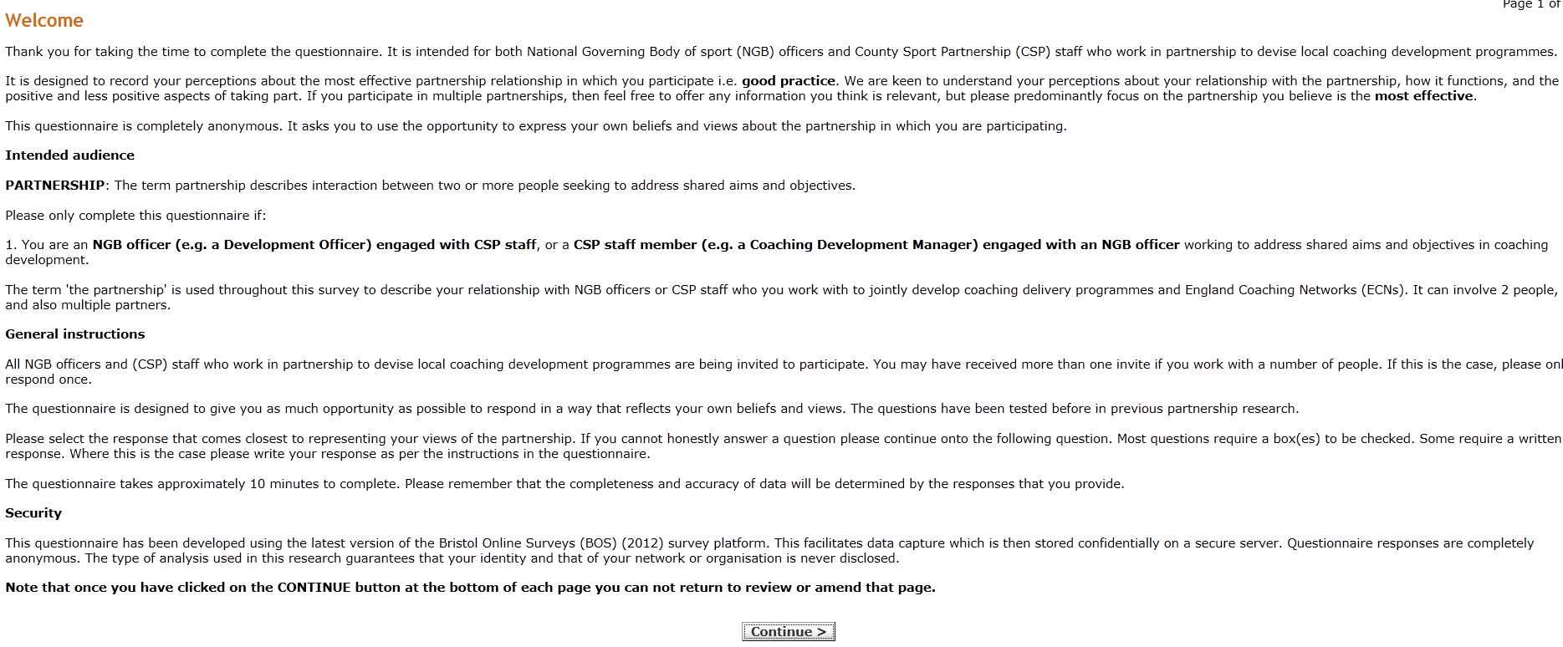
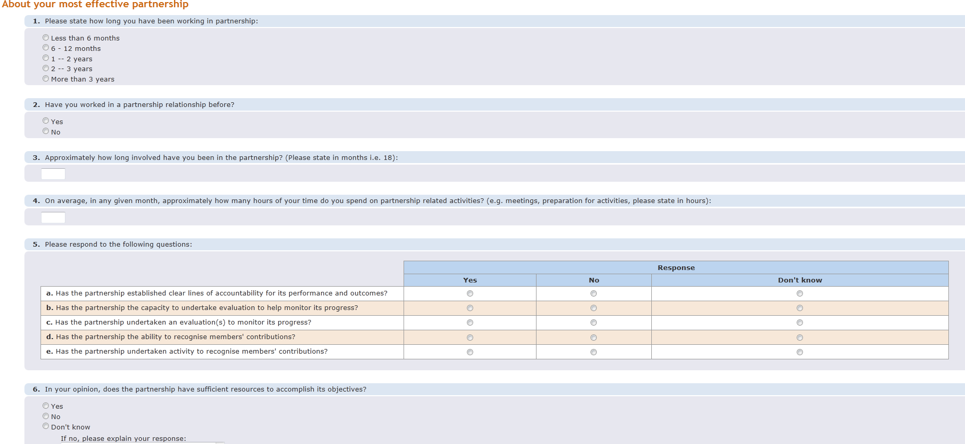
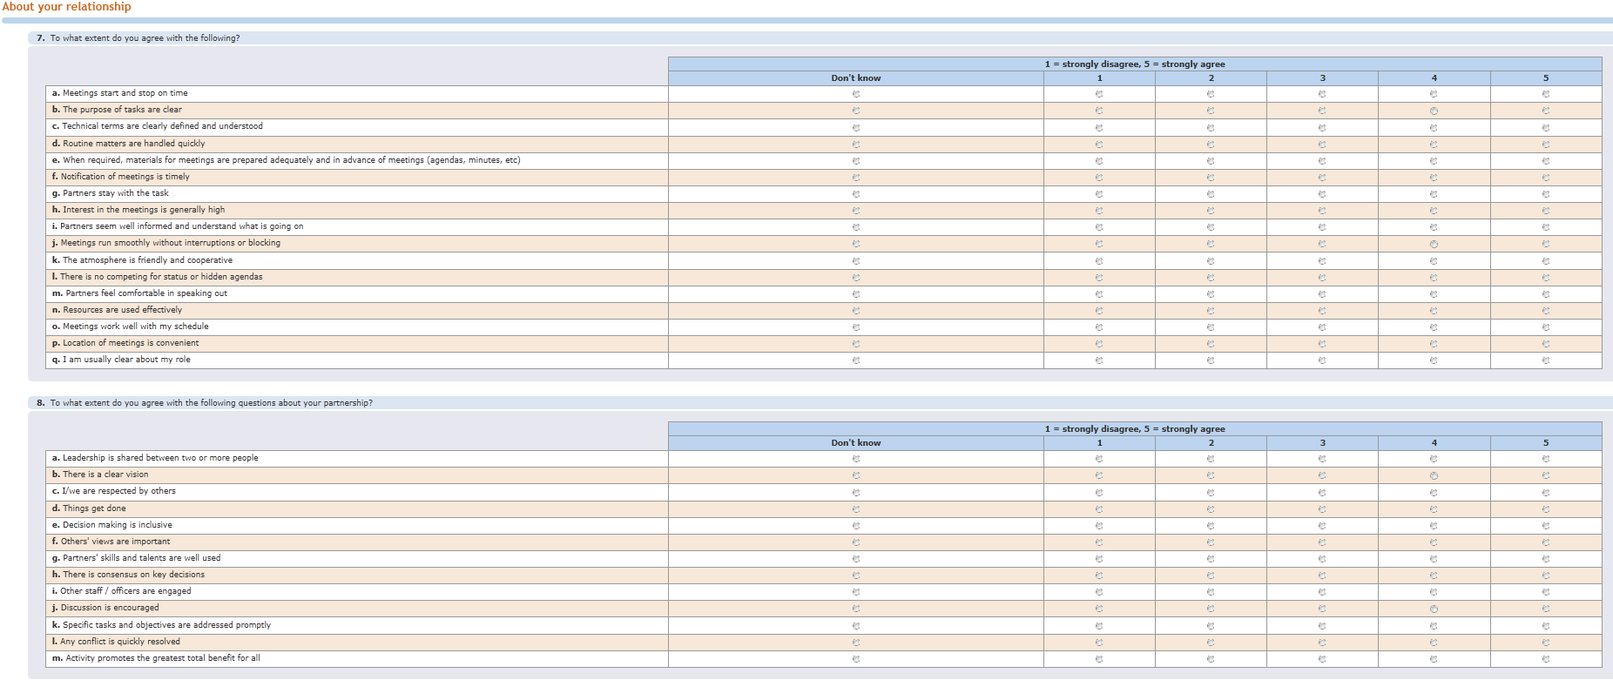
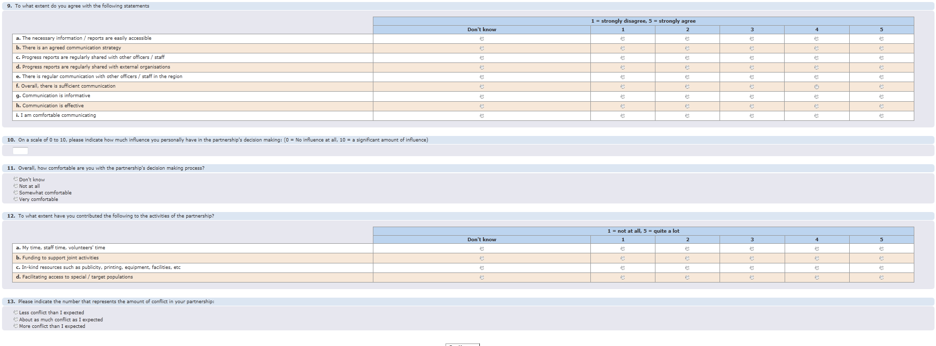
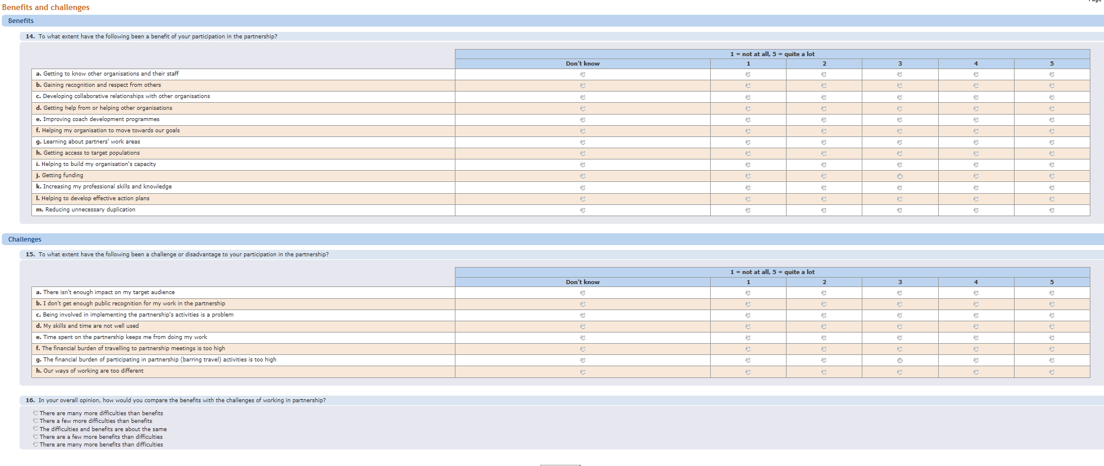
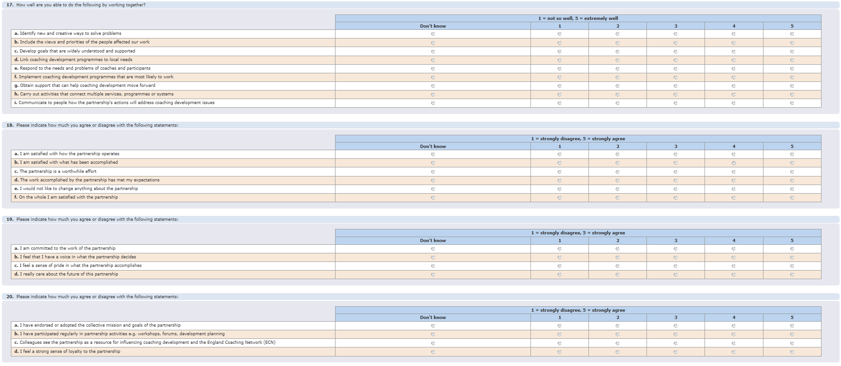
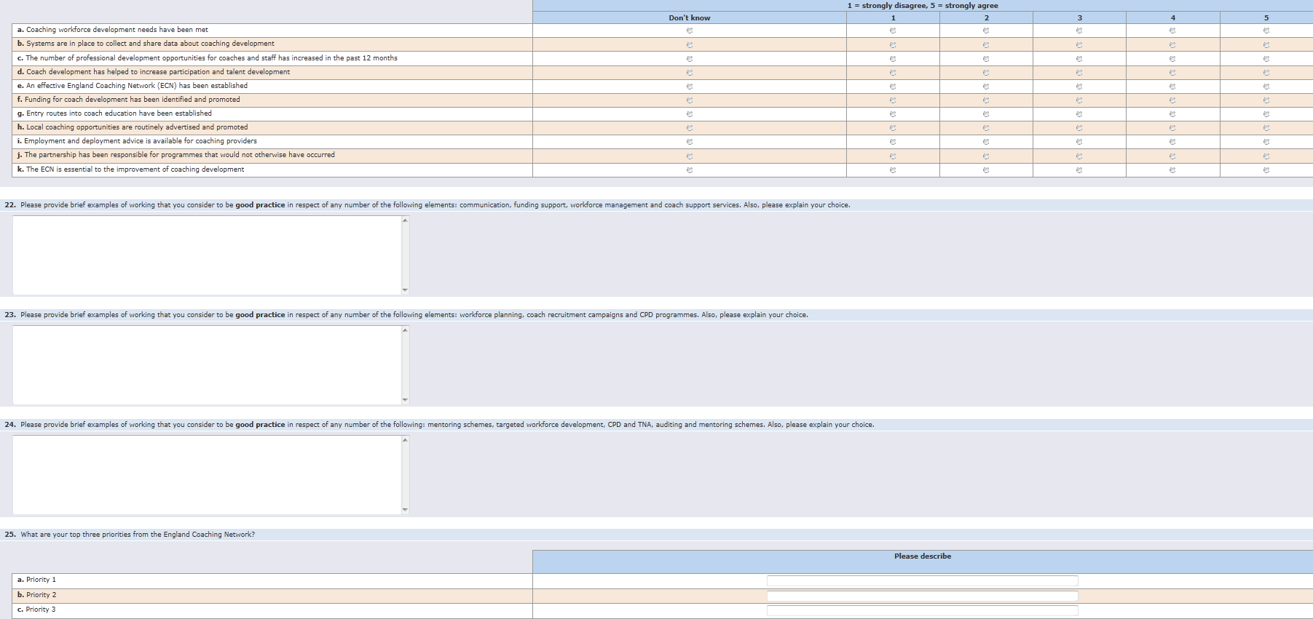
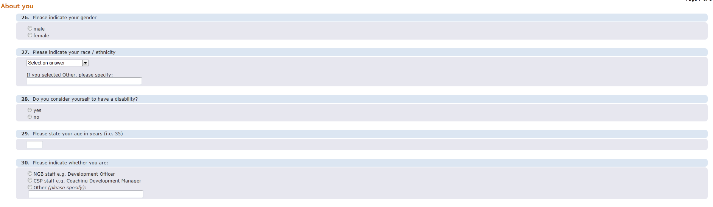
Appendix III: Interview question guide
n | Question | Prompts / follow up | Notes
1 | What is your overall opinion of the ECN / CSSN? | Why? What experiences? Practice and process. How using it as a tool for coach improvement?
2 | What do you think should be the impact on coaching of a successful partnership? | Why? Is this happening? Key enablers / challenges - process, people, etc.
3 | What are the key things that help make successful impacts? | Specifics? How did they make a difference and why? Experiences from other partnership situations helped?

4 | What are the challenges in achieving successful impacts? | How are these affecting progress / outcomes? Why is that?
5 | Going forward, what improvements could be made | List key points. Why? What is the ‘dream’ scenario?

