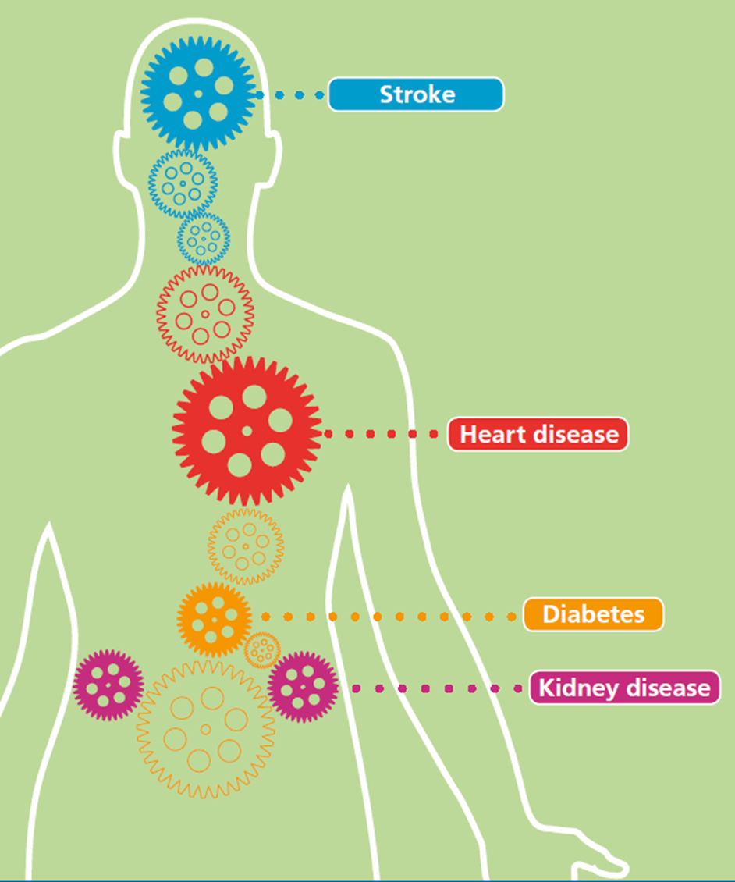

**Gloucestershire Health Checks**

**Evaluation Report**

For the period July 2011 to July 2012

University of Gloucestershire

December, 2013

Prepared by: Drs Colin Baker and Elizabeth Loughren, and Professor Diane Crone

# Acknowledgements

We are grateful to Dr Nevila Kallfa and Michele Le Mero who worked with the evaluation team to compile the data and develop the approach, design and methods that facilitated the evaluation of the Gloucestershire Health Checks Programme. We are also grateful Dr Ruth Wain for her advice, support and knowledge, and to those staff who assisted in preparing the data, particularly Christian Howe and Bruce Bennetts. The depth and complexity of the data provided a number of challenges and without their close assistance the task of assessing the various elements of the programme would have been that much more difficult.

The Evaluation Team recognise the importance of working closely with commissioners and practitioners to ensure that research is embedded into an applied project to ensure that it is as insightful as possible. We are certain that this report demonstrates an in-depth look at the Gloucestershire Health Checks Programme which will help inform future research and practice in a service that has the potential to positively impact many lives.

.

To reference this report, please use the following citation: Baker, C., Loughren, E. & Crone, D. (2013). *Gloucestershire Health Checks (2012) Evaluation Report*. University of Gloucestershire, UK.

Contents

Executive summary i

1) Introduction 1

1.0 Background and context 1

1.1 The state of Gloucestershire’s health 2

1.2 Deprivation 4

1.3 Programme description 6

1.4 Health Check care pathway and processes 7

1.4.1 Patient identification and invitation 7

1.4.2 Risk Assessments 9

1.4.3 Patient follow-up 9

2) Evaluation aims and objectives 11

2.0 Introduction 11

2.1 Evaluation aims and objectives 11

3) Methodology 13

3.0 Introduction 13

3.1 Service Audit 14

3.2 Patient Survey 15

3.2 Stakeholder evaluation 16

4) Findings 18

4.0 Introduction 18

4.1 Are Health Checks reaching the right people? 19

4.1.1 Eligible patients and invites 19

4.1.2 Uptake 19

4.1.3 Patient gender and age 20

4.1.4 Ethnicity 21

4.1.5 Deprivation and uptake 22

4.1.6 Deprivation, invitations and completions 25

4.2 Are all components of the NHS Health Checks being performed? 26

4.2.1 Patient identification and invitation 26

4.2.2 Equipment 28

4.2.3 Blood tests (pre visit) 29

4.2.4 Risk assessments 30

4.3 Are modifiable risk factors and diseases being picked up? 33

4.3.1 Identification of risk factors 33

4.3.2 Actual versus expected identification of risk factors 33

4.4 Are people with risk factors for CVD being managed appropriately? 35

4.4.1 Referrals to services 35

4.4.2 Actual versus expected referrals or treatment 36

4.4.3 Perceived quality of referral services 37

4.4.4 High risk patients and CVD diagnoses 39

4.4.5 Actual versus expected CVD / diabetes diagnoses 41

4.5 Perceived impact of Health Checks 43

4.5.1 Are the Health Checks preventing premature CVD? 43

4.5.2 Workforce impact and development 44

4.5.3 What works well? 45

4.5.4 What needs improving? 46

4.6 Patient perceptions 49

4.6.1 Motivation to attend 49

4.6.2 Perceived quality of Health Checks 49

4.6.3 Was the health Check worth attending? 50

4.6.4 Patient recommendations for improvement 52

5) Discussion and conclusion 54

5.0 Introduction 54

5.1 How is the Gloucestershire NHS Health Checks care pathway followed and interpreted? 54

5.1.1 Invites 54

5.1.2 Uptake 55

5.1.3 Equipment and services 55

5.1.4 Risk assessments 55

5.1.5 High risk patients and CVD / diabetes diagnoses 56

5.1.6 Referrals and treatment 57

5.2 What are the challenges that practices and other providers face in implementing the Health Checks? 57

5.2.1 Health Checks Pathway versus administrative capabilities 57

5.2.2 Patient engagement and motivation 58

5.2.3 Confidence in delivery 58

5.2.4 Knowledge updates 59

5.3 Stakeholder interaction at the point of patient interface 59

5.3.1 Communication 60

6) Conclusion 61

7) Key recommendations 63

7.1 Patient identification, invitation and uptake 63

7.2 Awareness and purpose of the NHS Health Checks programme 64

7.3 Programme delivery - feedback 64

7.4 Programme delivery – organisation 64

References 67

Appendix A: Pre-assessment questionnaire 69

Appendix B: Clinical advice 71

Appendix C: Patient Card 72

Appendix D: Service Audit Indicators 73

Appendix E: Service Audit Headline Results 76

Appendix F: Health Check Ready Reckoner (Gloucestershire PCT, 2011) 77

Appendix G: Patient Survey 78

Appendix H: Practice interview schedule 80

Appendix I: Stakeholder interview schedule 83

Appendix J: Search Strategy 84

**List of Tables**

Table 1: Overview of evaluation 11

Table 2: Evaluation strands 13

Table 3: Stakeholder evaluation methods and sample 17

Table 4: Ethnicity of patients 22

Table 5: Breakdown of NHS HC invitations 26

Table 6: Risk assessments performed 31

Table 7: Identification of risk factors (actual vs. expected) 34

Table 8: Referrals to services 35

Table 9: Expected versus actual referrals / treatment 37

Table 10: Practice perceptions of referral services 39

Table 11: CVD / diabetes diagnoses and outcomes post Health Check 41

Table 12: Actual versus expected CVD / diabetes diagnoses 42

Table 13: What works well? 45

Table 14: Challenges to Health Check success 48

Table 15: Why was the Health Check worth attending? 51

Table 16: Why was the Health Check not worth attending? 52

Table 17: Patient recommendations 53

**List of Figures**

Figure 1: Ethnic Profile of Gloucestershire 3

Figure 2: Gloucestershire Health Check practices by deprivation 5

Figure 3: NHS Health Check Care Pathway 8

Figure 4: Age profile of Patient Survey responders (%) 16

Figure 5: Health Checks invitations and uptake 20

Figure 6: Number of Health Check completions according to age and gender 21

Figure 7: Deprivation and uptake of Health Checks 23

Figure 8: Quintiles of deprivation: Patient Survey 24

Figure 9: Patient ages and quintiles of deprivation (%) 25

Figure 10: Invitations and completions according to deprivation (n) 25

Figure 11: Invitation strategies adopted by practices (%) 27

Figure 12: Equipment and services used in Health Checks 28

Figure 13: Comparison of Service Audit and Patient Survey for risk assessments (%) 32

Figure 14: Age and CVD risk (n) 40

Figure 15: Practice perceptions of Health Check effectiveness in reducing CVD 43

Figure 16: Health Check improvements 47

## Executive summary

Cardiovascular Disease (CVD) is a broad category of diseases which affect the heart and circulatory system and is a major cause of death and disability. It accounts for 36% of deaths and is responsible for a fifth of all hospital admissions in England (Department of Health, 2008). The NHS Health Checks programme is a national initiative designed to identify individuals aged between 40 and 74 years old at risk of, or living with undiagnosed CVD (diabetes, stroke, chronic kidney disease). Health Checks is a 5 year rolling programme delivered via general practitioners to 20% of the eligible cohort each year.

A process evaluation using a quasi-experimental design was deployed to evaluate some of the key outputs of the Health Check Programme in Gloucestershire for the period July 2011 to July 2012. The evaluation adopted a mixed methods approach that included data from three evaluation strands: Service Audit (quantitative, conducted by Gloucestershire Primary Care Clinical Audit Group (PCCAG)); Patient Survey (quantitative, managed in Public Health), and stakeholder interviews (qualitative, by the University of Gloucestershire). The University of Gloucestershire was commissioned to bring together all the elements of the NHS Health Check programme evaluation to help inform the future development of the programme.

Annual output data (invited n = 42,103 of which 49.8% attended) from a GP system Audit was combined with a patient survey (n = 2,346 of which 42.5% responded), and interviews conducted with stakeholders involved in service delivery (n = 30 out of 55 targeted in a total sample of 195, 170 of which represented practices (2 per practice)). Analysis was guided by research questions established in collaboration with public health professionals at Gloucestershire County Council (formerly NHS Gloucestershire) and involved deductive (quantitative) and inductive (qualitative) techniques. These established evidence concerning key aspects of the Health Check programme including a number of themes and sub themes.

**Key findings**

There was a small negative and non-statistically significant correlation (*r* = -.143, *p =* .192)between uptake and deprivation across the cohort of 85 GP practices. Due to lack of data, deprivation could not be measured at an individual level which may mean that there was inter-practice variation. In total, 15.5% of patients were identified as obese; 9.3% were recorded as being current smokers; 7.9% had high blood pressure; 7.1% had a poor physical activity rating, and 2.5% had high fasting blood glucose / HbA1c.

Overall cardiovascular disease diagnoses were 8.1% less than the expected national average based on the [NHS Health Checks Ready Reckoner tool](http://www.healthcheck.nhs.uk/commissioners_and_healthcare_professionals/national_resources/ready_reckoner_tools/). Actual versus expected diagnoses were the same for diabetes, a lower than expected rate of -0.9% for CKD and significantly lower for hypertension (-19.9%). The results might be explained by the national average baseline not adequately representing the Gloucestershire population, indicating a potential overestimation of CVD or that proactive work already underway in primary care is helping to identify and address CVD. Further, inconsistencies in search strategies employed by practices and the difficulty in fully distinguishing between checks undertaken by GPs as part of the NHS Health Checks programme and those identified outside of the programme may have impacted the results.

The following variations in the detection of modifiable risk factors between expected and actual were identified: hypertension (-19.9%) (when interpreted as a modifiable risk factor); obesity (-7.1%); low physical activity (-57.7%) and smoking (-14.3%). Variations for subsequent referrals and clinical management were: weight loss (-2.7%), suggesting a lack of, or lack of knowledge where to refer patients to; smoking (+3.9%); brief exercise intervention (+1.1%), antihypertensive (+2.7%) and statins (+2.9%), suggesting a potential over-prescription of drug therapy. Due to limitations with the data we were unable to assess cholesterol as a modifiable risk factor.

Patients strongly agreed that the Health Check was worth attending and stakeholders perceived early disease identification as a key benefit.

**Summary of key findings**

|  |  |  |
| --- | --- | --- |
| **Area** | **Source** | **Key findings** |
| Identification of risk factors | Service Audit | 15.5% of patients were identified as obese; 9.3% were current smokers; 7.9% had high blood pressure; 7.1% had a poor physical activity rating, 2.5% had high fasting blood glucose / HbA1c. |
| Identifying high risk groups | Service Audit | 30.3% of BME patients were identified as obese. |
| Identifying high risk patients | Service Audit | 6.5% of patients were identified with a high CVD risk score. |
| Referrals and advice | Service Audit | 74.1% of patients with identified lifestyle issues were referred to a Health trainer; 66.6% of smokers received a referral / advice; 47.9% of patients with poor/average diet received a referral; 44.2% of patients with a low exercise grading received a brief exercise intervention. |
| Practice perceptions | Practice Survey | Health Checks provided a useful means of identifying risk factors for, and diagnoses of CVD, particularly diabetes.  There were minimal technical issues in delivering Health Checks. |
| Patient perceptions | Patient Survey | 90.2% agreed that the health Check was worth attending; 88% agreed that they had the time to ask questions during the NHS HC and there were minimal general difficulties.  64.9% were told about their CVD risk score.  41.5% indicated that they had, or were going to change their lifestyles as a result of the Health Check.  Benefits of attending a Health Check included: reassurance; information and advice, and risk identification. |

**What works well?**

|  |  |  |
| --- | --- | --- |
| **Area** | **Source** | **Key findings** |
| **Early detection** | Practice Survey / Patient Survey | Alerting patients about lifestyle issues.  Increasing patient awareness of risks  Getting non-regular patients to come in rather than just “worried-well”.  ‘Thanks to check-up high blood pressure was discovered - and steps taken to reduce.’  ‘Found out I am diabetic type 2.’ |
| **Consultation** | Practice Survey | Good for encouraging people to come in for an assessment that isn't necessarily about illness.  Helps develop/maintain rapport and communication with patients.  Being able to dedicate nurses' time to consultations allows for discussion/rapport with patients and better communication of information.  QRISK score gives something to look at and understand in real terms.  For men, being given a 'number' to focus on is useful. Advice is more important for women. |
| **Reassurance** | Patient Survey | Strong agreement that the NHS HC was worth attending (90.2%, n = 901)  The majority of patients (91.7%, n = 805) rated the overall NHS HC experience highly, stating 4 or more (on a scale of 1 to 5, 5 indicating a very positive experience).  ‘As I rarely see a doctor, it made sense to arrange a general health check.’  ‘Good to check that everything is ok.’ |
| **Information and advice** | Patient Survey | ‘This helped me realise about units of alcohol per week.’  ‘Good to know details so I can take action.’  ‘I was delighted with the advice given by the nurse I saw. I was provided with leaflets and scores and guidance.’ |

**What needs improving?**

|  |  |  |
| --- | --- | --- |
| **Area** | **Source** | **Key findings** |
| Uptake | Service Audit | Overall uptake was 25.2% less than the target (75%).  Those in deprived areas were less likely to complete a health Check. |
| Ineligible invites | Service Audit | 5.3% of patients who received a Health Check were ineligible. |
| Implementation of the Health Check care pathway | Practice Survey / Patient Survey | There were wide variations in invitation strategies, use of diagnostic equipment during Health Checks and service, risk assessment and identification, and referrals across the practice cohort. |
| Data tracking | Practice Survey / Stakeholder interviews | Collection and recording of information on Health Check assessments and patient referrals was inconsistent across the practice cohort, primarily in relation to:   * Coding of Health Check assessments * Use of the PCCAG template * Tracking patients who had been referred to local services |
| Practice perceptions | Practice Survey / | Difficulty in understanding the impact of the programme.  Challenges included staffing issues and lack of information concerning referral pathways. |
| Stakeholder perceptions | Stakeholder interviews | Tracking Health Check referrals into local lifestyle services was a principal challenge.  Engaging with practices to establish effective pathways with referral services can be challenging. |
| Patient perceptions | Patient Survey | Although a minority, some felt that the Health Check experience had not met their expectations.  We identified a theme whereby some patients wanted more feedback about their risk score and potential action to address lifestyle issues. |

**Key recommendations**

Patient identification, invitation and uptake

**Recommendation 1**: Improved systems are needed in general practices to identify and invite individuals who are hard to reach and seldom heard, such as the homeless, or find it difficult to access services, particularly those living in deprived areas. These could include outreach work with workplaces, care homes and community associations.

**Recommendation 2**: Measures should be taken to ensure that invitation strategies are effective in attracting a range of patients from diverse backgrounds. Particular attention should be paid to how invitations are made e.g. by telephone, and whether these are appropriate for the eligible population being targeted.

**Recommendation 3**: Flexibility in invitation strategies being used by general practices should be checked to ensure that the eligible population is consistently being targeted. Consultation and support for general practices most in need, in addition to spot checks and contract reviews, might help improve the effectiveness of invitation strategies.

**Recommendation 4**: Increased flexibility in the timing of appointments for NHS HC should be considered to account for patient lifestyles in order to improve uptake.

**Recommendation 5**: Benefits of the NHS HC programme might be further enhanced by ensuring that there is better quality and more frequent communication between all stakeholders involved (including general practices and lifestyle services providers) to improve relationships and interaction between stakeholders. This should include identifying issues that impact patients’ service uptake and compliance (e.g. location of lifestyle services and accessibility issues), sharing knowledge and awareness of local lifestyle services and exploring potential links between those involved in delivering and/or supporting the NHS HC programme.

Awareness and purpose of the NHS Health Checks programme

**Recommendation 6**: The role and purpose of the NHS HC programme should be reinforced to ensure that general practices understand its function and are able to pass this information to patients.

**Recommendation 7**: Better marketing and communication of the role and purpose of the NHS HC should be undertaken to improve patient awareness and understanding and thus establish clearer expectations. This might include advertisements and outreach work with workplaces, care homes and community associations, etc. outlining the free service and its benefits.

Programme delivery - feedback

**Recommendation 8**: This report should be shared with general practices to draw attention to areas that are working well and areas that need improving.

**Recommendation 9**: The practical implications (i.e. workload, staffing issues) for Practices delivering the NHS HC programme should be recognised and understood as factors which, at times, can impact the delivery of the programme.

Programme delivery - organisation

**Recommendation 10**: Uptake of the NHS HC programme might be further improved by ensuring that all stakeholders involved (including general practices and local lifestyle service providers) work together to identify issues that impact patients’ service uptake and compliance (e.g. location of lifestyle services and accessibility issues).

**Recommendation 11**: General practices should be supported to ensure that drug therapy is not the principal response in high risk patients to avoid the risk of over-prescribing drug therapies.

**Recommendation 12**: Regular CVD training and support for general practice staff is required to improve interpretation of, and adherence to, the NHS HC pathway particularly in relation to invitations, assessments, referrals and follow up appointments. This will likely also increase morale in those delivering the NHS HC.

**Recommendation 13**: Improvements to the ways risk assessments are carried out are needed to ensure that the information needed to accurately calculate CVD risk scores is acquired and how this information is relayed to patients.

**Recommendation 14**: Commissioners and general practices should consider how CVD risk factors are discussed with patients as it is apparent that women might favour discussion of lifestyle factors whereas men might act on ‘harder’ information e.g. the definitive risk score.

**Recommendation 15**: Positive feedback indicates that patient motivation for long term behaviour change is promising. Training in Motivational Interviewing techniques should be provided to all practice staff delivering the NHS HC to ensure that patient needs are understood and appropriate health behaviour changes are advised and supported.

**Recommendation 16**: Near Patient Testing (NPT) should be considered as a potential means of improving the NHS HC programme in that it can: reduce the number of visits required to complete the Health Checks process; improve uptake by providing a quicker and more convenient service for patients, and reduce the workload on Practices.

**Recommendation 17**: HbA1c tests should be introduced as a standard diagnostic test for diabetes due to its ability to avoid day-to-day variability of glucose values and the lack of requirement for patients to fast before testing.

**Recommendation 18**: Practice staff delivering the NHS HC should ensure that patients are provided with sufficient time to ask questions and receive feedback regarding their CVD risk e.g. via patient cards, information sheets or follow up appointments to discuss lifestyle issues.

**Recommendation 19**: All general practices should appoint a NHS HC lead to ensure effective communication and coordination within, and between practices and commissioners. If not the appointed CVD GP Lead, they should work closely with the appointed CVD GP Lead to ensure effective programme delivery.

**Recommendation 20**: Benefits of the NHS HC programme might be further enhanced by ensuring that there is better quality and more frequent communication between all stakeholders involved (including general practices and lifestyle services providers) to improve relationships and interaction between stakeholders. This should include identifying issues that impact patients’ service uptake and compliance (e.g. location of lifestyle services and accessibility issues), sharing knowledge and awareness of local lifestyle services and exploring potential links between those involved in delivering and/or supporting the NHS HC programme.

**Recommendation 21**: Streamlining services e.g. via an integrated lifestyle service model might help create a more joined up approach between general practices and local lifestyle service providers by providing a single point of access and so overcome the disjointed nature of some referral pathways in Gloucestershire. This might improve referrals into pathway addressing specific issues e.g. hazardous levels of alcohol consumption.

**Recommendation 22**: Greater and more consistent adherence to the NHS HC pathway is needed to ensure that each element of the NHS HC pathway is being undertaken in order to improve outcomes for patients and the quality of data being collected.

**Recommendation 23**: Measures should be put in place e.g. unique patient identifier, to facilitate the long term tracking of patient progress through the NHS HC programme and beyond. This would facilitate patient follow up in terms of take-up of referrals, the long term management of CVD risk and monitoring of morbidity and mortality.

**Recommendation 24**: A distinction between advice and referral to services should be maintained in order to help clarify the type of support being provided to patients.

# Introduction

## 1.0 Background and context

Cardiovascular Disease (CVD) is a broad category of diseases which affect the heart and circulatory system and is a major cause of death and disability. It accounts for 36% of deaths and is responsible for a fifth of all hospital admissions in England (Department of Health, 2008). CVD is a common cause of heart attacks and most strokes, whilst adults with diabetes have a heart disease death rate 2-4 times higher than adults without diabetes. Vascular diseases are linked by a common set of risk factors including those that are fixed including age, sex, ethnicity and family history. Almost all vascular diseases are preventable, the most important modifiable CVD risk factors are; smoking, elevated cholesterol, elevated blood pressure, diabetes, obesity, and alcohol and dietary salt intake (British Heart Foundation, 2008). Having one vascular condition increases the likelihood of people suffering from others and the burden of disease tends to fall disproportionately on people living in deprived circumstances, especially ethnic groups such as South Asians and African Caribbean (Care Quality Commission, 2009). In total, CVD is estimated to cost the UK economy £30 billion annually, almost half of these costs being directly attributable to health care provision (Luengo-Fernández et al., 2006).

Launched nationally in April 2009 the NHS Health Checks (NHS HC) are about helping people stay well for longer. They are designed to support individuals aged between 40 and 74 manage their risk of developing vascular diseases by offering a cardiovascular risk assessment every five years. A key objective of the NHS HC programme is to identify people with previously unidentified established vascular disease risk factors so that they are able to obtain the maximum benefits from diagnosis and prevention (Department of Health, 2009). The underpinning rationale is that preventative approaches could address premature deaths, illness and the associated costs to society by helping to avoid some forms of cancer, vascular dementia and a significant proportion of circulatory diseases (Department of Health, 2010).

Although assessments have shown that NHS HC result in potential savings over the long term, particularly in relation to diabetes where up to 9,700 cases or the equivalent of 63 cases per PCT each year are estimated (Martin, 2011), there is limited information on the effectiveness of CVD risk assessment programs in real world settings (Artac et al., 2013a). Challenges to understanding the impact of NHS HC include variations in patient uptake, delivery methods costs and patient targeting (Artac et al., 2013a; Cochrane et al., 2012; Martin, 2011) and more evidence is needed concerning how best to implement the programme in order to produce the desired effects. Evidence suggests that even in low-uptake situations the NHS HC programme has the potential to identify high risk patients and establish appropriate responses. Artac et al. (2013a) found a marked increase in high risk patients prescribed with statin drug therapy (17.7% before and 52.9% after the programme) where uptake was ≈30%, which might suggest that NHS HC might provide a useful means of identifying those most at risk of CVD although it should be recognised that the recommended first line of treatment should be lifestyle modification. Further, significant but modest reductions in CVD risk in addition to diastolic blood pressure, total cholesterol levels and lipid ratios have also been attributed to NHS HC (Artac et al., 2013b). This suggests that the greater NHS HC uptake may help identify and respond to modifiable CVD risk factors.

Ensuring that a high percentage of those offered a NHS HC actually take up the offer is critical for optimising the clinical and cost effectiveness of the programme (Department of Health, 2013). This is especially important for populations with the greatest health needs where the programme may help to narrow health inequalities. However, there is concern that the NHS HC programme is not being fully understood as a mechanism for communicating the risk of CVD to patients. In a study exploring the experiences of NHS HC attendees (n = 10), Chipchase et al. (2012) found that many patients were not aware that NHS HC was a specific CVD health screen designed to assess risk and provide an opportunity to review health and lifestyle behaviours, rather than a general check-up. Furthermore, some sections of the eligible population may be less likely to receive a NHS HC than others. Turner and Mitchell (2012) found that less than half of eligible adults with learning disabilities have actually had a NHS HC and research by Cochrane et al. (2012) demonstrates that older aged patients and those from more affluent areas are more likely to respond to a NHS HC invitation. This suggests it is important to devise targeting strategies that are sufficiently flexible to accommodate a range of patient needs and contexts. One suggestion has been to promote opportunistic invitations (Kumar et al., 2011) in that pre-booked appointments may not always be a realistic proposition, particularly for men who may perceive ‘there and then’ appointments as being more acceptable than scheduled visits to the GP practice (Sankla et al., 2013). Such approaches are supported within existing search strategy guidance which identifies the systematic identifying of at-risk patients via screening family members of patients with existing CHD, Diabetes, Hyperlipidaemia and Rheumatoid Arthritis, and via opportunistic screening and open clinics.

## 1.1 The state of Gloucestershire’s health

Gloucestershire’s population stands at 575,000 and is projected to increase to 644,000 in 2021. The health of Gloucestershire’s population is generally better than the England average, all-cause mortality rates having fallen in recent years with both men and women having a higher than average life expectancy (Department of Health, 2012a). However, there is considerable variation within Gloucestershire. Overall levels of adult 'healthy eating', smoking and physical activity are also better than the England average. However, data show that 23.6% of the population in Gloucestershire have increasing or high risk drinking behaviour which is higher than England (22.3%) and higher than South West (23.5%). Further, it is estimated that 24.7% of the adult population in Gloucestershire are classified as obese which is 0.5% higher than England, slightly less than the South West (Public Health England, 2013).

Age is a key factor in cardiovascular disease and the prevalence of CVD increases significantly after the age of 40 years. The percentage of the population aged 40 or over in Gloucestershire is expected to increase from 25.6% to 26.2% for males and from 28.1% to 28.5% for females between 2011 and 2021 (Public Health England, 2013). These figures are higher than England where it is expected to increase from 23.5% to 25.1% for males and increase from 25.8% to 26.8% for females, suggesting that CVD is likely to become an increasing burden on primary care services. While the majority of Gloucestershire’s population is classified as ‘White’, (Figure 1) there has been an increase in almost all other ethnic groups since 2001. South Asian men in are more likely to develop CVD, particularly CHD at younger age, and have higher rates of myocardial infarction, while Black people have the highest stroke mortality rates (Public Health England, 2013). Although CVD mortality rates for Gloucestershire as a whole are significantly lower than the England average, there is a clear discrepancy between males and females where male CVD mortality rates are significantly higher than female mortality rates (175.2 versus 106.4 respectively) (Public Health England, 2013).

Figure 1: Ethnic Profile of Gloucestershire

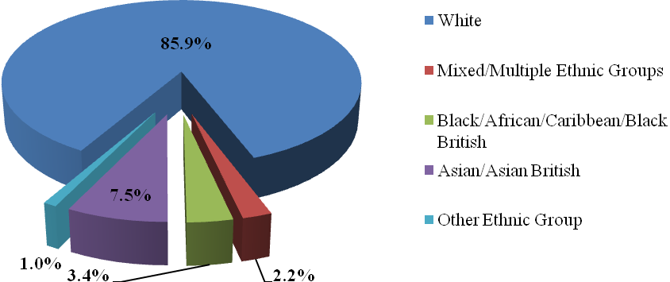

Source: Service Audit

## 1.2 Deprivation

Of the 85 practices registered for the NHS HC programme, 60% (n = 51) are in areas with deprivation[1] scores less than the Gloucestershire average and nearly 90% in areas with deprivation scores less than the England average (Figure 2). While deprivation is generally lower than average in Gloucestershire there are pockets of high deprivation within the county, 7.2% of Gloucestershire’s population living in the most deprived national quintile (Public Health England, 2013). CVD mortality rates for people living in the most deprived areas is 1.3 times greater than the rate for the rest of Gloucestershire and 1.6 greater than those living in the least deprived area (Public Health England, 2013), and life expectancy is 7.0 years lower for men and 4.8 years lower for women in the most deprived areas of Gloucestershire than in the least deprived areas (Department of Health, 2012a).

Figure 2: Gloucestershire Health Check practices by deprivation

Source: PHIU, 2012

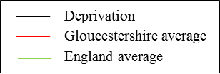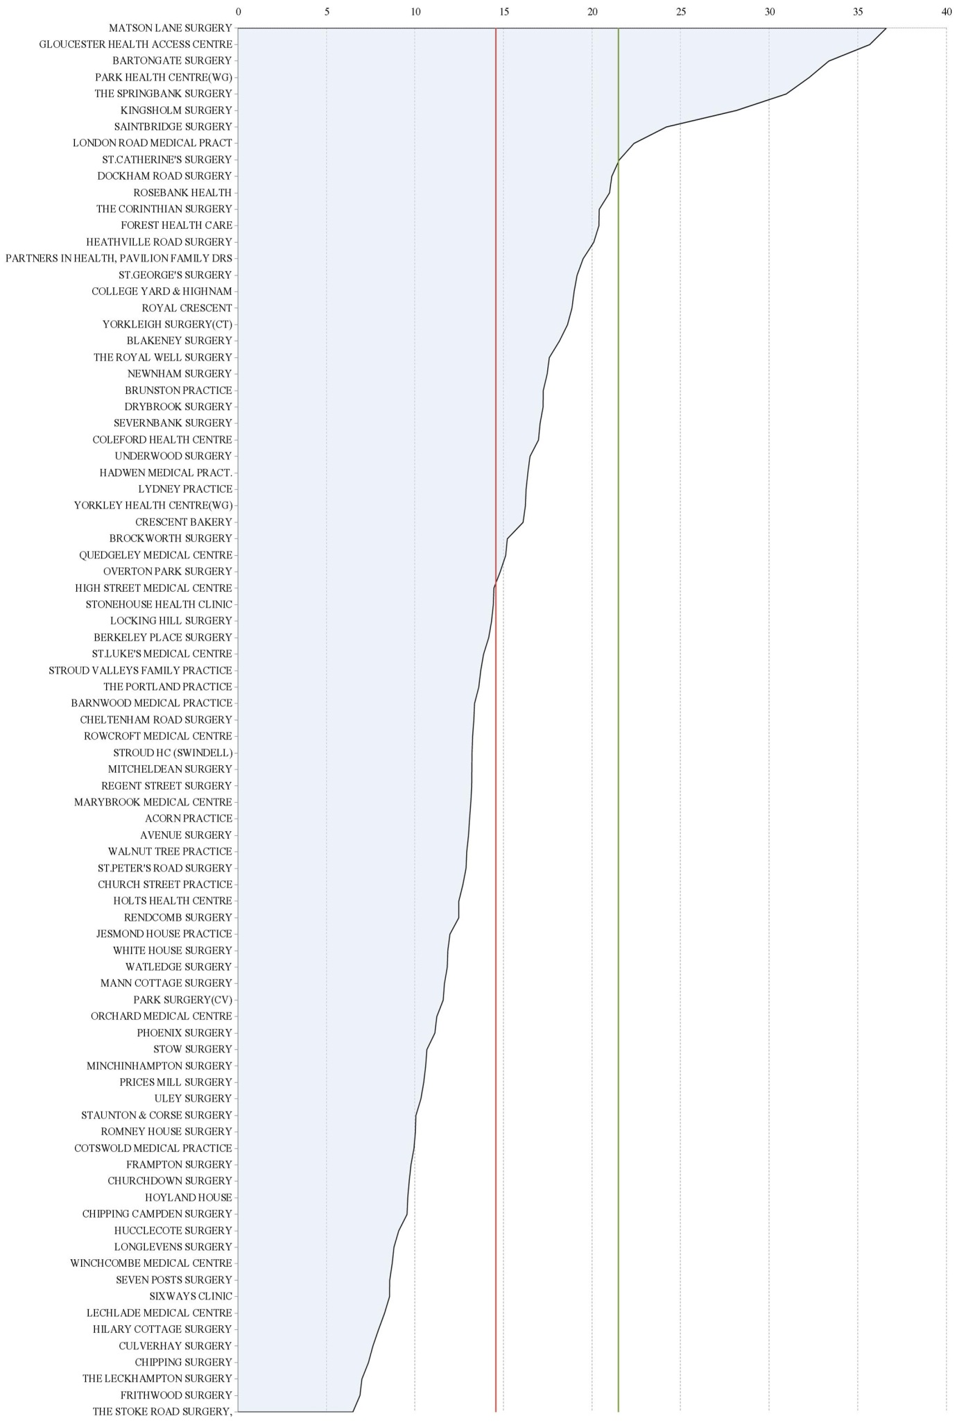

## 1.3 Programme description

The NHS HC programme is a mandated service designed to cover the enhanced aspects of clinical care of patients that lie beyond the scope of contracted services in respect of the identification of patients that are at high risk of developing Vascular Disease. The overarching aim of the NHS HC programme in Gloucestershire is to reduce mortality and morbidity from all CVD conditions and more specifically myocardial infarction and stroke in under 75 year olds. Health Checks were started in Gloucestershire in 2010. The total practice population of Gloucestershire is 617,175 of which approximately 249,465 are in the 40-74 age groups. Overall, 34.1% (*n* = 210,513 not including patients who are already on CVD practice registers) are estimated to be eligible for a HC based on the number of 40-74 year old patients registered with GP practices[2], versus the national [NHS Health Checks Ready Reckoner tool](http://www.healthcheck.nhs.uk/commissioners_and_healthcare_professionals/national_resources/ready_reckoner_tools/) which calculates it at 180,760. The NHS Health Check ready reckoner tool is designed to provide a snapshot of the potential cost and savings that can be made by NHS Health Checks to health and social care commissioners and other interested parties using gender and age-based national estimates and applies these to local populations.

The programme also holds potential to impact health inequalities in the county particularly with respect to: reducing mortality from CVD; lowering the rate of CVD mortality in Gloucester City and the Forest of Dean, and releasing savings by a reduction of: 880 Myocardial Infarction admissions; 55 Transient Ischaemic Attacks; 54 strokes; 33 angina attacks, and over £500k savings to the NHS, not including rehabilitation costs. The programme also assessed alcohol intake which is not a currently a core component of the NHS HC Ready Reckoner tool that is used for comparisons in this report. Alcohol-related problems are widespread and it recognised that the NHS HC programme offers scope for supporting alcohol identification and brief advice (IBA) as a means to reduce harmful drinking patterns and associated problems (Holmes and Waterall, 2010).

All participating practices were advised to nominate a CVD lead GP and two practice staff (within the primary care health care team) to attend the Primary Care Trust (PCT) approved training courses. The PCT initiated a comprehensive support to participating practices delivering the NHS HC including:

* Templates to facilitate the compilation of registers and recording of assessment details;
* MIQUEST queries to interrogate the clinical systems;
* Sample templates for patient invites;
* Protocol for initial CVD risk assessment (search criteria, Glos NHS Health Checks Pathway etc.);
* Web based information about where to refer patients for lifestyle change programmes and support;
* CVD Risk Assessment courses including motivational interviewing skills;
* Lifestyle information support;
* NHS Health check information leaflets/Card
* Patient assistance cards

## 1.4 Health Check care pathway and processes

**A single NHS HC care pathway (Figure 3) has been developed in Gloucestershire in collaboration with GPs, Nurses and managers to ensure the systematic, equitable and high quality provision of the programme across the county.**

### 1.4.1 Patient identification and invitation

The NHS HC care pathway is designed to triage patients according to their CVD risk. Initial contact with patients includes the sending of a pre-assessment questionnaire (Appendix A) that is returned prior to the first risk assessment. This allows practices to identify patients who require a Fasting Blood Glucose (FBG) test.

The Health Checks programme affords significant flexibility for practices in the way that patients are invited as it is recognised that opportunistic sampling has the potential to reach a greater number of patients. The patient identification and invitation process involves a staged approach for calling people forward from current registrations:

1. **First invite:**

Patients aged 40-74 years old who:

* are not on Hypertension, Diabetes, CKD, Stroke, PVD, CHD or Palliative Care registers;
* have no record of CVD or CHD 10 year risk assessment;
* with no CVD risk assessment done;
* with no invite for CVD high risk monitoring;

1. **Second invite (after one month):**

Patients aged 40-74 years old who:

* do not have a record of CVD risk assessment done;
* do not have a CVD or CHD 10 year risk assessment;
* DNA patients who have received two letters of invite and have no record of CVD risk;
* have had / declined assessment or CVD risk assessment.

Figure 3: NHS Health Check Care Pathway

Treatment /Referral

Perform test/assessment

Patient Appointment

Administrative Action

Record patient does not want to attend. Do not re-invite

Does not attend twice

Send Reminder Letter

Search for eligible patient by birthday❶

Does not attend once

Conditional

Source: Gloucestershire County Council (2011).

**Pre-visit for blood test**

**lipid profile & FBG if high risk**

Send invitation, enclose:

PIS, Pre-visit Questionnaire, return envelope ❷

**10 year CVD Risk**

**10 days**

Recall in 5 years - Start over

**(≤10%)**

**Low**

**(10-20%)**

**Moderate**

**(≥20%)**

**High**

**First appointment – assess risk based on QRISK 2 score**

Total cholesterol/ HDL ratio

FBG

≥6mmol

BP≥140/85 mmHg / repeat

If pulse irregular rate/rhythm

If CVD 10 year risk ≥ 20%



Smoking Cessationn

Lifestyle advice

Exercise Referral

Risk Assess refer to GP

If eGFR low

Current Smoker

BMI & Waist Circumference ❸

Hazardous/Harmful drinking (5+)❺

Consider referral to Health Trainer

Poor Diet❹

Physical Activity less than

30min x 5/week

**Second appointment - confirm risk**

Prescribe Statins

Independence Trust

If Cholesterol ≥ 7, 5 consider Family History

Weight Management Advice

Refer to GP Practice for ECG + further assessment

Update GP register

**KEY**

PIS Patient Information Sheet

FBG Fasting Blood Glucose

ECG Electrocardiogram

BP Blood Pressure

HDL High Density Lipoprotein

BMI Body Mass Index

TSH Tiroxin Stimulating Hormone

GFR Glomerular Filtration Rate

DM Diabetes Mellitus

CKD Chronic Kidney Disease

CVD Cardio Vascular Risk

If BP≥140/85 mmHg or

BP≥130/80 mmHg complicated with DM/CKD

CKD Assessment

**If CVD risk ≥20%**

Specific disease care pathway;

* DM – primary care clinic
* CKD – refer to GP
* Hypertensive – refer to GP

Appointment for Annual review

Update GP register

Further assessment + Prescribe Anti hypertensive

Type 2 Diabetes Risk Assessment Form

Serum Creatinin / repeat

Serum TSH and free T4 index

Oral Glucose Tolerance Test

### 1.4.2 Risk Assessments

Risk assessments are key components of the NHS HC programme designed to identify patients at high risk of developing CVD in order to inform appropriate lifestyle guidance and advice or disease management. As part of the NHS HC all patients should receive:

* + An explanation of CVD risk and diagnosis and guidance on other diseases, rheumatoid arthritis, intermittent claudication, palliative care.
  + Advice and/or referral to appropriate services for lifestyle interventions aimed at reducing vascular disease risk. This may be within the patient’s practice or elsewhere in the community (e.g. Smoking Cessation, physical activity, weight management programmes, etc.);
  + Information about reducing modifiable risk factors including appropriate referral to community based supporting services as above;
  + Further assessment and follow up criteria;
  + Management of any other conditions found coincidentally (e.g. Chronic Kidney Disease (CKD), diabetes etc.) as per normal clinical practice and protocol.

Patient risk scores are calculated using the QRISK tool which has been developed by Doctors and academics working in the UK National Health Service to assess the risk of patients having a heart attack or stroke over the next 10 years. The [QRISK2](http://www.qrisk.org/) tool is calibrated to the contemporary UK population and able to provide appropriate risk estimates to help identify high risk patients. Risk scores are estimated by using data already collected within the patient’s electronic health record and by using default values for body mass index, cholesterol concentration, and systolic blood pressure where these data have not been recorded in the past five years (Hippisley-Cox et al., 2008).

### 1.4.3 Patient follow-up

Protocols for advice and patient follow up form an essential part of the NHS HC pathway (see Appendix B for an example). Following the assessment, patients should be provided with information about their CVD risk e.g. via a patient card (Appendix C). High risk patients (i.e. those with a CVD risk score of 20% or more) are put onto the risk register for appropriate management. These patients are invited for a 12 month follow up appointment to review their treatment regime and progress towards lifestyle goals while discretionary follow up appointments are offered to lower risk patients. Patients with ≥10 - 19% risks with an identified and recorded lifestyle risk factor are offered lifestyle advice and referred to available local public health interventions, and patients with < 10% risk are recalled at 5 years for further risk assessment.

# Evaluation aims and objectives

## 2.0 Introduction

This evaluation was commissioned by the Public Health Directorate in NHS Gloucestershire. Its aim is to assess the impact and efficacy of the NHS HC programme for the period July 2011 to July 2012.

It is a process evaluation focused on outputs of the NHS HC programme. It assesses effectiveness by determining what works by looking at programme inputs, activities and outputs (Table 1). As such, it measures effects above and beyond any change that may have occurred due to other factors and seeks to increase the impact of the NHS HC programme by assessing its implementation and seeks to inform future programme development and commissioning. It does not make an assessment of CVD outcomes i.e. mortality, or make economic assessments based on the findings.

Table 1: Overview of evaluation

|  |  |  |  |
| --- | --- | --- | --- |
| **Inputs** | **Activity** | **Outputs** | **Outcomes** |
| Staff training  Programme guidance | Training in NHS HC administration  Technical assistance  Monitoring  Referral services | No. patients invited  Uptake  Risk assessments  Referrals  CVD diagnoses | CVD mortality  Myocardial infarction |

## 2.1 Evaluation aims and objectives

The overarching aim of the evaluation was to evaluate the impact of the NHS HC programme for Gloucestershire for the period July 2011 to July 2012.

This aim translated into the following objectives:

1. How is the Gloucestershire NHS Health Checks care pathway followed and interpreted?
2. What are the challenges that practices and other providers face in implementing the Health Checks?
3. What is the nature of stakeholder interaction at the point of patient interface?

*Research questions*

Five research questions were established in order to guide data analysis and address the evaluation objectives:

1. Are NHS HC reaching the right people?
2. Are all components of the NHS HC being performed?
3. Are modifiable risk factors being identified?
4. Are people with risk factors for CVD being managed appropriately
5. What are the perceptions of patients receiving Health Checks?

# Methodology

## 3.0 Introduction

The overall evaluation approach deployed a quasi-experimental approach as we used existing databases that allowed us to compare Gloucestershire and national level data. We used two main cohorts; those receiving the NHS HC (Service Audit), and those who completed the NHS HC Patient Survey.

The evaluation was underpinned by a mixed methods design in order to address the evaluation aims. Mixed methods approaches are distinguished from other research by the integration of quantitative and qualitative components (O’Cathain et al., 2008) and have been promoted as useful research responses to complex issues (Greene and Caracelli, 1997). This provided scope to augment the evaluation with qualitative data that gave insight into the experiences of patients receiving NHS HC and those involved in delivering the Health Check programme, and those involved in delivering wider lifestyle services. Following Bryman (2006), the principal reason for the research approach was that of completeness i.e. the use of more than one method (i.e. audit data, survey data and interview data) within a single piece of research to provide a more sophisticated response to the research problem and produce a more comprehensive understanding of NHS HC in Gloucestershire.

Table 2 outlines the three core evaluation strands included in the evaluation. These are explained below.

Table 2: Evaluation strands

|  |  |  |  |  |
| --- | --- | --- | --- | --- |
| **Strand** | | **Data type** | **Proposed sample (n)** | **Data collection lead** |
| **1** | Service Audit | Quantitative | 42,103 (total eligible) | Public Health Gloucestershire |
| **2** | Patient Survey | Quantitative | 2,376 (total eligible) | Public Health Gloucestershire |
| **3** | Stakeholder evaluation | Qualitative | 55 (total) | University of Gloucestershire |
|  | * Practice Survey |  | 25 (170 eligible) |  |
|  | * Stakeholder interviews |  | 5 (25 eligible) |  |

## Service Audit

The Service Audit was commissioned by the Public Health directorate and conducted in-house by PCCAG NHS Gloucestershire. It provides the principal data source for the evaluation and is based on data received from practices concerning the key elements of the NHS HC care pathway. The Audit included 39 key indicators (Appendix D) which assess the performance of the programme including invitation strategies, number of patient invites, risk assessments and referrals, and diagnoses of CVD. In total, 83 of the 85 Gloucestershire practices delivering NHS HC took part in the audit. Data were analysed in house and independently of the other evaluation components. Headline results from the Audit are available in Appendix E. While the indicators provide a comprehensive overview of the programme this report represents only a snapshot of the NHS HC in Gloucestershire. Furthermore, there are certain limitations in terms of the availability of data. These are highlighted throughout the report where relevant.

Estimates presented below are based on the NICE costing template concerning the prevention of cardiovascular disease published in June 2010 (NICE, 2010). These estimates account for an overall Gloucestershire population of 575,000 and a programme uptake of 75%. These assumptions include local estimates for CVD prevalence and investments in preventative services such as smoking cessation and weight management. Alcohol reduction investments are not incorporated.

*Issues of bias and validity*

It is important to recognise potential sources of bias and threats to validity within the data used in this report. We note that the size of the cohort referred to in this evaluation report differs from that established using national level statistics and thus the sample may be qualitatively different from that expected. Further, provision of, access to and uptake of the NHS HC programme and referral services is not even across Gloucestershire and are subject to a range of factors including deprivation, cultural differences and practice management of the pathway. We also recognise that CVD risk factors are likely to have been identified by primary proactive work in primary care which is not solely attributable to this programme, particularly in relation to hypertension, obesity and smoking cessation. Further, the diversity of practices across the county is likely to account for differences in delivery of the NHS HC programme e.g. invitation strategies, which is likely to influence the nature of the data acquired across the three evaluation strands.

Services are continually evolving and it should be noted that weight referral services in particular have undergone significant changes during, and since, the period which this report covers which will have impacted the use of local lifestyle services in certain areas. As such, the sensitivity of data to changes within NHS HC delivery and provision of broader lifestyle services should be noted. We also recognise that while qualitative data reflect the world as seen through participants’ eyes, it is not possible to judge the credibility of data and conclusions drawn reflect only a set of propositions based on the evidence acquired. These considered, there are confounding variables that cannot be controlled or accounted for and it is not possible to demonstrate a causal link between the NHS HC and CVD outcomes.

*Key comparisons*

The results in this report are based on actual uptake of NHS HC in Gloucestershire for the period July 2011 to July 2012.[3] NHS HC uptake numerators from the Service Audit (n = 20,973) and the Gloucestershire NHS HC Ready Reckoner (Appendix F) (n = 27,114) are used to assess data where comparable. This enables comparisons to explore actual versus expected data for key elements of the NHS HC pathway e.g. identification of risk factors and referral to services.

The Gloucestershire NHS HC Ready Reckoner Tool provides local estimates of the total eligible population, uptake, risk assessment and referral. Differences between the Ready Reckoner Tool and the data contained within the Service Audit data mean that it is not possible to make direct comparisons for all NHS HC criteria e.g. alcohol intake, which was included as a component of the Gloucestershire NHS HC for the period covered by this report but was not included in the Ready Reckoner Tool.

## Patient Survey

The NHS HC Patient Survey (Appendix G) was conducted in-house by Public Health NHS Gloucestershire. It assessed patient perceptions on a range of factors including risk assessments carried out at the NHS HC, advice and information received during the appointments, referrals, and actions taken by the patient. In total, 2,376 surveys were sent out by GPs and the Commissioner using freepost envelopes. Patients were selected randomly from each of the participating practices (48%, n = 40) which agreed to take part. Just over 1,000 (1011) were completed and returned representing a response rate of 42.5% across the practices. Data were analysed in house and independently of the other evaluation components.

More than half of the respondents were female (55.2%, n = 551) and the largest proportion of responses were received from patients aged 56-60 years old (19.0%, n = 190), the lowest form those aged 40-45 years old (10.8%, n = 108) (Figure 4).

Figure 4: Age profile of Patient Survey responders (%)

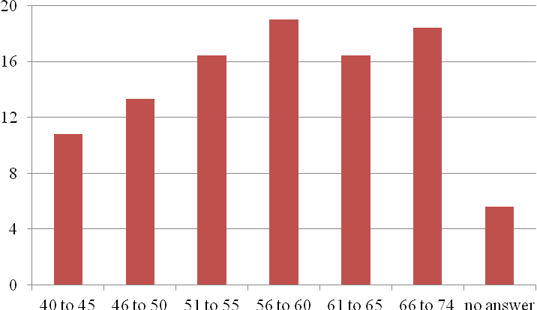

Source: Patient Survey

## Stakeholder evaluation

The stakeholder evaluation was conducted by the University of Gloucestershire. A qualitative approach was deployed to investigate the perspectives, experiences and opinions of professionals in relation to the NHS HC programme, its implementation and challenges. Stakeholders included:

1. GP Practices delivering NHS HC;
2. Other services and organisations indirectly involved in NHS HC including referral services (e.g. Health Trainers, Exercise Referral Schemes).

Purposive and snowball sampling strategies (Onwuegbuzie and Collins, 2007; Robson, 2002) were used to identify information-rich subjects relevant to the evaluation from two target audiences (Table 3). Standardised data collection tools for GP Practices delivering NHS HC (Practice Survey - Appendix H) and other services and organisations indirectly involved in NHS HC (stakeholder interviews - Appendix I) were developed in consultation with Public Health NHS Gloucestershire to ensure that the evaluation aim and objectives were addressed.

The Practice Survey was conducted using an online survey tool to aid data capture and retrieval for analysis while stakeholder interviews were recorded using a digital voice recorder and transcribed for analysis. The qualitative software package NVIVO 9 was used to manage and organise the data and facilitate inductive content analysis (Creswell, 2013) to explore participant perceptions. Data were analysed by the University of Gloucestershire, independently of the other evaluation components.

Table 3: Stakeholder evaluation methods and sample

|  |  |  |  |
| --- | --- | --- | --- |
| **Target audience** | **Description** | **Data collection** | **Total n** |
| Providers | Purposive (to ensure geographical diversity) including:   * Practice Managers (n = 14) * Practice Nurses (n = 6) * Health Care Assistants (n = 2) * GPs (n = 2) * Administrator (n = 1) | * Standardised survey questionnaire administered via telephone | 25 |
| Stakeholders | Purposive and snowball sampling (to identify knowledgeable participants) including:   * Lifestyle service managers (n = 2) * Health Trainer (n = 1) * Exercise Referral Coordinator (n = 2) | * Individual telephone interviews * Face-to-face interviews | 5 |

# Findings

## 4.0 Introduction

This section presents findings from the three evaluation strands including the Service Audit, Patient Survey and qualitative stakeholder evaluation. The section is organised around the five research questions:

1. Are NHS HC reaching the right people?
2. Are all components of the NHS HC being performed?
3. Are modifiable risk factors being identified?
4. Are people with risk factors for CVD being managed appropriately
5. What are the perceptions of patients receiving Health Checks?

Each question is addressed individually using the appropriate data from each of the three evaluation strands in order to understand the Health Check programme from the perspectives of those involved.

## 4.1 Are Health Checks reaching the right people?

The advised Search Strategy (Appendix J) is designed to help identify all people eligible for NHS HC. Primarily, these include patients aged 40-74 years old who are not on a Hypertension, Diabetes, CKD, Stroke, PVD, CHD or Palliative Care register and do not have a record of CVD or CHD 10 year risk assessment (initially Framingham or JBS, latterly QRISK, not estimated) i.e. the NHS HC eligible population. It is highly likely that some patients had been risk-scored prior to the NHS HC programme via other methods before all practice adopted the QRISK tool, hence the numbers of patients identified with CVD via the NHS HC may have been affected. Practices are encouraged to identify other at-risk individuals e.g. through screening family members of patients with existing CHD, Diabetes, Hyperlipidaemia and Rheumatoid Arthritis, opportunistic screening and healthy heart open clinics.

### 4.1.1 Eligible patients and invites

Data from the Service Audit showed that of the eligible population, 39,871 patients were invited to a NHS HC (94.7%), a -5.3% variation from the expected figure (100%, n = 42,103) for the period covered in this report. There was considerable variation in invitations across the practice cohort, the lowest rate being 0%, the highest being 427.5% of the 1/5th eligible target number (Figure 5).

### 4.1.2 Uptake

Just under half of the eligible patients received a NHS HC (49.8%, n = 20,973).This represented a variance of -25.2% from the national expected (75%, later revised down to 50% in 2013). There was considerable variation in uptake across the practice cohort, the lowest being 0% of those targeted for invitation, the highest 168.8% (Figure 5). One practice recorded 100% uptake and five reported uptake exceeding 100% and a lack of consistency is apparent in invitation strategies whereby practices are both over and under-inviting patients and recording inconsistencies.

The relatively low uptake (i.e. patients that received an invite and attended the NHS HC) might be attributable to a number of factors including the smaller than expected sample, proactive work being undertaken by other services, and practices not consistently following the NHS HC search strategy on the PCCAG website or using the correct codes (see Section 4.2.1).

*Ineligible patients*

In total, 5.3% (n = 1,179) of patients who received a NHS HC were classified as ineligible (excluding duplicate clients) based on the search strategy.

Figure 5: Health Checks invitations and uptake

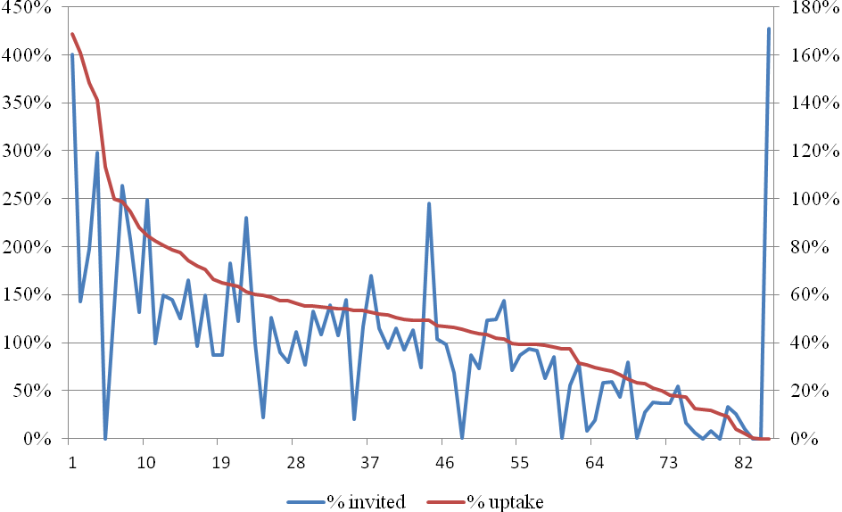

### 

Practice cohort

### 4.1.3 Patient gender and age

The Service Audit revealed that just over half those who received a NHS HC were female (54.8%, n = 11,487) compared to males (45.2%, n = 9,486). We were surprised to find that patients aged 45-49 years old (n = 3,622) accounted for the largest proportion of those who had received a Health Check for both females (9.6%, n = 1,999) and males (17.4%, n = 1,623). This might reflect an approach in which GPs are inviting younger patients first. The number of patients taking up the NHS HC declined steadily across the age spectrum although there was a noticeable spike for patients aged 60 – 64 years old, particularly females (Figure 6). Females consistently outnumbered males across all age groups.

Figure 6: Number of Health Check completions according to age and gender

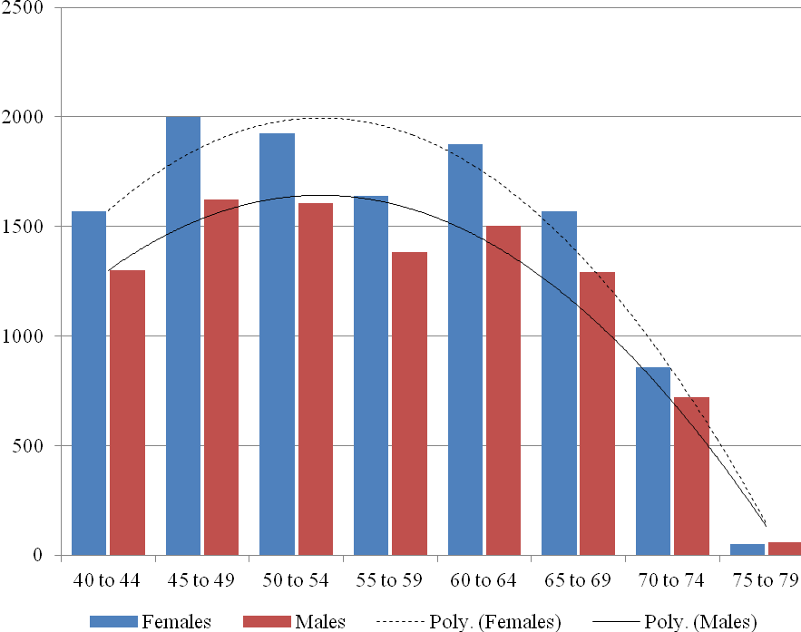

Polynomial (Poly) trend lines are used as a useful means of displaying fluctuations in data. Source: Service Audit.

### 4.1.4 Ethnicity

Nearly two-thirds of eligible patients (65.9%, n = 13,766) who received a NHS HC had their ethnicity recorded. The overwhelming majority were British or Mixed British (94.8%, n = 13,055). A full breakdown of respondent ethnicity is provided in Table 4 and demonstrates that BME groups are underrepresented in the data.

Table 4: Ethnicity of patients

|  |  |  |
| --- | --- | --- |
| **Ethnicity** | **%** | **(n)** |
| British or Mixed British | 94.8% | (13,055) |
| Other a | 2.1% | (289) |
| Asian b | 0.67% | (92) |
| Black / African c | 0.51% | (70) |

Data presented for those who had ethnicity recorded at the NHS HC. a Includes; any other white background, Irish, Chinese, any other mixed background, other Ethnic Groups, Mixed. b Includes; Asian or Asian British, any other Asian background, Indian, White and Asian, Pakistani, Bangladeshi. c Includes; White and Black Caribbean, Caribbean, Black or Black British, African, White and Black African, Any other black background.

Source: Service Audit.

### 4.1.5 Deprivation and uptake

There was a small negative and non-statistically significant correlation (*r* = -.143, *p =* .192)[4]between uptake and deprivation across the cohort of 85 GP practices (Figure 7)[5]. Due to lack of data, deprivation could not be measured at an individual level which may mean that there was inter-practice variation.

Figure 7: Deprivation and uptake of Health Checks

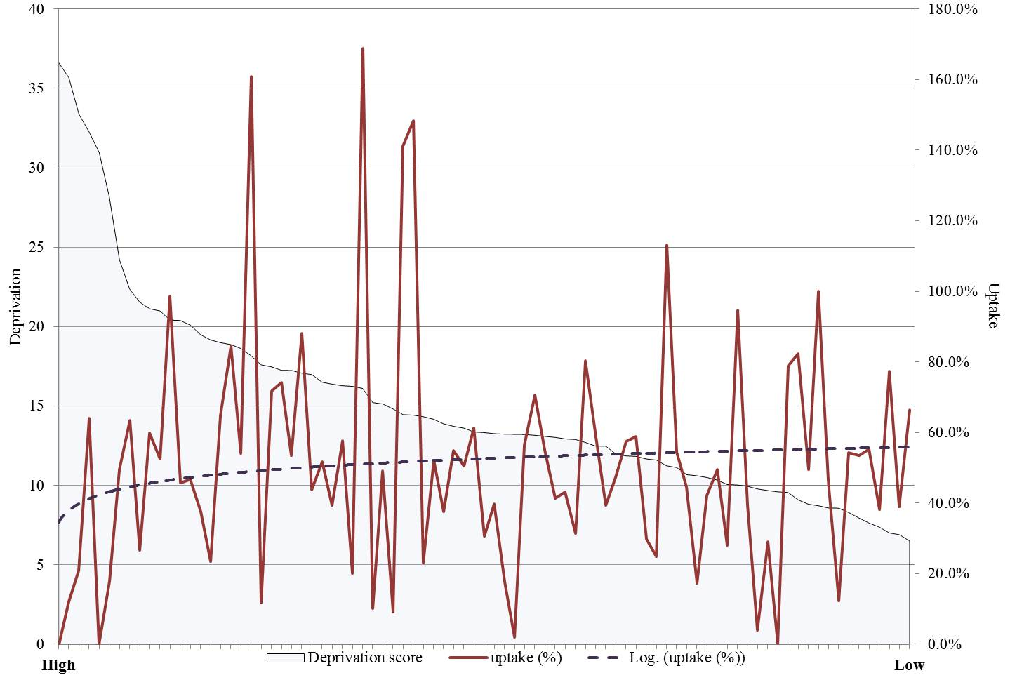

Source: PHIU, 2012.

Responses to the Patient Survey provide additional information concerning the demographic makeup of patients that received a NHS HC. There was variation in response rates across the GP clusters with the highest being Berkeley and South Cotswold clusters, the lowest for Stroud and North Cotswold. The experience of patients from Tewkesbury, South Cotswold and Cheltenham clusters is over-represented in the sample whilst Gloucester City and Berkeley cluster patients are under-represented in the sample. This is concerning given that it is known that residents living in these areas face a number of health inequalities whereby life expectancy is lower for men women in the most deprived areas and there is a higher than average incidence of adult obesity and diabetes (Department of Health, 2012b).

Responses were fairly evenly split across the five quintiles of Practice Deprivation, patients in the highest quintile (Q1-most deprived) accounting for 18.4% (n = 184), those in the least (Q5) accounting for 19.3% (n = 193). Q2 was the least represented deprivation quintile (15.6%, Figure 8).

Figure 8: Quintiles of deprivation: Patient Survey

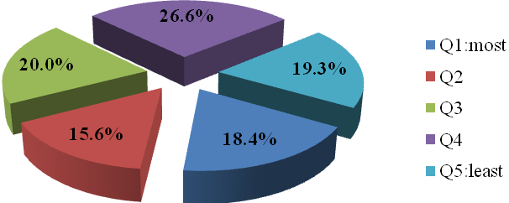

Source: Patient Survey. Practice rather than individual level data is presented.

Patient Survey data demonstrated that the most deprived quintile (Q1) accounted for 18.4% (n = 184) of survey respondents. Within Q1, non-White British respondents were over-represented accounting for 39.5% of the total non-white British population compared to 7.4% of White British respondents. A comparison of deprivation and age groups revealed that approximately 25% of those living in the most deprived areas are 66 - 74 years old (Figure 9), suggesting that older aged people might be disproportionately affected by high deprivation.

Figure 9: Patient ages and quintiles of deprivation (%)

Source: Patient Survey.

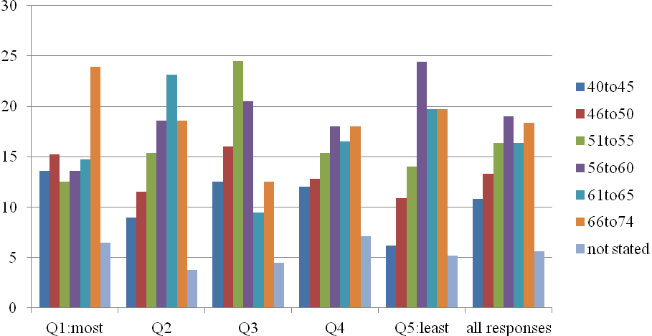

### 4.1.6 Deprivation, invitations and completions

The Service Audit data (Figure 10) showed that although the total population eligible for NHS HC were split relatively evenly across the five quintiles of Practice Deprivation, invitation rates varied, ranging from 13.7% (Q5) to 18% (Q3). Patients in Q5 had the highest rate of NHS HC completion (41.3%, n = 2,499), but those in Q1 showed the lowest (29%, n = 1,773), suggesting that uptake is highest in the least deprived quintile.

Figure 10: Invitations and completions according to deprivation (n)

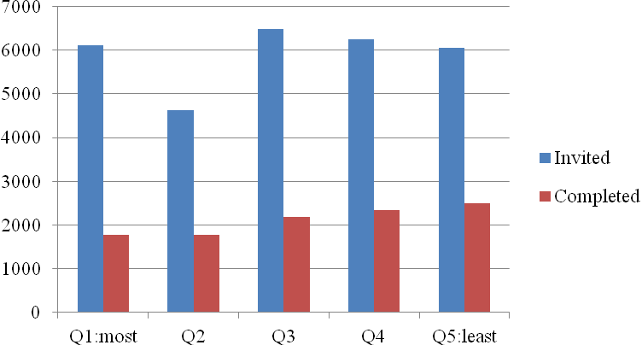

Source: Service Audit.

## 4.2 Are all components of the NHS Health Checks being performed?

This section assesses the performance of key components of the NHS HC care pathway including patient invitations, risk assessments and signposting or intervention.

### 4.2.1 Patient identification and invitation

The Service Audit revealed that the majority of patients eligible for a NHS HC were invited (94.7%). Four practices recorded no invites but did in fact carry out NHS HC, uptake ranging between 0.2% and 113.1%, suggesting that in some instances patients were being invited but not necessarily coded correctly.

Table 5 presents data for the numbers of eligible patients who received a NHS HC and who received first and second letter invitations, in addition to telephone and verbal invitations.

Table 5: Breakdown of NHS HC invitations

|  |  |  |
| --- | --- | --- |
| **Invite** | **%** | **(n)** |
| Patients with 1st invite code | 80.4 | (16,873) |
| Patients with 2nd invite code | 28.9 | (6,065) |
| Patients with telephone invite code | 0 | (0) |
| Patients with verbal invite code | 2.8 | (591) |
| Total patients invited | 84.2 | (17,671) |
| Total patients not invited | 15.7 | (3,302) |

Source: Service Audit.

Practice Survey data showed that respondents perceived age-based search and invitation strategies the most commonly approach followed by opportunistic approaches. Random was the approach least used (Figure 11).

Figure 11: Invitation strategies adopted by practices (%)

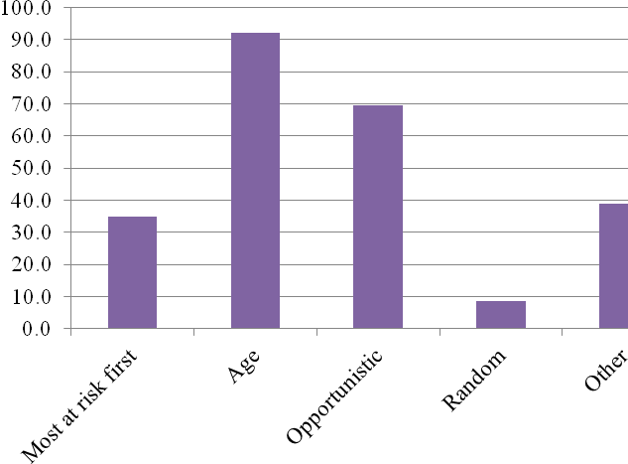

Source: Practice Survey.

Data from the Practice Survey showed that practices employed a range of approaches for inviting patients to NHS HC including age based approaches; ‘*we’re working in descending order*’, and alphabetical approaches; ‘*we work on an alphabetical approach based on the search results*.’ Opportunistic approaches were highlighted by a number of respondents; ‘*we identify patients when attending for other appointments*’, and; ‘*we review new patient checks, chronic disease management patients and INPS clinical system*.’

One respondent highlighted that they had merged existing practice processes with the NHS HC care pathway; ‘*there was a similar in-house system established before NHS HC which meant a number of patients had already been scored. Following this we now select invitees based on risk score*.’ Whilst this was a single isolated example of a practice not following the contracted approach, it suggests there is a more general need to support practices in understanding the pathway, its requirements, and correct delivery of the NHS HC.

One concern highlighted by a Practice was that it was not always possible to identify patients due to a lack of information ‘*a lot patients do not fill out the questionnaires properly in order for us to pick them out’*, although this was an isolated comment. In contrast, a common issue was that it was the ‘worried wells’ who tended to be most interested in the NHS HC; ‘*we tend to have patients who show an interest in their health and so see them quite a lot, especially ones with existing chronic diseases.*’This highlighted the difficulty in engaging with patients who were potentially able to receive the most benefit from a NHS HC rather than those who frequently or routinely attended their surgery. We noted that, in response to this issue, practices periodically reviewed who they knew they hadn't seen and then sent invites in order to address this issue.

### 4.2.2 Equipment

The Practice Survey assessed the type of equipment and services used to support the delivery of NHS HC. Key elements of the NHS HC pathway include the use of:

1. Electronic BP monitors;
2. Near patient testing;
3. Laboratory services;
4. Vital signs equipment (e.g. pulse, respiratory rate);
5. Waist measurement tape.

Laboratory services (91.3%, n = 23) were most frequently used while Near Patient Testing (54.2%, n = 13) was the least used (Figure 12). Near Patient Testing is not a component of the NHC HC and the data suggest that contrasting levels of understanding of the NHS HC pathway between, or within, practices in Gloucestershire.

Figure 12: Equipment and services used in Health Checks

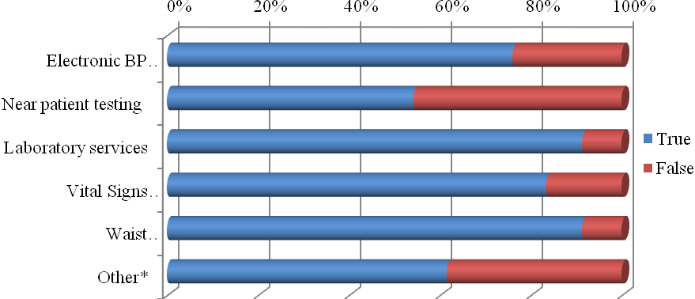

* Responses (n = 8, ‘yes’: Practice Manager = 3; Practice Nurse = 2; GP = 1; Health Care Assistant = 1; Administrator = 1) included: Additional range of blood tests not normally completed for Health Check; BP, height, pulse; Electronic scales; C02 analyser; Vitaligraph, ECG; Weighing scales; Height measure.

Source: Practice Survey.

Practices were also asked about how well they thought they were doing in delivering aspects of the Health Check (using a 5-point scale, 5 = very well). The results showed that practices were most confident in first appointments (*Mean* = 4.12, *SD* = .60), invitations (*Mean* = 4.04, *SD* = .79) and laboratory tests (*Mean* = 4.04, *SD* = .79), and less confident in second appointments (*Mean* = 3.52, *SD* = 1.3), risk communication (*Mean* = 2.68, *SD* = .1.8) and changing behaviours (*Mean* = 2.44, *SD* = 1.6). The data would appear to suggest that there is a level of uncertainty concerning the delivery of certain aspects of the NHC HC programme and a need for further training in the pathway and its requirements.

### 4.2.3 Blood tests (pre visit)

The NHS HC protocol involves a pre-NHS HC visit to the practice in order for a blood test to assess lipids, blood glucose and Serum Creatinin and includes a pre-assessment Health Check questionnaire (Appendix A).

*Cholesterol blood tests*

The Service Audit data showed that just under one third (29.1%, n = 6,106) of eligible patients had NHS HC and cholesterol blood tests done on the same date rather than on separate visits to the practice. This means that the QRISK score could not be calculated correctly and would default to the average cholesterol of 5. Several practices (n = 9) returned high rates (>80%) of Health Check and cholesterol blood test done on the same date, suggesting that the NHS HC care pathway is not being followed. It is stipulated that blood tests should be done 7-10 days before the NHS HC so blood test results have been received in order to accurately calculate the QRISK score.

It is possible that some practices are electing to conduct the Health Check and cholesterol blood test at the same time or that there are issues with automatic invites which result in difficulties in attending for patients. As such, it is evident that the NHS HC care pathway needs to be reinforced to ensure that the correct protocols are being followed and opportunities for patients to discuss disease risks are maximised. In this respect, Near Patient Testing (NPT) might provide a useful means of improving the NHS HC programme in that it can: reduce the number of visits required to complete the Health Checks process; improve uptake by providing a quicker and more convenient service for patients, and reduce the workload on Practices.

*Blood Glucose*

Service Audit data showed that 6,106 (29.1%) patients had their blood tests done on the same day as their NHS Health Check which meant that fasting blood glucose or HbA1c could not be calculated as these tests need to be performed up to one month prior to NHS Health check date (i.e. not on the actual date of the NHS HC appointment). This is concerning as it potentially indicates that practices are failing to follow the NHS HC care pathway and are not giving patients the opportunity to discuss assessment results with GPs.

### 4.2.4 Risk assessments

The first NHS HC appointment is an essential component that provides an opportunity to assess and discuss patients’ risk factors for CVD.

*QRISK*

In total, 71.9% (n = 15,086) of patients had a QRISK score recorded as part of their Health Check.[6] Of these patients 9.1% (n = 1,372) were classified with a QRISK score of 20 or above (or 6.5% of the total eligible population).

*Family history*

The Service Audit showed that approximately one-third (34.4%, n = 7,213) of patients had a family history of CVD or CHD recorded as part of their Health Check while 17.5% (n = 3,662) had a family history of diabetes recorded.

*Waist circumference*

The proportion of non-ACJ (Asian, Chinese, Japanese) and ACJ patients who had a waist circumference measured as part of their NHS HC was about the same (62.7%, n = 11,411 and 65.2%, n = 178 respectively).

Table 6 highlights Service Audit data for risk assessments (first NHS HC appointment) consistent with elements of the NHS HC care pathway. Risk assessments for smoking, cholesterol and blood pressure are critical for calculating patient CVD risk scores. Hence, a low or sub-optimal rate of these being performed is a concern and it could be suggested that practices should review performance in these areas.

*Cholesterol*

While cholesterol was assessed as part of the Health Check i.e. it was one of the risk assessment components, patient data for cholesterol levels was not analysed because the evaluation was focused on NHS HC processes. As such, data are only presented for risk assessments performed.

Table 6: Risk assessments performed

|  |  |  |
| --- | --- | --- |
| **Assessment** | **%** | **(n)** |
| Physical activity | 87.8 | (18,408) |
| Diet | 84.2 | (17,656) |
| Smoking | 83.2 | (17,447) |
| Cholesterol | 75.7 | (15,883) |
| Blood Pressure | 70.8 | (14,858) |
| Waist Circumference (ACJ patients a) | 65.2 | (178) |
| Waist Circumference (Non ACJ) | 62.7 | (11,411) |
| Pulse b | 60.8 | (12,760) |
| Alcohol | 53.9 | (11,294 ) |
| Fasting Blood Glucose | 38.8 | (8,132) |
| (Non-Fasting Blood Glucose / unknown) | 6.9 | (1,466) |
| HbA1c c | 1.3 | (269) |

a ACJ = Asian, Chinese, Japanese. b Refers to post-NHS HC (including NHS HC date) as MIQUEST queries only pick up the latest pulse rate, so this may not be the pulse rate done at the NHS health check. c While HbA1c is not mandatory it is considered best practice to offer all patients the test. This is being introduced via a stepped approach.

Source: Service Audit.

While Patient Survey data revealed a similar pattern concerning perceptions of many of the risk assessments performed, there were clear disparities for blood pressure, blood glucose and alcohol (Figure 13). These data might suggest that practices are not following the NHS HC care pathway correctly or not using the PCCAG template. A further explanation may be that not all patients who receive a NHS HC are necessarily clear on the nature of risk assessments being performed and interpret the appointment differently.

Figure 13: Comparison of Service Audit and Patient Survey for risk assessments (%)

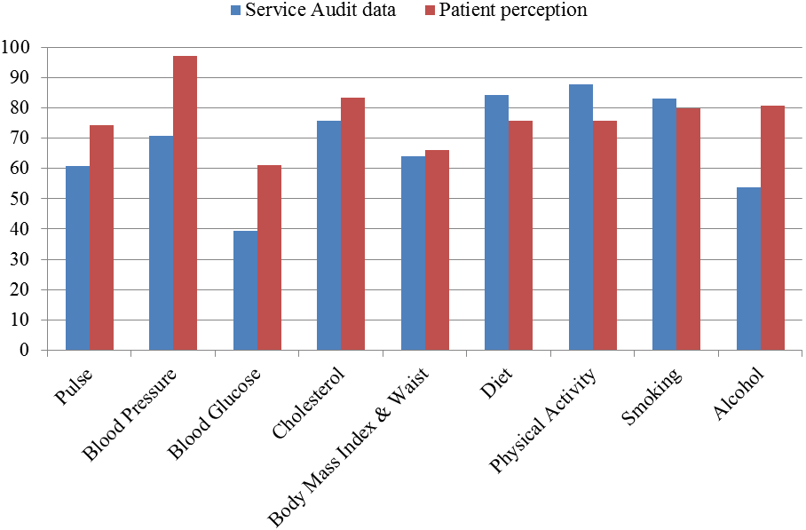

Source: Service Audit / Patient Survey

## 4.3 Are modifiable risk factors and diseases being picked up?

Identifying modifiable risk factors and CVD is a core objective of NHS HC to help people change these before damage is done, as well as identifying patients with existing disease who need medical treatment. These include:

1. Current smoker
2. Low levels of physical activity
3. BMI over 30 or waist circumference over 94cm for men and 88cm for women (90cm and 80cm respectively for patients from the Asian sub-continent)
4. Hypertension
5. Hyperlipidaemia
6. Alcohol intake significantly above recommended levels
7. Diabetes
8. Arrhythmia
9. CKD

4.3.1 Identification of risk factors

Table 7 highlights the relative rates of modifiable risk factors picked up during the NHS HC. Comparisons with expected figures are made where possible.

A number of practices reported that a key benefit of the NHS HC programme was the ability to identify risk factors for Diabetes and to manage these appropriately. It is not known whether this was a genuine benefit or due to other factors for example, because of a higher rate of incidence in a particular area or due to possible inconsistencies in the delivery of the NHS HC care pathway. Further confounding factors might be the differences in base cohort for which this report covers and the effect of other primary care services in identifying patient CVD risks.

### 4.3.2 Actual versus expected identification of risk factors

Table 7 shows that actual rates for risk factors were lower for all indicators for the period under assessment. The largest difference was for hypertension where the rate identified in patients was approximately 20% less than expected although 45.5% (n = 234) of those diagnosed with hypertension since their NHS health check had lifestyle advice recorded as part of their NHS Health check.

**Table 7: Identification of risk factors (actual vs. expected)**

|  |  |  |  |  |  |  |
| --- | --- | --- | --- | --- | --- | --- |
| **Risk factors/CVD** | | **Actual** | | **Expected** | | **+/-** |
| **%** | **(n)** | **%** | **(n)** |
| Low PA a | | 7.1 | 1,490 | 64.8 | 17,576 | -57.7 |
| Hypertension b | | 7.9 | 1,663 | 27.8 | 7,549 | -19.9 |
| Smoking | | 9.3 | 1,942 | 23.6 | 6,416 | -14.3 |
| Obesity | | 15.5 | 3,255 | 22.6 | 6,132 | -7.1 |
|  | BME patients (BMI = ≥ 25) c | 30.3 | (132) | - | - | - |
|  | Non BME patients (BMI = ≥ 30) d | 17.4 | (3,123) | - | - | - |
| Raised Fasting Blood Glucose | | 275 | 1.3 |  | 1,139 | -2.9 |

a While the Ready Reckoner uses a dichotomous division to define Inactive and Active patients, the Service Audit employs classifications based on Good, Average or Poor. The table above compares Inactive and Poor, and hence does not necessarily make a meaningful direct comparison. b Hypertension represents both a risk factor and CVD diagnosis. c Based on total BME (Black and Minority Ethnic) population (n = 435). d Based on total non-BME population (n = 17,923). Source: Service Audit.

## 4.4 Are people with risk factors for CVD being managed appropriately?

This section reviews data relating to referrals to services as a result of attending a NHS HC. The provision of lifestyle advice, signposting and referral to services and appropriate drug therapy is an integral component of the NHS HC programme, particularly for high risk patients (those with a QRISK score of > 20%). It is recommended that patients whose CVD risk score is between approximately 10-19% and who have one or more lifestyle risk factors should be offered lifestyle advice and referred appropriately to local public health interventions.

### 4.4.1 Referrals to services

Table 8 presents Service Audit data for those patients who received advice or were referred to services following the risk assessment.

Table 8: Referrals to services

|  |  |  |  |
| --- | --- | --- | --- |
| **Risk factor / service** | **Referral population\*** | **%** | **(n)** |
| Health Trainer | Patients with identified lifestyle issues a | 74.1 | (123) |
| Smoking | Current smokers | 66.6 | (1,300) |
| Diet | Patients with poor/average diet | 47.9 | (6,392) |
| Physical activity | Low to moderate grading | 44.2 | (6,830) |
| Alcohol | High Audit C / FAST (= ≥ 5) | 43.8 | (1,153) |
|  | Medium Audit C / FAST (3 or 4) | 0.7 | (17) |
| BMI | Non-BME with BMI = >30 | 41.2 | (1,287) |
|  | BME with BMI = >27.5 | 31.1 | (41) |
| GP | Patients referred to GP | 3.0 | (631) |

* Figures are based on the total population of each respective risk factor. a The percentage referred to Health Trainer is deceptively high given the small number of patients with lifestyle issues referred to a Health Trainer recorded as part of their NHS Health Check. Source: Service Audit.

The Service Audit showed that in total, no patients with a lifestyle issue were seen by health trainer recorded as part of their NHS Health check (up to 2 months post NHS Health check date). This might be attributable to problems with recording or coding patient progress or that information is not being fed back by the health trainer to the GP after patients have been seen by the Health Trainer.

The Patient Survey highlighted that 13.2% (n = 132) of patients were referred to a Doctor, 3.8% (n = 38) to Stop Smoking services and 0.7% (n = 7) to Alcohol services. Taking this finding in conjunction with Service Audit data which revealed that 0.7% of patients with an Audit C or FAST value =>5 (hazardous or harmful drinking) received an alcohol referral suggests that improvements are needed in the management of patient with dangerous levels of alcohol consumption although it is recognised that the low numbers could be due to practices not following the care pathway or not using the PCCAG template. Overall, referrals to a Health Trainer were minimal (1.6%, n = 16) but it is known that Health Trainers work specifically with population groups experiencing high levels of deprivation and so the service is not equal across the county.

Smoking referrals were proportionally greater in number than Health Trainers, indicating that the majority of smokers (66.6%, n = 1,300) received advice or a referral as part of the NHS HC. Numbers for diet and physical activity referrals were the greatest overall.

Results from the Practice Survey indicated that the majority of practices (83.3%, n = 20) were confident that the patients referred for lifestyle services had received the service although there was a degree of uncertainty for some Practice Survey respondents who ‘*couldn’t really say*’ if patients had received the services they had been referred to. Other respondents identified local challenges in referring including a lack of nearby lifestyle services and the distance to local healthy living centres, suggesting that local contextual factors played a key role in the use of referral services.

### 4.4.2 Actual versus expected referrals or treatment

Service Audit data was compared with the Health Check Ready Reckoner tool to explore differences between data expected and actual referrals or treatment. Four direct comparisons were possible using the available data (Table 9).

**Table 9: Expected versus actual referrals / treatment**

|  |  |  |  |  |  |
| --- | --- | --- | --- | --- | --- |
| **Referrals / treatment** | **Actual a** | | **Expected b** | | **+/-** |
| **%** | **(n)** | **%** | **(n)** |
| Smoking c | 6.2 | (1,300) | 2.3 | (622) | + 3.9 |
| Statin d | 7.9 | (1,662) | 5.0 | (1,367) | + 2.9 |
| Antihypertensive | 5.8 | (1,219) | 3.1 | (853) | + 2.7 |
| PA intervention | 32.5 | (6,833) | 31.4 | (8,526) | +1.1 |
| Weight loss | 6.3 | (1,328) | 9.0 | (2,450) | -2.7 |

a Based on actual uptake (n = 20,973). b Based on expected uptake (n = 27,114). c It is known that an effective smoking cessation service is operating in Gloucestershire. d Data refer to whole NHS HC population. Statin prescriptions for high risk patients (n = 1,372) were 29.3% (n = 403). Source: Service Audit.

The recommended first line of treatment for high cholesterol is lifestyle modification through a process of managed change for patients with risk scores above and below 20%. Compared with expected figures, the data suggest that Statins are being oversubscribed, as are antihypertensives. This finding suggests there is need for further investigation in this area in order to assess the precise nature of prescriptions i.e. who received them and in what circumstances.

Weight loss referrals were marginally less than expected although it should be noted that there was a lack of weight management services over the period covered by this report and significant service developments are now in place.

### 4.4.3 Perceived quality of referral services

Respondents to the Practice Survey expressed a range of views concerning referral services linked to the NHS HC programme. Five referral services were assessed including:

1. Weight management
2. Smoking cessation
3. Alcohol services
4. Health Trainer
5. Other

Analysis revealed differences in perceptions across the five referral services with smoking cessation being rated the best (*Mean* = 4.43, *SD* = .59). Health Trainers were also well thought of (*Mean* = 4.13, *SD* = .83) but responses were low (n = 8), and it was clear that many respondents were not aware of what Health Trainers were (Table 10). Weight management (*Mean* = 3.76, *SD* = .90) and alcohol services (*Mean* = 3.76, *SD* = .90)were the least rated services. Several respondents to the Practice Survey revealed that smoking cessation services and support was provided ‘in-house’ and that this was perceived as more effective in supporting patients to reduce or stop smoking than using local services.

Table 10: Practice perceptions of referral services

|  |
| --- |
| **Referral area / comments** |
| **Weight management** |
| * Criteria for [Health Checks] are too restrictive i.e. BMI of 42* |
| * Don't know |
| * In house & referral to community Health Trainers |
| * Long waiting times to access services |
| * Not involved |
| * Not sure about, rarely if ever used |
| **Smoking Cessation** |
| * Have 3 internal advisors |
| * In house & Glos stop smoking service |
| * Not sure about, rarely if ever used |
| **Alcohol (Independence Trust)** |
| * Don't know |
| * Long waiting times, protracted process |
| * Not sure about, rarely if ever used |
| * Not used |
| * Pass to specialist GP to review & refer to GDAS if necessary |
| **Health Trainer** |
| * Don't know what these are |
| * Don't use |
| * Don't use - not available |
| * Not heard of |
| * Not involved |
| * Not used / unaware of service |
| * Refer to community health trainers and / or to local gym via exercise referral programme |
| * Referrals have been refused due to level of deprived |
| **Other (i.e. local authority services)** |
| * ERS |
| * Healthy lifestyles |
| * Work with local leisure centre schemes e.g. exercise on prescription |

Same or similar responses are combined. Source: Practice Survey. * This comment demonstrates a misunderstanding of the NHS HC because a patient with a BMI this high should be clearly be referred to specific weight management or secondary care services.

### 4.4.4 High risk patients and CVD diagnoses

NHS HC provide a means of identifying high risk patients (those with a QRISK score of >20%or more, in addition to any underlying conditions detected e.g. CKD). The development and implementation of a practice protocol for follow up is recommended in order to assist with the management of CVD and disease risks.

*High risk patients*

Results from the Service Audit revealed that of those patients with a QRISK score (n = 15,086), 9.1% (n = 1,372) had scores of 20% or more (6.5% of the eligible population that received a Health Check). Service Audit data (June, 2012) was retrieved to investigate the association between age and CVD risk. The data showed that the majority of high risk patients were those aged 65-74 years old (Figure 14). A Chi-square test for independence indicated a statistically significant association between age and CVD risk, χ2 (3, *n* = 4,103) = 1048.3, *p* = < 0.05, *phi* = .50. Further, it was apparent that a relatively large number of patients aged 55-64 were classified with a medium CVD risk score suggesting that a higher number of patients in the future will potentially be classified with a high CVD risk classification as they grow older.

Figure 14: Age and CVD risk (n)

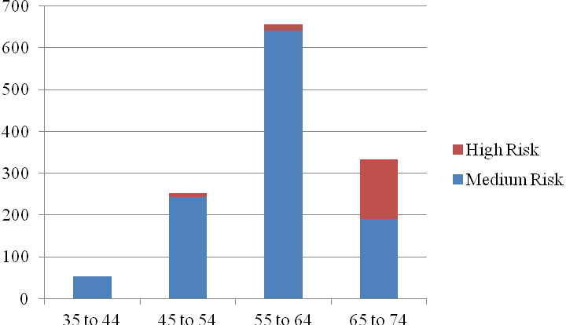

Source: Service Audit

Age group

.

*Diagnoses*

Of the total eligible population, 4.9% (n = 1,031) were diagnosed with a CVD / diabetes diagnosis (Table 11).

Table 11: CVD / diabetes diagnoses and outcomes post Health Check

|  |  |  |
| --- | --- | --- |
| **Diagnosis** | **%** | **(n)** |
| Hypertension | 2.4 | (514) |
| Chronic Kidney Disease | 1.2 | (258) |
| Diabetes | 0.90 | (188) |
| Atrial Fibrillation | 0.17 | (35) |
| Coronary Heart Disease | 0.10 | (22) |
| Myocardial Infarction | 0.02 | (5) |
| Peripheral Vascular Disease | 0.02 | (5) |
| Transient Ischaemic Attack | 0.02 | (5) |
| Heart Failure | 0.00 | (1) |

Source: Service Audit.

### 4.4.5 Actual versus expected CVD / diabetes diagnoses

Three direct comparisons between expected and CVD / diabetes diagnoses were possible using the available data. Diagnoses were between 0.04 and 19.9% less than expected (Table 12).

Table 12: Actual versus expected CVD / diabetes diagnoses

|  |  |  |  |  |  |
| --- | --- | --- | --- | --- | --- |
| **Condition** | **Actual** | | **Expected** | | **+/-** |
| **%** | **(n)** | **%** | **(n)** |  |
| Hypertension | 7.9 | 1,663 | 27.8 | 7,549 | -19.9 |
| CKD | 1.2 | 258 | 2.1 | 580 | -0.9 |
| Diabetes | 0.9 | 188 | 0.86 | 233 | -0.04 |

Source: Service Audit

## 4.5 Perceived impact of Health Checks

This section highlights data that was extracted from the three evaluation strands (Service Audit, Patient Survey, Stakeholder evaluation) concerning perceptions of NHS HC impact.

### 4.5.1 Are the Health Checks preventing premature CVD?

Data from the Practice Survey showed that nearly three quarters of respondents (72%, n = 18) perceived that NHS HC were preventing premature CVD. Follow-on comments revealed a mix of positive and less certain perspectives concerning overall effectiveness, some of which are provided as examples in Figure 15.

Figure 15: Practice perceptions of Health Check effectiveness in reducing CVD

Source: Practice Survey.

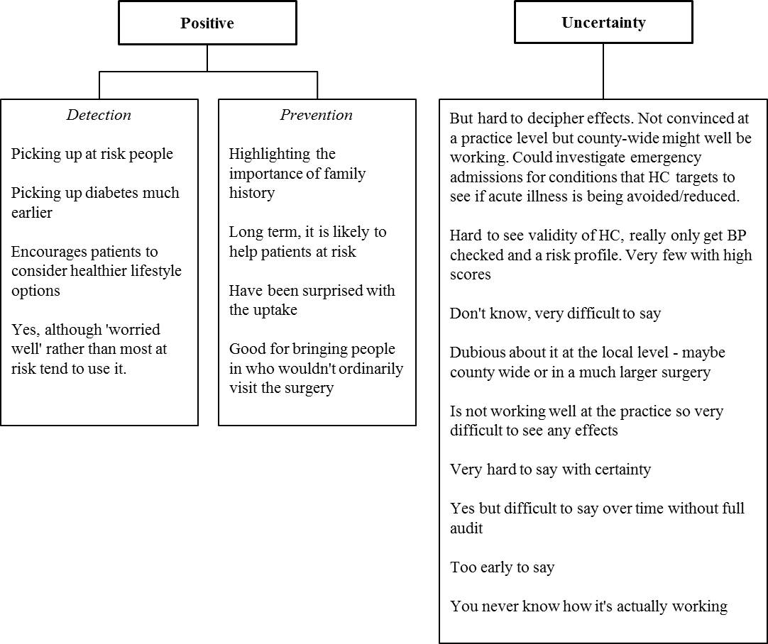

### 4.5.2 Workforce impact and development

The majority of NHS HC providers (96%, n = 22) estimated that between 1% and 25% of their job involved NHS HC, 80% (n = 20) of respondents were practice managers or practice nurses who had been involved in NHS HC since the inception of the programme, or for at least 10 months. However, the majority of the Practice Survey sample were Practice Managers (56%, n = 14) which is likely to have impacted the results in that Practice Managers are generally only involved in administration rather than direct delivery.

*Training*

More than two-thirds (70.8%, n = 17) of Practice Survey respondents indicated that they had training in CVD prevention and 45.8% (n = 11) indicated that they required further training. This suggested that for some practitioners there was a perceived shortfall in skills and expertise required and a need to continually refresh knowledge and practice for others. Requests for Continuing Professional Development (CPD) were recommended to ensure NHS HC service delivery was effective, as were updates concerning the type and availability of lifestyle services. Further suggestions included CVD knowledge updates and additional training in motivational interviewing techniques.

*Practical issues*

Whilst key documentation for NHS HC advises practices to identify a CVD GP lead, results from the Practice Survey revealed that 3 of the 25 Practices had not done so, all of whom had been involved in the programme since its inception. Approximately 40% of Practice Survey respondents indicated that there had been issues with staffing levels. For some, this was recognised as a normal pressure in the surgery although some respondents attributed staffing issues to the extra workload created by the NHS HC: ‘*NHS HC generates a huge workload for our staff in addition to what we do, a roughly 20% additional workload*’, and ‘*NHS HC has generated a lot of extra work for the practice.*’ One practice highlighted that the administrative system behind the NHS HC had to be well-designed in order to schedule time for follow ups and ensure availability. This necessitated a need to be flexible in terms of the times offered for patients and effective forward-planning of the service.

It was clear that contextual factors including practice size were perceived to influence practice workloads: ‘*NHS HC does place additional pressure on the team when patients respond to invites as we are only a small practice.*’ However, it was evident that some practices modified their systems and procedures to better manage the NHS HC, with one respondent stating that they had taken on a Health Care Assistant to cover the main NHS HC work as it didn't initially need input of GPs or Practice Nurses. Here, it was noted that NHS HC created work in terms of invites and then following them up and conducting the assessments, but they were looking to modify or streamline the system so a second appointment was not necessary, although didn’t know how this would be done. This suggests that there are potential issues at the practice level which need addressing in order to improve the efficiency of the NHS HC pathway.

### 4.5.3 What works well?

Practice Survey respondents identified a number of areas that were perceived to work well, particularly in relation to: early detection; the ability to offer one-to-one consultations, and time to discuss patient health and lifestyles (Table 13). These provide useful evidence in demonstrating the efficacy of the NHS HC programme in identifying at-risk patients and help to mitigate resistance towards the programme that was apparent early on in its development.

Table 13: What works well?

|  |
| --- |
| **Theme / comments** |
| **Early detection** |
| * Alerting patients about lifestyle issues. Can reassure or motivate to change |
| * Engaging with people who don't visit surgery regularly. Doctor's invites are more compelling |
| * Early detection |
| * Ability to see/assess people who don't normally attend the surgery and then identify and treat issues |
| * Increasing patient awareness of risks and being able to undertake 'spot checks'. |
| * Getting patients in that we don't normally see |
| * Early prevention - catching things early, getting non-regular patients to come in (seems to be working with those actually most at risk rather than just worried-well) |
| * Screening and support system |
| **Consultation** |
| * Face to face help, support and encouragement without being judgemental |
| * Good for encouraging people to come in for an assessment that isn't necessarily about illness or health problems, plenty of time to talk with PN and feel reassured by thoroughness of the session |
| * Bringing infrequent visitors into the surgery, good for passing on lifestyle advice, opportunity for longer discussion with patients |
| * Helps develop/maintain rapport and communication with patients |
| * Informal one-to-one consultations |
| * Consulting with people that might not ordinarily attend practice |
| * Being able to dedicate nurses' time to consultations allows for discussion/rapport with patients and better communication of info |
| **General comments** |
| * QRISK score gives something to look at and understand in real terms |
| * For men, being given a 'number' to focus on is useful. Advice is more important for women |

Source: Practice Survey.

### 4.5.4 What needs improving?

Data from participants in the stakeholder interviews and Practice Surveys were reviewed to produce a composite picture of challenges in delivering the NHS HC programme. A number of themes emerged from the analysis and are presented in the conceptual diagram (Figure 16). The diagram highlights key themes that it was felt could be addressed in order to improve the NHS HC programme. The outer circles represent two key themes emerged through data analysis (implementation and referral network). The central overlapping area represents a convergent theme (clarity). Sub-themes which represent participants’ perceptions are presented on the outside of the main themes and include participant comments for further explanation of the themes.

*Referral system*

A key issue was the difficulty in tracing patients from NHS HC into referral pathways. For example, those overseeing local exercise referral schemes could not state with any degree of certainty whether a patient that presented for exercise services had been referred as a result of a NHS HC. It was noted that patients were not necessarily aware of the distinction between a NHS HC and a check-up, or examination, hence they did not necessarily attribute their attendance specifically to a NHS HC. As a result, whether due to capacity issues (in terms of staff time) or process issues (in terms of setting up systems to monitor patient information) it was not possible to identify new participants with a NHS HC referral or monitor them within exercise programmes.

*Health Check development*

A key concern noted by the five stakeholders (i.e. those that did not represent practices) was the lack of involvement in the development of the NHS HC programme: ‘…*not being in that structure, my impression is that the Health Check message went to GPs but then sort of stopped there and there was no follow up to say “these are the referral routes, these are the people you should be signposting to.”*’Consequently, there was concern that local lifestyle services e.g. Health Trainers were being seen as deliverers of services rather as providers of an information and signposting service. In addition, stakeholders also revealed concerns over limited resources available for running local lifestyle services which contrasted sharply with the investments being made in the NHS HC programme.

Figure 16: Health Check improvements

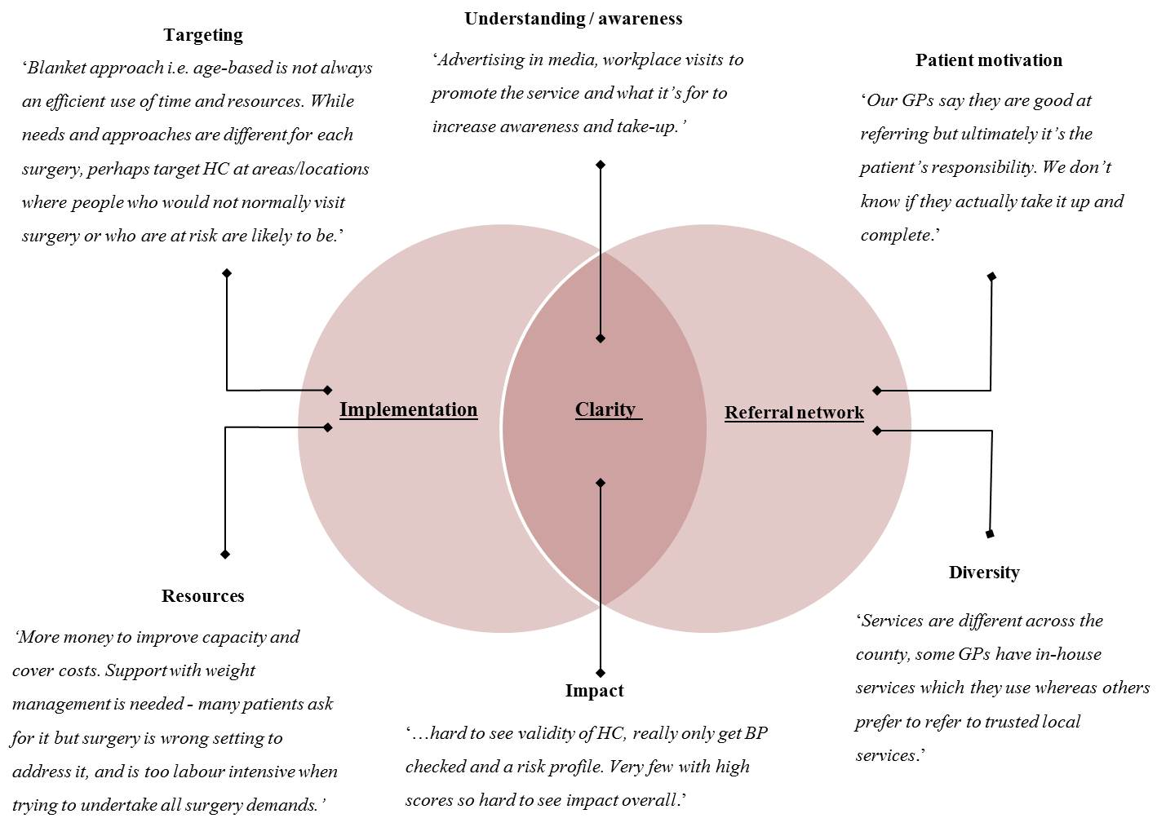

Source: Stakeholder interviews / Practice Survey.

Hence, whilst it was recognised that the NHS HC programme had the potential to positively impact the health of at-risk individuals there was a general concern that the programme needed to be better embedded and a greater level of common understanding was required concerning its place within the spectrum of local services;

‘*I don’t know what’s going on with Health Check, I don’t know if there have been any changes. Last thing I heard there were some GPs that were doing it, some weren’t. They were arguing about cost. But again, we’re not kept in the loop. If they were from the corresponding practices in our local area we would we able…to engage with GPs and talk on a regular basis about Health Trainers, and we could make Health Check part of that discussion and stress its importance. Because we don’t get any information at all, we’re just left hanging with it.’*

For clarity, key aspects of the themes and sub-themes are explained in Table 14.

Table 14: Challenges to Health Check success

|  |  |  |  |
| --- | --- | --- | --- |
| **Main theme** | | **Description** | **Sub-theme** |
|  | Implementation | The way in which NHS HC are interpreted and understood. This varied between practices and health professionals and was influenced by role, local health priorities and capacity. | Targeting: NHS HC could make more of an impact if undertaken in a variety of settings.  Resources:  Concern that NHS HC could be challenging to deliver. |
|  | Clarity | Understanding of the aim and scope of NHS HC programme and its design. | Understanding / awareness: NHS HC needs to be better promoted and marketed, including exactly what its purpose is and for whom.  Impact: Frequent and precise feedback on NHS HC impact would help identify good practice and help refine the service. |
|  | Referral network | The wider sets of services supporting healthy lifestyles. These varied across the county whose make-up and uptake were influenced by local contextual conditions e.g. resources. | Patient motivation: No referrals could be successful without. Need better tracking to follow progress.  Diversity: Engaging with GPs sometimes challenging. Variety and history of local services a source of potential confusion and perceived service duplication. |

Source: Stakeholder interviews, Practice Survey.

## 4.6 Patient perceptions

This section presents feedback acquired from patients via the Patient Survey. It is broken down into three sections covering motivation, perceived quality and whether the Health Checks were perceived as worth attending.

### 4.6.1 Motivation to attend

Concerns about health was a principal driver of attendance at NHS HC (30.5%, n = 305) followed by family history (24.9%, n = 249).

Several respondents to the Practice Survey indicated that patient motivation was critical, without which referral to healthy lifestyle services yield little benefit, despite best efforts within the practice to assist with lifestyle modification. Beyond discussing lifestyle risks and encouraging patients to consider healthier lifestyles, there were a number of concerns that patients were not necessarily motivated to make behaviour changes in the long term and that contextual factors including work and family commitments were key barriers to change. However, data from the Patient Survey was promising, indicating that 41.5% (n = 415) indicated that they had, or were going to, change their lifestyles as a result of the NHS HC.

### 4.6.2 Perceived quality of Health Checks

Data from the Patient Survey indicated that the majority (88%, n = 879) agreed that they had the time to ask questions during the NHS HC and that there were minimal general difficulties (1.5%, n = 15), language difficulties (0.7%, n = 7) or difficulties understanding (1.1%, n = 11).

*CVD risk score*

Nearly two-thirds of patients reported that they were told about their CVD risk score (64.9%, n = 648) and 61.9% (n = 558) rated their understanding of the CVD risk score highly (4 or above on a scale of 1 to 5, 5 indicating a high level of understanding).

*Advice received*

Smoking accounted for the majority of advice given (60.4%, n = 612), followed by weight (46.8%, n = 468) and exercise advice (40.7%, n = 407). Alcohol advice was the least given out (29%, n = 290).

### 4.6.3 Was the health Check worth attending?

There was strong agreement that the NHS HC was worth attending (90.2%, n = 901) and the majority of patients (91.7%, n = 805) rated the overall NHS HC experience highly, stating 4 or more (on a scale of 1 to 5, 5 indicating a very positive experience).

We explored comments from Patients who agreed the NHS HC was worth attending in order to assess their perceptions. Three themes were identified including; reassurance, information and advice, and risk detection / diagnosis. These are presented in Table 15 with illustrative comments.

Table 15: Why was the Health Check worth attending?

|  |  |
| --- | --- |
| **Theme / comments** | |
| **Reassurance** | |
|  | * After reaching 60 years the health check gave me peace of mind, thankfully all was well. |
|  | * Nice to confirm all ok |
|  | * Good to check that everything is ok |
|  | * It’s like an annual MOT for the body and may pick up things before they get too serious |
|  | * As I rarely see a doctor, it made sense to arrange a general health check |
|  | * Just in case there is something wrong |
| **Information & advice** | |
|  | * It proved to be a good warning shot! |
|  | * Good to know details so I can take action |
|  | * Opportunity to get advice on bad habits re health I'd fallen into |
|  | * This helped me realise about units of alcohol per week |
|  | * I was delighted with the advice given by the nurse I saw. I was provided with leaflets and scores and guidance |
|  | * A good chance to have any queries answered without wasting Doc's time |
|  | * I was made aware that I needed to cut down on saturated fats |
|  | * Worthwhile. I found out my risk score |
|  | * Made me more aware of my state of health |
| **Risk identification / diagnosis** | |
|  | * Picked up cholesterol problem |
|  | * Thanks to check-up high blood pressure was discovered - and steps taken to reduce |
|  | * Found out I am diabetic type 2 |
|  | * Found out my cholesterol was raised |

Source: Patient Survey.

We also explored comments from Patients who disagreed the NHS HC was worth attending. While comments from these respondents were far less numerous (6.3%, n = 61) we identified two main themes including; Health Check delivery and lack of feedback. Further detail is presented in Table 16 with illustrative comments.

Table 16: Why was the Health Check not worth attending?

|  |  |  |
| --- | --- | --- |
| **Theme / comments** | | |
| **Health Check delivery** | | |
|  | ***Procedure*** | |
|  |  | * I felt insulted, uncomfortable and that my surgery had “ticked a box” |
|  |  | * Only cholesterol check was worthwhile, everything else could be done by myself |
|  |  | * Not at the appointment long enough to discuss future health risks |
|  |  | * It needs to be more thorough and complete |
|  | ***Staff concerns*** | |
|  |  | * Health check not carried out properly and nurse did not know how to use the computer! |
|  |  | * The nurse involved didn't seem to take it very seriously |
|  |  | * It was a waste of time - nurse seemed useless |
| **Lack of feedback** | | |
|  | * Hardly any feedback means that I am assuming everything is OK but I don't have actual results of any tests | |
|  | * I would have liked to know my cholesterol and other blood test results | |
|  | * The result was too vague to be useful | |
|  | * Because they told me nothing I didn't already know | |
|  | * My Q Risk is 11%. But after getting someone to Google it for me, we still have no idea what it means. Should be explained better in letter from Doctor. | |

Source: Patient Survey.

### 4.6.4 Patient recommendations for improvement

The majority of patients rated location of Doctor’s surgery (69.5%, n = 610) and time and availability of appointment highly (70.7%, n = 621), indicating 5 (on a scale of 1 to 5, 5 indicating a strong agreement). More than 90% of patients (93.8%, n = 824) rated confidence in staff knowledge at Doctor's surgery at 4 or more (on a scale of 1 to 5, 5 indicating a strong agreement).

However, a number of observations and recommendations were made by patients on ways to improve NHS HC in the future. These are presented in three themes including; the Health Check experience, follow up advice and support, and additional tests. Further detail is presented in Table 17 with illustrative comments.

Table 17: Patient recommendations

|  |  |  |
| --- | --- | --- |
| **Theme / comments** | | |
| **The Health Check experience** | | |
|  | ***Time and timing*** | |
|  |  | * Evening appointments |
|  |  | * Quicker appointments |
|  |  | * More time for questions |
|  |  | * A bit more time allocated per person |
|  |  | * More early or late appointments for those that work |
|  |  | * I always feel rushed through any appointment - I come away feeling I should have asked more questions but don't feel like I should |
|  | ***Knowledge and advice*** | |
|  |  | * In particular, training and competence of staff |
|  |  | * Tell the patient to fast before they come so the blood sugar test can be taken |
|  |  | * If staff had greater knowledge of problems of a wheelchair user. Staff assume you can't transfer to a bed - they don't ask! They seem frightened of dealing with wheelchair users. |
|  |  | * Leaflet explaining all the checks |
| **Follow up advice and support** | | |
|  |  | * Follow-up in giving results |
|  |  | * Printed Report |
|  |  | * I would like a proper 'well-woman’ clinic run annually for 65+ - (I am now 68) and had to ask for a check-up; it should be an automatic check |
|  |  | * Maybe annual checks to gauge improvements |
|  |  | * I do not recall being given the CVD risk score - could be written down for patients on a card |
|  |  | * It would have been useful to have received this questionnaire about a month afterwards whilst it was still fresh in my mind - it was several months ago now |
| **Additional tests** | | |
|  |  | * More blood tests e.g. PSA for common problems |
|  |  | * Maybe check for prostate problems? |
|  |  | * Include an ECG |

Source: Patient Survey.

# Discussion and conclusion

# 

## 5.0 Introduction

This section brings together the findings from all three strands (Service Audit, Patient Survey and Stakeholder interviews). Discussion is arranged around the three evaluation objectives that help to assess how the provision of the NHS HC programme can be improved for providers and patients:

1. How is the Gloucestershire NHS Health Checks care pathway followed and interpreted?
2. What are the challenges that practices and other providers face in implementing the Health Checks?
3. What is the nature of stakeholder interaction at the point of patient interface?

We recognise that it is too early in the NHS HC programme to make assessments concerning overall effectiveness in relation to CVD outcomes including heart disease, stroke, kidney disease and diabetes. As such, the following discussion draws on data for the period July 2011 to July 2012 and seeks only to present an overview to assist practitioners in identifying potential areas for improvement as the programme continues.

## 5.1 How is the Gloucestershire NHS Health Checks care pathway followed and interpreted?

Whilst it is clear that the NHS HC care pathway is providing a useful framework from which to implement the programme, there are inconsistencies in the ways that the NHS HC care pathway is being followed and interpreted across all areas including invitations, risk assessments and referrals.

### 5.1.1 Invites

The high proportion of eligible patients invited for NHS HC suggests that, broadly speaking, practices are able to identify appropriate patients. Data would appear to suggest that engaging with patients can be challenging and second invites are required for one third of eligible patients. However, the diversity of invitation approaches to call patients for a NHS HC suggests that the pathway in Gloucestershire is providing practices with a high degree of flexibility and is consistent with the suggestion local knowledge should drive invitation strategies. However, that some practices did not record any invites but actually completed NHS HC suggests there are issues in the ways in which invites are being coded. Furthermore, the ineligible patients identified in the Service Audit who received a NHS HC (5.3%, n = 1,179) suggests that invitation strategies may in some instances lead to ineffective use of resources whereby the pathway is used for patients other than those deemed eligible. Hence, it is clear that the flexibility in invitation strategies being used by general practices should be maintained but also checked to ensure that the eligible population is consistently being targeted.

### 5.1.2 Uptake

Uptake by males and females was roughly even and it was evident that the programme was reaching a wide range of patients, particularly those aged between 40 and 65, falling steadily after. While the overall level of NHS HC uptake (49.8%) falls short of the 75% target stipulated for the period this evaluation covers it is comparable with recent national Health Checks uptake data (49.6%, Quarter 2, 2012-2014). However, the finding in the Service Audit that those in the highest quintile of practice deprivation had the lowest rate of NHS HC uptake is concerning and suggests that alternative ways of conducting NHS HC e.g. workplace visits, mobile units may help be a useful practical response to address this issue. Clear disparities in uptake across the practice cohort also demonstrate that the implementation of the NHS HC care pathway in Gloucestershire is still evolving. High invitation rates (i.e. >100%) suggest that some practices are over-inviting patients which increases the danger that patient CVD risks may not be appropriately assessed due to disruptions to the five year risk assessment cycle.

### 5.1.3 Equipment and services

No practices indicated that equipment and services were being used fully in NHS HC which suggests that there is room to improve the way in which NHS HC programme is conducted. Practices were broadly confident of their ability to deliver NHS HC which might suggest that issues with the use of equipment and services are related to specific issues within the NHS HC itself (i.e. the patient), issues within the surgery, or with availability of services outside of the surgery.

### 5.1.4 Risk assessments

The relatively high proportion (71.9%) of patients with a QRISK score recorded as part of the NHS HC suggests that the practices were generally clear on the importance of using the NHS HC to establish a patient risk profile. A particular benefit of the programme identified by Practices was the ability to pick risk factors for, and incidences of, diabetes where it was perceived that appropriate measures had been taken earlier than might have been the case. NHS HC assessments for diabetes have recently come under scrutiny whereby Smith et al. (2013) found that it failed to identify a third of people that were at high risk of having or developing diabetes. As a component of a broader set of risk assessments it is likely that further standardisation is required i.e. the use of the HbA1c test in order that comparable evidence can be obtained in relation to the feasibility of diabetes risk assessment tools used in the programme nationally.

As expected, BME patients had a higher incidence of obesity (30.3%) than their non-BME counterparts (17.4) which suggests the programme was effective in identifying at risk patients in these populations.

However, it was evident that not all respondents to the Practice Survey perceived that they were confident in explaining disease risks clearly, an issue that was also raised by some respondents to the Patient Surveys who felt unclear on what the appointments were for.

Variation in rates of risk assessment components performed at the NHC HC suggests that other factors might be influencing the identification of modifiable disease risks. One potential factor is that proactive work in primary care, not solely attributable to the NHS HC programme in relation to hypertension, obesity and smoking cessation, is helping to identify and address risks outside of the programme.

### High risk patients and CVD / diabetes diagnoses

While total CVD / diabetes diagnoses were less than the national average, CKD and Diabetes diagnoses were approximately the same as expected which indicates the NHS HC pathway is being used to good effect to identify and address CVD in Gloucestershire’s eligible population.

Overall cardiovascular disease diagnoses were 8.1% less than the expected national average (i.e. national ready reckoner). Actual versus expected diagnosis were the same for diabetes, -0.9% for CKD and significantly lower for hypertension (-19.9%). While the data indicate the NHS HC pathway is being used to good effect to identify and address CVD in the eligible Gloucestershire population it is important to remember that differences between the expected and actual eligible sample, and variations in implementation of the programme may have impacted the findings.

It was evident that not all patients’ QRISK scores were calculated during the NHS HC. Risk scores form an important part of the process, representing a patient’s 10 year risk of having a heart attack or stroke. The data showed that statin prescriptions were higher than expected for the whole sample whereas the recommended first line of treatment for high cholesterol is lifestyle modification through a process of managed change for patients with risk scores above and below 20%. In total, 29.3% of high risk patients were prescribed statins which might suggest that alternative approaches e.g. lifestyle interventions, are being employed for this cohort or that there is a need to improve the ways in which high risk patients are identified and managed.

### 5.1.6 Referrals and treatment

In total, 17,774 referrals were made across all services but assessing patient compliance is problematic given the diversity of services involved and lack of tracking information. Challenges of information governance and issues in synchronising databases are recognised more broadly in the NHS HC programme across England and are not easily resolved. As such, this is not necessarily a characteristic specific to Gloucestershire.

However, it was clear that there were challenges in linking NHS HC referrals with wider service including exercise referral schemes and Health Trainers which may have influenced the ways in which practices used these services. Results from the Practice Survey revealed that there was general agreement that patients who had been referred to services had received them. However, the evaluation data did not allow us to confirm that this was absolutely the case.

## 5.2 What are the challenges that practices and other providers face in implementing the Health Checks?

A number of challenges were identified representing a range of systemic and practical factors.

### 5.2.1 Health Checks Pathway versus administrative capabilities

The lack of technical issues identified by practices is a positive finding. Respondents to the Practice Survey highlighted issues with software were early on in the roll out of the NHS HC programme but it was recalled that these had quickly been resolved. However, a constant theme within the data (particularly the Service Audit) was practices failing to follow the NHS HC care pathway correctly or not using the PCCAG template, leading to inconsistencies across the programme indicators and uncertainty over whether these were providing an accurate picture of how the NHS HC were progressing. As such, there is a need to continue the support provided to practices in order to ensure that the processes are implemented as per the pathway and that key data are recorded correctly.

### 5.2.2 Patient engagement and motivation

The data demonstrated a lower level of NHS HC uptake for those living in deprived areas. This is a concern given disproportionate effects of health inequality within these areas. Further, patient motivation was cited as a key factor in the overall success of the NHS HC in preventing CVD in the long term. The number of patients who had or intended to make a lifestyle change is promising but more needs to be done to encourage behaviour changes given the overall aim of the programme and the investment of time and resources by practices in supporting at-risk patients. It is important that the NHS HC programme is marketed and advised at a practice level in a way that clearly conveys its purpose, creates an interest in the programme and the potential benefit for patients. This would help patients understand the role of NHS HC, establish realistic expectations and encourage attendance. The use of different marketing approaches i.e. targeting specific locations with contrasting types of media might support this in addition to on-going training in motivational interviewing and closer links with local lifestyle services.

It is also important to link NHS HC with wider lifestyle services that are embedded in the community e.g. Health Trainers so that the services are better able to complement each other whilst simultaneously supporting patients to lead healthier lifestyles. This may help to redress the tendency of worried-wells to present for NHS HC that, whilst potentially helping to identify CVD risk, are less likely to make the same sort of impact as on those at greater risk of CVD either through family history, lifestyle or the negative effects of deprivation.

### 5.2.3 Confidence in delivery

A principal challenge that practices and other providers face is a potential lack of clarity concerning the exact purpose of the NHS HC. As such, there is a need for greater clarity in terms of what the NHS HC programme is trying to achieve and who it is for among the patient population. While practices were cognisant of the programmes aims it was not always easy to translate this into simple terms for patients. Consequently, practices were not always confident in communicating risk or in changing behaviours. Furthermore, we found 23 references by patients to the fact that they thought NHS HC were a ‘health MOT’ rather than a specific CVD risk assessment. This finding supports the study by Chipchase et al. (2012) who found that many patients were not necessarily aware that NHS HC was a specific CVD health screen rather than a general check-up. It is likely that this assumption influenced perceptions of the programme whereby we were able to identify a qualitative theme which suggested that the NHS HC had missed important aspects of their health and thus needed to be more rigorous. Hence, it is apparent that more work is needed in order to improve understanding and awareness of the programme so as to improve patient expectations and assist practices in delivering high quality NHS HC experiences.

While the majority of patients confirmed that the NHS HC was worth attending and agreed that they had the time to ask questions, it is possible that the quality of NHS HC might be further improved if patients are supported with motivational interviewing techniques and provided with timely and useful follow up information concerning the implications of their CVD risk score. This may help to reinforce messages given at the NHS HC and support lifestyle changes, or intentions to change long term.

### 5.2.4 Knowledge updates

We found limited evidence to suggest that there were any major issues in terms of knowledge and skills relating to NHS HC. We did identify one theme whereby nearly half of the Practice Survey respondents indicated further information and training was required in order to feel confident in delivering the NHS HC. The preferred option was knowledge updates through which it was felt that effective service delivery could be maintained. Further assessment of practice requirements in this respect may help to identify what is needed and how this should be delivered, for example in motivational interviewing techniques. This might increase staff confidence, skills and overall effectiveness of the NHS HC and potentially improve perceptions concerning the efficacy of the programme. While the vast majority of patients rated staff knowledge highly we identified several comments from patients that suggested staff were not always delivering the NHS HC in a way that was deemed appropriate by patients.

## 5.3 Stakeholder interaction at the point of patient interface

Interaction between practices and other stakeholders varied across the county, some relationships being stronger than others in terms of the knowledge of and frequency of interaction with, local services. We identified examples of practices working well with local services to provide continuity between the NHS HC itself and subsequent lifestyle support. Conversely, we also found that practice staff had concerns over the perceived quality of some services whereby they preferred to keep some services e.g. smoking cessation and weight management in-house rather than seek external services. We also identified limited instances where referral services were not well thought of in terms of their ability to help support patients and their lifestyle issues but it was also clear practice staff sometimes lacked knowledge concerning the type and availability of referral services in their local areas. Stakeholders also highlighted that practices could at times be hard to engage with in terms of establishing relationships that would assist in the referral process, thus making it difficult to establish pathways on to which patients could be referred.

### 5.3.1 Communication

Communication between providers of referral services and practices is fundamental to improving relationships and the quality of interaction between stakeholders. Communicative relationships are likely to foster greater trust and help strengthen links between services. They may also increase uptake by helping patients and staff develop a realistic picture of the function and availability of local services and pathways. While providing up to date information is fundamental it is likely that personal factors are of equal importance. As such, refining the support being provided to practices could help to improve knowledge, awareness and understanding between service providers.

# Conclusion

The NHS HC programme is a significant undertaking and is subject to a number of structural and process related challenges which combine to create a complex set of factors affecting delivery. It is important to state that the findings in this evaluation demonstrate that practices are delivering a generally high quality service in a complex service area. Given the large discrepancy between the target and actual uptake (75% vs. 49.8%) it is likely that the 75% target may be unrealistic in the short term while the NHS HC programme is refined, promoted and embedded. As such, the recent revision down to 50% (in 2013) is likely to provide a more realistic baseline for future evaluations in this area.

This report represents a snapshot of the programme for one period in time and it is important to understand the results in light of a complex set of contextual factors. Improvements to, and the continuation of the Service Audit on an annual basis will help establish evidence concerning the long term effectiveness of the programme on CVD outcomes in Gloucestershire. It is crucial that measures are put in place that allows patient progress to be followed through the programme and beyond so that those receiving referrals and / or advice are monitored. Importantly, this will allow commissioners to develop an understanding of what happens within community and secondary care services and provide evidence concerning the efficacy (i.e. ability to effect patient change) and effectiveness (i.e. the overall performance) of the NHS HC programme.

More information is needed concerning the point at which patients come into contact with lifestyle services in the county and the use of signposting to ensure patients receive the appropriate lifestyle support. Little is known about what works for patients and what produces outcomes that reduce the burden of CVD in Gloucestershire. It is possible that an integrated model of commissioning that links services together in a more coordinated way might address this issue and would facilitate the acquisition of evidence concerning the long term impact of the programme.

Although it is too early to note the impact in reducing early mortality from CVD, it appears that Health Checks are effective in early diagnosis and in identifying modifiable CVD risk factors. The low levels of risk factor identification may indicate proactive work in primary care which is not solely attributable to this programme particularly in relation to hypertension, obesity and smoking cessation. Issues of bias should not be ruled out including differences between expected and actual sample sizes (and therefore the possibility of a qualitatively different sample), variations across in administrative approaches across practice cohort (e.g. invitations, performance of assessments), and the ways in which the pathway was followed (including use of coding and follow up appointments). While there was good take up of the NHS HC in younger patients i.e. 45-49 years old, the data indicated that high risk patients tended to be older i.e. 65 years old and above, suggesting that balanced invitation strategies are important so that that a broad range of patients are targeted. Potential over-subscribing of statins and antihypertensives should be investigated further to ensure the NHS HC pathway training is being followed. Attention should also focus on tracking medium CVD risk patients, particularly those under 65 years old, to ensure that the potential of becoming high risk is minimised.

While patients strongly agreed that the Health Check was worth attending and stakeholders perceived early disease prevention as a key benefit, the results suggest that commissioners need to consider ways in which to improve the consistency of the programme across practices and how best to improve uptake in areas of deprivation. Hence, efforts should be made to improve key aspects of the programme including invitations, risk assessments and referrals in order to improve the programme’s uptake and effectiveness. Consistent with recommendations elsewhere (Diabetes UK, 2012), greater collaboration between those delivering the NHS HC programme and wider local community risk assessment programmes and awareness raising campaigns might help improve uptake in traditionally hard to reach groups. Improvements also require input from a range of services underpinned by a clear, common and agreed programme aim. Better communication with patients and between service providers and targeted marketing are fundamental to these improvements.

This report covers only a limited period and the Health Check pathway has been modified to include additional assessments. While patients consider Health Checks a valuable service, variations in patient uptake, referral and CVD diagnoses are likely to be attributable to inconsistencies in the way the service is delivered and a number of patient factors including motivation and location. These issues are likely to present long term challenges to the delivery of Health Checks. Support for practices could include regular knowledge updates, progress feedback and training in motivational interviewing. Commissioners also need to consider how best to improve the programme uptake in areas of deprivation.

# Key recommendations

The Gloucestershire NHS Health Checks programme provides a useful means of identifying cardiovascular disease, its risk factors and support for lifestyle modification for those eligible. Programme. As a result of the discussion and conclusion above, which are in turn based on the synthesis of considerable empirical evidence, we make the following recommendations:

## 7.1 Patient identification, invitation and uptake

**Recommendation 1**: Improved systems are needed in general practices to identify and invite individuals who are hard to reach and seldom heard, such as the homeless, or find it difficult to access services, particularly those living in deprived areas. These could include outreach work with workplaces, care homes and community associations.

**Recommendation 2**: Measures should be taken to ensure that invitation strategies are effective in attracting a range of patients from diverse backgrounds. Particular attention should be paid to how invitations are made e.g. by telephone, and whether these are appropriate for the eligible population being targeted.

**Recommendation 3**: Flexibility in invitation strategies being used by general practices should be checked to ensure that the eligible population is consistently being targeted. Consultation and support for general practices most in need, in addition to spot checks and contract reviews, might help improve the effectiveness of invitation strategies.

**Recommendation 4**: Increased flexibility in the timing of appointments for NHS HC should be considered to account for patient lifestyles in order to improve uptake.

**Recommendation 5**: Benefits of the NHS HC programme might be further enhanced by ensuring that there is better quality and more frequent communication between all stakeholders involved (including general practices and lifestyle services providers) to improve relationships and interaction between stakeholders. This should include identifying issues that impact patients’ service uptake and compliance (e.g. location of lifestyle services and accessibility issues), sharing knowledge and awareness of local lifestyle services and exploring potential links between those involved in delivering and/or supporting the NHS HC programme.

## 7.2 Awareness and purpose of the NHS Health Checks programme

**Recommendation 6:** The role and purpose of the NHS HC programme should be reinforced to ensure that general practices understand its function and are able to pass this information to patients.

**Recommendation 7:** Better marketing and communication of the role and purpose of the NHS HC should be undertaken to improve patient awareness and understanding and thus establish clearer expectations. This might include advertisements and outreach work with workplaces, care homes and community associations, etc. outlining the free service and its benefits.

## 7.3 Programme delivery - feedback

**Recommendation 8:** This report should be shared with general practices to draw attention to areas that are working well and areas that need improving.

**Recommendation 9:** The practical implications (i.e. workload, staffing issues) for Practices delivering the NHS HC programme should be recognised and understood as factors which, at times, can impact the delivery of the programme.

## 7.4 Programme delivery – organisation

**Recommendation 10**: Uptake of the NHS HC programme might be further improved by ensuring that all stakeholders involved (including general practices and local lifestyle service providers) work together to identify issues that impact patients’ service uptake and compliance (e.g. location of lifestyle services and accessibility issues).

Checks programme

**Recommendation 11**: General practices should be supported to ensure that drug therapy is not the principal response in high risk patients to avoid the risk of over-prescribing drug therapies.

**Recommendation 12**: Regular CVD training and support for general practice staff is required to improve interpretation of, and adherence to, the NHS HC pathway particularly in relation to invitations, assessments, referrals and follow up appointments. This will likely also increase morale in those delivering the NHS HC.

**Recommendation 13**: Improvements to the ways risk assessments are carried out are needed to ensure that the information needed to accurately calculate CVD risk scores is acquired and how this information is relayed to patients.

**Recommendation 14**: Commissioners and general practices should consider how CVD risk factors are discussed with patients as it is apparent that women might favour discussion of lifestyle factors whereas men might act on ‘harder’ information e.g. the definitive risk score.

**Recommendation 15**: Positive feedback indicates that patient motivation for long term behaviour change is promising. Training in Motivational Interviewing techniques should be provided to all practice staff delivering the NHS HC to ensure that patient needs are understood and appropriate health behaviour changes are advised and supported.

**Recommendation 16**: Near Patient Testing (NPT) should be considered as a potential means of improving the NHS HC programme in that it can: reduce the number of visits required to complete the Health Checks process; improve uptake by providing a quicker and more convenient service for patients, and reduce the workload on Practices.

**Recommendation 17**: HbA1c tests should be introduced as a standard diagnostic test for diabetes due to its ability to avoid day-to-day variability of glucose values and the lack of requirement for patients to fast before testing.

**Recommendation 18**: Practice staff delivering the NHS HC should ensure that patients are provided with sufficient time to ask questions and receive feedback regarding their CVD risk e.g. via patient cards, information sheets or follow up appointments to discuss lifestyle issues.

**Recommendation 19**: All general practices should appoint a NHS HC lead to ensure effective communication and coordination within, and between practices and commissioners. If not the appointed CVD GP Lead, they should work closely with the appointed CVD GP Lead to ensure effective programme delivery.

**Recommendation 20**: Benefits of the NHS HC programme might be further enhanced by ensuring that there is better quality and more frequent communication between all stakeholders involved (including general practices and lifestyle services providers) to improve relationships and interaction between stakeholders. This should include identifying issues that impact patients’ service uptake and compliance (e.g. location of lifestyle services and accessibility issues), sharing knowledge and awareness of local lifestyle services and exploring potential links between those involved in delivering and/or supporting the NHS HC programme.

**Recommendation 21**: Streamlining services e.g. via an integrated lifestyle service model might help create a more joined up approach between general practices and local lifestyle service providers by providing a single point of access and so overcome the disjointed nature of some referral pathways in Gloucestershire. This might improve referrals into pathway addressing specific issues e.g. hazardous levels of alcohol consumption.

**Recommendation 22**: Greater and more consistent adherence to the NHS HC pathway is needed to ensure that each element of the NHS HC pathway is being undertaken in order to improve outcomes for patients and the quality of data being collected.

**Recommendation 23**: Measures should be put in place e.g. unique patient identifier, to facilitate the long term tracking of patient progress through the NHS HC programme and beyond. This would facilitate patient follow up in terms of take-up of referrals, the long term management of CVD risk and monitoring of morbidity and mortality.

**Recommendation 24**: A distinction between advice and referral to services should be maintained in order to help clarify the type of support being provided to patients.

# References

Artac, M., Dalton, A.R.H., Majeed, A., Car, J., Huckvale, K. & Millett, C. (2013a). Uptake of the NHS Health Check programme in an urban setting. *Family Practice,* 30(4), 426-35.

Artac, M., Dalton, A.R.H., Majeed, A., Car, J. & Millett, C. (2013b) Effectiveness of a national cardiovascular disease risk assessment program (NHS Health Check): Results after one year. *Preventive Medicine*, 57(2), 129-134.

Bryman, A. (2006). Integrating quantitative and qualitative research: How is it done? *Qualitative Research*, 6, 97-113.

BHF (2008). Modelling the UK burden of cardiovascular disease to 2020. London: British Heart Foundation.

Care Quality Commission (2009). *Closing the Gap. Tackling cardiovascular disease and health inequalities by prescribing statins and stop smoking services*. London: Care Quality Commission.

Chipchase, L., Waterall, J. & Hill, P. (2012). Understanding how the NHS Health Check works in practice. *Practice Nursing*, 24(1), 24-29.

Cochrane, T., Gidlow, C.J., Kumar., J., Mawby, Y., Iqbal, Z. & Chambers, R.M. (2012). Cross-sectional review of the response and treatment uptake from the NHS Health Checks programme in Stoke on Trent. *Journal of Public Health*, 35(1), 92-98. doi: 10.1093/pubmed/fds088.

Creswell, J.W. (2013). *Qualitative inquiry and research design: choosing among the five approaches* (3rd). Sage: Los Angeles, CA.

Department of Health (2013). *NHS Health Check Programme Best Practice Guidance*. London:Department of Health.

Department of Health (2012a). *Health Profile 2012: Gloucestershire*. London:Department of Health.

Department of Health (2012b). *Health Profile 2012: Gloucester*. London:Department of Health.

Department of Health (2010). Healthy Lives, Healthy People: Our strategy for public health in England. London:Department of Health.

Department of Health (2009). Putting Prevention First – NHS Health Check: Vascular Risk Assessment and Management Best Practice Guidance. London:Department of Health.

Department of Health (2008)*. Putting Prevention First. Vascular checks: Risk assessment and management.* London:Department of Health.

Diabetes UK (2012). *The NHS Health Check Programme: Let’s Get it Right*. Diabetes UK: London.

Greene, J.C. & Caracelli, V.J. (1997). Defining and describing the paradigm issue in mixed-method evaluation. *New Directions in Evaluation*, 74, 5-18.

Holmes, M., & Waterall, J. (2010). Health checks: could we be left with a hangover? *Practice Nursing*, 21(2), 91.

Kumar, J., Chambers, R., Mawby, Y., Leese, C., Iqbal, Z...Richardson, D. Delivering more with less? Making the NHS Health Check work in financially hard times: Real time learning from Stoke-on-Trent. *Quality in Primary Care*, 19,193–9.

Luengo-Fernández, R., Leal, J., Gray, A., Petersen, S. & Rayner, M. (2006). Cost of cardiovascular diseases in the United Kingdom. *Heart*, 92:1384-1389. doi:10.1136/hrt.2005.072173.

Martin, H. (2011). Delivering NHS health checks to all. *British Journal of Healthcare Management*, 17(6), 250-255.

NICE (2010). *Prevention of cardiovascular disease: Costing template*. London: NICE.

O'Cathain, A., Murphy, E. & Nicholl, J. (2008). The quality of mixed methods research studies in health services. *Journal of Health Services Research and Policy*, 13(2), 92-98.

Onwuegbuzie, A.J. & Collins, K.M.T. (2007). A typology of mixed methods sampling designs in social science research. *The Qualitative Report*, 12(2), 281-316.

Robson, C. (2002). *Real world research: a resource for social scientists and practitioner researchers*. Oxford: Blackwell Publishers Ltd.

Public Health England (2013). *Cardiovascular disease Local Authority health profile:* G*loucestershire*. Public Health England: Oxford.

Sankla, L., Kaushal, P.R. & Rossiter, P (2013). *Final Report – Oct 2011- Mar 2013 for the provision of CVD Prevention - Men’s Health Outreach Project for Gloucestershire Primary Care Trust*. Solutions 4 Health: Reading.

Smith, S., Waterall, J. & Burden, A.C.F. (2013). An evaluation of the performance of the NHS Health Check programme in identifying people at high risk of developing type 2 diabetes. *British Medical Journa.* doi:10.1136/bmjopen-2012-002219.

Turner, S. & Mitchell. (2012). Making sure service users receive the right health check. *Learning Disability Practice*, 15(5), 16-20.

World Health Organisation (2011). *Use of Glycated Haemoglobin (HbA1c) in the Diagnosis of Diabetes Mellitus*. WHO: Geneva.

## Appendix A: Pre-assessment questionnaire

❷ **NHS Health Check (Pre-assessment questionnaire)**

**Important information, please read.**

Your Doctor has invited you for a NHS cardiovascular disease health check because you do NOT have heart disease, diabetes, stroke, high blood pressure or chronic kidney disease. The purpose of this questionnaire is to help us find out your current risk of developing these diseases so it is important that you answer each question as accurately as you can.

**1. On an average day how many portions of fruit and vegetables do you eat?**

*A portion is roughly a handful e.g. a medium apple or pear, 7 strawberries or cherry tomatoes, 2 satsumas, vegetables (not potatoes) OR a glass of juice*

|  |  |
| --- | --- |
| (Please tick one box) | **√** |
| **Under 3** |  |
| **3 to 4** |  |
| **5 or more** |  |

**2a. Do you smoke?** (Please circle ) **Yes / No If yes how many per day**?

**2b. If you no longer smoke in what year did you quit? Year:** …. . .

**3. On an average week how many days would you usually do at least 30 minutes of moderate intensity physical activity?**

*Moderate intensity physical activity means working hard enough to raise your heart rate and make you feel warm, yet still being able to carry on a conversation.*

|  |  |
| --- | --- |
| (Please tick one box) | **√** |
| **Less than once** |  |
| **1 to 2** |  |
| **3 to 4** |  |
| **5 or more** |  |

**4a. How often do you have a drink that contains alcohol?**

|  |  |
| --- | --- |
| (Please tick one box) | **√** |
| **Never** |  |
| **Monthly or less** |  |
| **2 – 4 times per month** |  |
| **2 – 3 times per week** |  |
| **4 + times per week** |  |

**4b. How many drinks do you have that contain at least one unit of alcohol on a typical day when you are drinking?** *(One unit is about equal to half a pint of ordinary strength beer, lager or cider, a standard pub measure of spirits or small glass of ordinary strength wine ).*

|  |  |
| --- | --- |
| (Please tick one box) | **√** |
| **1 - 2 per day** |  |
| **3 - 4 per day** |  |
| **5 - 6 per day** |  |
| **7 - 9 per day** |  |
| **10+ per day** |  |

**4c. How often do you have 6 or more drinks that contain at least 1 unit of alcohol on one occasion?** *(One unit is about equal to half a pint of ordinary strength beer, lager or cider, a standard pub measure of spirits or small glass of ordinary strength wine ).*

|  |  |
| --- | --- |
| (Please tick one box) | **√** |
| **Never** |  |
| **Less than monthly** |  |
| **Monthly** |  |
| **Weekly** |  |
| **Daily or almost daily** |  |

**5. Has an immediate family member suffered from either a heart attack or angina under 60 years of age?** (Your parents, brother or sister) (Please circle ) **Yes / No**

**6. Has an immediate family member been diagnosed with diabetes ?** **Yes / No**

**Personal Information**

**Your name:** ………………………………… ……… **Your date of birth:** _ _ /_ _ /_ _ _ _

**First line of your address**: …………………………………………… **Your postcode:** _ _ _ _ _ _ _ _ _

**Your Gender** (Please circle ) **Male / Female**  **Todays Date**: _ _ /_ _ /_ _ _ _

**What ethnic group are you from?** (*Please tick the appropriate box)*

It is important for us to know this as risks for some diseases changes depending on your ethnicity.

**√ √**

**For office Use only**

**Practice Name ;**

**Practice Code:**

**L84 _ _ _**

|  |  |  |  |
| --- | --- | --- | --- |
| White British |  | Indian |  |
| White Irish |  | Pakistani |  |
| Other white background |  | Bangladeshi |  |
| White and Black Caribbean |  | Other Asian background |  |
| White and Black African |  | Caribbean  (Black /Black British) |  |
| White and Asian |  | African (Black /Black British) |  |
| Other Mixed background |  | Other Black background |  |
| Chinese |  | Other ethnic Group |  |

## Appendix B: Clinical advice

|  |  |  |  |  |  |
| --- | --- | --- | --- | --- | --- |
| **Advice** | **See**  **GP / Nurse Prescriber** | **See**  **GP or Nurse** | **Within:**  **1 week** | **Within:**  **1 month** | **Within:**  **3 months** |
| **Syst BP**  **150-170** |  | ✓ |  | ✓ |  |
| **Syst BP**  **⮚170** | ✓ |  | ✓ |  |  |
| **Diast BP**  **⮚100** |  | ✓ |  | ✓ |  |
| **Cholest**  **⮚7** | ✓ |  |  |  | ✓ |
| **Random Gluc**  **⮚6** |  | ✓  for fasting glucose |  | ✓ |  |
| **Q Risk 2 score of CVD event within 10 yrs**  **⮚20%** | ✓ |  |  |  | ✓ |

## Appendix C: Patient Card

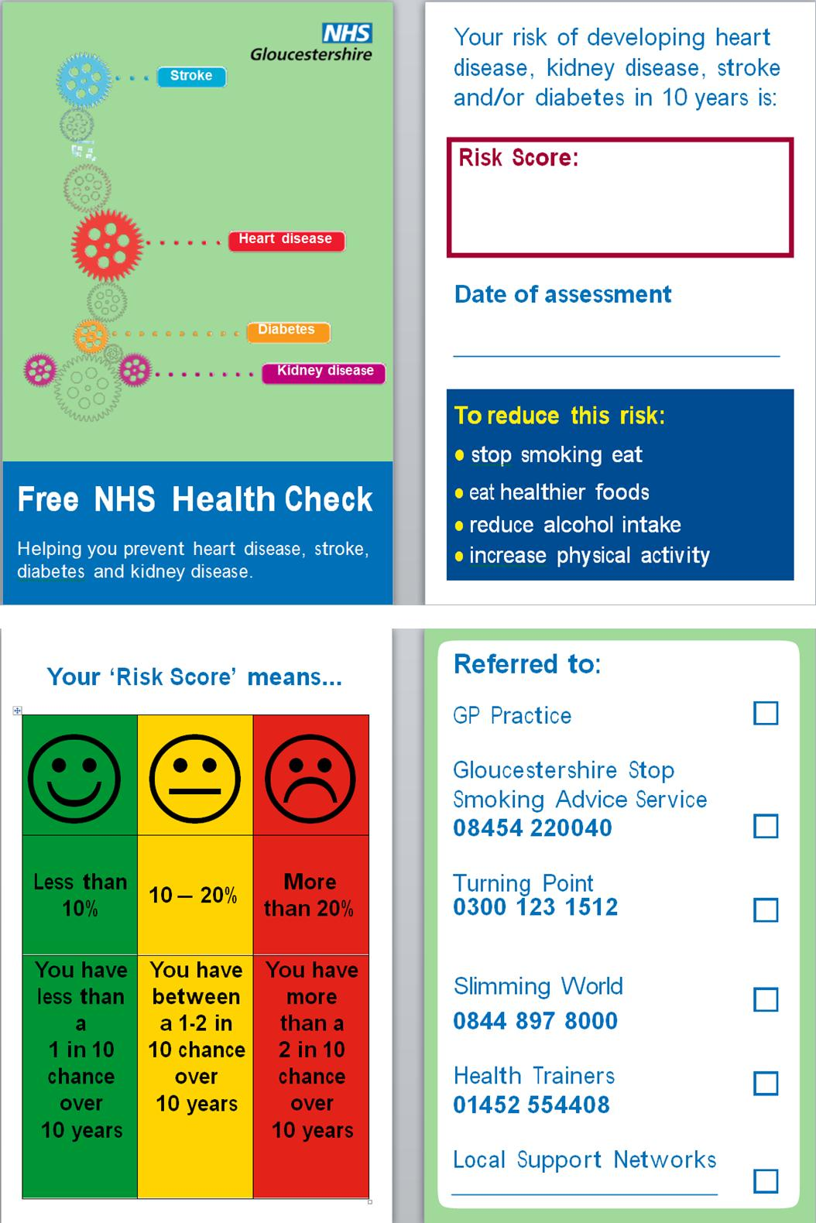

## Appendix D: Service Audit Indicators

|  |  |
| --- | --- |
| **n** | **Description** |
| 1 | 1/5th of the HC eligible practice population. |
| 2 | Patients who have been invited for a HC of eligible population |
| 3 | Patients who have received a HC of eligible population |
| 4 | Ineligible patients who have received a HC of total HC's completed |
| 5 | Number of eligible patients who have received an NHS Health check in the last 12 months who had their ethnicity recorded as part of their NHS Health check (1 month up to and including the Health check date) |
| 6 | Number of eligible patients who have received an NHS Health check in the last 12 months by practice split by post code area. |
| 7 | Numbers of eligible patients who have received an NHS Health check in the last 12 months who received a 1st letter invitation/2nd letter invitation/telephone invitation/verbal invitation/no invitation. |
| 8 | Numbers of eligible patients whose cholesterol blood test and Health check were completed on the same date. |
| 9 | Number of patients who have received an NHS Health check in the last 12 months with dietary history code recorded as part of their NHS Health check (1 month up to and including the Health check date) |
| 10 | Number of patients with a poor or average diet with dietary advice given or a diet referral made or diet referral declined recorded as part of their NHS Health check (1 month post and including the Health check date) |
| 11 | Number of patients who have received an NHS Health check in the last 12 months with a smoking status recorded as part of their NHS Health check (1 month up to and including the Health check date) |
| 12 | Number of current smokers recorded in last 12 months with smoking advice or smoking referral recorded as part of their NHS Health check (1 month post and including the Health check date) |
| 13 | Number of patients who have received an NHS Health check in the last 12 months with exercise grading recorded as part of their NHS Health check (1 month prior to and including the Health check date) |
| 14 | Number of patients with an exercise grading of Poor or Average recorded as part of their NHS Health check (1 month either side of NHS Health check date) with Exercise advice or exercise referral or exercise referral declined also recorded as part of their NHS Health check (1 month post NHS Health check date). |
| 15 | Number of patients who have received an NHS Health check in the last 12 months with an audit C or FAST recorded as part of their NHS Health check (1 month prior to and including the Health check date) |
| 16 | Number of patients who have received an NHS Health check in the last 12 months with an audit C or FAST recorded as part of their NHS Health check (with an Audit C or FAST value of 3 or 4 (Medium alcohol risk) 1 month prior to and including the Health check date ) with alcohol advice given (up to 1 month post and including the Health check date) |
| 17 | Numbers with a NHS Health check code recorded in the last 12 months with an Audit C or FAST value =>5 (hazardous or harmful drinking) (1 month prior to and including the Health check date) with alcohol referral or referral declined recorded as part of their NHS Health check (up to 1 month post and including the Health check date) |
| 18 | Numbers with a NHS Health check code recorded in the last 12 months with an actual family history of CVD or CHD recorded as part of their NHS Health check (1 month prior to NHS Health check date). |
| 19 | Numbers with a NHS Health check code recorded in the last 12 months with an actual family history of diabetes recorded as part of their NHS Health check (1 month prior to NHS Health check date). |
| 20 | Number of non BME patients with an NHS Health check in last 12 months with a BMI =>30 recorded as part of their NHS Health check (1 month prior to NHS Health check date). |
| 21 | Number of BME patients with an NHS Health check in last 12 months with a BMI recorded =>27.5 recorded as part of their NHS Health check (1 month prior to NHS Health check date). |
| 22 | Number of non BME patients with a BMI recorded as part of their NHS Health check (1 month prior to NHS Health check date) =>30 with weight advice or weight referral or diet referral recorded as part of their NHS Health check (up to 1 month post of NHS Health check date). |
| 23 | Number of BME patients with a BMI recorded as part of their NHS Health check (up to 1 month prior to NHS Health check date).=>27.5 with weight advice or weight referral or diet referral (up to 1 month post of NHS Health check date) |
| 24 | Number of non ACJ patients with an NHS health check in last 12 months with a waist circumference recorded as part of their NHS Health check (1 month prior to NHS Health check date). |
| 25 | Number of Asian or Chinese or Japanese Patients with an NHS health check in last 12 months with a waist circumference recorded as part of their NHS Health check (up to 1 month prior to NHS Health check date) |
| 26 | Number of patients with an NHS health check in the last year diagnosed with Hypertension since their NHS health check date with a Lifestyle code recorded as part of their NHS Health check (up to 1 month post NHS Health check date) |
| 27 | Number of patients with a life style issue referred to a Health Trainer recorded as part of their NHS Health check up to 1 month post NHS Health check date) out of total referred to Health trainer. |
| 28 | Number of patients with a lifestyle issue seen by health trainer recorded as part of their NHS Health check (up to 2 month post NHS Health check date). NB: No data as Seen by Health trainer is not being recorded or not being fed back by the health trainer to the GP. |
| 29 | Number of patients with a health check in last 12 months with a high BP as part of their NHS Health check or post NHS Health check date)  NB: We amended this to post HC (including HC date) as no BP’s were recorded 1 month post and including HC date. MIQUEST queries will only pick up the latest BP, so this may not be that the BP was actually done at the NHS health check but was also done after the HC date as well which would be their latest recorded; this is due to the limitations of MIQUEST. |
| 30 | Number of patients with an NHS health check in the last 12 months with a pulse rate recorded (post` NHS Health check date and including HC date).  We amended this to post HC (including HC date) as no pulse rates were recorde post and including HC date. MIQUEST queries will only pick up the latest pulse rate, so this may not be the pulse rate done at the NHS health check; this is due to the limitations of MIQUEST. |
| 31 | Number of patients with an NHS health check in the last 12 months Number with a cholesterol recorded as part of their NHS Health check (up to 1 month prior to NHS Health check date) |
| 32 | Number of patients with an NHS health check in the last 12 months with a fasting blood glucose or HbA1c recorded as part of their NHS Health check (up to 1 month prior to NHS Health check date) |
| 33 | Number of patients with an NHS health check in the last 12 months with a raised fasting blood glucose (>=6) recorded as part of their NHS Health check (up to 1 month prior to NHS Health check date) |
| 34 | Number of patients with an NHS health check in the last 12 months advised to contact a GP recorded as part of their NHS Health check (up to 1 month post NHS Health check date) |
| 35 | Number of patients with an NHS health check in the last 12 months with a QRISK score recorded as part of their NHS Health check. (= NHS Health check date). NB: MIQUEST queries will only pick up the latest QRISK recorded, so this may not be that the QRISK was actually done at the NHS health check but was also done after the HC date as well which would be their latest recorded; this is due to the limitations of MIQUEST. |
| 36 | Number of patients with an NHS health check in the last 12 months with a statin drug prescribed post NHS health check |
| 37 | Number of patients with an NHS health check in the last 12 months with an anti-hypertensive therapy drug prescribed post NHS health check |
| 38 | Number of patients with an NHS health check in the last 12 months diagnosed with any CVD/diabetes diagnosis post NHS health check date. |
| 39 | Number of eligible patients with an NHS health check in the last 12 months with a QRISK score > 20 recorded as part of their NHS Health check (= NHS Health check date) prescribed a statin post NHS HC. |

## Appendix E: Service Audit Headline Results

|  |  |  |  |  |  |  |  |  |  |  |
| --- | --- | --- | --- | --- | --- | --- | --- | --- | --- | --- |
| **Audit Criteria** | | **Practice Audit Results** | | | | |  | **National Audit** | **Glos Audit** |  |
| Denominator | Numerator | Expected a  (n) | Achieved  (%) | Variance b  (%) |  | National Expected c (%) | NHS Glos average  (%) | Variance d  (%) |
| 1 | 1/5th of the NHS HC eligible practice population | 210513 | 42103 | - | - | - |  | - | - | - |
| 2 | Patients who have been invited for a NHS HC of eligible population | 42103 | 39871 | 42103 | 94.7 | -5.3 |  | 100.0 | 94.7 | -5.0 |
| 3 | Patients who have received a NHS HC of eligible population | 42103 | 20973 | 31577 | 49.8 | -25.2 |  | 75.0 | 49.8 | -25.2 |
| 4 | Ineligible patients who have received a NHS HC of total NHS HC completed | 22152 | 1179 | n/a | 5.3 | n/a |  | n/a | 5.3 | n/a |
| 5 | Patients with no NHS HC invite code recorded of eligible population who have received a NHS HC | 20973 | 3302 | 0 | 15.7 | +15.7 |  | 0.0 | 15.7 | 15.7 |
| 6 | Non BME patients with weight advice or weight/diet referral of non BME NHS HC obese patients | 3123 | 1287 | 4551 | 41.2 | +18.6 |  | 22.6 | 41.2 | 18.6 |
| 7 | BME patients with weight advice or weight/diet referral of BME NHS HC obese patients | 132 | 41 | 192 | 31.1 | +8.4 |  | 22.6 | 31.1 | 8.4 |
| 8 | Patients with smoking advice/referral recorded of NHS HC current smokers | 1942 | 1300 | 4963 | 66.9 | +43.3 |  | 23.7 | 66.9 | 43.3 |
| 9 | Patients with exercise advice / referral of NHS HC patients with exercise grading of low to moderate | 15456 | 6830 | 13595 | 44.2 | -20.6 |  | 64.8 | 44.2 | -20.6 |
| 10 | Patients with an alcohol referral of NHS HC patients with an Audit C or FAST value >= 5 | 2425 | 17 | 839 | 0.7 | -3.3 |  | 4.0 | 0.7 | -3.3 |
| 11 | Patients with a QRISK score >= 20 of NHS HC patients with a QRISK score | 15086 | 1372 | n/a | 9.1 | n/a |  | n/a | 9.1 | n/a |
| 12 | Patients diagnosed with CVD since NHS HC of eligible population who have received a NHS HC | 20973 | 1031 | 2726 | 4.9 | -8.1 |  | 13.0 | 4.9 | -8.1 |

a Based on national data. b Variance from National average. c Percentage of total eligible practice population. d NHS Glos percentage vs. National percentage.

## Appendix F: Health Check Ready Reckoner (Gloucestershire PCT, 2011)

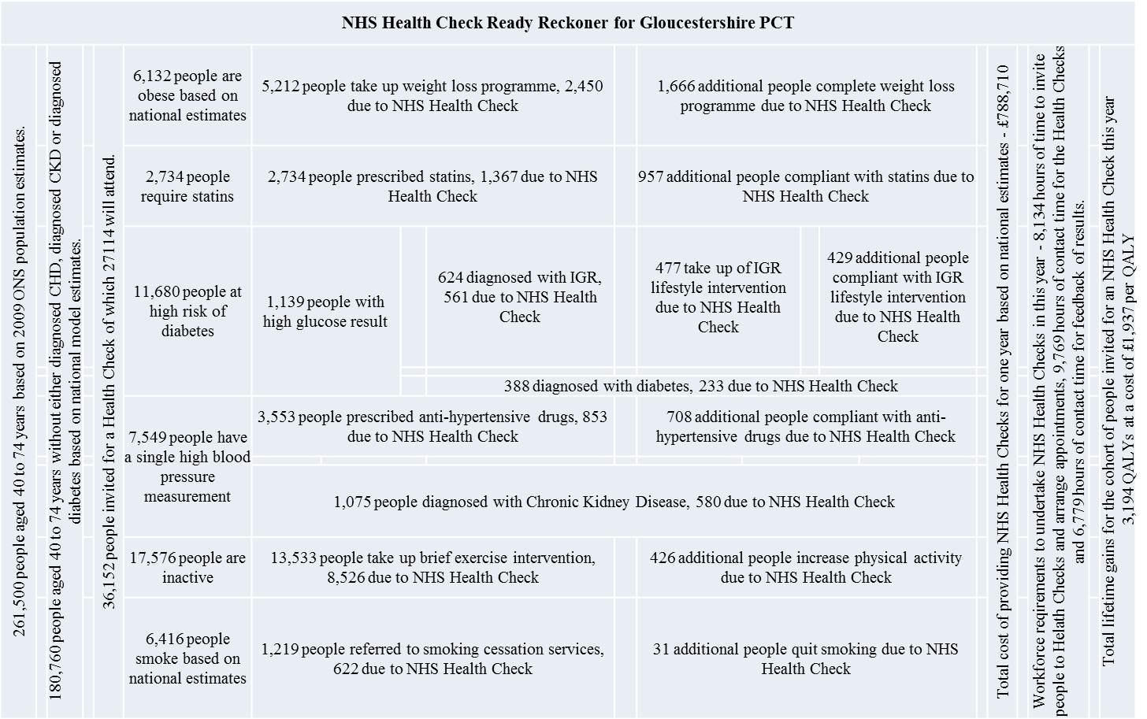

## Appendix G: Patient Survey

**NHS Health Check Questionnaire** Please help us by completing the following questionnaire. We do not need to know your name, and the answers you give will only be used to evaluate the NHS Health Check programme and will not be passed on to anyone or used for any other purpose.

Please answer **Y** for **YES** and **N** for **NO** and give comments if applicable. You can give more than 1 answer if necessary.**1. Which of the following were checked at your health check? Y/N**

Pulse ☐ Blood Pressure ☐ Blood Glucose ☐ Cholesterol ☐ Body Mass Index & Waist ☐ Diet ☐Physical activity ☐ Smoking ☐ Alcohol ☐

**2. Which of the following were you given advice on? Y/N**

Weight ☐ Exercise ☐ Smoking ☐ Alcohol ☐**3. Which of the following services were you advised to attend? Y/N**

Stop smoking ☐ Doctor Appointment ☐ Alcohol service ☐ Health trainer ☐Other (please add any other services here) _________________________

**4. Were you told about your Cardiovascular Disease risk score? Y/N**☐

**5. How much do you understand about your Cardiovascular Disease risk score?** Score between1-5, where 1 means you do not understand it at all and 5 means you understand very well. ☐ (1-5)

**6. Overall, do you think it was worth attending the NHS Health Check?**  **Y/N** ☐ Comments:__________________________________________

**7. Why did you choose to attend the NHS Health Check? Y/N**

Concerned about your health? ☐Family history? ☐Other, give details____________________________________________

**8. Have/will you change(d) your lifestyle as a result of the health check? Y/N** ☐

If yes, please give details___________________________________________

|  |  |
| --- | --- |
| **9. Please rate the Health Check service that you received?**  Score between 1-5, where 1 means poor and 5 means excellent. | Score (1-5) |
| **A.** Location of your Doctors surgery to where you live |  |
| **B.** Time and date availability of your appointment |  |
| **C.** Confidence in staff knowledge at your Doctors surgery |  |
| **D.** Overall experience of the Health Check service? |  |

**E.** Did you have time to ask questions? **Y/N** ☐

**F**. What part of the service could be improved? _______________________________

**G.** Do you have any other comments? ______________________________________

_____________________________________________________________________**10. Did you experience any difficulties during the health check? Y/N** ☐ Language ☐ Understanding ☐

Other, give details _________________________________

**11. When did you have your health check?** Date (___Day____Month___Year)

(If you are not sure of the exact date please estimate)

**12. Are you?** Male ☐ Female ☐

**13. How old are you?** 40-45 ☐ 46-50 ☐ 51-55 ☐ 56-60 ☐ 61-65 ☐ 66-74 ☐**14. Please tell us your ethnic group?**

|  |  |
| --- | --- |
| **Asian or Asian British**  ☐Bangladeshi  ☐ Indian  ☐ Pakistani  ☐ Asian other (please state)  **-------------------------------------------------** | **White**  ☐ British  ☐ Irish  ☐ Gypsy  ☐ Traveller  ☐ White other (please state)  **-------------------------------------------------** |
| **Black or Black British**  ☐African  ☐ Caribbean  ☐ Black other (please state)  **................................................................** | **Other Ethnic Group**  ☐ Chinese  ☐ Any Other (please state)  **................................................................** |
| **Mixed Background**  ☐ White and Asian  ☐ White and Black African  ☐ White and Black Caribbean | ☐ **Other mixed background**  (please state)  **____________________________** |

## Appendix H: Practice interview schedule

The NHS Gloucestershire has been running the 'NHS Health Check' programme to identify people that are at risk of developing cardiovascular disease (CVD) in the next 10 years. This questionnaire has been designed to see how the well programme is going and to identify ways in which to improve it. The NHS team using this questionnaire do not need to know the name of the person completing the form but do need to know the name of your practice.Please answer **Y** for **YES** and **N** for **NO** and give comments if applicable.**1. What is your role?**_______________________________________________**2. How much of your job involves Health Checks? 0%** ☐ **1-25%** ☐ **26-50%** ☐ **51-75%** ☐ **76-100%** ☐ **3. How long have you been involved in NHS Health Checks (months)?**___________**4. How well is your practice doing at delivering the NHS Health Check? Score between 1-5, where 1 means poor and 5 means excellent. Give comments if necessary.**

|  |  |
| --- | --- |
|  | **Score (1-5)** |
| **A.** Invitation (call and recall) |  |
| **B.** Laboratory tests |  |
| **C.** First appointments (risk assessment) |  |
| **D.** Risk communication |  |
| **E.** Changing behaviours |  |
| **F.** Second appointments (including follow-ups) |  |

Comments:_______________________________________________________________________________________________________________________

|  |  |  |  |
| --- | --- | --- | --- |
| **5. What equipment do you use currently to do the Health Checks? Y/N** | | **Comments** | |
| Electronic BP monitor |  |  |
| NPT |  |  |
| Lab |  |  |
| Vital Signs Equipment |  |  |
| Waist measurement tape |  |  |
| Other (specify)............................................ |  |  |

|  |  |  |  |
| --- | --- | --- | --- |
| **6. Do you have any issues with the equipment? Y/N** | | **Comments** | |
| Electronic BP monitor |  |  |
| NPT |  |  |
| Lab |  |  |
| Vital Signs Equipment |  |  |
| Waist measurement tape |  |  |
| Other (specify)............................................ |  |  |

**7. Have you experienced any issues with the risk calculator tool, Qrisk2? Y/N** ☐ If yes, please comment__________________________________**8. Have the patients that you have referred for lifestyle service received that service? Y/N** ☐ **A.** Do you record this? **Y/N** ☐  **B.** If yes, where ________________________________________________________________**9. How do you rate your local healthy lifestyle service provision? Score between 1-5, where 1 means poor and 5 means excellent. Give comments if necessary.**

|  |  |  |
| --- | --- | --- |
|  | **Score (1-5)** | **Comments** |
| **A.** Weight management |  |  |
| **B.** Smoking Cessation |  |  |
| **C.** Alcohol (Independence Trust) |  |  |
| **D.** Health Trainer |  |  |
| **E.** Other (i.e. local authority services) |  |  |

**10. Did you have any training in CVD prevention? Y/N** ☐ **A. Do you require any further training? Y/N** ☐If yes, in what area?___________________________________________**11. Have you had any issues with staffing levels? Y/N** ☐ Comment__________________________________________________**12. Do you have a CVD GP lead in your practice? Y/N** ☐ **13. Please indicate how do you decide who to invite for Health Checks:**

|  |  |  |
| --- | --- | --- |
| **Do you use the following strategies?** | **Y/N** | **Comment if necessary** |
| **A.** Random invitations? |  |  |
| **B.** Most at risk first? |  |  |
| **C.** Age? |  |  |
| **D.** Opportunistic invitations? |  |  |
| **E.** Other? (please specify) |  |  |

**14. Do you think this programme is preventing premature CVD? Y/N** ☐ If yes, please explain? ______________________________________________________**15. What do you think works well?**_____________________________________________________________________________________________**16**. W**hat works well?** ________________________________________________________________________________________________________________________________________________________________________**17. In your opinion, are there any ways we can improve the programme? Y/N ☐ If yes, please comment**________________________________________________________________________________________________________________________________________________________________________

|  |  |  |
| --- | --- | --- |
| **18. Have you encountered any problems with regard to the NHS Health Check data quality?** | Y/N | Comments |
| Read Coding |  |  |
| Running of MIQUEST Queries |  |  |
| System Reports |  |  |
| Other |  |  |

## Appendix I: Stakeholder interview schedule

1. **Why have patients been referred?**

(e.g. because it is a good / well known service, because patient is ready for change, because patient is worried about their health)

1. **How were patients referred?**

(e.g. GP, PN, NHS HCA – are there patterns, particular things to look at? Did the patient contact the service directly? Did the service receive a direct call from primary care?

How many referrals do they get from the NHS Health Check? How do they record this information? Do they share / feedback this information, and how?)

1. **What was the process of working with the patient?**

(e.g. level of support, advice, goal setting, diaries / logs, etc.)

1. **What percentage of patients met goals / objectives?**

(e.g. what happens as a result of the service intervention?)

1. **What percentage of patients who were referred were diagnosed with CVD**

(be clear on definition and conditions. Was there any further on referral to other providers ? If so who?)

1. **Any other comments**

## ****Appendix J: Search Strategy****

**Standard 4 of the NSF states; *GPs and primary health care teams should identify all people at significant risk of cardiovascular disease but who have not developed symptoms and offer them appropriate advice and treatment to reduce their risks.***

❶ **Search Strategy**

A staged approach is advised calling forward people from current registrations

**Stage 1 – 1st invite**

Patients aged 40-74 years old whose month of birth is in the active* month, who are NOT ON a Hypertension, Diabetes, CKD, Stroke, PVD, CHD or Palliative Care register AND DO NOT have a record of

* CVD or CHD 10 year risk assessment (Framingham, JBS or QRISK, not estimated) in the last 5 years
* CVD risk assessment done (9OhA) or declined (9Oh9)
* DNA for CVD risk assessment (9NiM)
* Invite for CVD high risk monitoring in last 3 years (9Ox2)

**Stage 2 – 2nd Letter of invite (after one month)**

Identify patients invited for the active* month (identified by date of CVD high risk monitoring first letter) that DO NOT have a record of

* CVD risk assessment done (9OhA) or declined (9Oh9)
* CVD or CHD 10 year risk assessment (Framingham, JBS or QRISK, not estimated) in the last 5 years

**Stage 3 – Flag DNAs (after a further month)**

DNA patients who have received two letters of invite and have no record of CVD risk assessment or CVD risk assessment done or declined.

***\*Active Month: Invite patients for a NHS health check whose birthday falls in the selected month (start by inviting all patients whose birthday is in January).***

Subsequently, as well as managing patients who have been screened for vascular disease risk, practices will need to decide how to identify the remaining population of ‘at–risk’ individuals.

This may be by systematically:-

* screening family members of patients with existing CHD/ Diabetes/ Hyperlipidaemia / Rheumatoid Arthritis
* Opportunistic screening
* Healthy heart open clinics

*Invite patients eligible for a NHS Health check (stage 1 and 2 above), enclose the Patient Information Leaflet and pre-visit questionnaire asking the patient to complete the pre-visit questionnaire and bring along to their appointment.*

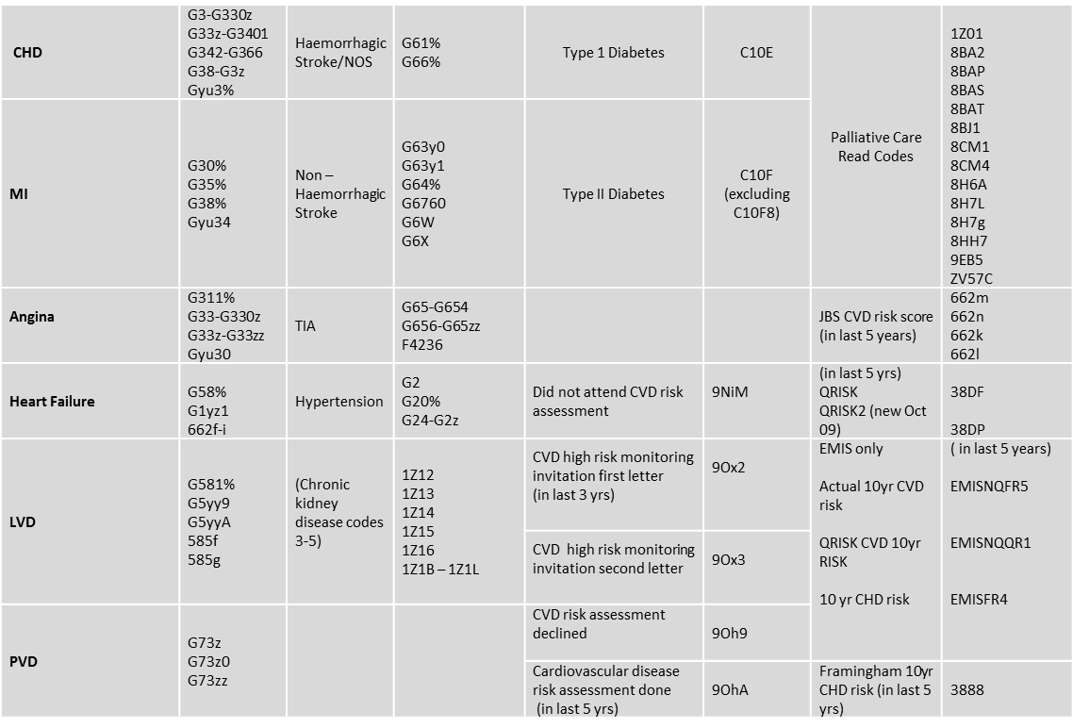

Read codes to exclude patients that are not eligible for NHS Health Check screening

1. The IMD score is used to compare (rank) areas, but is not a direct or meaningful measure of deprivation. IMD is made up of several distinct dimensions including: income; employment; health and disability; education; skills and training; barriers to housing and services; crime, and living environment.
2. Based on Gloucestershire Health Checks audit tool for the period July 2011 to July 2012.
3. Uptake is defined as NHS HC invitees who completed the two appointments.
4. Correlation assessed using Practice Deprivation and Uptake as two continuous variables.
5. Three practices were included in the Service Audit that recorded zero uptake or ceased to deliver NHS HC. This includes one practice which had the highest deprivation score and zero uptake, hence the results are skewed slightly. These are left in the analysis to highlight variation across the county and do not dramatically impact the overall small negative correlation across the cohort.
6. MIQUEST queries will only pick up the latest QRISK recorded, so it may be that the QRISK was also done after the HC date which would be their latest recorded, and is a limitation of MIQUEST.