‘Let’s Get Moving’ Physical Activity Care Pathway (Gloucestershire)

Post-Programme Evaluation Report

Prepared by Interventions4Health
University of Gloucestershire
April, 2014

Evaluation team:
Dr Elizabeth Loughren, Dr Colin Baker and Professor Diane Crone

Acknowledgements

We are grateful to Public Health NHS Gloucestershire, pathway developers, Community Health Trainers, surgery Nurses and GPs, and Physical Activity delivers who agreed to share their experiences with us and who provided valuable insight.

To reference this report, please use the following citation:

Loughren, E., Baker, C. & Crone, D. (2014). ‘Let’s Get Moving’ Physical Activity Care Pathway (Gloucestershire): Post Programme Evaluation Report. University of Gloucestershire, U.K.

Contents
Executive Summary i
1.0 Introduction 1
2.0 Let’s Get Moving in practice 3
3.0 Evaluation design, aims and research questions 4
3.1 Aims 4
3.2 Research questions 4
4.0 Data collection methods and procedures 6
5.0 Data analysis methods and procedures 7
6.0 Results 8
6.1 Stakeholders 8
6.2 Health Professionals 9
6.3 Community Health Trainers 9
6.4 Physical Activity (PA) Deliverers 10
6.5 Overview of themes 11
7.0 Discussion and conclusion 14
7.1 Stakeholders and health professionals 14
7.2 Health trainers and physical activity deliverers 14
7.3 Conclusion 15
8.0 Recommendations and Lessons Learnt 16
References 18

List of Tables

Table 1: Participant description 4
Table 2: Stakeholder themes and sub themes 8
Table 3: Health professionals' themes and sub themes 9
Table 4: Community Health Trainers’ themes and sub themes 10
Table 5: PA delivers' themes and sub themes 11
Table 6: Overview of themes 13

List of Figures

Figure 1: Let's Get Moving Pathway 1
Figure 2: Gloucestershire LGM Flowchart 2

Executive Summary

Introduction:
The Gloucestershire LGM programme was rolled out in early 2011. While the intention was to identify sedentary adults for the prevention and management of chronic disease by supporting them to become more active through a brief intervention, it was recognised over time that the programme did not appear to be a popular option for health referrers or patients, leading to poor patient uptake. In view of this poor patient uptake the evaluation was modified to understand and investigate the reasons for this.

Research aims:
Aim 1: To explore stakeholder and health professionals’ perceptions of the LGM Physical Activity Care Pathway Gloucestershire (PACPG) project;

Aim 2: To explore health trainers and physical activity deliverers’ perceptions of the LGM Physical Activity Care Pathway Gloucestershire (PACPG) project.

Results:
Two main themes were identified including challenges to implementation and benefits of LGM which helped to explain the nature of the programme’s implementation in Gloucestershire.

Recommendations:

Pathway development

Recommendation 1: The establishment of a steering group or committee to oversee the development of a county wide intervention such as LGM, including representation from relevant health professionals, patient boards and community health programmers would have assisted with greater overall coordination.
Recommendation 2: To help ensure embedding such interventions into the health services landscape, wider consultation with community health assets e.g. pharmacies, community associations etc., needed to have been undertaken.
Recommendation 3: Better alignment with current health programmes e.g. ERS and Health Checks would have embedded LGM into current practice as a viable referral option.
Recommendation 4: The supporting LGM literature needed to be clearer to allow professionals to understand its purpose and relevance within local health services.
Recommendation 5: Streamlining the pathway e.g. simplified paperwork would have assisted with aligning LGM with current health programmes and improved its potential in practice.

Pathway delivery

Recommendation 6: Scheduling of patient appointments with HTs at regular times within local surgeries may have led to increased patient through flow by providing routine opportunities for engagement with the programme.
Recommendation 7: The supporting LGM literature needed to be clearer to allow patients to understand its purpose and relevance to them as individuals.
Recommendation 8: Stronger central coordination was recommended to ensure the full involvement of health professionals within the LGM pathway and ownership at the local level.
Recommendation 9: Better marketing and promotion of the LGM brand was needed to increase its visibility with health professionals and patients e.g. LGM launch events or the presentation of LGM at CCG meetings.

Recommendation 10: The pathway needed to allow for greater flexibility so that patients were able to select a physical activity type or location e.g. gym or leisure centre that is compatible with their own needs and preferences.

1.0 Introduction

First launched in February 2009 as a means of providing advice on physical activity in primary care, Let’s Get Moving (LGM) is an evidence-based behaviour change intervention (Department of Health, 2012). The pathway approach (Figure 1) is based on the recommendations of NICE public health guidance (NICE, 2006) which endorses the delivery of brief interventions for physical activity in primary care as being both clinically effective and cost-effective in the long term. The intervention can be accessed by any patient aged between 16 and 74 years old who is classified as being less than physically active (not meeting current recommended guidelines of 150 minutes of moderate intensity physical activity per week) and was designed to provide a systematic approach to identifying, supporting and guiding adults to become more active for the purpose of both prevention and management of inactivity-related chronic disease. These include cardiovascular disease (CVD), coronary heart disease, stroke, type 2 diabetes, chronic kidney disease, some cancers, chronic obstructive pulmonary disease (COPD), obesity, musculoskeletal conditions and some mental illness (Department of Health, 2012). In addition to addressing physical activity LGM can also link patients with other public health initiatives and care pathways such as NHS Health Checks, COPD, obesity, stop smoking, falls prevention and cancer (six-month follow-up) (Department of Health, 2012).

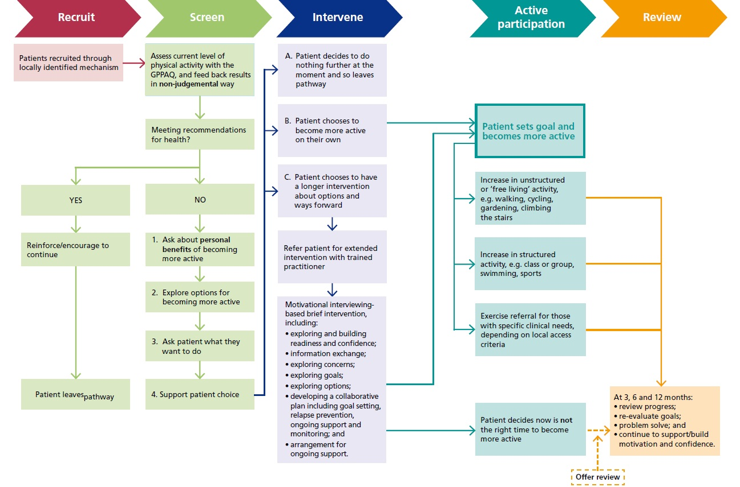
Figure 1: Let's Get Moving Pathway
Source: Department of Health (2012).
In 2010 NHS Gloucestershire initiated a pilot LGM programme to complement its successful Physical Activity Referral Service (PARS) running in five of the six Gloucestershire districts with the intention of adding value by supporting patients’ attempts to resolve ambivalence and increase intrinsic motivation for physical activity. Existing evidence suggests that physical activity care pathways such as LGM might provide a cost effective means of increasing physical activity behaviour compared to other means, although further research is needed (Boehler et al., 2011). The LGM pilot proposed to use existing services (Figure 2) to increase sustainability and was provided in areas of need in Cheltenham, Gloucester and Forest of Dean as identified by information concerning deprivation in the county (APHO and Department of Health, 2010). GP Practices in these areas were selected to deliver LGM via GPs and Nurse Practitioners with support from Community Health Trainers and Physical Activity deliverers.

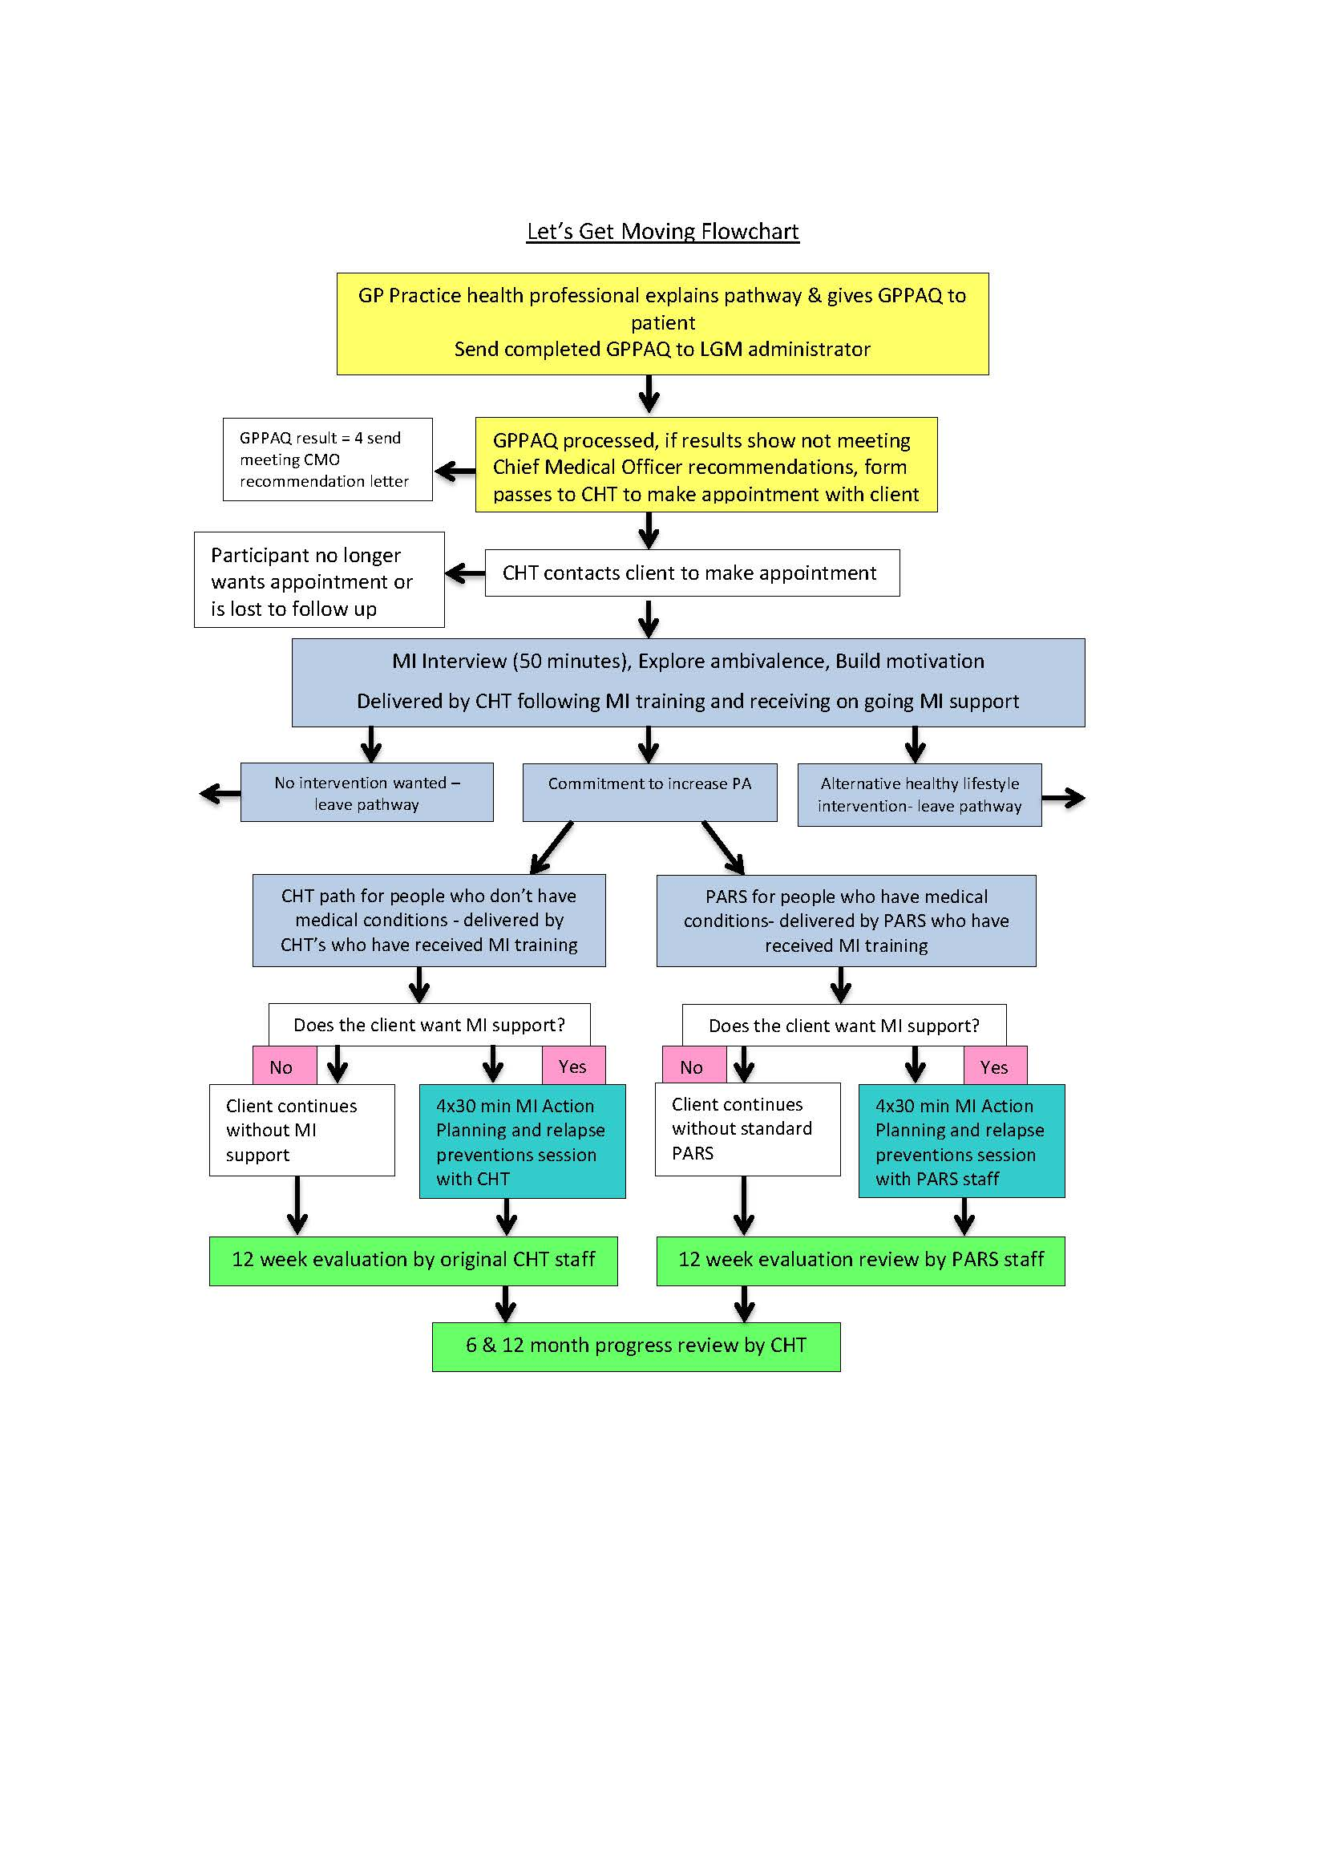
Figure 2: Gloucestershire LGM Flowchart

2.0 Let’s Get Moving in practice

While it is understood that physical activity is beneficial for health it is less well understood how practitioners can ensure that people from all sectors of society are able to reap the rewards of regular participation wherever they live and whatever their circumstances. Scholars and practitioners seeking to address spiralling levels of physical inactivity are challenged by a lack of evidence concerning the effectiveness of community physical activity interventions (Baker et al., 2011). An LGM feasibility trial with London surgeries (n = 14) conducted by the British Heart Foundation National Centre for Physical Activity and Health, and Loughborough University (Bull, Milton, & Boehler, 2008) with patients (n = 302 females, n = 244 males) ranging in age from 10-88 years (M = 56.7, SD = 14.9) found that of the 300 patients who received signposting, the most frequently signposted activities were ‘local authority leisure services’ (n = 118) and ‘self-directed outdoor activities’ (n = 89). Feedback from practitioners indicated that the design of the care pathway and the specific focus on how to promote physical activity helped them raise the topic and emphasise the importance of physical activity to patients. Aspects of the care pathway approach to the promotion of physical activity were liked by patients and considered to be feasible (see Figure 2 LGM flowchart). The patient-centred method supported by motivational interviewing techniques helped increase the likelihood of patients changing their physical activity behaviour whereby 367 (83%) patients screened showed interest in the pathway and the brief intervention, demonstrating that LGM was feasible for delivery in primary care and suitable for wider implementation.

The Gloucestershire LGM programme was rolled out in early 2011. While the intention was to identify sedentary adults for the prevention and management of chronic disease by supporting them to become more active through a brief intervention, it was recognised over time that the programme did not appear to be a popular option for health referrers or patients, leading to poor patient uptake. As such, there is a need to understand the nature of the challenges that prevented the successful implementation of the programme in order to inform future practice and other LGM programmes currently being implemented elsewhere for example, Brighton; Southampton; Portsmouth; Hastings and Rother PCT; Wigan and Leigh (Wigan Council), Peterborough; Ipswich, and Leeds.

3.0 Evaluation design, aims and research questions

A qualitative research design utilizing telephone and face to face semi-structured open-ended interviews with stakeholders, health professionals, health trainers and physical activity deliverers (total number of participants, n=10) was deployed. The pathway commissioner and project lead provided to the evaluation team with a list of potential key informants and their contact details.

Table 1: Participant description
Title | Description | n | Role
Stakeholders | Those involved in the design, formulation and implementation of the project | 2 | Coordination & training
Health professionals | Those who were able to refer patients onto the programme | 2 | Coordination & referral
Health trainers | Those who attended the preparatory training and were the planned deliverers | 4 | Delivery
Physical activity deliverers | Those associated with the delivery of LGM | 2 | Delivery

3.1 Aims
Aim 1: To explore stakeholder and health professionals’ perceptions of the LGM Physical Activity Care Pathway Gloucestershire (LGM) project;

Aim 2: To explore health trainers and physical activity deliverers’ perceptions of the LGM Physical Activity Care Pathway Gloucestershire (LGM) project.

3.2 Research questions
Relating to aim 1:
- What are the stakeholders’ and health professionals’ perceptions of the LGM project including:
    - information prior to the project starting;
    - its launch;
    - subsequent implementation in practice?
- What was their understanding of the pathway and project?
- How did they perceive it as a referral option for patients?
- What are the perceived reasons for a lack of recruitment of patients into the programme?
- What key lessons can be learnt from the LGM project?

Relating to aim 2:
- What are the health trainer and PA deliverers perceptions of the LGM project including:
    - information prior to the project starting,
    - its launch, and;
    - subsequent implementation in practice?
- What was their understanding of the pathway and project?
- What are their opinions on the pathway as a suitable referral option for patients in Gloucestershire?
- What are the perceived reasons for a lack of recruitment of patients into the programme?
- What key lessons can be learnt from the LGM project?

4.0 Data collection methods and procedures

- To address Aim 1:
Stakeholders and health professionals (n = 4) who were involved in the LGM project were invited via an email or a phone call to take part in a brief telephone or face to face interview. All interviews were scheduled to be held at a convenient time for the stakeholder or health professional. The questions were semi-structured and open ended based on those detailed in section 3.2. Interviews were recorded for the purposes of data analysis and all participants were informed responses would be anonymous and confidential. Interviews ranged from 10-30 minutes. Two participants provided responses via email.

- To address Aim 2:
Health trainers and PA deliverers (n = 6) who were involved in the LGM project were invited via email to take part in a short face to face or telephone interview. Interviews were recorded for the purposes of data analysis, with all participants being notified that responses would be anonymous and confidential. The semi-structured, open ended questions were based on those detailed in section 3.2. Interviews ranged from 10-40 minutes.

Data was stored in an anonymised format and key identifiers (name and practice/service provider) removed prior to the release of data for analysis. All findings were presented fully anonymised from all interviews. Transcripts of interviews were only available to the evaluation team. Interview confidentiality was ensured via the use of pseudonyms within the transcripts. Data protection was ensured through the use of password protected University computers, and raw data was stored in locked filing cabinets within the researchers’ secure office. Research ethics were ensured via compliance with University of Gloucestershire research ethics regulations.

5.0 Data analysis methods and procedures

Interview data were recorded using a digital voice recorder and upon completion the responses were transcribed verbatim. Analysis was undertaken in the context of the evaluation aims. Inductive content analysis (Waltz et al., 2010) was used to analyse the data which involved a series of coding ‘text units’ (or sections of text), initially into general themes and then through a systematic review of these into more detailed themes and subthemes. Memos (research notes) were attributed to each theme to help understand the participant’s perceptions and to provide a voice for their experiences and opinions within the text. Following this, a systematic review of themes was conducted to confirm or amend themes to ensure they accurately represented the data. These themes are presented in Section 6 and include quotations from the transcripts to provide a link to the experiences of those taking part in the evaluation.

6.0 Results

Two main themes of challenges to implementation and benefits of LGM emerged through data analysis and are presented in Tables 6.1 to 6.4. Each table presents the main theme or themes according to the type of participant e.g. health professional. Sub-themes are used to present concepts, or factors, which help explain the main themes and link them with each specific participant group in the evaluation. Quotations from participant transcripts are provided for each sub theme to maintain a link between the data and the participants’ voices. Table 6.5 presents a composite picture of the key themes to provide an overview of the key findings and associated consequences.

6.1 Stakeholders

While LGM was considered a positive and potentially effective tool for supporting patients to change their physical activity behaviour it was clear that a number of perceived challenges made this very difficult to achieve in practice including time pressures and competing priorities, and the perceived lack of distinctiveness of the LGM programme. The provision of motivational interviewing training was perceived as a key benefit that could help enhance practice within LGM and other service areas.

Table 2: Stakeholder themes and sub themes
Theme / subtheme | » | Direct quotation from participant
Challenges to implementation
Time pressures & competing priorities | The idea was for nurses to do screening and MI but in reality it was never really going to work as they didn’t have the time and knew straight away from our own experiences working with GP practices it was going to be a real difficult job to try and get them and to do the training
Gatekeeper access | The hardest thing was getting [practice managers] to liaise with me (stakeholder). Once I got in there it was fine. Trying to get them to answer emails, phone calls was really, really hard…Once on board some of the practice managers were a little more hesitant and some really embraced it. Getting in there the first place was really hard work.
Distinctiveness & visibility | Although we could explain the added value of LGM the impression I got from front-line staff in was that it wasn’t different enough from what was already on offer (e.g. the Physical Activity Referral Scheme) to be worth the hassle of having yet another thing to think about

Contd.
Theme / subtheme | » | Direct quotation from participant
Benefits of LGM
MI training | People were able to get some really, really superb [Motivational Interviewing] training out of it and I would hope the Health Trainers are finding their jobs a little easier because they are not so focused on trying to find an answer for the person sitting in front of them, but sitting back and listening and helping the person [find the] right answer for them. I would hope it has made their practice more comfortable.

6.2 Health Professionals

Health professionals recognised that the perceived complexity of the LGM pathway and competing priorities presented a significant barrier to its successful implementation.

Table 3: Health professionals' themes and sub themes
Theme / subtheme | » | Direct quotation from participant
Challenges to implementation
Complexity | It is not easy to sell [LGM] when you are presenting just an A4 piece of paper and a questionnaire…I don’t know how it can be presented differently to engage [patients]…whether it’s us [nurses] who need to be better engaged to sell it better, I don’t know…
Time pressures & competing priorities | Initially we were engaged [but] other things took over. It’s a shame as the initial enthusiasm was there, it was just hard to explain [LGM] to patients…it’s due to the time restrictions. You kind of know if someone is interested or not when you see this questionnaire and explain it to them.  I think the main problem was time explaining [to patients] and that put most of us off in the end. There is so much pressure on our appointments and what we have to say with them it is difficult then to try and add in something extra that we have to explain to patients…

6.3 Community Health Trainers

Health Trainers (HTs) recognised a number of challenges relating to the LGM development process, patient recruitment and the programme’s distinctiveness. In practice, these issues meant that it was difficult to maximise the potential of LGM because it was difficult to link with existing offers e.g. Exercise on Referral and local services e.g. pharmacies and to embed the programme within normal practices within GP surgeries where other concerns were prioritised.

Table 4: Community Health Trainers’ themes and sub themes
Theme / subtheme | » |  | Direct quotation from participant
Challenges to implementation
Pathway development |  | It was complex in terms of set up, how it would be sold, especially to GPs. We need to work around GPs to have them buy-in into it long term.  LGM is not very high profile. Posters were put up but were quite last minute and should have been done much sooner. It was suddenly upon us and hadn’t been rolled out early enough
Complexity |  | It’s too complicated, we tried to build it into existing paperwork but that made it more complicated. It was really putting people off as we couldn’t understand it. If someone was referred we were unsure of how to properly be able to follow the paperwork.  It was difficult to explain LGM to other staff members. We need narrower pathway fields e.g. A, B, C, etc., it needs to be more simple
Time pressures & competing priorities |  | IPAQ- very long time to complete, approx. 20 minutes. Found it difficult to fit it all in with the meeting time of roughly 40 minutes.  It takes time to get GPs on board. Constantly need to [keep] after them. Need to use monthly newsletter, cluster meetings, etc. The practice nurses, HCAs, reception staff all need to be informed.
Benefits of LGM
MI training |  | MI Training was the best training we’ve had and with a competent trainer.  MI significantly changed the way in which we work with clients. Also changed how we use and developed our paperwork. Still using it with clients today and a tool in a toolkit that they can now use. This would not have happened without the LGM.

6.4 Physical Activity (PA) Deliverers

A core concern for PA deliverers was a perceived lack communication between partners during the development of LGM and its impact on understanding of the overall programme and their ability to influence its design. This was reflective of concerns shared by the HTs whereby certain aspects of programme planning appeared not to have been dealt with in sufficient detail so as to provide a succinct or coordinated approach in terms of the way the programme was marketed. More positively, PA deliverers identified that they were trained and ready to implement the programme despite not receiving referrals.

Table 5: PA delivers' themes and sub themes
Theme / subtheme | » | Direct quotation from participant
Challenges to implementation
Pathway development | We didn’t want it to dilute what we were already doing by adding another initiative that wasn’t really dissimilar. We definitely felt there was a place for it [but] perhaps it would have been nicer to have a say in it and how we did that, and what it looked like. If we had been involved in the process from the start and shaped it differently t would have been different.
Communication | We had various conversations with NHS colleagues about the LGM pathway and other partners to get something off the ground. It seemed to be going somewhere and then we didn’t hear from them, we didn’t know what was going on...there were a few issues along the way, but they all seemed to be sorted out during the project set up. I think communication was always a bit of an issue.
Complexity | It was adding on to what was already offered, it felt like it was over complicating the other pathway and schemes
Distinctiveness & visibility | Our concern this was that it was very similar to the existing paperwork for the ERS… things were going to get confused because LGM wasn’t really that different from the criteria for our ERS. There were concerns that the person referring the patient were going to get confused-which paperwork do I use. What is the difference?  It never really launched itself. We never received any referrals for the LGM pathway. We got to the stage where the NHS has sent certain agreements across to the leisure centre that were signed and sent back [but] I’m pretty sure that was kind of the end of things, we never had any follow on or anything like that. Our instructors were trained and all set to go…

6.5 Overview of themes

Table 6 presents an overview of the two main themes; challenges to implementation and benefits of LGM. Together with the sub themes, these themes provide an explanation of the meaning of participation in LGM for the participants in this evaluation. The themes are presented alongside a number of corresponding consequences which help to contextualise the implementation of the LGM programme in Gloucestershire inform the brief discussion in Section 7.

Table 6: Overview of themes
 | Theme / subtheme | » | Consequences
Challenges to implementation
 | Pathway development | Due to a perception of limited consultation with health professionals and programme deliverers, difficulties in engaging GP practices the lack of opportunity to align LGM with existing health services, the potential to embed LGM more fully within the wider ERS context was missed.
 | Time pressures & competing priorities | LGM failed to gain widespread recognition from health professionals as a viable resource for behaviour change. The potential of LGM is understood but it competes with other services that are more embedded in practice. Health professionals have only a limited time with patients and it is evident that LGM may not presently provide the principal resource when decisions are made concerning advice or support given to patients.
 | Complexity | The complexity of the pathway made it difficult to understand thus reducing its appeal in comparison with existing schemes e.g. ERS. This made it difficult to explain the programme to professionals and patients who were already pressed for time with other competing priorities. Complicated paperwork was perceived as time consuming and lacking flexibility e.g. the specific referral steps, presenting a potential barrier to effective sessions with patients.
 | Communication | The lack of information concerning the development and implementation of LGM meant that understanding of its progress was limited. This led to the perception that the programme was stalling and was not being rolled out effectively within the county which in turn meant that it became less of a priority over time.
 | Distinctiveness & visibility | The perceived lack of distinctiveness of LGM meant that its place within the local health services landscape was not sufficiently clear to foster the sense that it was a viable and useful service for patients. A lack of awareness or promotion of LGM within GP surgeries potentially harmed its implementation.
 | Gatekeeper access | The significant amount of time and effort required to convince practice managers of LGM’s potential slowed down the programme’s roll-out within the county.
Benefits of LGM
 | MI training | MI training made a positive and lasting impression and was perceived as a useful tool in contexts outside of the LGM programme for managing patients and supporting health behaviour change and provided a practical means of supporting health professionals to engage with patients.

7.0 Discussion and conclusion

This report presents the findings of an evaluation that sought to understand the reasons why the LGM programme in Gloucestershire did not appear to be a popular option for health referrers or patients, leading to poor patient uptake. The findings highlight a number of factors that collectively posed a significant challenge to the successful implementation of the programme. Capturing the experiences of those involved in the coordination, training and delivery of the programme helps not only to illustrate the magnitude of issues facing LGM in Gloucestershire but to also explore potential responses that might mitigate these where future development is planned. These are presented below in respect of the two participant groups included in this evaluation.

7.1 Stakeholders and health professionals

While the LGM pathway ostensibly provides a succinct framework for delivery it is not easily translated into practice. LGM and its attendant processes and paperwork were not necessarily compatible with more established local ERS and other health interventions programmes and lacked the distinctiveness to be perceived as something genuinely different. The flow chart was perceived as overly complicated and it was felt that LGM lacked the simplicity it needed to align it with or link it to other programmes e.g. Health Checks that might have improved its potential to reach a wider patient audience. In response better communication across the board will likely lead to an improved understanding of the programme and its relative stage of development. The challenge of establishing effective communication between all partners suggests that their needs to be a significant investment in the marketing and promotion of LGM to health professionals and those involved in the programme’s delivery to ensure that its role and purpose is understood and embedded over time into the mosaic of local health services. The same is true of the need for communication with wider local services e.g. pharmacies and the potential use of these services as resources for LGM delivery via the training of staff in LGM administration and motivational interviewing techniques.

7.2 Health trainers and physical activity deliverers

Training in motivational interviewing was a principal benefit of the programme but opportunities to deliver this in practice were limited due to the apparent lack of enthusiasm and support for the programme as an option for health referrers or patients. The lack of visibility, including an absence of a launch meant that the programme’s roll out happened almost incidentally and went largely unnoticed within the county. Streamlining the LGM paperwork might alleviate the challenge of delivering the intervention in a setting that is constrained by time and resources, particularly if there is the flexibility to overlap the administration of LGM with existing referral services e.g. using similar paperwork or physical activity settings. Attempts should also be made to improve the referral process so that the LGM administrator is able to minimise the amount of time between the referral being made and the intervention taking place, although this is likely to be challenging without effective communication, strong support from health professionals, and a greater awareness of the programme. These improvements would likely increase its appeal to those responsible for its delivery within primary care settings. Furthermore, providing patients with simple information hand outs and the opportunity to schedule appointments at a time convenient to them will likely increase the fidelity of LGM as a viable pathway for physical activity behaviour change.

7.3 Conclusion

This report represents a snapshot of the LGM programme for one period in time and it is important to understand the results in light of a complex set of contextual factors. Changes in the wider health services landscape have resulted in the reorientation of a number of public health services and the ways in which services are designed, commissioned and delivered. Consequently, there have been changes in personnel, staff roles and administrative processes which are likely to have had a confounding effect on the roll-out of the programme. Notwithstanding these issues, the findings in this report reflect those identified elsewhere whereby the time required to deliver lifestyle counselling, the lack of integration with and competition from existing ERS (in the sense that these were seen as the first port of call even where LGM may have been more appropriate), and the need for on-going support for deliverers are major factors determining implementation success (Bull et al., 2010).

8.0 Recommendations and Lessons Learnt

As a result of the discussion and conclusion above we make the following recommendations that have been written to ensure their transferability to other PA related primary care pathway interventions that may be developed in the future:

Pathway development

Recommendation 1: The establishment of a steering group or committee to oversee the development of a county wide intervention such as LGM, including representation from relevant health professionals, patient boards and community health programmers would have assisted with greater overall coordination.

Recommendation 2: To help ensure embedding such interventions into the health services landscape, wider consultation with community health assets e.g. pharmacies, community associations etc., needed to have been undertaken.

Recommendation 3: Better alignment with current health programmes e.g. ERS and Health Checks would have embedded LGM into current practice as a viable referral option.

Recommendation 4: The supporting LGM literature needed to be clearer to allow professionals to understand its purpose and relevance within local health services.

Recommendation 5: Streamlining the pathway e.g. simplified paperwork would have assisted with aligning LGM with current health programmes and improved its potential in practice.

Pathway delivery

Recommendation 6: Scheduling of patient appointments with HTs at regular times within local surgeries may have led to increased patient through flow by providing routine opportunities for engagement with the programme.

Recommendation 7: The supporting LGM literature needed to be clearer to allow patients to understand its purpose and relevance to them as individuals.

Recommendation 8: Stronger central coordination was recommended to ensure the full involvement of health professionals within the LGM pathway and ownership at the local level.

Recommendation 9: Better marketing and promotion of the LGM brand was needed to increase its visibility with health professionals and patients e.g. LGM launch events or the presentation of LGM at CCG meetings.

Recommendation 10: The pathway needed to allow for greater flexibility so that patients were able to select a physical activity type or location e.g. gym or leisure centre that is compatible with their own needs and preferences.

References

APHO and Department of Health (2010). Health Profile Gloucestershire 2010. Retrieved from: http://goo.gl/ZQfJSk
Baker, P.R.A., Francis, D.P., Soares, J., Weightman, A.L., & Foster, C. (2011). Community wide interventions for increasing physical activity. Cochrane Database Systematic Reviews, 13(4). doi: 10.1002/14651858.CD008366.pub2
Boehler, C.E.H., Milton, K.E., Bull, F.C., & Fox-Rushby, J.A. (2011). The cost of changing physical activity behaviour: evidence from a "physical activity pathway" in the primary care setting. BMC Public Health, 11: 370. doi: 10.1186/1471-2458-11-370
Bull, F.C., & Milton, K. (2010). A process evaluation of a “physical activity pathway” in the primary care setting. BMC Public Health, 10:463.
Bull, F.C., Milton, K. & Boehler, C. (2008). Report of the Evaluation of the Physical Activity Care Pathway London Feasibility Pilot – Final Technical Report. BHF National Centre.
Department of Health (2012). Let’s Get Moving Commissioning Guidance: A physical activity care pathway. London: Department of Health.
NICE (2006) Four commonly used methods to increase physical activity: brief interventions in primary care, exercise referral schemes, pedometers and community-based exercise programmes for walking and cycling, London: National Institute for Health and Clinical Excellence (NICE).
Waltz, C.F., Strickland, O.L. & Lenz, E.R. (2010). Measurement in Nursing and Health Research (4th). New York: Springer.

