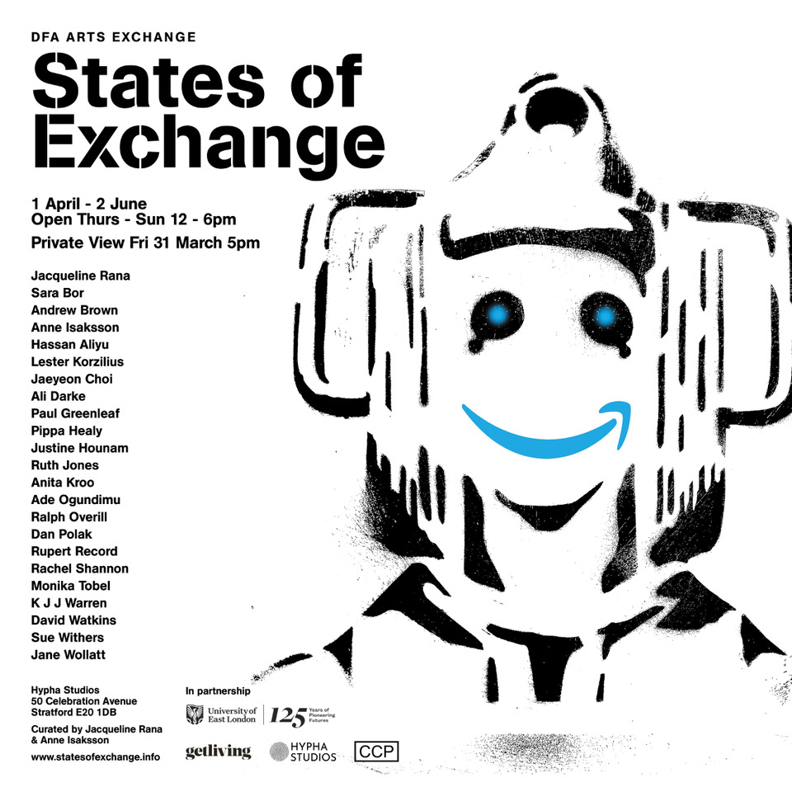

Publicity documents for States of Exchange and Super Sewer event at Hypha Studios.

