Landscapes of Hope
Rachael Champion and Susie Olczak
Curated by Becca Pelly-Fry

List of Works

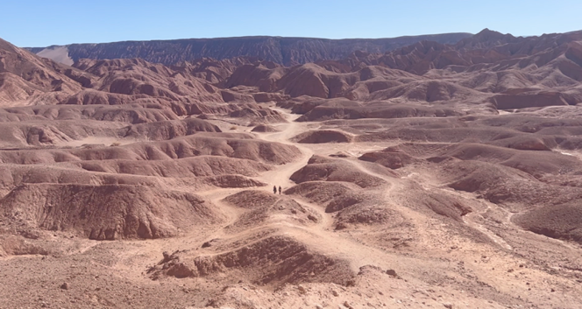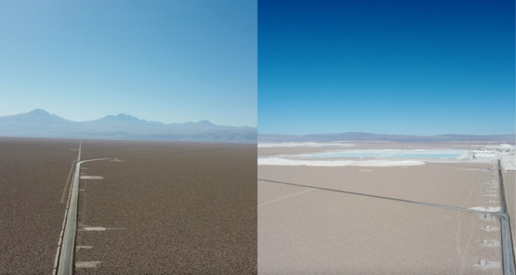
Film Reel

Ayni (2024)
Susie Olczak
07 min 35 secs
Single channel moving image
Conduit (2025)
Susie Olczak
9 mins 18 Secs
Single Channel Moving Image

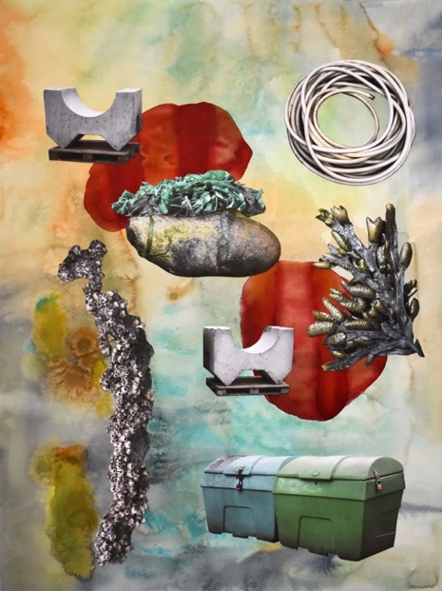 Acid
s, 2021
Extraterrestrial Amino Acids (2021)
Rachael Champion
70 x 50 cm
Acrylic sheet, archival digital collage over watercolour, plywood polyethylene terephthalate panel, hardware fixings

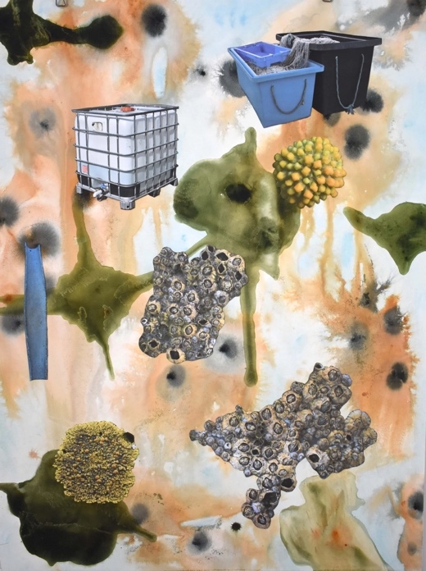
Nutrient Translocation (2021)
Rachel Champion
70 x 50 cm
Acrylic sheet, archival digital collage over watercolour, plywood polyethylene terephthalate panel, hardware fixings
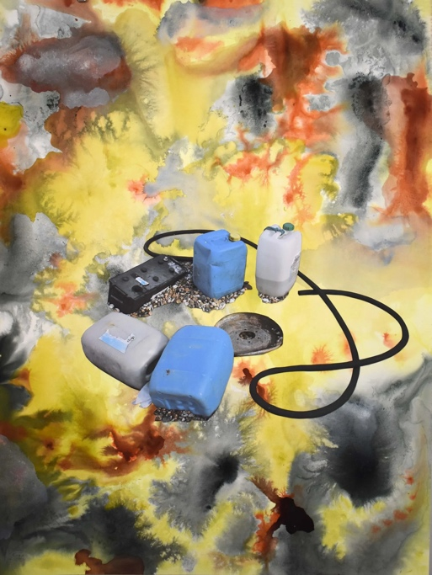
Binary Fission (2021)
Rachael Champion
70 x 50 cm
Acrylic sheet, archival digital collage over watercolour, plywood polyethylene terephthalate panel, hardware fixings

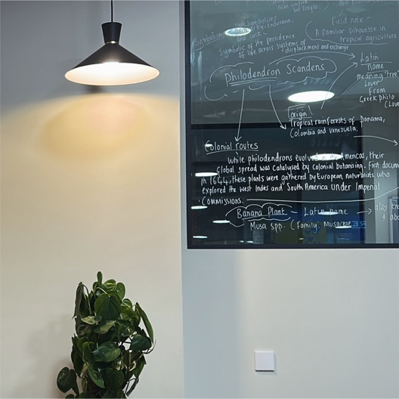
Cultivate (2025)
Susie Olczak
Dimensions variable
Plants, soil, grow lights, ceramic, chalk on glass

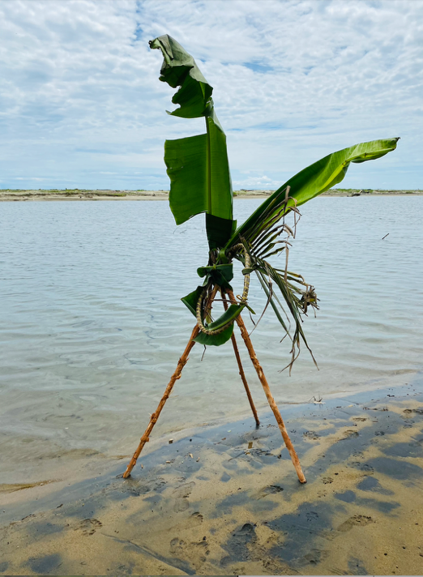
Hope (2025)
Susie Olczak
100 x 140 cm
Sustainable printing onto Panama Flo cotton
Shot in Armila, Panama in 2022

Your Place and Mine (2024)
Susie Olczak
50 x 30 x 25 cm
Mixed media on reclaimed banana crate
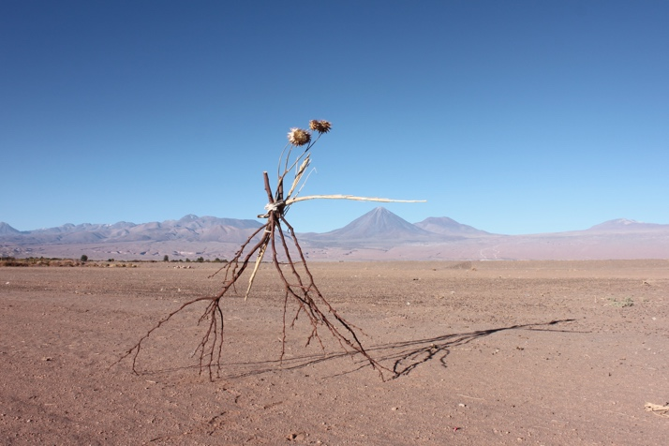
Finding Water (2025)
Susie Olczak
220.5 x 147 cm
Sustainable printing onto Panama Flo cotton
Shot in Atacama Desert, Chile in 2023
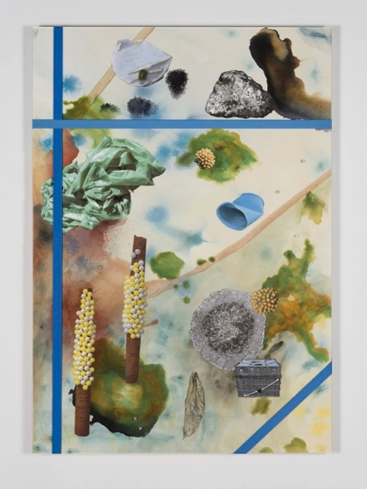
Fry Harvest (2021)
Rachael Champion
119 x 84.5cm
Acrylic sheet, archival digital collage over watercolour, plywood polyethylene terephthalate panel, ratchet strapping
Watercolour and archival digital collage on paper 7

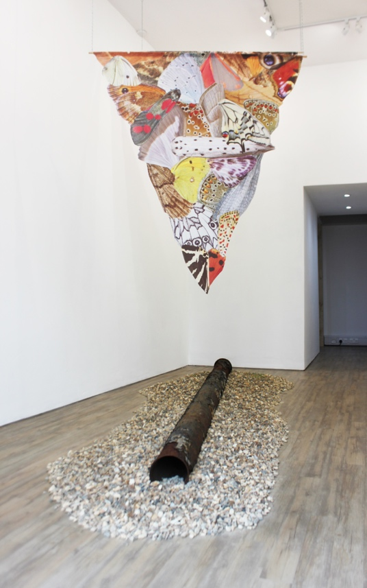

Drift Thrust Flow (2025)
Rachael Champion
350 x 306 x 110 cm
PLUTO pipeline, shingle, wheatgrass, digitally printed nylon

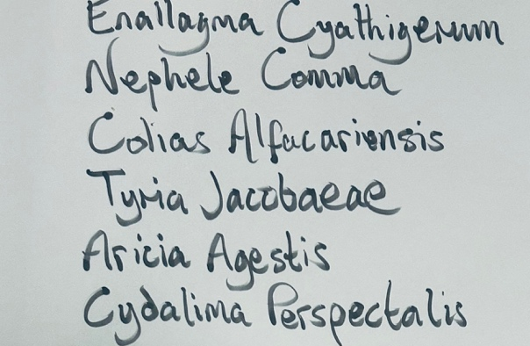

Nomenclature (2025)
Rachael Champion and Susie Olczak
Dimensions Variable
Chalk on glass

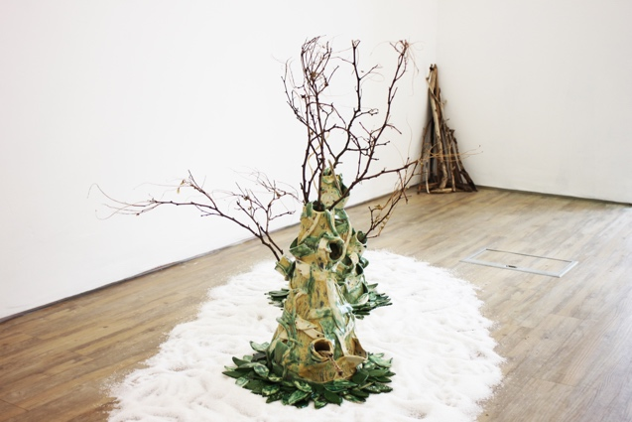
The leaves fell, falling, until the only tree was the falling itself (2025)
Susie Olczak
Dimensions Variable
Glazed ceramic, driftwood, found natural materials, salt

