Landscapes of Hope
Rachael Champion and Susie Olczak
Curated by Becca Pelly-Fry

Gloucester City Campus, Kings Square, Gloucester, GL11AW
26 September to 23 November 2025

Opening: Friday 26 September 6 - 8 pm
Day of Talks 21st November 10am- 4:30 pm

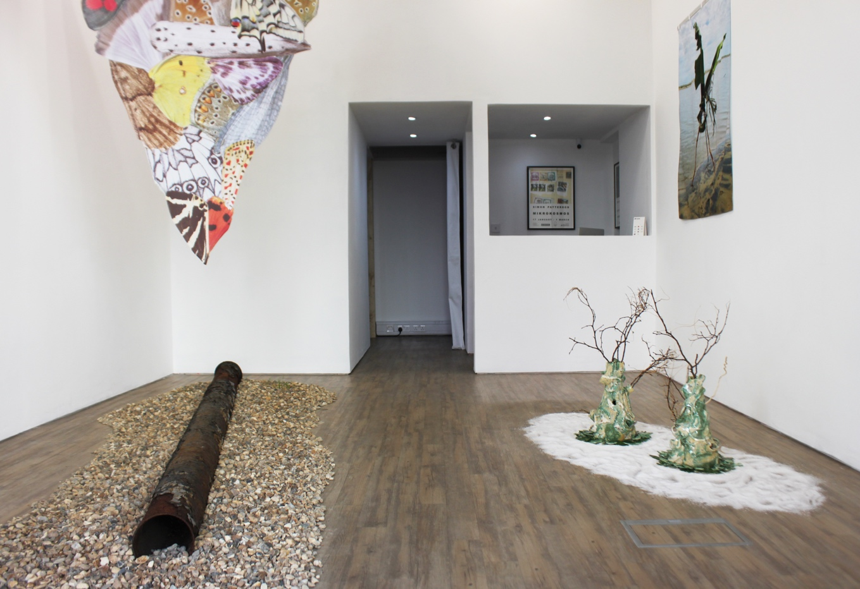

Landscapes of Hope is a two-person show of works by Rachael Champion and Susie Olczak, curated by Becca Pelly-Fry. Both artists transmit ideas of local hopefulness in the context of the widespread climate challenges we all face, through stories of adaptation. Olczak’s recent research in Latin America considers local rituals and routines of life as the foundations for making engaging stories in extreme environments. Champion's work addresses the corporeality of the materials we extract, transform and consume, and how these actions affect the physical characteristics of landscapes and ecosystems. Considering local storytelling, customs and rituals, the exhibition is a visual experiment in responding to landscape, exploring community resilience and adaptability. The exhibition was originally shown in Folkestone in a 'borderland' territory, both a coastal location and a frontier town facing Europe, following a research trip to Dungeness (one of the UK's driest locations). Its second iteration in Gloucester offers a chance to connect with the other side of England (a much wetter part of the country). The exhibition and day of talks will celebrate Gloucestershire's pioneering Arts and Health and Nature on Prescription services and consider the health implications of natural spaces (both green and watery). It asks pertinent questions about how the health benefits of these spaces might change as they become more precarious or extreme. Ideas of tending to a small patch of land or garden as a metaphor for care for the environment arose as a way to consider ideas of hopefulness, climate resilience and adaptation and small ways that everyone can contribute to climate resilience. Being attentive becomes an act of solidarity, of resistance and a method to learn to live with the other (both non-human and human) more harmoniously. Landscapes of Hope offers ways of navigating the most pertinent and challenging issues of our time. Both artists are interested in overturning ideas of human supremacy, encouraging a return to nature-led intelligence and tending to the pockets of hope that exist within hostile conditions.

Susie Olczak's work Your Place and Mine considers how plants and food would have been shipped from far flung parts of the world (such as the Caribbean) and how they often follow similar migration routes to birds and people. Connections are made with the Caribbean coastline of Panama and the coastlines of Venezuela. Packaging materials are used to ask questions about consumerism, how goods are shipped, stored and transported as well as how humans inherently mend and quickly tape objects together out of necessity. In this way the aim is to be outward looking from Gloucester but also to consider the local communities in the city and the connections to the Caribbean who play a part in the vibrancy of the city. A new film work, Conduit, interweaves collaged footage from several locations, including Panama, Chile and the East coasts and the South West of the UK, finding commonalities. Human beings have ordered their lives, forging identities and cultural landscapes in relation to dry/wet extremes for many centuries; the film aims to ask questions about how this local resilience can counteract the worst effects of climate change. In an attempt to remedy the increasingly divided nature of our communities, Conduit aims to promote reconnection with nature, landscape, and each other. The film is also a call to listen more closely to local and indigenous knowledge and to consider the world from a less anthropocentric viewpoint - perhaps enabling better adaptation to extremes of climate. Footage in the film creates comparison points between the North, East, South and West, highlighting how climate issues are exacerbating the global north and south divide and disproportionately affecting different parts of the UK. The title of the work, Conduit, refers to both the moving of water from one place to another and the passing down of stories or knowledge.

Rachael Champion’s installation, Drift Thrust Flow 2025, features a three-metre section of covert Allied WWII infrastructure sitting amongst a bed of shingle. Above hang two pennants depicting collaged textures of wings of both birds and invertebrates observed at Dungeness. Drift Thrust Flow characterises aspects of this extraordinary paradoxical landscape, Europe’s largest expanse of vegetative shingle, where wartime industry, energy infrastructure and a rich fragile ecology coexist on a stark elemental headland. During World War II, Dungeness was central to Operation PLUTO (PipeLine Under The Ocean) — a top-secret Allied engineering feat that pumped fuel under the English Channel to supply the forces after the D-Day landings. The PLUTO pipelines were laid across the seabed from sites like Dungeness to France, ensuring a steady flow of petrol to advancing Allied troops. Remnants of this history — rusted pipework, concrete blocks, military infrastructure — remain embedded in the landscape, quietly monumental and half-reclaimed by nature. This particular section of pipeline is on loan from The Pilot Inn at Dungeness, where it is displayed amongst other decaying relics of local maritime history.

ABOUT THE ARTISTS

Rachael Champion’s work explores the physical, material and historical relationships between ecology, industry and the built environment. Coalescing at the intersection between biology, geology and architecture, her practice interrogates the corporeality of the materials we extract, transform and consume, and the effects these actions have on the physical characteristics of landscapes and ecosystems. She has exhibited widely throughout the UK and internationally in a variety of site-specific contexts. Leading contemporary art galleries where her work has been presented include the Whitechapel Gallery, Camden Arts Centre, Hales Gallery, Zabludowicz Collection and Modern Art Oxford. She is a recipient of the Arts Foundation Future Awards and the Red Mansion Prize as well as a former artist-in-residence at the Bemis Center for Contemporary Art. Rachael is a graduate from the Royal Academy of Arts.

Susie Olczak is a multidisciplinary artist with a focus on sculpture. Her work considers ideas of contingent making and adaptation in relation to climate change and asks the viewer to look again at the world, drawing parallels between contingent making processes of artworks and methods in society of human and natural adaptation, i.e. the human drive to build temporary structures, shelters and rafts, used both for adventure and survival. Her current research juxtaposes distinct landscapes facing uncertainty due to climate change and extreme scenarios of too much or too little water. Her work has been shown internationally in Berlin, Japan and the United States. She has exhibited around the United Kingdom, attended residencies in Finland, Panama and Chile. She has been commissioned to produce artworks by BBC Scotland, Charles Saatchi at the Big Chill Festival, the National Trust, The Institute of Astronomy and the Fitzwilliam Museum in Cambridge, as well as for King’s, Jesus, and Peterhouse Colleges of Cambridge University. She is a recipient of the Villiers David Travel Grant and a bursary award winner at the Royal Society of Sculptors. Recent accolades include the Ingram Collection Purchase Prize, the Mark Tanner Sculpture Award residency and exhibitions at Standpoint Gallery, Hestercombe Gallery, Tremenheere Gallery, White Conduit Projects and The Lightbox. Susie Olczak is a graduate from the Royal College of Art.

ABOUT THE CURATOR

Becca Pelly-Fry is an independent curator, consultant and Reiki Master, based in Folkestone. She is Associate Curator for SCHOOL and works across the UK, collaborating with galleries, art fairs and cultural organisations. Her curatorial practice has a focus on the intersection between art and healing practices, creating space for transformative experiences that reconnect audiences with the earth, other living beings and their true selves. Between 2013 and 2019, Becca was Head Curator for art materials company Colart International where she first ran their flagship space, Griffin Gallery, before launching a warehouse-style contemporary art space, Elephant West, converted from a derelict petrol station. Recent projects include the exhibition La Mariposa (Butterfly Woman) at Soho Revue; the Platform section of London Art Fair 25, entitled Today for You, Tomorrow for Me; and the feminist provocation across time, Body Poetics, co-curated with Marcelle Joseph at GIANT in Bournemouth. Becca is a member of Association of Women in the Arts, British Art Network, A-N and International Futures Forum. She is also on the committee of local artist-led festival, Open Art Folke, and offers a one-to-one Reiki healing practice at her home in Folkestone.

