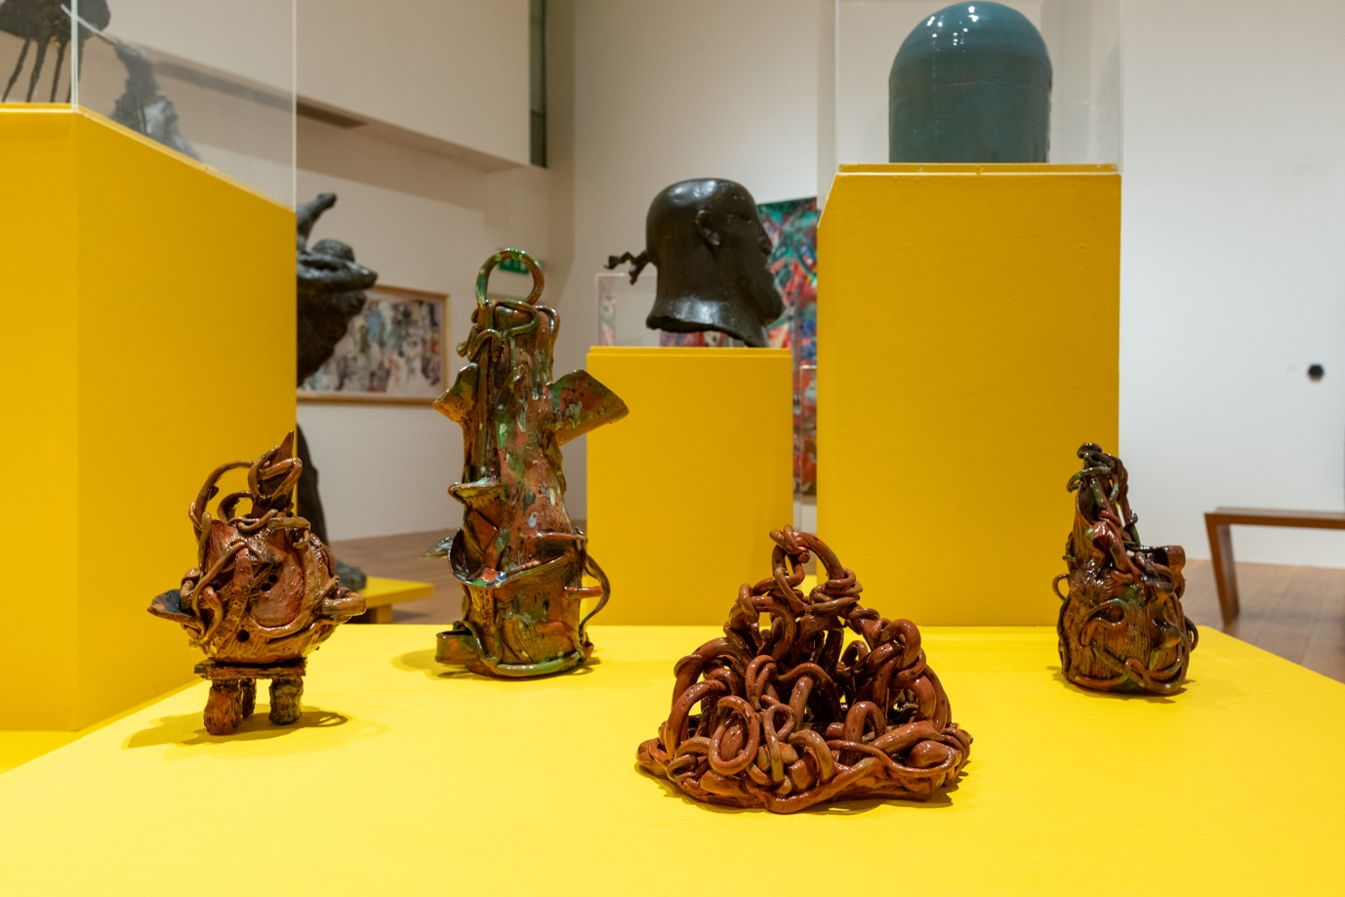
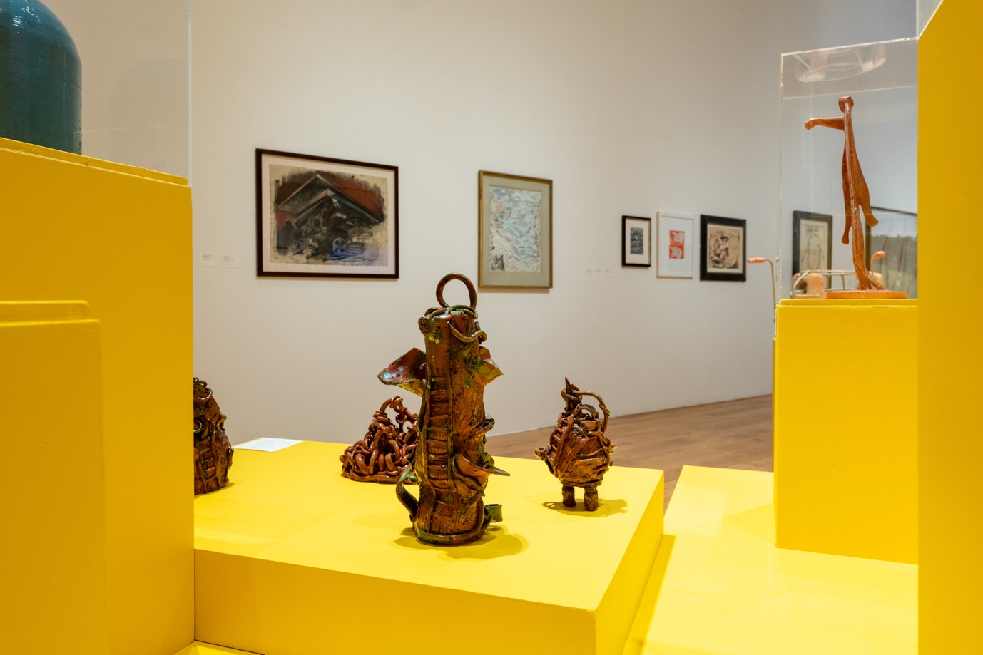
Snakes and Ladders
Susie Olczak
2024
Glazed ceramics
Dimensions variable
Shown in Material Thinking at the Lightbox, Woking
Photo credit
© Deniz Guzel, 2024

