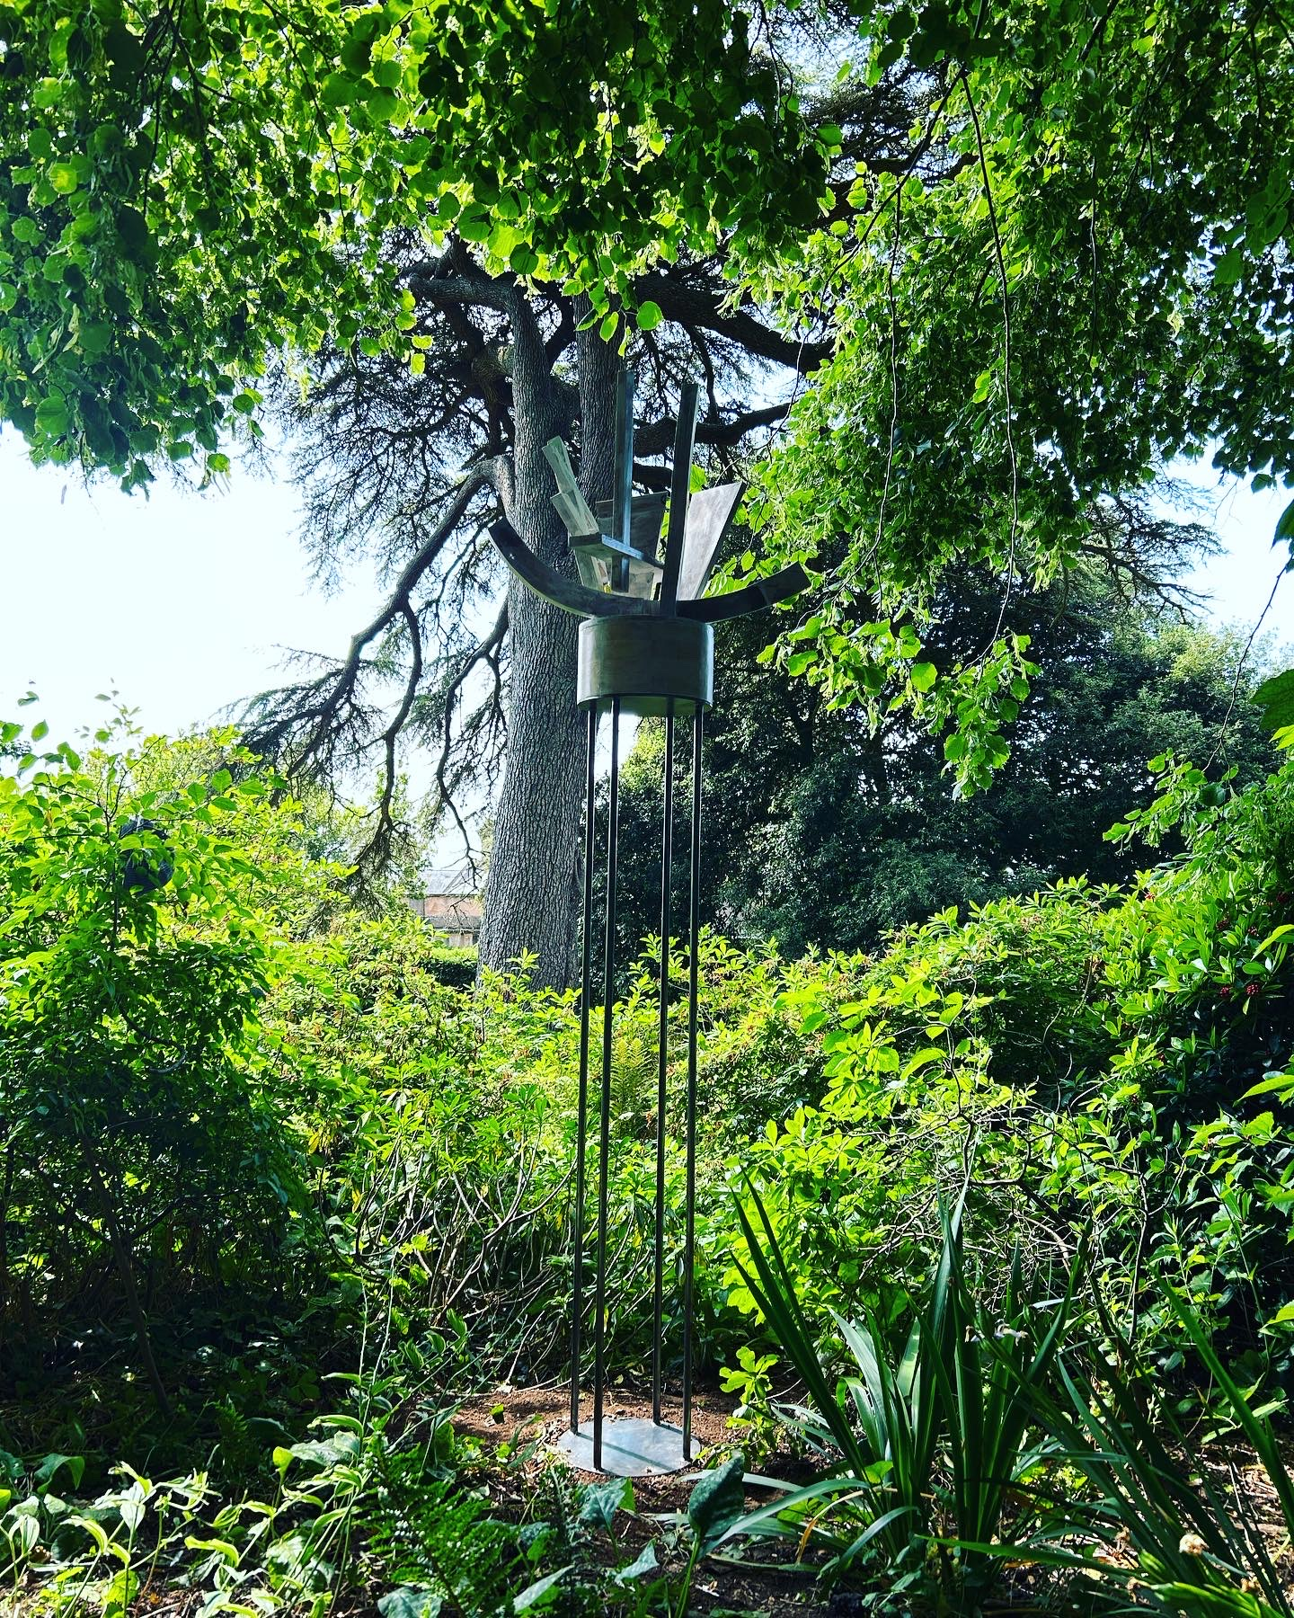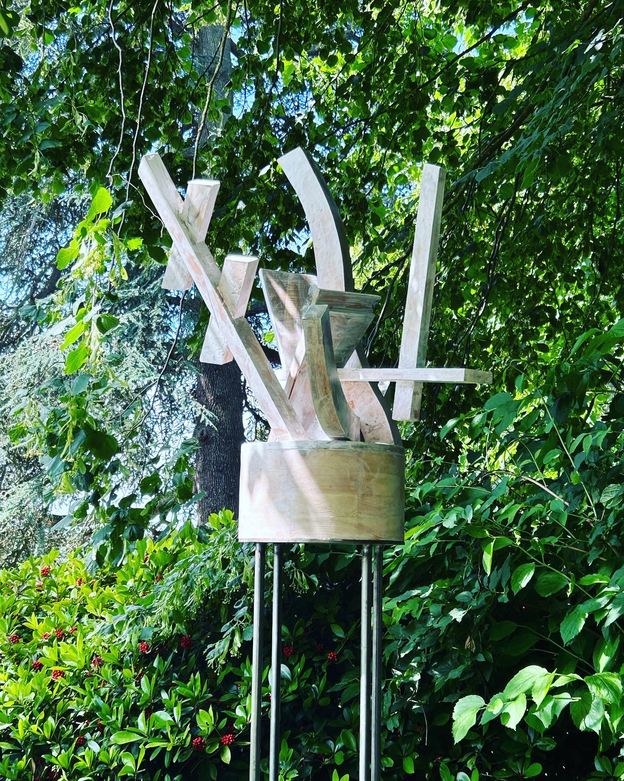
To Propagate: To Graft
Reclaimed wood, reclaimed house-paint, varnish and steel
190 x 60 x 40 cm
2023
Installed at Hestercombe House and Gardens.

