The Smart City and the Urban Housing Crisis
https://theacademic.com/smart-city-and-urban-housing-crisis/
Seyedeh Zahra Hosseini ª
ª Faculty of Civil Engineering, Architecture and Art, Science and Research Branch, Islamic Azad University, Tehran, Iran
Email: s.zahrahosseini73@gmail.com
Mostafa Parpanchi^{b}
^{b}Faculty of Architecture and Urbanism, Islamic Azad University, Qazvin, Iran
Email: mosiparpanchi@gmail.com
Martin Wynn^{c}*
^{c}The Business School, University of Gloucestershire, Cheltenham, UK.
Email: MWynn@glos.ac.uk
The smart city concept has developed and grown in the past two decades and many of the world’s leading cities now have smart city programs underway. These may help address problems of network infrastructure, traffic flows and parking, for example, and support the development of knowledge-based enclaves, but the dire housing conditions of many major cities remain untouched by smart city projects and plans. Are Smart City initiatives adequately recognizing and addressing these housing issues? What role can digital technologies play now, and in the future, to address these problems?

The Smart City Movement

The smart city concept assumes that a city will be more “liveable” and better able to respond to challenges through improvements in digital technologies, vital infrastructure and social capital. While technology is the key enabler for smart cities, it is not an end in itself. The point of a smart city is to improve the lives of residents and businesses through the application of advanced technologies. It modernizes digital, physical and social infrastructure to make delivery of city services more efficient, innovative, equitable, connected, secure, sustainable and exciting. Directly or indirectly, this should bring about improvements in the city’s housing stock and the lives of the those living there.

With the population of major cities projected to continue to grow significantly in the coming decades, the development of smart cities is urgently needed. The effective provision of housing is a fundamental requirement in a smart city. Without it, the city's ability to thrive and expand is severely hampered. As recently observed by Vince and Morrissey, “the projected growth trajectory for urban environments means that cities will face increasing challenges in all aspects of their operations — including social imbalances, traffic congestion, pollution and strains on resources — if no action is taken. Mayors around the world are realizing that integrating smart tech into planning and sustainability strategies will improve quality of life, which in turn attracts investment and leads to positive growth in cities”.

Smart Cities and Housing Issues
Hitherto housing has not been seen as a key focus of smart city initiatives, in contrast to transportation, street lighting, parking spaces and communications networks. However, this is changing as smart cities shift their focus from connected infrastructure and technology innovations toward a broader conception of quality of life. Godijo, writing in the context of slum developments in Ecuador, noted that “smart cities means that everything in these cities is designed to be intelligent, including infrastructure, energy, housing, grids, and mobility”. Recent research in Tehran, however, has shown how the smart city plans are having limited impact in addressing the poor provision of housing. 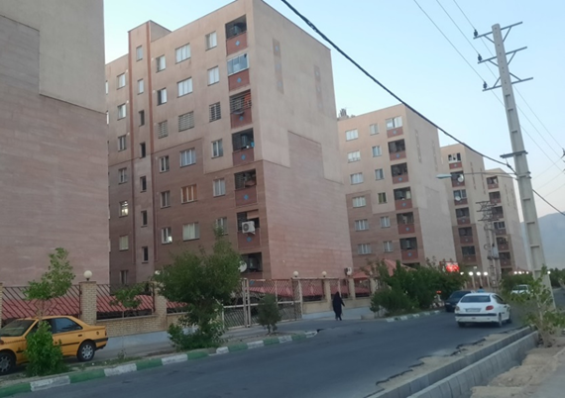
Figure 1. Andisheh new town, west of Tehran (Photo: Zahra Hosseini)
Although there are some high-quality residential areas, the majority of housing is characterized by poor quality construction and lack of adequate services. This includes the four new towns (Figure 1) built outside Tehran, described as “huge islands of soaring sky-scrapers and indiscriminately developed apartments filled with crowds of people and cars”, and the illegal shanty developments that remain in some parts of the city (Figure 2). Whilst the city has been actively involved in the smart city movement, and the city’s “Smart Tehran Program” is currently underway, there is a disconnect between the Smart Tehran initiatives and the levers of housing policy and development. 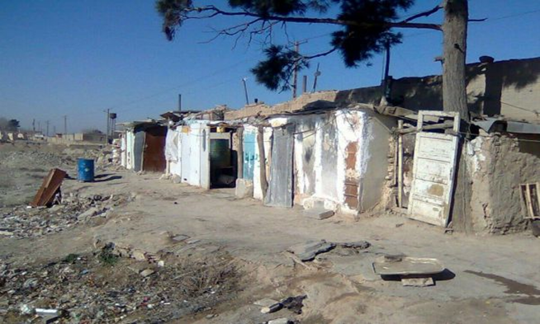
Figure 2. Illegal housing at Farahzad in the north of the Tehran municipality (Photo: Zahra Hosseini)
The effective coordination of smart city initiatives with the urban planning process is illustrated in other major urban centres. In Melbourne, the smart city initiative of “working with the community (residents, workers, businesses, students and visitors) to design, develop and test the best ways for you to live, work and play” overlaps with the 2026 Melbourne City plan which aims to “provide affordable options for accommodation, food and services”, and “will offer a mix of housing, facilities and recreation to support a diverse and inclusive community”. Such integration and co-ordination between smart city initiatives and city planning is particularly important for instigating change in housing provision.

How can smart city digitalisation help the housing crisis?
Past experience provides some key lessons that can help activists and planners address the housing problems through smart city initiatives. There are a number of issues of importance, such as the coordination of the activities of planning and development agencies, and the nature of the planning system itself. But above all, past experience suggests that citizen participation in finding solutions to housing problems is key. In the case of Tehran, Noori et al. suggest there is limited citizen involvement in the smart city initiatives in Tehran and that “poor citizen participation is due to low trust and awareness levels”.
By contrast, Barcelona is seen as leading the way in terms of citizen involvement in smart city initiatives. “Barcelona puts citizens at the head of its new smart city strategy: the use of data has to provide better and more affordable services as well as make government more transparent, participative and effective”. This is the key issue that allows the smart city to address housing issues: use digital technologies to make the local authorities more transparent, participative and effective. Harness the power of digital technologies to provide the residents of sub-standard housing developments with the means to work with planners and politicians to reshape their deficient estates or shanties. Then use digital technologies – artificial intelligence, extended reality, big data - creatively to find and implement appropriate solutions, be they small scale provision of new service infrastructure or more significant house upgrade or replacement programmes.
Figure 3. The shanty development at Campo de la Bota, Barcelona in the 1970s (Photo: Martin Wynn)

The recent history of housing development in Barcelona illustrates the importance of such citizen involvement. The shanty developments of the 1970s and 80s at Campo de la Bota (Figure 3) were eventually replaced by a new motorway, park areas and marina (Figure 4). Many of the residents were relocated, some against their will, to the nearby La Mina estate, which has been plagued by serious social problems, and has itself been the subject of a series of plans to upgrade the housing conditions there.
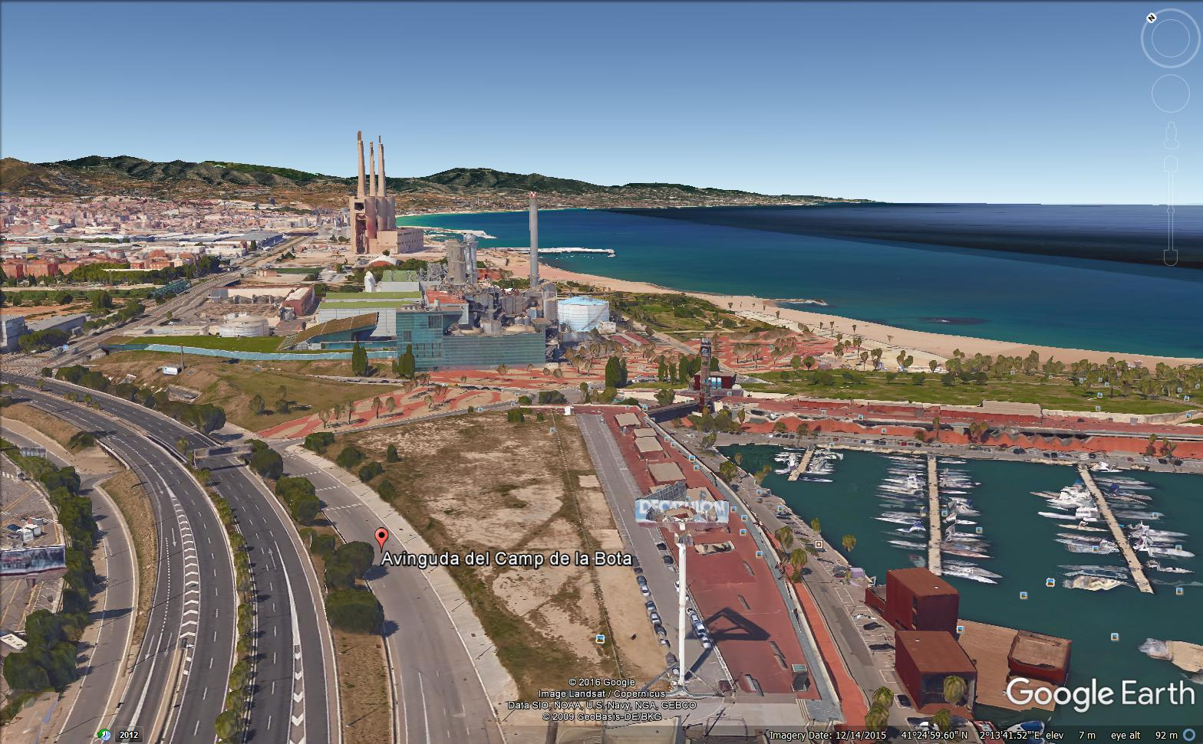
Figure 4. Campo de la Bota today: motorway, park areas and marina (source: Google Earth)
It is now recognised that a different approach is needed. The Barcelona Digital City notes that “public connectivity, and a large-scale civic digital infrastructure deployment, will enable better learning and better digital skills for all citizens, helping to narrow the digital divide. Having a clear strategy for investment, development and deployment of long-term research and innovation is a key element in creating better social policies like social housing, reducing energy poverty, improving health outcomes, and adding meaningful and high-quality jobs. We have, therefore, evolved from a top-down process to a bottom-up one, promoting collective intelligence and involving all the key players of the city's innovation ecosystem”. It is this type of approach that may finally see smart city digitalisation making a meaningful contribution to addressing the poor housing conditions that persist in many of our major cities.
Reference
Wynn, M., Hosseini, S. Z. and Parpanchi, S. M. (2023). Housing development and the smart city: a case study of Tehran, Iran. Journal of Infrastructure Policy and Development, 7(2), 1-24. doi:10.24294/jipd.v7i2.2070.
https://systems.enpress-publisher.com/index.php/jipd/article/view/2070
Zahra Hosseini holds a masters degree in urban planning from the Science and Research Branch of the Islamic Azad University in Tehran, Iran. Her research studies focused on codifying knowledge-based urban development components and indicators in Qazvin, Iran. She has worked as a project manager for the Alvand municipality in Iran and was a member of the executive committee of the Second National Conference on Knowledge-Based Urban Development and Architecture held at the Islamic Azad University, Tehran. She has worked as an urban planning specialist in the Facilitation Office for Districts 1 and 2 of Qazvin City, Iran and is currently employed as a freelance researcher at the Qazvin Science and Technology Park. Her research interests include knowledge-based urban development, smart cities, and the application of artificial intelligence in urban planning. She is especially interested in investigating new methods for urban data acquisition, processing, visualization, and advanced modelling.
ORCID: 0000-0002-5487-3988
LinkedIn: https://www.linkedin.com/in/zahra-hosseini-555a7a18a/
Seyedeh Zahra Hosseini

Seyed Mostafa Parpanchi holds a masters degree in urban planning from Qazvin Islamic Azad University. He completed his thesis on the smart city and sustainable development, publishing his results in the Iranian articles database (CIVILICA). He has worked in the private sector in Qazvin, Iran for 2 years, and gained experience in urban management. He is currently a researcher in the field of urban planning and the smart city.
Martin Wynn is Associate Professor in Information Technology in the Business School at the University of Gloucestershire. Having gained his PhD at Nottingham Trent University, he was appointed Research Fellow at East London University, and then spent 20 years in industry at Glaxo Pharmaceuticals and HP Bulmer Drinks, now part of Heineken UK, before returning to academia in 2002. His research interests include digitalisation, information systems, sustainability, project management and urban planning. His latest book, Handbook of Research on Digital Transformation, Industry Use Cases, and the Impact of Disruptive Technologies, was published in 2022. (https://www.igi-global.com/book/handbook-research-digital-transformation-industry/265448).
ORCID: https://orcid.org/my-orcid?orcid=0000-0001-7619-6079
LINKED IN: https://www.linkedin.com/in/martin-wynn-79296a2/?originalSubdomain=uk
SCOPUS: https://www.scopus.com/authid/detail.uri?authorId=7005117935

Dr Martin Wynn

