BUSINESS/ENVIRONMENT/FASHION/INFORMATION TECHNOLOGY/SUSTAINABILITY STUDIES

From tattered threads to digital dreams: Unleashing the circular revolution in fashion!
How can the adoption of digital technologies facilitate the transition to a circular economy in the T&C industry?
Tina Wiegand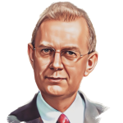Martin Wynn

July 17, 2023

The textile and clothing (T&C) industry has long been associated with unsustainable practices, lacking in recycling and circularity. However, a paradigm shift is underway as the industry recognises the need for change. Here, we explore the transformation of the German T&C industry and assess the role of digital technologies in supporting a more sustainable future.

The textile and clothing industry
The T&C industry is the fourth largest consumer of primary raw materials and water after the food, housing and transport industries, and the fifth largest producer of greenhouse gas emissions. Over the past few decades, the industry has witnessed exponential growth in demand, leading to complex global supply chains in which the European Union (EU) is playing a key role as a major importer and end-user. However, there are growing concerns over energy and water consumption, chemical usage, solid waste production, and CO2 emissions. The current linear system of production in the T&C industry leads to significant resource loss, with less than 1% of textiles being recycled into new products.
More specifically, the industry has undergone significant structural changes in Germany since the 1970s, leading to decreased production and employment. Globalisation and international trade played a major role in this transformation, as German companies faced increasing competition. The fashion industry became globally interconnected, with production processes distributed across different locations. This shift towards internationalisation and cost optimisation through low-tech systems and outsourcing have led to increased competition, resulting in Germany becoming one of the largest importers of textiles.

Sustainability, the circular economy and digitalisation
As part of the Green Deal, the EU has launched a Circular Economy Action Plan, specifically focusing on resource-intensive sectors like textiles and clothing. It aims to transition towards a sustainable circular economy that separates economic growth from resource consumption. The circular economy seeks to preserve natural resources, safeguard the environment and human health, ensure the availability of raw materials, and decrease greenhouse gas emissions, thereby serving as a valuable instrument for climate protection. The EU Strategy for Sustainable and Circular Textiles requires that by 2030 only durable, repairable and recyclable textiles, largely made of recycled fibres, free of hazardous substances and manufactured in compliance with social rights, be placed on the market. The German Government is already taking steps towards implementing this strategy into its national circular economy strategy.
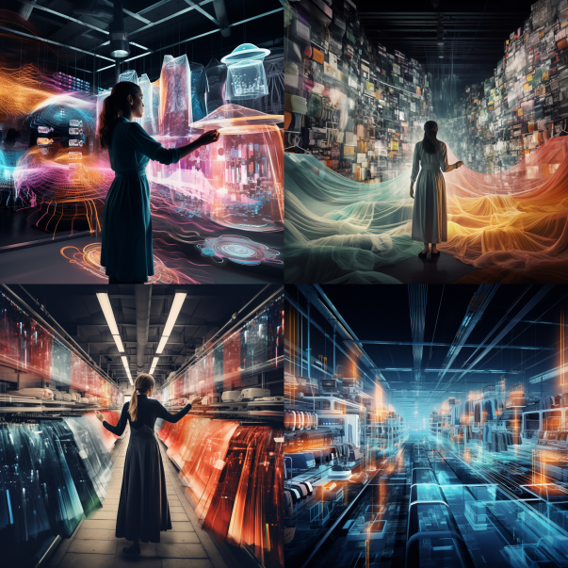Credit. Midjourney

Recent research suggests that digital technologies can support the transition to a circular economy. The Internet of Things (IoT), big data and analytics, for example, have been identified as crucial tools in this transition, offering functionalities like improved product design, monitoring and tracking, technical support, and predictive maintenance. In the T&C industry, transparent traceability and information sharing throughout the supply chain are prerequisites for sustainability and circularity. Still, barriers such as technology availability, economic viability, and digital expertise hinder widespread digitalisation in the industry.

A framework for transitioning to the circular economy
A recent investigation into 29 small and medium-sized T&C companies, largely based in Germany, indicates that the industry is turning, with the circular economy gradually becoming a strategic priority. To fully embrace the circular economy, partnerships and collaborative investments are vital. Companies must gain a holistic understanding of their supply chains to achieve the goals outlined in the EU strategy. This includes the implementation of digital product passports to ensure transparency and traceability throughout the supply chain. Companies need to shift their focus beyond the upstream supply chain and consider downstream processes such as product use, disposal, and recycling, supported by appropriate measures in product development.
A practical operational framework can help companies transition to the circular economy (Figure 1) and act as a top-level blueprint to kick-start and monitor the transition.
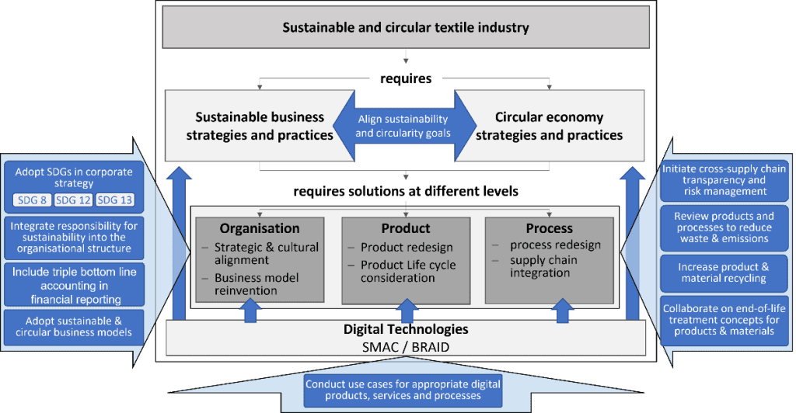Figure 1. Operational framework for transitioning to the circular economy
SDGs = Sustainable Development Goals. SMAC = social media, mobile, analytics/big data, cloud. BRAID = blockchain, robotics, artificial intelligence, internet of things, digital fabrication.
Credit. Wiegand and Wynn, 2023
This blueprint involves aligning circular economy strategies with broader sustainability goals and incorporating them into the overall business strategy. Initiatives to change company culture, instigate training programs, drive through organisational restructuring, and introduce product redesign are crucial. The essential elements are collaboration among supply chain partners, end-of-life treatment, quality assessment, and data transparency. The adoption of digital technologies, through pilot projects and wider technology change initiatives, will further facilitate this transition.
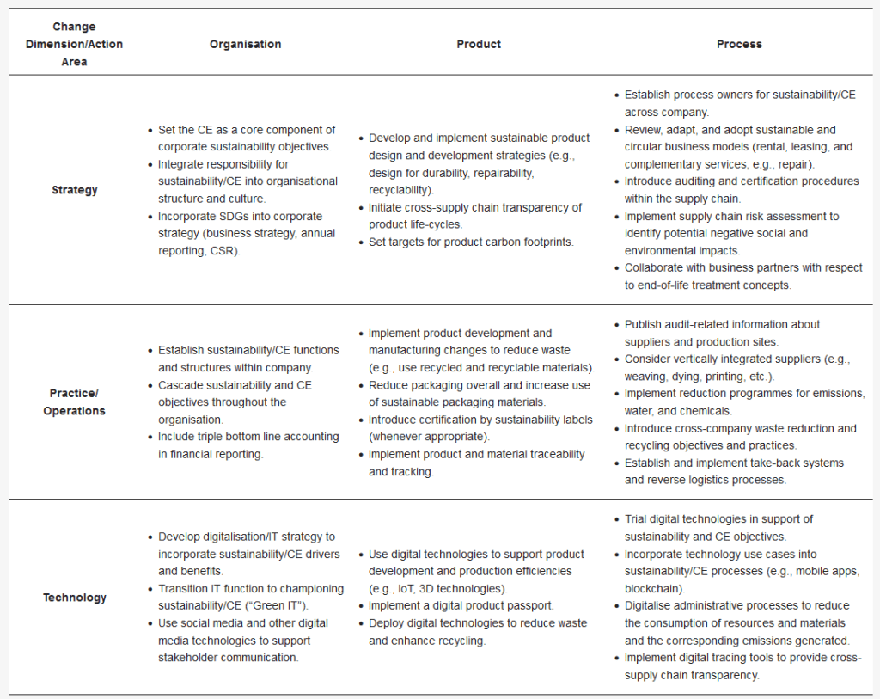Table 1. Action list matrix for transitioning to the circular economy

Table 1 indicates potential actions to support this transition, including those related to product development, manufacturing, and associated processes. These initiatives, while not exhaustive, require coordination, cross-referencing, and effective leadership from the company senior management.

Conclusions
Government regulation and consumer pressure lead many industry sectors to adopt sustainability goals and objectives. To survive and prosper, the T&C industry must radically change its mode of operation and speed its transition to circular economy principles. Digital technologies can play a key role in redesigning products, changing working practices, and adopting new business models across the extended supply chain to create a more sustainable future for the T&C industry.
Journal reference
Wiegand, T., & Wynn, M. (2023). Sustainability, the circular economy and digitalisation in the German textile and clothing industry. Sustainability, 15(11), 9111. https://doi.org/10.3390/su15119111
BIG DATA/CIRCULAR ECONOMY/CLOTHING/DIGITAL TECHNOLOGY/EUROPEAN UNION/FASHION/GERMANY/HOF UNIVERSITY OF APPLIED SCIENCES/INTERNET OF THINGS/SUSTAINABILITY/TEXTILE WASTE/UNITED KINGDOM/UNIVERSITY OF GLOUCESTERSHIRE

- TI
Tina Wiegand is a lecturer at Hof University of Applied Sciences. She completed a dual degree in Business Administration with a focus on supply chain management and a Master's degree with a focus on project management. She worked in the textile industry for over ten years in project and process management, with managerial responsibilities in operational and strategic purchasing for different corporate brands. Additionally, she gained experience in significant systems projects. Currently, she is pursuing a PhD degree at the University of Gloucestershire, UK, researching digitalisation and circularity in the textile supply chain.

Martin Wynn is Associate Professor in Information Technology in the School of Computing and Engineering at the University of Gloucestershire and holds a PhD from Nottingham Trent University. He was appointed Research Fellow at East London University, and he spent 20 years in industry at Glaxo Pharmaceuticals and HP Bulmer Drinks. His research interests include digitalisation, information systems, sustainability, project management, and urban planning. His latest book, Handbook of Research on Digital Transformation, Industry Use Cases, and the Impact of Disruptive Technologies, was published in 2022.

