EE and the SDGs: all in it together?
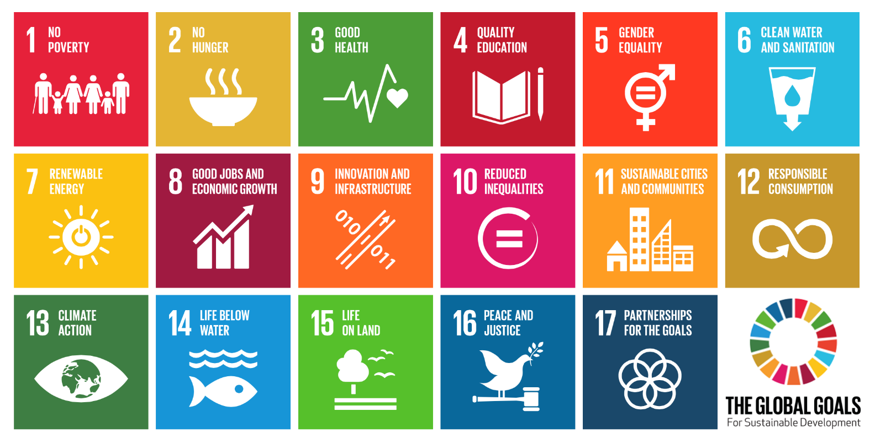
Thinking about where the UN Sustainable Development Goals (SDGs) and environmental education overlap, two answers spring to mind: ‘outside’ and ‘within’.
The outdoors doesn’t come in corralled packages labelled ‘society’, ‘economy’, etc. and neither does the learning that happens there. Whether our topic is arachnids or architecture, by taking it outside we invite our learners to look around them, get some exercise, renegotiate their relationships, develop an interest, if not a passion, for their environment as they begin to make connections between the topic of study and the wider world – as well as, ideally, having fun.
By enabling learners to make these connections, EE transgresses academic disciplines and fixes the learning back into the world we inhabit rather than separating it off.
This is where the SDGs come in. For perhaps the first time, an internationally agreed set of priorities provides us with a map full of connections. At first glance all those coloured boxes can be bewildering but presented as a conclusion to outdoor, connective learning, the SDGs can help us see how health, wealth, cities and spiders might all feature in one overarching framework. The ability to make connections, unforeseen or otherwise, is surely one learning outcome worth measuring.
As for ‘within’ – our minds are no more compartmentalised than the outdoors. Despite the mental frames that schooling imposes as it differentiates between disciplines, we all unlearn this as we reassemble our world in ways that have meaning for us.
Organisations that work on sustainability issues sometimes struggle to find effective ways of framing issues so that they can connect to our busy lives. Again, the SDGs can help us here, not by starting with the whole list of goals but by mapping the connections that start with you and me and lead to the wider concerns that organisations wish to raise. For once we have a set of international priorities that demonstrate that we really are all in it together.
Paul Vare (334 words)

