STAKEHOLDER SATISFACTION SURVEY
CSPN NATIONAL REPORT

February 2013

Prepared by Dr Colin Baker (University of Gloucestershire) on behalf of Active Gloucestershire

Acknowledgements

I am grateful to the Development Group members who contributed to the survey development, particularly Adrian Ledbury and Russell Fairman. Large scale surveys of this type inevitably pose a number of challenges in terms of management and reporting. In this respect I am grateful for the professionalism and positivity of CSP staff from across the Network who helped to address a range of challenges, minimise disruption and aid collective learning across the duration of the survey. I am certain that this survey represents a step forward in the CSPN’s commitment to understanding key stakeholders and provides an example of good practice for future surveys.

Contents
Executive summary i
Process Recommendations ii
Improvement Recommendations iii
1.0 Background 1
1.1 Purpose 1
1.2 Survey Objectives 1
1.3 Survey development 1
1.4 Target Group 1
1.5 Survey methodology 2
2.0 Sample profile 3
2.1 Response rate 3
2.2 Respondent profile 3
3.0 Main Findings 4
3.1 Contact with the CSP 4
3.2 Understanding and knowledge of the role of the CSP 4
3.3 Key Services 5
3.4 Overall Satisfaction with the CSP 8
4.0 Net Promoter Score (NPS) 9
4.1 Overall NPS scores 9
4.2 Key Drivers 10
4.3 Common Threads 11
5.0 Key Comparisons 12
5.1 Satisfaction with Contact 12
5.2 Understanding and knowledge of the role of the CSP 12
5.3 Contact with Key Services 12
5.4 Overall Satisfaction 16
6.0 Recommendations 18
6.1 Process Recommendations 18
6.2 Improvement Recommendations 19
Appendix A: Stakeholder Survey 20
Appendix B: Guidance 33
Appendix C: Response rates for CSPs 36

List of Tables
Table 1: Principal design features 2
Table 2: Type of representation 3
Table 3: Contact with the CSP 4
Table 4: Satisfaction with Key Services (very satisfied – very dissatisfied) 6
Table 5: Satisfaction with Key Services (other responses) 7
Table 6: Satisfaction with Contact – 2011 vs 2012 13
Table 7: Satisfaction with Key Services– 2011 vs 2012 (very satisfied – very dissatisfied) 14
Table 8: Satisfaction with Key Services– 2011 vs 2012 (other responses) 15
Table 9: Overall Satisfaction by Representation – 2011 vs 2012 16

List of Figures

Figure 1: Understanding and knowledge of the role of the CSP 4
Figure 2: Key Services- very satisfied and satisfied (combined %) 5
Figure 3: Overall Satisfaction 8
Figure 4: Overall NPS scores 9
Figure 5: NPS score by representation 10
Figure 6: Understanding and knowledge of the role of the CSP 2011 vs 2012 12
Figure 7: Overall Satisfaction 2011 vs 2012 16
Figure 8: Comparison of 2011 & 2012 satisfaction rates for representation groups 17

Executive summary

The CSPN Stakeholder Survey forms a key element of CSP improvement planning processes. It aims to: gauge stakeholder satisfaction levels with the service offered by CSP core teams (individually and collectively); identify good practice and areas for improvement; provide a tool to support benchmarking across partnerships; provide material for use in advocacy and business planning; help identify the demand for CSP services to support future CSP business development, and help support Sport England monitoring requirements.

Main findings

- In total, 48 of the 49 CSPs took part.
- Approximately 9205 invites were sent and 2264 responses were received (mean response rate 24.6%), exceeding the 2011 survey response rate (13%).
- 1972 valid responses were received, a decrease from the 2011 survey (n = 2576) due to tighter sampling techniques.
- National Governing Bodies of Sport (NGBs) (24.4%), local authority leisure and sport services (20.3%) and community sports clubs (7.3%) were the most represented types of organisation.
- Satisfaction with CSP contact was generally very high with no less than 89.6% of respondents indicating ‘very satisfied’ or ‘satisfied’ in any contact area.
- Respondents were generally clear on the role of the CSP with 82% having a ‘very good’ or ‘good’ understanding, an increase of 5% from the 2011 survey.
- The average rating for respondents who were ‘very satisfied’ or ‘satisfied’ across all key services was 90.1%. Respondents were most satisfied with ‘Coordination of the ‘Sportivate programme’ (93.9%, n = 1427, very satisfied /satisfied), and least satisfied with ‘Advocate for sport on school sites’ (83.1%, n = 897, very satisfied /satisfied). The average rating for respondents who were ‘very satisfied’ or ‘satisfied’ across all key services was 90.1%.
- There was a 1.7% increase in overall satisfaction compared with 2011 (91.9%), with 93.6% of respondents indicating that they were ‘satisfied’ or ‘very satisfied’.
- Satisfaction within partner representation groups revealed that scores exceeded 80% in all cases, with NGBs (96.2%) and Higher/Further Education (97.2%) reporting the highest satisfaction among the most represented partner groups (i.e. more than 100 responses).
- Results showed a general improvement in the relevance of CSP services compared with the 2011 survey.
- The NPS results were favourable. Compared to the nearest sector (health and fitness), the overall NPS result was 3% higher, at 28%.
- There was wide variation in NPS scores between representation groups, the highest being 48% (County NGB / association), the lowest 12% (School Sport, 48%). NGB partners rated the NPS score at 35%.
- Key drivers for NPS promoters were great relationships (personal and professional), and sharing and understanding of objectives.
- Factors that were common to detractors were: Lack of awareness/understanding of what they do; lack of communication, and poor perceived relationship.

Process Recommendations

The 2012 survey highlighted the utility of using a centrally administered approach. To build upon work to date, the following recommendations should be taken into consideration:

- Contractual agreements should provide clear guidelines concerning the role of the commissioning body and delivery partner, and associated partners, to ensure that timings, roles and responsibilities are fully understood. This will improve the overall management process.
- Contact arrangements with specified leads are integral to the management and delivery of the survey. Future surveys should ensure a single point of contact for each CSP is identified and communicated with at the outset of the development process.
- The support service is critical for trust building and problem avoidance. Consideration should be given to the time required to do this effectively in future services. This should be reflected in the project specification.
- A centrally administered survey has been shown to be effective. Equally, providing limited autonomy over the survey content at the local level is effective at engaging CSPs. Future surveys should ensure CSPs are absolutely clear on the approach being employed so as not to disrupt management and delivery of the survey. A series of ‘dos’ and ‘don’ts’ would help establish clear boundaries for activity. Wider consultation with CSP leads is recommended.
- Webinars are useful but not necessarily effective. Technical challenges and software incompatibilities are potentially disruptive and lead to an inefficient use of time. If a ‘catch all’ approach is used to disseminate information about the survey, consideration should be given to alternative or improved methods.
- CSPs should be engaged with in order to ensure consistency of sample size / type. Consistent information from the Development Group for CSP leads to assimilate and discuss the survey process e.g. at MARCOMMS or other quarterly meetings would support this.
- CSPs should be engaged with in order to maximise response rates. Clear and consistent information from the Development Group for CSP leads to assimilate and discuss e.g. at MARCOMMS or other quarterly meetings is critical.
- A significant challenge is to improve the process for partners and NGBs working across multiple CSPs. It is recommended that a single secondary Partner Satisfaction survey is devised to account for these respondents.
- Future surveys should make absolutely clear that URLs relate to specific CSPs i.e. responding to a particular URL implies that a respondent is talking about the CSP from which it originated. Removing the CSP’s name from the list presented in the ‘other CSP’ question on the CSP’s own survey would go some way to solving a number of problems, particularly that of partners using one CSP’s survey to respond about another CSP.

Improvement Recommendations

The data show impressive results in many areas. This should not detract from areas which could be improved upon, including.

- The CSPN Development Group recommends that the CSPN Board and individual CSPs set improvement targets that attempt to increase the number of ‘very satisfied’ partners thereby further improving partner loyalty and commitment.
- In addition to working with key partners around core business, CSPs must maintain a focus on smaller or less well represented organisations for example community organisations to ensure productive partnerships are built and high quality services are delivered irrespective of organisation type.
- Notwithstanding the impressive overall satisfaction figures, CSPs should continue strive to improve all aspects of their services even in areas that are performing well (e.g. advocating for sport on school sites; supporting SGOs to deliver level 2 of the School Games), and focus on acquiring marginal gains across the spectrum of CSP services.
- CSPs should focus on maintaining and improving partners’ overall understanding of the role of the CSP.
- Whilst there was general improvement in the relevance of CSP services compared with the 2011 survey it is recommended that CSPs use their local survey data as a critical element in their improvement journey and business planning, including comparisons with national averages and family clusters.
- Smaller locally-focused and need-led surveys are recommended as a means of investigating and understanding emergent themes within specific groups i.e. HEI, so that services are matched with local needs and preferences.
- The NPS data suggest that loyalty to the CSP ‘brand’ is not consistent across all types of representation. Efforts should be made to understand and address the wide variation in scores.

Background

This section briefly contextualises the County Sports Partnership Network (CSPN) Partner Satisfaction Survey and details the objectives of the survey.

1.1 Purpose

The Survey provides a critical element of the of the continuous improvement and development work programme that serves to inform the 49 individual County Sports Partnerships (CSPs) as part of any current or planned improvement. Primarily, it serves to develop evidence, both at the individual CSP level and collectively across England, that will help to identify examples of good practice, areas for improvement, provide an evidence base for advocacy work, and to help identify the nature of existing and future demands for CSP services.

1.2 Survey Objectives

The CSPN survey forms a key element of CSP improvement planning processes, and as such takes into account themes that are evaluated as part of continuous improvement tools, such as Quest, Towards an Excellent Service (TAES), the Culture and Sport Improvement Toolkit (CSIT) and the emerging CSPN Improvement Framework. The 2012 survey built on the 2011 survey developed by the Development Group and administered by Kent Sport. The survey objectives were:

- To provide a quantitative and qualitative assessment of partners’ views of the partnership.
- To provide data to inform improvement actions.
- To enable benchmarking and comparison at a regional level.

1.3 Survey development

The 2012 survey sought to build on and improve the existing survey and the methodology developed by CSPN Development Group and administered during 2010/11 by Kent Sport. Consultation with the development group revealed 3 key areas for development including:

- A need for both consistency and flexibility in the ways in which data is collected.
- The importance of regular monitoring and communication between CSPs and Project Lead to ensure greater representation of stakeholder types i.e. local authority and sports clubs within the survey sample.
- Simpler and less time-intensive methods of managing the Survey at a local level.

In response, the survey methodology was adjusted accordingly (see Section 1.5) and a revised survey and guidance developed (see Appendix A and B).

1.4 Target Group

The target group was defined as all key stakeholders working directly with your CSP over the past 12 months. To maximise the response rate CSPs were asked to consider whether the stakeholder was able to complete the majority of the questions based on their work with the CSPs over the past 12 months.

Those that did not fall into the target group included:

- someone who could not complete the majority of questions;
- a partner who sat on a local steering group but did not work directly with a CSP;
- individual volunteers or coaches;
- partners working across all or multiple CSPs (eg very small NGBs or national partners with only national officers);
- Sport England staff.

1.5 Survey methodology

A pragmatic methodology (Table 1) was deployed to meet the survey objectives. This sought to introduce a high degree of flexibility to facilitate the set-up, administration, sampling, data collection and data analysis processes involved in the survey. It also supported the development of a responsive support service to ensure that the needs and contexts of CSPs were recognised and understood.

Table 1: Principal design features

Criteria | Details / key procedures
Project rationale | To listen and respond to stakeholder needs.
Methodological framework | Pragmatic (in order to provide flexibility and responsiveness).
Sampling strategy | a. Quota sampling. This allowed for a population i.e. stakeholders, to be segmented into sub-groups and provided a means of targeting and managing responses. This sought to facilitate sampling and help ensure that a range of sub-groups were included.
Sampling techniques | a. Snowball (identifying stakeholders using local knowledge and key CSP contacts). b. Opportunistic (recruiting stakeholders as and when opportunities arise).
Data collection | a. Stakeholder survey via an online survey tool (Survey Monkey). The survey contained two components. Component 1 contained standardised questions addressing core areas for all stakeholders (to maintain continuity with the 2011 survey). Component 2 contained a selection of questions modified to meet the needs of CSPs and will reflect local circumstances. Questions in component 2 were amended after consultation with CSPs where appropriate so that continuity was maintained with the 2011 survey. Survey Monkey allowed for the central administration of the survey. Each CSP was provided with an individual survey accessed via a unique and secure survey URL allowing for customised data collection and reporting.
Data analysis | a. Data cleaning prior to installation in IBM-SPSS v.16 for analysis to filter out void responses i.e. empty responses. b. Descriptive statistics e.g. type of representation, etc. c. Comparative analysis i.e. analysis of stakeholder perceptions concerning CSPs in relation to the 2011 survey results.
Support service | CSPs were supported throughout the duration of the survey including online webinars* and an email and telephone support service.
*Of the 49 CSPs, 20 (41%) accessed webinar support.

2.0 Sample profile

This section presents the response rate and respondent profile.

2.1 Response rate

In total, 48of the 49 CSPs took part in the survey (see Appendix C). Two additional surveys were created to meet the needs of the local context (Pan London and a Partnership Survey for NGBs). Approximately 9205 invites were sent by CSP staff and 2264 responses were received. The combined response rate across all CSPs (mean) was 24.6%. This exceeded the 2011 survey response rate of 13%.The highest overall response rate was 57% (West Yorkshire Sport); the lowest was 7.3% (Lancashire Sport Partnership).

2.2 Respondent profile

In total, 1972 valid responses were received indicating a decrease from the 2011 survey (n = 2576) of 604. The highest representation in the sample was National governing body of sport (NGB) (Table 2), the lowest was ‘Other’. Combined with ‘Local authority – other’ (n = 84, 4.3%) this group represented a diverse range of partners including local authority services, community interest groups, consultants, tourism partners, disability services, and virtual schools.

Table 2: Type of representation

Type | N | %
National governing body of sport (NGB) | 481 | 24.4
Local authority - leisure/sport service | 400 | 20.3
Community sports club | 144 | 7.3
School Sport | 237 | 12.0
Higher / Further Education | 123 | 6.2
Facility / leisure operator | 49 | 2.5
Health partner | 54 | 2.7
Charity | 113 | 5.7
County governing body of sport or association | 42 | 2.1
Other community group / association | 40 | 2.0
National sports agency | 18 | 0.9
Other private sector partner | 31 | 1.6
Local authority - other | 84 | 4.3
Private coaching company | 23 | 1.2
Professional sports club | 15 | 0.8
Volunteering partner (e.g. volunteer centre) | 11 | 0.6
Skills / training partner | 5 | 0.3
Arts partner | 6 | 0.3
Youth club | 6 | 0.3
Tourism partner | 3 | 0.2
Uniform group | 3 | 0.2
Transport partner | 1 | 0.1
Community safety partner | 4 | 0.2
Economic regeneration partner | 5 | 0.3
Other | 74 | 3.8
Total | 1972 | 100.0

Main Findings

This section presents a summary of the main findings for the whole sample. The results are presented in order of the survey questions. Blank responses were removed to increase the fidelity of the results.

3.1 Contact with the CSP

Satisfaction with contact was generally very high (Table 3). Combining the two highest ratings revealed that no less than 89.6% were ‘very satisfied’ or ‘satisfied’ across all the items (Usefulness of the CSP’s website content), with ‘Professionalism and helpfulness of staff’ showing 95.9% ‘very satisfied’ or ‘satisfied’ overall.

Table 3: Contact with the CSP
Item | Very satisfied |  | Satisfied |  | Dissatisfied |  | Very dissatisfied
Item | n | % | n | % | n | % | n | %
Understanding of your organisation’s / group’s needs | 600 | 31.3 | 1195 | 62.2 | 105 | 5.5 | 20 | 1.0
Providing a lead role for sport and physical activity | 581 | 31.0 | 1132 | 60.3 | 129 | 6.9 | 35 | 1.9
Adding value to the services that you provide | 596 | 31.7 | 1092 | 58.0 | 152 | 8.1 | 43 | 2.3
Professionalism and helpfulness of staff | 1102 | 56.6 | 787 | 40.4 | 44 | 2.3 | 13 | 0.7
Accessibility of staff to assist with requests and queries | 923 | 47.9 | 920 | 47.7 | 72 | 3.7 | 12 | 0.6
Speed of response to telephone and email enquiries | 862 | 45.3 | 939 | 49.3 | 83 | 4.4 | 19 | 1.0
Quality of support and advice given | 794 | 41.5 | 994 | 52.0 | 103 | 5.4 | 21 | 1.1
Usefulness of the CSP’s website content | 444 | 24.8 | 1200 | 67.1 | 105 | 5.9 | 39 | 2.2
Note: Highest scores per item are emboldened. Response ‘don’t know’ is excluded from the results (n = 50 to 182 across all items). Categories n and % adjusted accordingly.

3.2 Understanding and knowledge of the role of the CSP

Respondents were generally clear on the role of the CSP (Figure 1), with 82% having a ‘very good’ or ‘good’ understanding (n = 1612).

Figure 1: Understanding and knowledge of the role of the CSP

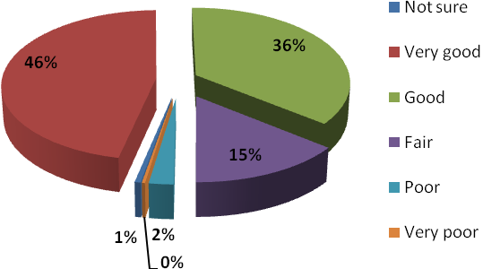

(Missing: n = 15)

3.3 Key Services

Respondents indicated their level of satisfaction with the key services provided by CSPs to support the development of sport and physical activity. Combining the categories ‘very satisfied’ and ‘satisfied’ (Figure 2) revealed that Coordination of the Sportivate programme’ had the highest rating (93.9%, n = 1427) whilst ‘advocate for sport on school sites’ had the lowest rating (83.1%, n = 897) (see Table 4).

As a crude measure, the average rating for respondents who were ‘very satisfied’ or ‘satisfied’ across all 16 items was 90.1%.

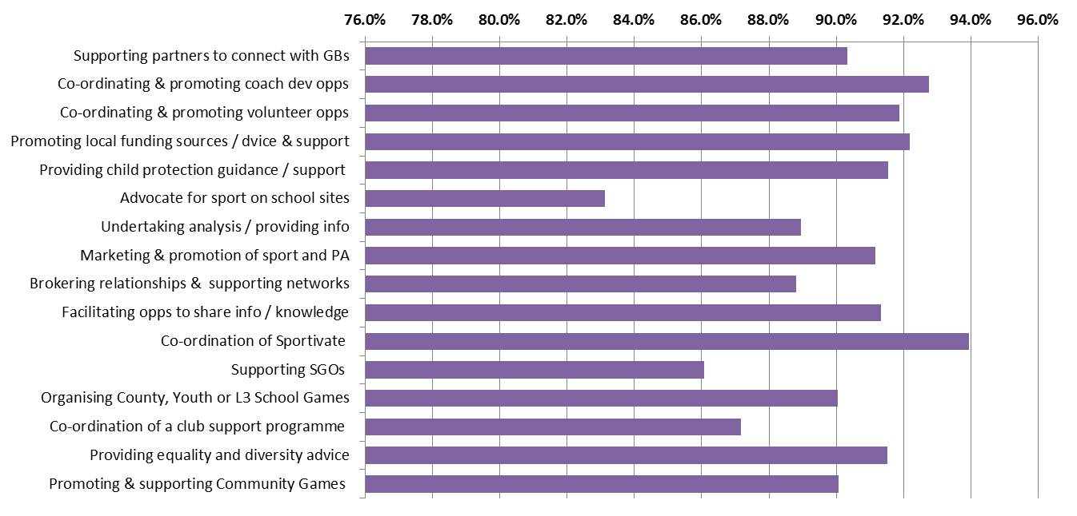
Figure 2: Key Services- very satisfied and satisfied (combined %)
Note: Scores are based only on those responding to the categories: ‘very satisfied’, ‘satisfied’, ‘dissatisfied’, ‘very dissatisfied’.

A range of responses including ‘not aware’ allowed participants to highlight a range of perceptions including a lack of awareness of services or those that were under used (see Table 5) Overall, ratings for ‘dissatisfied’ or ‘very dissatisfied’ did not exceed 12.8% (n = 138) across any of the 16 items (see table 5).

Table 4: Satisfaction with Key Services (very satisfied – very dissatisfied)

n
Item | Very satisfied / satisfied | Very Satisfied |  | Satisfied |  |  | Dissatisfied |  |  |  | Very dissatisfied
Item | Very satisfied / satisfied | n | % | n | % |  | n |  | % |  | n |  | % |  | n |  | %
1 | Supporting local partners to connect with Governing Bodies of Sport | 1391 | 90.3 | 476 |  | 30.9 |  | 915 |  | 59.4 |  | 121 |  | 7.9 |  | 28 |  | 1.8
2 | Co-ordinating and promoting coach development opportunities | 1470 | 92.7 | 522 |  | 32.9 |  | 948 |  | 59.8 |  | 96 |  | 6.1 |  | 19 |  | 1.2
3 | Co-ordinating and promoting volunteer development and deployment opportunities (e.g. Sport Makers) | 1438 | 91.9 | 508 |  | 32.5 |  | 930 |  | 59.4 |  | 102 |  | 6.5 |  | 25 |  | 1.6
4 | Promoting local funding sources and providing advice and support, (including Sport England Lottery Funding opportunities, Sportivate, Community Games) | 1544 | 92.2 | 676 |  | 40.4 |  | 868 |  | 51.8 |  | 106 |  | 6.3 |  | 25 |  | 1.5
5 | Providing child protection guidance and support Advocate for sport on school sites | 1092 | 91.5 | 317 |  | 26.6 |  | 775 |  | 65.0 |  | 82 |  | 6.9 |  | 19 |  | 1.6
6 | Advocate for sport on school sites | 897 | 83.1 | 232 |  | 21.5 |  | 665 |  | 61.6 |  | 138 |  | 12.8 |  | 44 |  | 4.1
7 | Undertaking analysis and providing information (e.g. Partner priorities and plans, mapping, Active People, market segmentation) | 1214 | 88.9 | 361 |  | 26.4 |  | 853 |  | 62.5 |  | 121 |  | 8.9 |  | 30 |  | 2.2
8 | Marketing and promotion of sport and physical activity (e.g. website, e-newsletter, social media) | 1507 | 91.2 | 507 |  | 30.7 |  | 1000 |  | 60.5 |  | 118 |  | 7.1 |  | 28 |  | 1.7
9 | Brokering relationships and providing support for local/county networks (e.g. CSNs) | 1334 | 88.8 | 490 |  | 32.6 |  | 844 |  | 56.2 |  | 123 |  | 8.2 |  | 45 |  | 3.0
10 | Facilitating opportunities for partners to share information and knowledge (meetings, workshops, electronically) | 1504 | 91.3 | 606 |  | 36.8 |  | 898 |  | 54.5 |  | 119 |  | 7.2 |  | 24 |  | 1.5
11 | Co-ordination of the Sportivate programme | 1427 | 93.9 | 658 |  | 43.3 |  | 769 |  | 50.6 |  | 76 |  | 5.0 |  | 16 |  | 1.1
12 | Supporting SGOs to deliver level 2 of the School Games, helping to find and deploy volunteers | 865 | 86.1 | 278 |  | 27.7 |  | 587 |  | 58.4 |  | 110 |  | 10.9 |  | 30 |  | 3.0
13 | Organising County, Youth or Level 3 School Games / activities | 1022 | 90.0 | 384 |  | 33.8 |  | 638 |  | 56.2 |  | 93 |  | 8.2 |  | 20 |  | 1.8
14 | Co-ordination of a club support programme (e.g. Clubmark) | 998 | 87.2 | 302 |  | 26.4 |  | 696 |  | 60.8 |  | 118 |  | 10.3 |  | 29 |  | 2.5
15 | Providing equality and diversity advice | 1003 | 91.5 | 287 |  | 26.2 |  | 716 |  | 65.3 |  | 71 |  | 6.5 |  | 22 |  | 2.0
16 | Promoting and supporting the local delivery of the Community Games e.g. provision of training, promotional material, additional grant aid. | 1051 | 90.1 | 321 |  | 27.5 |  | 730 |  | 62.6 |  | 91 |  | 7.8 |  | 25 |  | 2.1

Note: Excluding Very/Satisfied combined, highest categories are emboldened. Missing: n = 161 to 208 across items. Scores are based only on those responding to the categories: ‘very satisfied’, ‘satisfied’, ‘dissatisfied’, ‘very dissatisfied’.

Table 5: Satisfaction with Key Services (other responses)

n | Item | Unaware of |  | Not accessed |  | Not relevant
n | Item | n | % | n | % | n | %
1 | Supporting local partners to connect with Governing Bodies of Sport | 55 | 3.0 | 125 | 6.9 | 91 | 5.0
2 | Co-ordinating and promoting coach development opportunities | 26 | 1.5 | 110 | 6.2 | 56 | 3.2
3 | Co-ordinating and promoting volunteer development and deployment opportunities (e.g. Sport Makers) | 40 | 2.2 | 151 | 8.3 | 54 | 3.0
4 | Promoting local funding sources and providing advice and support, (including Sport England Lottery Funding opportunities, Sportivate, Community Games) | 32 | 1.8 | 78 | 4.3 | 26 | 1.4
5 | Providing child protection guidance and support Advocate for sport on school sites | 122 | 6.7 | 374 | 20.7 | 122 | 6.7
6 | Advocate for sport on school sites | 221 | 12.5 | 308 | 17.4 | 167 | 9.4
7 | Undertaking analysis and providing information (e.g. Partner priorities and plans, mapping, Active People, market segmentation) | 127 | 7.0 | 247 | 13.6 | 72 | 4.0
8 | Marketing and promotion of sport and physical activity (e.g. website, e-newsletter, social media) | 35 | 1.9 | 99 | 5.5 | 24 | 1.3
9 | Brokering relationships and providing support for local/county networks (e.g. CSNs) | 85 | 4.7 | 156 | 8.6 | 68 | 3.8
10 | Facilitating opportunities for partners to share information and knowledge (meetings, workshops, electronically) | 61 | 3.4 | 71 | 3.9 | 32 | 1.8
11 | Co-ordination of the Sportivate programme | 48 | 2.7 | 139 | 7.8 | 69 | 3.9
12 | Supporting SGOs to deliver level 2 of the School Games, helping to find and deploy volunteers | 161 | 9.2 | 312 | 17.8 | 277 | 15.8
13 | Organising County, Youth or Level 3 School Games / activities | 133 | 7.3 | 279 | 15.4 | 263 | 14.5
14 | Co-ordination of a club support programme (e.g. Clubmark) | 129 | 7.3 | 333 | 18.8 | 168 | 9.5
15 | Providing equality and diversity advice | 154 | 8.5 | 438 | 24.2 | 123 | 6.8
16 | Promoting and supporting the local delivery of the Community Games e.g. provision of training, promotional material, additional grant aid. | 134 | 7.6 | 327 | 18.5 | 139 | 7.9
Note: Highest categories are emboldened. Missing: n = 161 to 208 across items. Scores are based on whole sample and all responses for Key Services.

3.4 Overall Satisfaction with the CSP

Overall, 93.6% (n = 1617) of respondents indicated that they were ‘satisfied’ or ‘very satisfied’ (Figure 3). Those who indicated that they were ‘dissatisfied’ or ‘very dissatisfied’ with their CSP accounted for 6.4% of the sample (n = 110).

Figure 3: Overall Satisfaction
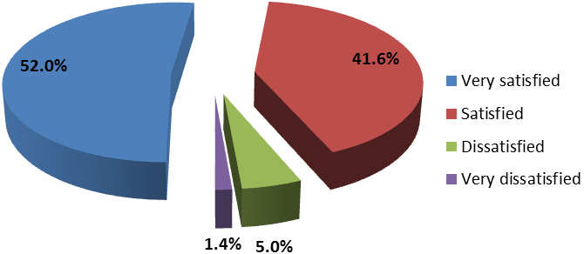
Note: For the purposes of reporting, overall score is adjusted to exclude ‘Not sure’ (n = 37). Overall satisfaction i.e. those ‘satisfied’ or ‘very satisfied’ when ‘Not sure’ included = 91.7%.

4.0 Net Promoter Score (NPS)

The the Net Promoter Score (NPS)® is a customer loyalty metric. Respondents answered a single question on a 0 to 10 rating scale: “How likely is it that you would recommend our company to a friend or colleague?” Respondents were categorised into one of three groups: Promoters (9-10 rating: loyal enthusiasts who keep buying from a company and urge their friends to do the same); Passives (7-8 rating: satisfied but unenthusiastic customers who can be easily wooed by the competition), and Detractors (0-6 rating: unhappy customers trapped in a bad relationship).

The percentage of detractors was subtracted from the percentage of promoters to obtain a Net Promoter score providing a clear measure of organisational performance. A score of 75 per cent or above is considered quite high. One of the basic premises behind NPS is that “satisfaction alone in not enough”. Research shows that typically 80% of people that leave or stop a service are actually “satisfied”, showing that satisfaction does not necessarily mean loyalty.

4.1 Overall NPS scores

Figure 4 highlights the NPS scores from the CSPN survey in comparison with the current NPS averages for the health and fitness sector i.e. the most relevant sector for comparison.

Figure 4: Overall NPS scores (%)
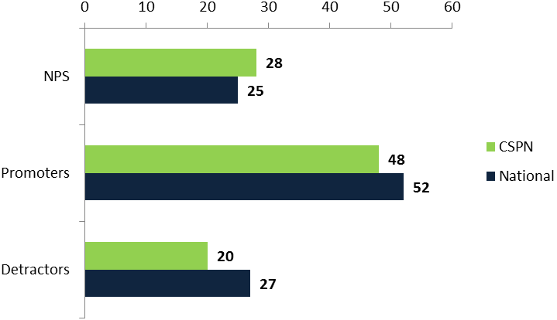

Figure 5 (overleaf) highlights overall NPS scores for representation groups. This demonstrates that there was wide variation in scores with 36% difference between the highest (County NGB / association, 48%) and lowest scores (School Sport, 12%). NGB partners rated the NPS score at 35%.

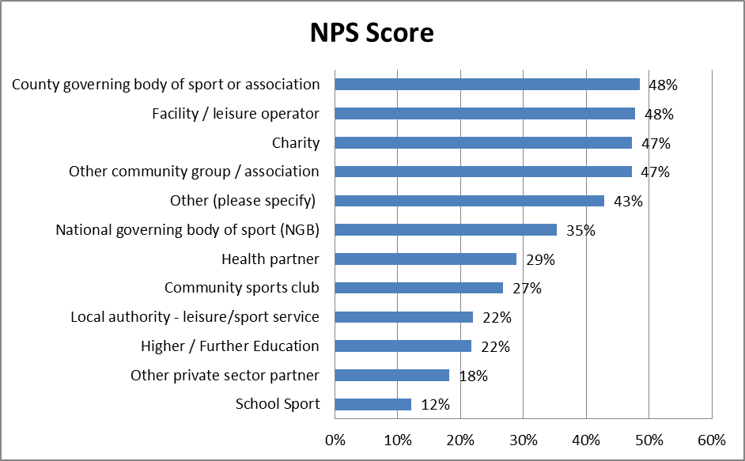
Figure 5: NPS score by representation

4.2 Key Drivers

The NPS question is always followed up with a supplementary question “why?” Below is a selection of comments relating to each of the groups that help give an understanding of what drives Detractors, Passives and Promoters. Generally speaking delivering the basics or “hygiene” factors will deliver a Passive score but most Promoter scores are only achieved where relationships are perceived to be key and overwhelmingly positive.

Detractors
- I am not really aware of what CSP can offer so I would not be able to recommend them.
- Lack of action!! Very strategic (almost too much sometimes) and seem to make things difficult rather than working with us
- As I don't believe they produce any support or assistance in any of our projects we deliver.
- I don't see the relevance of it anymore, it’s too rigid, and it doesn't have much to do that is useful.
- The CSP does not communicate any new ideas or lead as expected. The service I work for offers more support
- High level of expert knowledge that would provide the correct information to the colleague
- They have done very little to help us but we can and have helped them quite a lot.
- Not supportive at all, more a business operation rather than the CSP core specification

Passives
- The CSP offer's a professional service to customers, the challenge is getting greater definition of these services linked to swimming in Cumbria
- The CSP are very approachable and friendly. Whilst they are willing to market activities within their social media/newsletter this has not seemed to of had any significant effect on our targets. More support is needed to reach out to the wider audience.
- They have been supportive to our club but a bit more support in funding would be good
- Although we are well aware of the CSP we only make use of it in a limited way and therefore marked accordingly
- The staff at our CSP are very supportive and enthusiastic. The only reason I am not very likely to recommend to colleagues is that if you don't work in Sports development directly misunderstandings can easily come about. Club Coaches are particularly intimidated by the paperwork they are asked to complete which is where SDOs are often required.
- Too many overlaps of services need to streamline a lot in order for sports to all pull together to create a sportier and healthier nation. Sport development is too complicated!

Promoters
- Having worked closely with our CSP, I am more aware of its work and have been impressed with the professionalism and enthusiasm of all of its staff. I think it could publicise and promote its work more widely so that more people could access it.
- Overall the CSP provide a very good support to local clubs and sports bodies
- positive beneficial relationship
- I would always ensure partners contact the CSP for support and guidance.
- I have only been in my role with NGB for 4 months, however, I have always received accurate up to date information and find the CSP very approachable and knowledgeable and helpful to assist with my job.
- Friendly, effective staff members within the CSP
- Happy with the service provided
- Very helpful and friendly. Good advice / support provided and good knowledge of the local areas / partners
- Very professional and approachable staff
- the staff have been so helpful and given us a lead in sport development within the third sector sharing expertise and information so we can bring more sport to the sector and young people
- I regularly recommend the relevant CSP to colleagues for specific things.

4.3 Common Threads

The concept behind NPS is to identify the key drivers for each group and then address these on both an individual basis but also strategically by looking at common threads. The aim is to move people “up” the scale, from Detractors to Passives, or from Passives to Promoters. The common threads for the CSPN were:

  - Promotion
      - great relationships – personal and professional
      - sharing and understanding of objectives
  - Detraction
      - Lack of awareness/understanding of what they do
      - Lack of communication
      - Poor perceived relationship

5.0 Key Comparisons

This section presents key data comparisons between the 2012 data and the 2011 survey.

5.1 Satisfaction with Contact

Results were positive for all items which saw approximate increases of 5% for those classified as ‘very satisfied/ satisfied’ with the exception of ‘Adding value to the services that you provide’ which increase by nearly 10% (Table 6). The number of respondents dissatisfied increased for two contact items; ‘quality of support and advice given’ (0.5%), and ‘speed of response to telephone and email enquiries’ (0.3%). The number of respondents very dissatisfied increased on one item (usefulness of the CSP’s website, 0.7%). Overall, the number of those stating ‘don’t know’ decreased across all items.

5.2 Understanding and knowledge of the role of the CSP

The results were positive in relation to the 2011 survey demonstrating an increase of 5% in those stating ‘very good’ or ‘good’ (Figure 6), although 2% (n = 45) indicated a poor understanding.

Figure 6: Understanding and knowledge of the role of the CSP – 2011 vs 2012 (%)
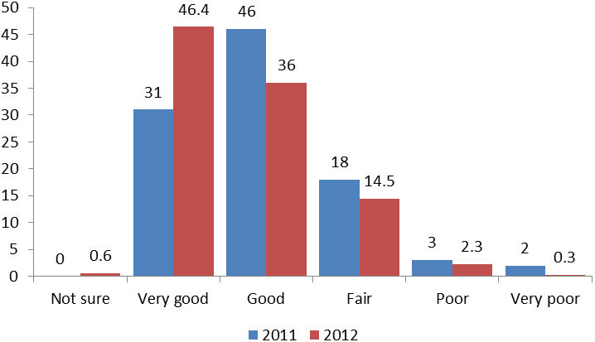

5.3 Contact with Key Services

Results were positive for all items, the biggest increase for those classified as ‘very satisfied/ satisfied’ being for ‘promoting local funding sources’ (27.8%) (Tables 7 and 8). There was a decrease in those responding ‘satisfied’ for the item ‘advocate for sport on school sites’ (7.5%) although the item was worded differently in 2011. The number of respondents who indicated that they were satisfied with services showed the biggest movement i.e. the category with the greatest overall improvement in scores between 2011 and 2012. A general improvement in the relevance of services was evident (2.0 - 4.2%).
Table 6: Satisfaction (%) with Contact – 2011 vs 2012

Item | Very satisfied/ satisfied |  | Very satisfied |  | Satisfied |  | Dissatisfied |  | Very dissatisfied |  | Don’t know
Item | 2011 | 2012 | 2011 | 2012 | 2011 | 2012 | 2011 | 2012 | 2011 | 2012 | 2011 | 2012
Understanding of your organisation’s / group’s needs | 85.6 | 91.2 | 26.2 | 30.5 | 59.4 | 60.7 | 6.2 | 5.3 | 1.7 | 1.0 | 6.6 | 2.5
Providing a lead role for sport and physical activity | 82.6 | 87.0 | 27.3 | 29.5 | 55.3 | 57.5 | 7.8 | 6.5 | 2.2 | 1.8 | 7.4 | 4.7
Adding value to the services that you provide | 76.3 | 85.7 | 25.4 | 30.3 | 50.9 | 55.4 | 9.8 | 7.7 | 3.1 | 2.2 | 10.7 | 4.4
Professionalism and helpfulness of staff | 91.7 | 95.8 | 52.8 | 55.9 | 38.9 | 39.9 | 2.6 | 2.2 | 0.9 | 0.7 | 4.9 | 1.2
Accessibility of staff to assist with requests and queries | 88.3 | 93.6 | 41.0 | 46.9 | 47.3 | 46.7 | 4.1 | 3.7 | 1.1 | 0.6 | 6.5 | 2.2
Speed of response to telephone and email enquiries | 87.1 | 91.5 | 41.0 | 43.8 | 46.1 | 47.7 | 3.9 | 4.2 | 1.2 | 1.0 | 7.8 | 3.4
Quality of support and advice given | 85.5 | 90.8 | 36.3 | 40.3 | 49.2 | 50.5 | 4.8 | 5.2 | 1.6 | 1.1 | 8.1 | 2.9
Usefulness of the CSP’s website content | 79.5 | 83.4 | 21.6 | 22.5 | 57.9 | 60.9 | 7.5 | 5.3 | 1.3 | 2.0 | 11.6 | 9.2
Note: Items are only shown where direct comparisons are possible between the 2011 and 2012 surveys. As such, some items from the 2011 survey are excluded.
Table 7: Satisfaction with Key Services– 2011 vs 2012 (very satisfied – very dissatisfied)
n | Item | Very satisfied / satisfied |  | Very Satisfied |  | Satisfied |  | Dissatisfied |  | Very dissatisfied
n | Item | ‘11 | ‘12 | ‘11 | ‘12 | ‘11 | ‘12 | ‘11 | ‘12 | ‘11 | ‘12
1 | Supporting local partners to connect with Governing Bodies of Sport | 67.2 | 76.8 | 20.0 | 26.3 | 47.2 | 50.5 | 7.5 | 6.7 | 1.5 | 1.5
2 | Co-ordinating and promoting coach development opportunities† | 57.2 | 82.7 | 18.0 | 29.4 | 39.2 | 53.3 | 7.0 | 5.4 | 1.1 | 1.1
3 | Co-ordinating and promoting volunteer development and deployment opportunities (e.g. Sport Makers) | 57.2 | 79.5 | 18.0 | 28.1 | 39.2 | 51.4 | 7.0 | 5.6 | 1.1 | 1.4
4 | Promoting local funding sources and providing advice and support, (including Sport England Lottery Funding opportunities, Sportivate, Community Games) | 57.4 | 85.2 | 17.8 | 37.3 | 39.6 | 47.9 | 8.0 | 5.9 | 1.4 | 1.4
5 | Providing child protection guidance and support | 55.1 | 60.3 | 17.3 | 17.5 | 37.8 | 42.8 | 4.8 | 4.5 | 0.5 | 1.0
6 | Advocate for sport on school sites ^{ⱡ} | 57.0 | 50.6 | 13.1 | 13.1 | 43.9 | 37.5 | 7.8 | 7.8 | 1.4 | 2.5
7 | Undertaking analysis and providing information (e.g. Partner priorities and plans, mapping, Active People, market segmentation)^{ⱡ} | 56.0 | 67.0 | 16.4 | 19.9 | 39.6 | 47.1 | 6.1 | 6.7 | 1.2 | 1.7
8 | Marketing and promotion of sport and physical activity (e.g. website, e-newsletter, social media) | 72.5 | 83.2 | 20.5 | 28.0 | 52.0 | 55.2 | 7.6 | 6.5 | 1.2 | 1.5
9 | Brokering relationships and providing support for local/county networks (e.g. CSNs) | 64.8 | 73.7 | 20.6 | 27.1 | 44.2 | 46.6 | 7.3 | 6.8 | 1.5 | 2.5
10 | Facilitating opportunities for partners to share information and knowledge (meetings, workshops, electronically)^{ⱡ} | 73.4 | 83.1 | 23.0 | 33.5 | 50.4 | 49.6 | 6.6 | 6.6 | 1.2 | 1.3
11 | Co-ordination of the Sportivate programme | n/a | 80.4 | n/a | 37.1 | n/a | 43.3 | n/a | 4.3 | n/a | 0.9
12 | Supporting SGOs to deliver level 2 of the School Games, helping to find and deploy volunteers | n/a | 49.2 | n/a | 15.8 | n/a | 33.4 | n/a | 6.3 | n/a | 1.7
13 | Organising County, Youth or Level 3 School Games / activities | n/a | 56.4 | n/a | 21.2 | n/a | 35.2 | n/a | 5.1 | n/a | 1.1
14 | Co-ordination of a club support programme (e.g. Clubmark) | n/a | 56.2 | n/a | 17.0 | n/a | 39.2 | n/a | 6.6 | n/a | 1.6
15 | Providing equality and diversity advice | 49.3 | 55.3 | 12.6 | 15.8 | 36.7 | 39.5 | 4.8 | 3.9 | 0.6 | 1.2
16 | Promoting and supporting the local delivery of the Community Games e.g. provision of training, promotional material, additional grant aid. | n/a | 59.5 | n/a | 18.2 | n/a | 41.3 | n/a | 5.1 | n/a | 3.2
† Items 2 and 3 were run as one item in 2011.^{ⱡ} 2011 and 2012 question item wording differed slightly but pertained to same work area. Based on responses from the whole sample. Responses; ‘unaware of’, ‘not accessed’, and ‘not relevant’ are not shown but count toward the overall %.

Table 8: Satisfaction with Key Services– 2011 vs 2012 (other responses)

n | Item | Unaware of |  | Not accessed |  | Not relevant
n | Item | ‘11 | ‘12 | ‘11 | ‘12 | ‘11 | ‘12
1 | Supporting local partners to connect with Governing Bodies of Sport | 7.1 | 3.0 | 9.8 | 6.9 | 7.0 | 5.0
2 | Co-ordinating and promoting coach development opportunities† | 5.3 | 1.5 | 9.3 | 6.2 | 6.0 | 3.2
3 | Co-ordinating and promoting volunteer development and deployment opportunities (e.g. Sport Makers) | 5.3 | 2.2 | 9.3 | 8.3 | 6.0 | 3.0
4 | Promoting local funding sources and providing advice and support, (including Sport England Lottery Funding opportunities, Sportivate, Community Games) | 6.7 | 1.8 | 8.4 | 4.3 | 4.2 | 1.4
5 | Providing child protection guidance and support | 9.0 | 6.7 | 19.7 | 20.7 | 10.9 | 6.7
6 | Advocate for sport on school sites ^{ⱡ} | 11.5 | 12.5 | 13.1 | 17.4 | 9.2 | 9.4
7 | Undertaking analysis and providing information (e.g. Partner priorities and plans, mapping, Active People, market segmentation)^{ⱡ} | 10.6 | 7.0 | 17.6 | 13.6 | 8.5 | 4.0
8 | Marketing and promotion of sport and physical activity (e.g. website, e-newsletter, social media) | 5.6 | 1.9 | 8.9 | 5.5 | 4.3 | 1.3
9 | Brokering relationships and providing support for local/county networks (e.g. CSNs) | 8.1 | 4.7 | 11.5 | 8.6 | 7.1 | 3.8
10 | Facilitating opportunities for partners to share information and knowledge (meetings, workshops, electronically)^{ⱡ} | 6.2 | 3.4 | 8.4 | 3.9 | 4.2 | 1.8
11 | Co-ordination of the Sportivate programme | n/a | 2.7 | n/a | 7.8 | n/a | 3.9
12 | Supporting SGOs to deliver level 2 of the School Games, helping to find and deploy volunteers | n/a | 9.2 | n/a | 17.8 | n/a | 15.8
13 | Organising County, Youth or Level 3 School Games / activities | n/a | 7.3 | n/a | 15.4 | n/a | 14.5
14 | Co-ordination of a club support programme (e.g. Clubmark) | n/a | 7.3 | n/a | 18.8 | n/a | 9.5
15 | Providing equality and diversity advice | 10.5 | 8.5 | 25.0 | 24.2 | 9.9 | 6.8
16 | Promoting and supporting the local delivery of the Community Games e.g. provision of training, promotional material, additional grant aid. | n/a | 7.6 | n/a | 18.5 | n/a | 7.9
† Items 2 and 3 were run as one item in 2011.^{ⱡ} 2011 and 2012 question item wording differed slightly but pertained to same work area. Responses; ‘very satisfied’, ‘satisfied’,
‘dissatisfied’ and ‘very dissatisfied’ are not shown but count toward the overall %.

5.4 Overall Satisfaction

Data comparisons revealed that there was an increase in overall satisfaction of 1.7% between 2011 and 2012 (Figure 7), and a large increase (15.9%) in the number of people responding ‘very satisfied’.
Figure 7: Overall Satisfaction (%) – 2011 vs 2012
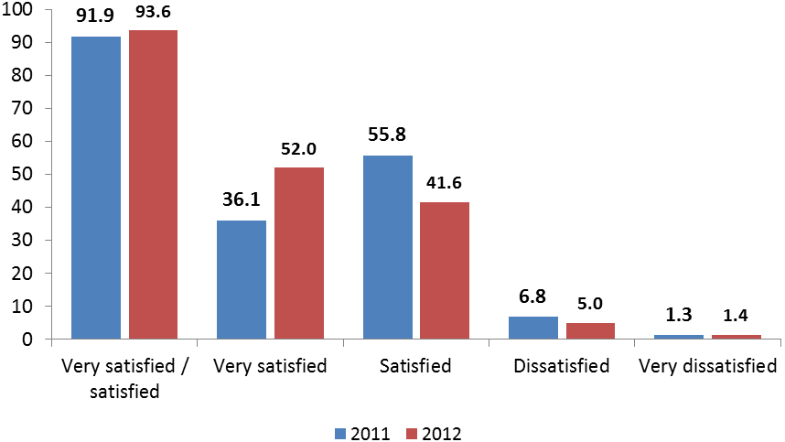

Table 9 and Figure 8 overleaf contrast the 2011 and 2012 survey results for representation type.

Table 9: Overall Satisfaction by Representation – 2011 vs 2012
Representation | 2011 |  | 2012 |  | + / -
 | n | % | n | % | + / -
National governing body of sport (NGB) | 401 | 97.1 | 409 | 96.2 | -0.9
Local authority - leisure/sport service | 279 | 89.4 | 315 | 92.1 | 2.7
Community sports club | 141 | 86.0 | 111 | 90.2 | 4.2
School Sport | 114 | 87.0 | 189 | 88.3 | 1.3
Higher / Further Education | 89 | 95.7 | 104 | 97.2 | 1.5
Facility / leisure operator | 65 | 89.0 | 42 | 93.3 | 4.3
Health partner | 71 | 94.7 | 49 | 98.0 | 3.3
Charity | 69 | 93.2 | 93 | 95.9 | 2.7
County governing body of sport or association | 63 | 90.0 | 34 | 97.1 | 7.1
Other community group / association | 36 | 100 | 35 | 94.6 | -5.4
National sports agency | 26 | 96.3 | 14 | 100 | 3.7
Local authority - other service | 95 | 88.8 | 68 | 93.2 | 4.4
Private coaching company | 22 | 100 | 17 | 89.5 | -10.5
Professional sports club | 20 | 83.3 | 13 | 86.7 | 3.4
Volunteering partner (e.g. volunteer centre) | 21 | 95.5 | 9 | 90.0 | -0.5
Skills / training partner | 6 | 100 | 4 | 100 | No change
Arts partner | 5 | 83.3 | 4 | 100 | 16.7
Youth club | 3 | 100 | 5 | 100 | No change
Tourism partner | 2 | 100 | 3 | 100 | No change
Uniform group | 1 | 100 | 3 | 100 | No change
Transport partner | 1 | 100 | 1 | 100 | No change
Community safety partner | 2 | 100 | 4 | 100 | No change
Economic regeneration partner | 1 | 100 | 4 | 100 | No change
Other | 37 | 97.4 | 64 | 95.5 | -1.9
Note: Comparisons shown only for identical groups. 2012 scores adjusted to exclude ‘Not sure’ for consistency with 2011 results.
Figure 8: Comparison of 2011 & 2012 satisfaction rates for representation groups (%)
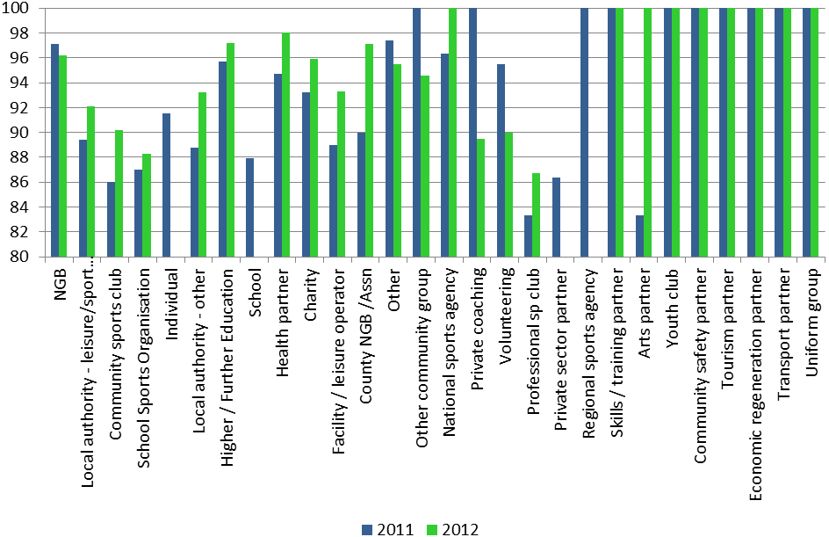

Note: All 2011 and 2012 groups included.

6.0 Recommendations

In light of the 2012 survey results and their comparison with the 2011 data, this section outlines recommendations for future satisfaction surveys, specifically in relation to process factors and key areas for improvement.

6.1 Process Recommendations

The 2012 survey highlighted the utility of using a centrally administered approach. To build upon work to date, the following recommendations should be taken into consideration:

- Contractual agreements should provide clear guidelines concerning the role of the commissioning body and delivery partner, and associated partners, to ensure that timings, roles and responsibilities are fully understood. This will improve the overall management process.
- Contact arrangements with specified leads are integral to the management and delivery of the survey. Future surveys should ensure a single point of contact for each CSP is identified and communicated with at the outset of the development process.
- The support service is critical for trust building and problem avoidance. Consideration should be given to the time required to do this effectively in future services. This should be reflected in the project specification.
- A centrally administered survey has been shown to be effective. Equally, limited autonomy over the survey content at the local level is effective at engaging CSPs. Future surveys should ensure CSPs are absolutely clear on the approach being employed so as not to disrupt management and delivery of the survey. A series of ‘dos’ and ‘don’ts’ would help establish clear boundaries for activity.
- Webinars are useful but not necessarily effective. Technical challenges and software incompatibilities are potentially disruptive and lead to an inefficient use of time. If a ‘catch all’ approach is used to disseminate information about the survey, consideration should be given to alternative or improved methods.
- CSPs should be engaged with in order to ensure consistency of sample size / type. Consistent information from the Development Group for CSP leads to assimilate and discuss the survey e.g. at MARCOMMS or other quarterly meetings would support this.
- CSPs should be engaged with in order to maximise response rates. Consistent information from the Development Group for CSP leads to assimilate and discuss the survey e.g. at MARCOMMS or other quarterly meetings would support this.
- A significant challenge is to improve the process for partners and NGBs working across multiple CSPs. It is recommended that a secondary Partner Satisfaction survey is devised to account for these respondents.
- Future surveys should make absolutely clear that URLs relate to specific CSPs i.e. responding to a particular URL implies that a respondent is talking about the CSP from which it originated. Removing the CSP’s name from the list presented in the ‘other CSP’ question on the CSP’s own survey would go some way to solving a number of problems, particularly that of partners using one CSP’s survey to respond about another CSP.

6.2 Improvement Recommendations

The data show impressive results in many areas. This should not detract from areas which could be improved upon, including.

- The CSPN Development Group recommends that the CSPN Board and individual CSPs set improvement targets that attempt to increase the number of ‘very satisfied’ partners thereby further improving partner loyalty and commitment.
- In addition to working with key partners around core business, CSPs must maintain a focus on smaller or less well represented organisations for example community organisations to ensure productive partnerships are built and high quality services are delivered irrespective of organisation type.
- Notwithstanding the impressive overall satisfaction figures, CSPs should continue strive to improve all aspects of their services even in areas that are performing well (e.g. advocating for sport on school sites; supporting SGOs to deliver level 2 of the School Games), and focus on acquiring marginal gains across the spectrum of CSP services.
- CSPs should focus on maintaining and improving partners’ overall understanding of the role of the CSP.
- Whilst there was general improvement in the relevance of CSP services compared with the 2011 survey it is recommended that CSPs use their survey data as a critical element in their improvement journey and business planning, including comparisons with national averages and family clusters.
- Smaller locally-focused and need-led surveys are recommended as a means of investigating and understanding emergent themes within specific groups i.e. HEI, so that services are matched with local needs and preferences.
- The NPS data suggest that loyalty to the CSP ‘brand’ is not consistent across all types of representation. Efforts should be made to understand and address the wide variation in scores.

Appendix A: Stakeholder Survey

County Sports Partnership Stakeholder Satisfaction Survey 2012

We are committed to continuous improvement and ensuring that the services we provide meet your expectations. We value your views and therefore would be grateful if you could spend a few minutes completing this survey and submit it by Friday 23rd November, 2012.

Core Questions

1. Tick one box that best describes you or the organisation you represent

National governing body of sport (NGB) |  | Private coaching company
Local authority - leisure/sport service |  | Professional sports club
Community sports club |  | Volunteering partner (e.g. volunteer centre)
School Sport |  | Regional sports agency
Higher / Further Education |  | Skills / training partner
Facility / leisure operator |  | Arts partner
Health partner |  | Youth club
Charity |  | Tourism partner
County governing body of sport or association |  | Uniform group
Other community group / association |  | Transport partner
National sports agency |  | Community safety partner
Other private sector partner |  | Economic regeneration partner
Local authority - other service (please specify) |  | Other (please specify)

- Please indicate the CSP that you work with (if you work with more than one CSP, please select all that apply). PLEASE NOTE: If you work with multiple CSPs you have the option of completing a separate survey for each CSP or one aggregate survey covering all the CSPs you work with.
Active Cumbria |  | Living Sport (Cambridgeshire & Peterborough Sports Partnership)
Active Devon |  | Merseyside Sport Partnership
Active Dorset |  | North Yorkshire Sport
Active Essex |  | Northamptonshire Sport
Active Gloucestershire |  | Northumberland Sport
Active Norfolk |  | Oxfordshire Sports Partnership
Active Surrey Sports Partnership |  | Pro-Active Central London
Active Sussex |  | Pro-Active East London
Berkshire Sport |  | Pro-Active North London
Birmingham Sport & Physical Activity Partnership |  | Pro-Active South London
Black Country Beactive Partnership |  | Pro-Active West London
Bucks Sport |  | Somerset Activity & Sports Partnership
Cheshire & Warrington Sports Partnership |  | South Yorkshire Sport
Cornwall Sports Partnership |  | Sport Across Staffordshire and Stoke-on-Trent
County Durham Sport |  | Sport Hampshire and IOW
CSW (Coventry, Solihull & Warwickshire Sport) |  | Sport Nottinghamshire
Derbyshire Sport |  | Sports Partnership Herefordshire & Worcestershire
Energize Shropshire (Telford & Wrekin Sports Partnership) |  | Suffolk Sport
Greater Manchester Sports Partnership |  | Team Beds & Luton
Herts Sports Partnership |  | Tees Valley Sport
Humber Sports Partnership |  | Tyne & Wear Sport
Kent Sport |  | Wesport
Lancashire Sport Partnership |  | West Yorkshire Sport
Leicestershire & Rutland Sport |  | Wiltshire & Swindon Activity and Sports Partnership
Lincolnshire Sports Partnership
- In relation to your contact with the CSP, please indicate your level of satisfaction by ticking the appropriate box:
 | Very satisfied | Satisfied | Dissatisfied | Very dissatisfied | Don’t know
Understanding of your organisation’s / group’s needs
Providing a lead role for sport and physical activity
Adding value to the services that you provide
Professionalism and helpfulness of staff
Accessibility of staff to assist with requests and queries
Speed of response to telephone and email enquiries
Quality of support and advice given
Usefulness of the CSP’s website content

- If you have stateddissatisfied or very dissatisfied for any areas in Q3, please state why and suggest ways that we could improve our service. If you are dissatisfied or very dissatisfied with more than one area, please specify which area(s) you are referring to.

- Overall how would you rate your understanding and knowledge of the role of the CSP?

Very Good |  | Good |  | Fair |  | Poor |  | Very Poor

- The CSP provides the following key services to its partners in order to support the development of sport and physical activity in the county. In relation to your contact with the CSP, please indicate your level of satisfaction with the service you have received, by ticking the appropriate box (CSPs can insert local, relevant examples in brackets):

 | Very satisfied | Satisfied | Dissatisfied | Very dissatisfied | Unaware | Not accessed
- Supporting local partners to connect with Governing Bodies of Sport
- Co-ordinating and promoting coach development opportunities
- Co-ordinating and promoting volunteer development and deployment opportunities (e.g. Sport Makers)
- Promoting local funding sources and providing advice and support, (including Sport England Lottery Funding opportunities, Sportivate, Community Games)
- Providing child protection guidance and support
- Advocate for sport on school sites
- Undertaking analysis and providing information (e.g. Partner priorities and plans, mapping, Active People, market segmentation)
- Marketing and promotion of sport and physical activity (e.g. website, e-newsletter, social media)
- Brokering relationships and providing support for local/county networks (e.g. CSNs)
- Facilitating opportunities for partners to share information and knowledge (meetings, workshops, electronically)
- Co-ordination of the Sportivate programme
- Supporting SGOs to deliver level 2 of the School Games, helping to find and deploy volunteers’
- Organising County, Youth or Level 3 School Games / activities
- Co-ordination of a club support programme (e.g. Clubmark)
- Providing equality and diversity advice
- Promoting and supporting the local delivery of the Community Games e.g. provision of training, promotional material, additional grant aid.

The following questions may be inserted as optional extras.
NOTE: IF YOU SELECT SECTION D AS AN OPTIONAL QUESTION, ALL ITEMS CONTAINED IN QUESTION 6 (INCLUDING OPTIONAL EXTRAS) WILL BE REPLICATED TO AID COMPARISONS
Developing links between sport & physical activity with health partners
Providing wider support for clubs & volunteers
Providing wider support for school sport
Providing wider support for disability sport
Organising County, Youth or School Games activities
Providing a coach agency service
Developing links between sport & physical activity with health partners

- If you have stateddissatisfied, very dissatisfied or not accessed for any of the services in Q6, please state why and suggest ways that we could improve our service. If you have stated dissatisfied, very dissatisfied or not accessed for more than one service please specify which service(s) you are referring to.

- Overall how satisfied are you with the CSP?

Very satisfied |  | Satisfied |  | Dissatisfied |  | Very dissatisfied

- How likely would you be to recommend your CSP to colleagues? (on a scale of 0 to 10, with 0 being Not at all likely and 10 being Extremely likely).

1 | 2 | 3 | 4 | 5 | 6 | 7 | 8 | 9 | 10

- Can you briefly give the main reason that you have given the score above?

- If you have any comments regarding what works particularly well please provide these below to help us continue to provide the required service:

- Please feel free to add any further comments or suggestions on how the CSP as a whole, or our specific services, could improve. Any comments regarding additional services that you could benefit from would also assist us in helping to meet your needs:

Name of person completing the survey (optional)

Job title (optional)

Organisation represented (optional)
Email address (optional)
Thank you for your time.

Optional Questions

- Any of the sections below can be selected for insertion into your survey.
- The red text indicates which parts of the questions you can amend. The examples are intended as a guide to help you to make changes that reflect your CSP/local area.
- Please only amend the text highlighted red.
- If you do not wish to make changes to the red text but would still like to use the section then you just need to make sure that you have saved the section ‘as it is’ in your survey before sending to Colin Baker.
- The entire section(s) that you select will be inserted into your survey if selected as an optional question i.e. all of the text and information below the corresponding black header bar.
- Please do not change the response types e.g. ‘satisfied’ as any changes to these will not be carried over.
- Please make sure you make it clear which sections you wish to use when replying via email e.g. A / B to ensure nothing is left out.
- IF YOU HAVE ANY QUERIES OR CONCERNS PLEASE CONTACT COLIN BAKER

- Communications

In delivering their service to the county how would you rate your satisfaction with the following communication tools used by the CSP?

 | Very satisfied | Satisfied | Dissatisfied | Very dissatisfied | Unaware
Press releases
Website
Email
E:newsletters
Newsletters
Social Media i.e. Twitter
Telephone
Complaints procedure
Events and conferences

If you have stateddissatisfied or very dissatisfied for any of the communication tools in Q1, please state why.

Please indicate whether you would like more information on / to receive any of the following communication tools.

Press releases
Website
E:newsletters
Newsletters
Social Media i.e. Twitter
Complaints procedure
Events and conferences
Other (please specify)

- Publications / guidance

Please rate your satisfaction level with the publications/guidance provided by the CSP in terms of how they raise awareness and support you/your work.

 | Very satisfied | Satisfied | Dissatisfied | Very dissatisfied | Unaware | Not applicable
Annual report
Business plan
Leaflets
Safeguarding policies
Equity policies
Marketing plan
Toolkits
Facilities strategy

If you have stateddissatisfied or very dissatisfied for any of the publications/guidance above, please state why:

- Assisting stakeholders

 | Very important | Important | Somewhat important | Not important | Don’t know
Supporting local partners to connect with Governing Bodies of Sport
Co-ordinating and promoting coach development opportunities
Co-ordinating and promoting volunteer development and deployment opportunities (e.g. Sport Makers)
Promoting local funding sources and providing advice and support, (including Sport England Lottery Funding opportunities, Sportivate, Community Games)
Providing child protection guidance and support
Advocate for sport on school sites
Undertaking analysis and providing information (e.g. Partner priorities and plans, mapping, Active People, market segmentation)
Marketing and promotion of sport and physical activity (e.g. website, e-newsletter, social media)
Brokering relationships and providing support for local/county networks (e.g. CSNs)
Facilitating opportunities for partners to share information and knowledge (meetings, workshops, electronically)
Co-ordination of the Sportivate programme
Supporting SGOs to deliver level 2 of the School Games, helping to find and deploy volunteers’
Organising County, Youth or Level 3 School Games / activities
Co-ordination of a club support programme (e.g. Clubmark)
Providing equality and diversity advice
Promoting and supporting the local delivery of the Community Games e.g. provision of training, promotional material, additional grant aid.
Developing links between sport & physical activity with health partners
Providing wider support for clubs & volunteers
Providing wider support for school sport
Providing wider support for disability sport
Organising County, Youth or School Games activities
Providing a coach agency service
How important do you think it is that the following services are provided, in terms of assisting you with your aims?
- Priorities

Are there any services that you think the CSP should offer and how important are these services, in terms of assisting you with your aims?

 | Not required | Very important | Important | Somewhat important
Event management
Consultancy
NGB hosting
Coaching agency
Team building via sport
Database management (e.g. Coach Web)
Other (please specify)
Other (please specify)

We would like to know what your 5 key priorities are for the next 12 months so that we can check and challenge the CPS’s priorities. Please state these below in rank order:

- Location

If you would like to know the specific geographical locations where stakeholders work, please provide Colin Baker (Active Gloucestershire) with a list of your local districts / areas so that this can be inserted in your survey.

- Background

Is your organisation / group currently working with / supporting young people / adults from Black and Minority Ethnic (BME) Groups?

Yes |  | No |  | Do not wish to disclose

Is your organisation / group currently working with / supporting disabled young people / adults?

Yes |  | No |  | Do not wish to disclose

Next steps

- If you happy to use only the core questions, please make this known to Colin Baker. If you wish to make any amendments to the red text in the core questions, use this document to make the changes you would like. This will provide Colin Baker with the information needed to set up your survey
- If you want to use the optional questions in addition to the core questions, save a Word document containing your choices and changes. It is recommended that you use this document to make the changes you would like. The document will provide Colin Baker with the information needed to set up your survey, so this must accurately reflect your preferences.
This will involve:
- amending the text marked red to suit your needs
- deleting questions from the Optional Questions that you don’t wish to use
- making sure that the changes to any questions you wish to use are present in the document
- savingthe document using your CSP name i.e. Stakeholder Survey Active Gloucestershire

- Email your Word file to Colin Baker with a brief note stating which sections you wish to include in the survey e.g. A / B, to ensure nothing is left out.
- Colin will place the optional questions into your survey and create a unique web link (URL) to the survey for your CSP.
- Colin will email you a pdf version of the online survey to check that it is accurate. Adjustments can be made as required after you have reviewed the survey.
- Colin will send you the URL when you have confirmed the changes are as desired.
- Colin will make the survey live.
- Once the survey is live you are able to send via emails, embed it in email signatures and place in your website

Appendix B: Guidance

CSP Stakeholder Satisfaction Survey 2012
Guidance notes for CSP lead officers

Introduction

The County Sports Partnership Network’s (CSPN) advocacy plan aims to ensure that the unique characteristics, role, contribution and potential of CSPs are well understood and highly valued by all key stakeholders, with CSPs recognized as the key strategic and delivery network for sport and physical activity.

The most powerful advocacy for CSPs comes from our stakeholders. It is critical that we listen and respond to their needs and preferences, supporting them to make the most of the CSP network and ensure a high level of satisfaction. The Stakeholder Satisfaction Survey was established as a means of understanding stakeholder views and forms a key element of the CSP improvement planning processes, taking into account themes that are evaluated as part of continuous improvement tools including; Quest, Towards an Excellent Service (TAES), and the Culture and Sport Improvement Toolkit.

The Survey also provides CSPs with information that helps identify demand for services and supports future business development. Now in its third year, the Stakeholder Satisfaction Survey is beginning to establish valuable and consistent evidence that helps CSPs and the CSPN Network understand their key stakeholders and develop services that meet their needs and expectations.

This document provides an overview of the CSPN Stakeholder Satisfaction Survey 2012 and addresses the following areas:

Aim

The aim of the survey is to assess stakeholder satisfaction levels with the services offered by CSPs in England.

Purpose

The survey’s purpose is to develop evidence, both at the individual CSP level and collectively across England, that will help to identify examples of good practice, areas for improvement, provide an evidence base for advocacy work, and to help identify the nature of existing and future demands for CSP services.

Roles & Responsibilities

Active Gloucestershire (AG) – managing data collection, CSP training and data analysis
CSPN Development Group – agreeing the survey and guidance notes, CSP training, contractor management, CSPN improvement planning and communications
CSPs – attend training, add additional questions to core questions if required, collect stakeholder emails, send out email to stakeholders inviting them to take part in the survey with web links provided by AG, write a chaser email encouraging them to complete the survey, CSP improvement planning.

Approach

A single online data collection system (Survey Monkey) is being used to manage the 2012 survey. A key advantage of this is that it will reduce the amount of work individual CSPs need to do. This system is being managed by Active Gloucestershire in collaboration with the CSPN Development Group. The survey will be designed and installed using a single Survey Monkey account. Each CSP will be given a URL (unique web address) for its own survey which it will use to collect stakeholder feedback. The full 2012 core and optional surveys is provided as a separate document to guide you as to which questions can be amended and returned to AG.

Core Questions: The 2012 survey will use most of the same core questions from the previous surveys to ensure consistency. Some questions have been updated based on the revised core specification with Sport England and to improve the questions overall. These are compulsory. Although very small modifications can be made if desired, all CSPs’ surveys will contain the core questions.

Optional Questions: All CSPs will also be able to select additional questions which they themselves have used previously, or wish to use to assess certain areas of their services. The addition of further questions is optional and is not a compulsory requirement. The type and wording of optional questions will be agreed with AG prior to the design and installation of the survey to ensure each CSP is satisfied with the survey it will be using. The questions in the surveys cannot be modified once the survey has been started.

Some of the Core and Optional questions include examples after the statements which provide an illustration to the reader of the precise nature of the question. We would encourage each CSP to complete these with very specific examples form your CSP.

The CSPN Development Group will provide all CSPs with an email template to use to send out to their stakeholders inviting them to complete the survey. CSPs are free to adapt this as they see fit

Target Audience

The survey should be distributed to all key stakeholders working directly with your CSP over the past 12 months. The size of your CSP will naturally determine the size of your sample and will differ from CSP to CSP. Hence, the emphasis should be maximising the response rate from those partners that you send the survey to.

What is a key stakeholder? This is quite difficult to define. The best way to assess this is whether the stakeholder is able to complete the majority of the questions based on their work with you over the past 12 months. CSPs will need to make an assessment regarding the inclusion of Activity Providers (e.g. clubs) but, overall, we would recommend that Activity Providers that you work with directly should be included.

What is NOT a key stakeholder?
- Someone who cannot complete the majority of questions
- A partner who may sit on a steering group with you but does not work directly with you
- The survey is NOT designed for individual volunteers or coaches but rather the partners you are working with in relation to coach and volunteer development. We recommend that CSPs undertake bespoke surveys for this target audience. NB. There may be national surveys for coach and volunteer web in the future.
- Please do not send the survey to partners working across all or multiple CSPs (eg very small NGBs or national partners with only national officers).
- Please do not send the survey to Sport England staff who already provide feedback on “satisfaction” with individual CSPs via performance measurement and the review meetings.

Partners working directly with multiple CSPs: In this case, it would be advisable to coordinate with your CSP colleagues in your region so that this type of partner only receives one email inviting them to complete the survey. The email will make it clear that they have the option of completing one survey per CSP they work with, accepting that their satisfaction may be different for each CSP, or completing one aggregated survey for all the CSPs they work with. The survey will have a question asking the stakeholder to list the CSP which the survey relates to. Multiple CSPs can be selected if the stakeholder wants to go for the aggregated version. In this scenario the stakeholders’ responses will count in each of the CSPs they relate to.

Important

- The survey should be sent directly to specific named contacts. Each contact should be encouraged to reply with an individual response thereby facilitating a more specific and high quality response. One organisational response on behalf of multiple individual stakeholders is not recommended.
- Please contact AG to confirm the total number of stakeholders you have invited to take part in the survey using emails containing the link to the survey

Outputs

Two key outputs will ensure that the results from the 2012 survey are disseminated effectively:

- Data file: each CSP will receive the results from its own survey (excel spreadsheet).
- Written report: a national level report of the findings will provide an analysis of satisfaction levels by stakeholder group and service areas.

Benchmarking

Results will be published on the portal showing overall satisfaction levels broken down by each CSP and stakeholder group. This will allow CSPs to benchmark their performance and facilitate the assessment of priorities for improvement action.

Support

Consistent with the previous surveys a range of support will be offered including:

- Prior to the survey starting a number of webinars will be organized to go through the guidance notes and ensure all CSPs are clear in terms of how it will work
- Prior to the survey starting, all CSP leads for the survey will be invited to talk with Colin Baker (Active Gloucestershire) to discuss the survey, arrange optional questions and raise any issues.
- When the survey is running, CSPs will be able to contact Colin Baker via email or telephone to discuss any issues.
- Each CSP will receive the results from its own survey at no cost. After the survey has closed CSPs will be able to access support to help generate reports form their own data if deemed necessary. This is at a cost of £250 per day (plus costs where incurred e.g. site visit).

Timescales

The table below highlights key actions between October 2012 and January 2013. Actions required of CSPs are highlighted in bold text.

What | Who | Date | Comment
Receive and understand guidance | CSPs |  | The Skype sessions are recommended as a very useful way of addressing queries / issues.
Online Skype support to CSP leads |  | October 17th - 2pm  October 18th - 2pm  October 19th - 11am
Send Word file containing individual survey to ready for installation to AG | CSPs | 26th October
Design & install surveys | AG | 4th November
Survey opens | AG | 5th November
Survey closes | AG | 23rd November
Preparation of Excel file for data analysis | AG | December
Data analysis | AG | January
Draft Report | AG | 16th January
Final Report | AG | 27th January
Sending of Excel data files to CSPs | AG | 27th January
Presentation of final Survey Report | AG | January

Appendix C: Response rates for CSPs
No. | Region | CSP | Invites sent | Total responses | Response rate (%)
1 | East | Suffolk Sport | 192 | 84 | 43.8
2 | East | Team Beds & Luton | 135 | 37 | 27.4
3 | East | Living Sport (Cambridgeshire & Peterborough) | 144 | 56 | 38.9
4 | East | Active Norfolk | 240 | 73 | 30.4
5 | East | Active Essex | 136 | 22 | 16.2
6 | East | Herts Sports Partnership | 420 | 76 | 18.1
7 | East Midlands | Leicestershire & Rutland Sport | 152 | 53 | 34.9
8 | East Midlands | Lincolnshire Sports Partnership | 179 | 44 | 24.6
9 | East Midlands | Northamptonshire Sport | 309 | 50 | 16.2
10 | East Midlands | Derbyshire Sport | 200 | 61 | 30.5
11 | East Midlands | Sport Nottinghamshire | 119 | 45 | 37.8
12 | London | Pro-Active South London | 120 | 36 | 30.0
13 | London | Pro-Active East London | 256 | 41 | 16.0
14 | London | Pro-Active North London | 152 | 66 | 43.4
15 | London | Pro-Active West London | 186 | 39 | 21.0
16 | London | Pro-Active Central London | 62 | 31 | 50.0
17 | North East | County Durham Sport | 124 | 25 | 20.2
18 | North East | Tees Valley Sport | 157 | 27 | 17.2
19 | North East | Northumberland Sport | 133 | 38 | 28.6
20 | North East | Tyne & Wear Sport | 115 | 31 | 27.0
21 | North West | Cheshire & Warrington Sports Partnership | 220 | 48 | 21.8
22 | North West | Active Cumbria | 120 | 41 | 34.2
23 | North West | Lancashire Sport Partnership | 700 | 51 | 7.3
24 | North West | Greater Manchester Sports Partnership | 248 | 95 | 38.3
25 | North West | Merseyside Sport Partnership | 475 | 64 | 13.5
26 | South East | Sport Hampshire and IOW | 161 | 18 | 11.2
27 | South East | Oxfordshire Sports Partnership | 80 | 27 | 33.8
28 | South East | Bucks Sport | 109 | 27 | 24.8
29 | South East | Active Sussex | 150 | 63 | 42.0
30 | South East | Berkshire Sport | 154 | 43 | 27.9
31 | South East | Active Surrey Sports Partnership | 305 | 68 | 22.3
32 | South West | Wiltshire & Swindon Activity and Sports Partnership | 108 | 48 | 44.4
33 | South West | Somerset Activity & Sports Partnership | 210 | 46 | 21.9
34 | South West | Wesport | 110 | 46 | 41.8
35 | South West | Active Dorset | 85 | 24 | 28.2
36 | South West | Active Devon | 98 | 53 | 54.1
37 | South West | Active Gloucestershire | 99 | 51 | 51.5
38 | South West | Cornwall Sports Partnership | 100 | 46 | 46.0
39 | West Midlands | Sports Partnership Herefordshire & Worcestershire | 72 | 38 | 52.8
40 | West Midlands | CSW Coventry, Solihull &Warwickshire Sport | 145 | 34 | 23.4
41 | West Midlands | energize Shropshire, Telford & Wrekin Sports Partnership | 101 | 33 | 32.7
42 | West Midlands | Birmingham Sport and Physical Activity Partnership | 150 | 22 | 14.7
43 | West Midlands | Black Country Beactive Partnership | 130 | 31 | 23.8
44 | West Midlands | Sport Across Staffordshire and Stoke-on-Trent | 166 | 66 | 39.8

Contd.
No. | Region | CSP | Invites sent | Total responses | Response rate (%)
45 | Yorkshire | West Yorkshire Sport | 100 | 57 | 57.0
46 | Yorkshire | Humber Sports Partnership | 156 | 49 | 31.4
47 | Yorkshire | South Yorkshire Sport | 800 | 80 | 10.0
48 | Yorkshire | North Yorkshire Sport | 95 | 34 | 35.8
49 | (Pan London) | Pro-Active South London, Pro-Active East London, Pro-Active North London, Pro-Active West London, Pro-Active Central London | 227 | 26 | 11.5
50 | (NGB Partnership Survey) |  | 2 | 2 | 100

By consent, Kent Sport did not run the 2012 survey.
Developed by Fred Reichheld, Bain & Company, and Satmetrix.

