University of Gloucestershire April, 2014
Artlift Gloucestershire

Update Report 2011-2014

Prepared by: Dr Elizabeth Loughren, Mr Joe Matthews, Dr Colin Baker, Ms Charlotte Speke and Prof Diane Crone

Contents
1.0 Introduction 1
2.0 Aim and objectives of the brief evaluation 1
3.0 Findings 1
3.1 Surgery Referral Locations and Referrer Profession 1
3.2 Location of Artlift Offer and uptake 3
3.3 Patient Demographics 5
3.4 Patient Uptake and Progression 7
3.5 Well-being 9
4.0 Review of findings with previous Artlift reports 10
5.0 Conclusion 10
6.0 Further information 11

List of Figures

Figure 1: Artlift Referral Surgeries (%) 2
Figure 2: Patient Referrer Profession (%) 3
Figure 3: Location of Artlift programmes (%) 4
Figure 4: Programme Uptake (%) 4
Figure 5: Patient Occupation (%) 5
Figure 6: Patient by Postcode Location (%) 6
Figure 7: Reason for Initial Referral/Re-Referral (%) 7
Figure 8: CONSORT Diagram of patients and progression through the intervention 8

To reference this report, please use the following citation:
Loughren, E.A., Matthews, J., Baker, C., Speke, C. & Crone, D. (2014). Artlift Gloucestershire: Update Report 2011-2014. University of Gloucestershire, U.K

1.0 Introduction

Artlift Arts on Referral scheme is a primary care based art intervention in Gloucestershire where health professionals refer patients for an 8-10 week art programme, usually delivered in a community based or primary care setting. Patients are referred for a range of reasons (to reduce stress, anxiety or depression; to improve self-esteem or confidence; to increase social networks; alleviate symptom of chronic pain or illness; distract from behaviour related health issues; improve overall wellbeing).

The 8-10 week intervention involves art sessions delivered by artists working with activities such as words/poetry, ceramics, drawing, mosaic and painting. This update report summarises a brief evaluation of the available Artlift data (April, 2014) conducted by the Interventions4Health team at the University of Gloucestershire.

This evaluation represents an update from the original evaluation published in 2011 (Crone et al., 2011) which resulted in two international peer reviewed academic publications (Crone et al., 2012; Crone et al., 2013). Recall that the evaluation design/method and Warwick Edinburgh Mental Well-Being Scale (WEMWBS) are described in the original evaluation. This evaluation had added the referred patients since the 2011 evaluation which has increased the overall patient data base. The Artlift database remains, to date, one of the largest database of an arts on referral programme available and this evaluation presents the largest known data set of patients referred onto such a programme in the world.

2.0 Aim and objectives of the brief evaluation

Aim: To investigate health professional referral to the Artlift programme, and uptake, adherence and outcomes of participation for patients.

Objectives:

- To investigate which GP practices and professional roles refer patients to Artlift.
- To investigate Artlift uptake service location and art intervention type.
- To investigate patients’ characteristics (e.g., gender, age, referral reason, place of residence) and their progress through the intervention (e.g., attendance, completion and re-referral).
- To investigate the impact of the intervention(s) on mental well-being of patients using a validated measure (the Warwick Edinburgh Mental Well-Being Scale [WEMWBS], pre and post intervention.

3.0 Findings

Service user data was collected from 2009 until February 2014. Anonymised Artlift service user completed packets were returned to the University of Gloucestershire by the artists leading the sessions.

This information was entered into a SPSS (v.20) data file by the Interventions4Health team who conducted all of the analysis. In total, data was provided for 666 patients, with 665 meeting the inclusion criteria (aged 18 or older).

3.1 Surgery Referral Locations and Referrer Profession

The surgeries referring to the Artlift programme are detailed in Figure 1. The highest referral rates were Abbotswood (6.9%), Church Street (5.1%), and Royal Crescent (5.1%). Patients were typically referred by their GP (42.8%), and less commonly by a primary care nurse (8%) or a mental health nurse (6%) (Figure 2).
Figure 1: Artlift Referral Surgeries (%)
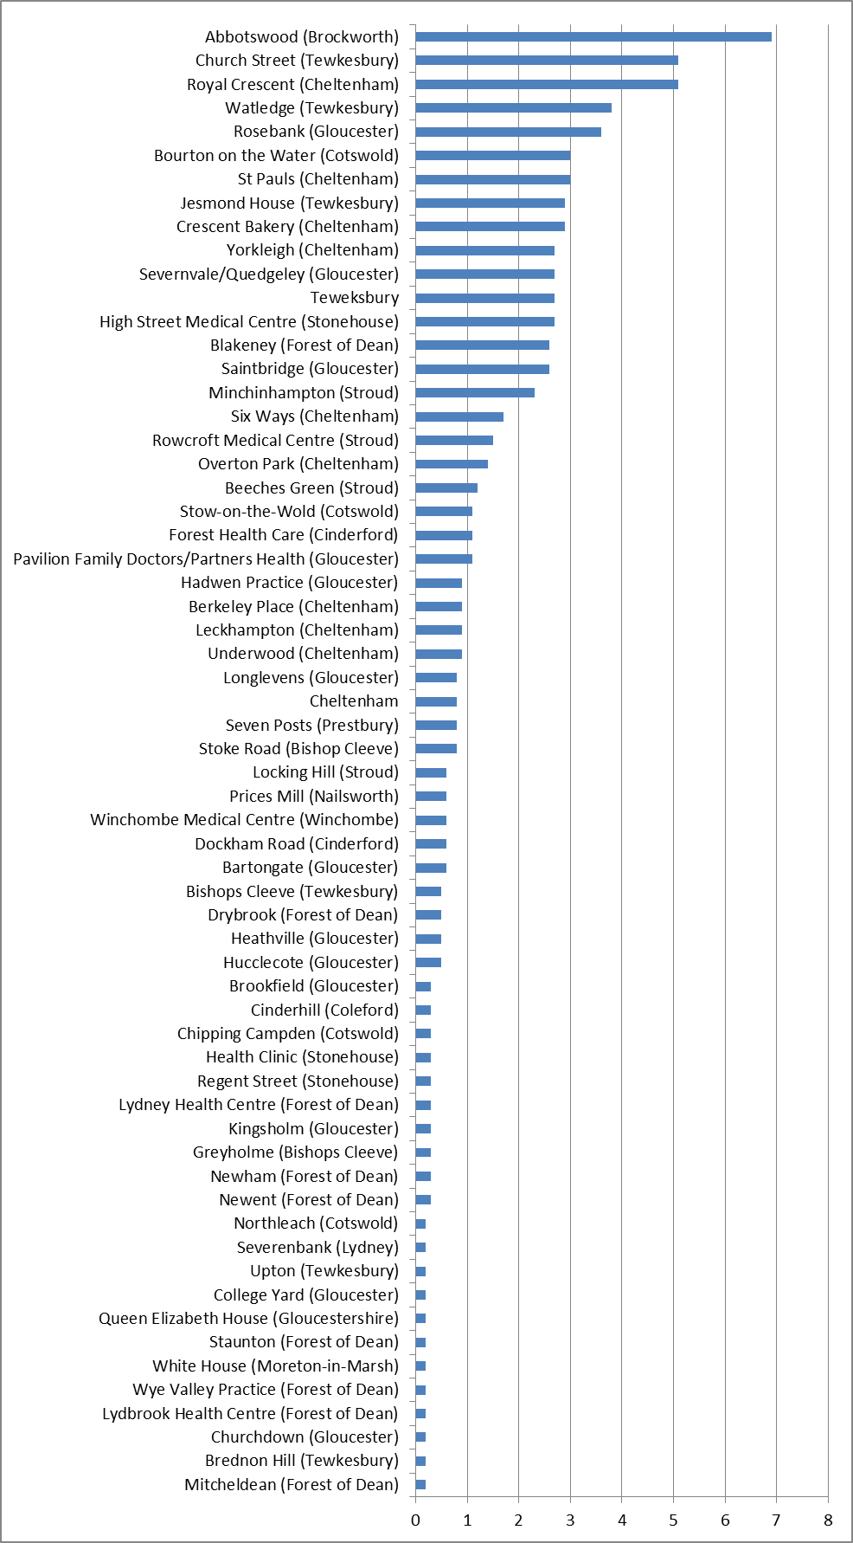Note: N= 665 (n = 638 responses, n = 27 no response).
Figure 2: Patient Referrer Profession (%)

Note: N = 665 (n = 516 responses, n = 149 no response).

3.2 Location of Artlift Offer and uptake

Artlift is offered at many locations throughout Gloucestershire including Cheltenham Community Resource Centre (12.9% of all referrals), Abbotswood Surgery Brockworth (10.1% of all referrals), and Stonehouse Surgery/Medical Centre (7.7% of all referrals) were the three most utilized programme settings (Figure 3).

The majority of participants participated in a combination of visual art/mixed media (52.5%) as part of their art intervention but other specific art forms were available (see Figure 4).

Figure 3: Location of Artlift programmes (%)

Note: N = 665 (n = 576 responses, n = 89 no response).
Figure 4: Programme Uptake (%)

Note: N = 665 (n = 567 responses, n = 98 no response).

3.3 Patient Demographics

From 2009-February 2014 a total of 665 (n = 490 females [74%]; n = 154 males [23%]; n = 21 gender not indicated) patients were referred to Artlift ranging in age from 19-93 years old (M= 53.05, SD= 16.16) with a modal age of 57. Most patients were unemployed (38%) or retired (21%) (Figure 5) and were based in the Gloucester GL20 postcode (18%) (see Figure 6).

Figure 5: Patient Occupation (%)

Note: N = 665 (n = 637 responses, n = 28 no response).

Figure 6: Patient by Postcode Location (%)

Note: N = 665 (n = 638 responses, n = 27 no responses).

Patients are referred to the Artlift programme for a variety of reasons and can upon initial programme completion be re-referred to complete another course offering. On analysis of reasons for referral, patients were commonly referred and re-referred with a criterion of stress/anxiety/depression, to improve well-being, or self-esteem and/or confidence (see Figure 7).

Figure 7: Reason for Initial Referral/Re-Referral (%)

Note. a: Initial n = 637; b: RR1 n = 143; c: RR2 n = 51; d: RR3 n = 26; e: RR4 n = 14; f: RR5 n = 4; g: RR6 n = 2.

3.4 Patient Uptake and Progression

Of the 665 initial patients 390 (57%) completed their first Artlift referral course with an additional 142 (36%) being re-referred to the service. Some patients (n = 2) have been re-referred up to six times over the duration of Artlift i.e. since 2009 (see Figure 8). A partial completer was determined by the artist at each location and defined as patient who attended up to half of the sessions offered, but not all session offerings due to other personal circumstances e.g., illness, family commitments, work conflicts, etc.

Figure 8: CONSORT Diagram of patients and progression through the intervention
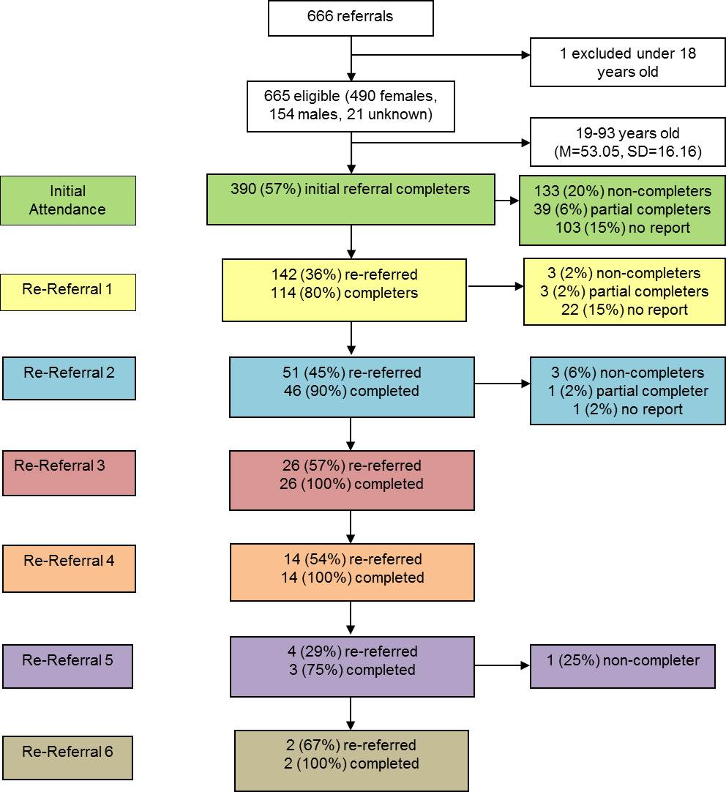

3.5 Well-being

All patients completed the Warwick Edinburgh Measurement of Well-Being Scale (WEMWBS) at the beginning and concluding programme time points.

- Initial referral

There was a statistically significant increase in well-being from the programme start (M = 37.05, SD = 10.95) to completion (M = 42.10, SD = 13.66), t(350) = -8.63, p < .000 (two-tailed).

The mean increase in well-being scores was -5.06 with a 95% confidence interval ranging from -6.21 to -3.90. A follow-up eta squared statistic (.18) indicated a large effect size supporting magnitude of the patients self-report.

- Re-Referral 1(RR1)

There was a statistically significant increase in well-being for those re-referred once from the programme start (M = 39.17, SD = 9.53) to completion (M = 42.75, SD = 9.92), t(100) = -3.99, p < .000 (two-tailed).

The mean increase in well-being scores was -3.58 with a 95% confidence interval ranging from -5.37 to -1.80. A follow-up eta squared statistic (.14) indicated a large effect size supporting magnitude of the patients self-report.

- Re-Referral 2(RR2)

There was a statistically significant increase in reported well-being for those re-referred twice from the programme start (M = 40.51, SD = 9.92) to completion (M = 44.94, SD = 10.38), t(46) = -4.90, p < .000 (two-tailed).

The mean increase in well-being scores was -4.43 with a 95% confidence interval ranging from -6.24 to -2.61. A follow-up eta squared statistic (.34) indicated a large effect size supporting magnitude of the patients self-report.

- Re-Referral 3, 4, 5, and 6 (RR3-6)

No statistically significant differences were found in well-being for patients re-referred three to six times. This can be attributed to the small number of patients to be included within each analysis (e.g., 24 people RR3 times, 16 people RR4 times, 3 people RR5 times, and 2 people RR6 times).

4.0 Review of findings with previous Artlift reports

The 2011 Artlift Evaluation report (Crone et al., 2011) main findings included:
- A total of 255 referrals to Artlift.
- High attendance and completion rates for programme participants.
- A significant improvement in from the pre- and post- WEMWBS data for those that completed.
- Successful recruitment of people from a broad range of socio-economic backgrounds.
- Patients identified increased confidence, distraction from illnesses and everyday life, enjoyment, a new interest, offering therapeutic value and providing social interaction and support as key benefits.
The 2013 Artlift Extension report (Baker et al., 2013) (qualitative findings from five patients who were re-referred to Artlift) included:
- Art activities provided a focus that contrasted sharply with traditional treatment approaches. The acquisition and development of specific skills over time improved confidence and provided participants with an alternative view of themselves as artists.
- Art activities provided a useful and effective tool to respond to episodes of increased mental and physical distress which gave participants confidence to better manage their condition long term.

5.0 Conclusion

The main findings are:
- GPs are engaging with referring to the programme and from a variety of surgery locations throughout Gloucestershire including those from rural areas and of lower deprivation levels.
- Patients were commonly referred and re-referred to support them to manage with stress/anxiety/depression, well-being, or to increase levels of self-esteem and confidence.
- There is a diverse range of patient postcode locations suggesting that Artlift is an accessible service across the rural and urban areas of the county.
- There were high attendance and completion rates when compared with other primary care based health referral programmes such as exercise referral schemes.
- For those that completed the initial referral there was a significant improvement in well-being after the initial 8-10 weeks of art sessions.
- There was a significant improvement in well-being for patients who were re-referred once and twice to the programme.
- No statistically significant differences were found in well-being for patients re-referred three to six times. This can be attributed to the small number of patients at these referral stages.
- Artlift continues to report successful attendance, adherence and outcomes as a primary care intervention to address mental health problems and appears a useful adjunct to the management of longer term chronic problems that people face within the country.

6.0 Further information

For additional Artlift outputs please refer to:

Baker, C., Crone, D., Clark-Stone, F. & Kilgour, L. (2013). Artlift (Extension), Gloucestershire: Evaluation Report. University of Gloucestershire, U.K.
Crone, D., O’Connell, E., James, D.V.B., Tyson, P. and Clark-Stone, F. (2011). Artlift, Gloucestershire: Evaluation Report. University of Gloucestershire, U.K.
Crone, D. M., O’Connell, E.E, Tyson, P.J., Clark-Stone, F., Opher, S., & James, D. V. B. (2012). ‘It helps me make sense of the world’: The role of an art intervention for promoting health and wellbeing in primary care—perspectives of patients, health professionals and artists. Journal of Public Health, 20 (5), 519-524. DOI 10.1007/s10389-012-0495-x.
Crone, D.M., O'Connell, E.E., Tyson, P.J., Clark-Stone, F., Opher, S., James, D.V.B. (2013). 'Artlift' intervention to improve mental well-being: An observational study from UK general practice. International Journal of Mental Health Nursing, 22(3), 279-286. DOI: 10.1111/j.1447-0349.2012.00862.x

Statistical significance suggests that the result is meaningful and did not occur by chance i.e. there has been a true effect of the art programme and a health outcome.
Two-tailed tests are used to calculate the statistical significance of data. Tails represent the extreme distribution of data within a normal bell-curve. Two tails account for both directions i.e. extremes on both sides of the curve and are used when extremes on both directions are considered equally likely in the data.
95% confidence interval relates to the reliability of the results i.e. whether the same findings would arise if the study were repeated. It is expressed as a percentage which represents how often the true percentage of the population would pick an answer that lies within the confidence interval i.e. 95%.
The effect size is a measure of the strength of a phenomenon which provides a practical way of quantifying the size of the difference between data e.g. baseline and follow up measures.

